METU

Department of Economics
Econ 101: Introduction to Economics I
Sections 01-02
2024-2025 Fall Semester
TA: Zeki Oğulcan Şengül

PROBLEM SET 1 SOLUTIONS

PART A - QUESTIONS

- You are given two equations as follows:
y = mx+b (1)
z = - mx+b (2)

where x, y, z are variables; b and m are positive constants. For the equations above;

- Define the dependent variable(s).

- Define the independent variable(s).

- Show the intercept and slope terms, and interpret them.

- Explain whether the variables are positively or negatively related. Give economic examples of what the variables in equations may be.

- Graph the following equations and indicate their respective slopes and intercepts. Explain whether the variables are positively or negatively related.

- 3y+9x-15=0
- -2y+3x+5=0
- -3y +x-12=0
- 5y+20x-15=0

- Write the equations of the linear functions whose graph
- has slope 2/3 and intercept (3, 0)
- has slope 4 and intercept (4, 3)
- has slope 6 and passes through the point (5, 2)
- has slope -1/4 and passes through the point (2, -3)
- passes through the points (2, 1) and (3, 5)

- Using the following figure;

y

80 b

60 a

40 c

Z Z
20
0
30 60 90 120 150 x

- What is the slope of the curve ZZ at point a?
- What is the slope of the curve ZZ at point b?
- What is the slope of the curve ZZ at point c?

- From the graphs below, indicate which graph(s);

  - are increasing for all x,
  - are decreasing for all x,
  - are increasing at a constant rate for all x,
  - are decreasing at a constant rate for all x,
  - are increasing at an increasing rate for all x,
  - are increasing at a decreasing rate for all x,
  - are decreasing at an increasing rate for all x,
  - are decreasing at a decreasing rate for all x,

y y

x x

  - (b)

y y

x x
(c) (d)

y y

x x

- (f)

y y

x x

(g) (h)

- Table below gives the values of Y in 2010 and 2011 in US dollars.

Year | Y
2010 | 731000$
2011 | 774860$

- Calculate the percentage change in Y from 2010 to 2011.
- During 2012, Y grows 2 percent. Find the value of Y in 2012.

- Suppose we have the following total cost functions. Please derive the corresponding marginal cost functions by benefiting from the total cost.

TC₁= 60+2.5Q
TC₂= 100Q
TC₃= 7500+3Q+0.2Q²
TC₄= 500

- Determine the concavity/convexity of following functions

f(q) = −(1/3)q² + 8q − 3.

f(q) = q²+ 6q+9

PART B: MULTIPLE CHOICE QUESTIONS

1)If the equation y = 3x + 9 was plotted:
- the vertical intercept would be 9.
- the slope would be 3.
- it would look as an upward sloping line.
- the horizantal intercept would be – 3.
- all of the above would be true.

Answer the questions from 2 to 5 according to figure below
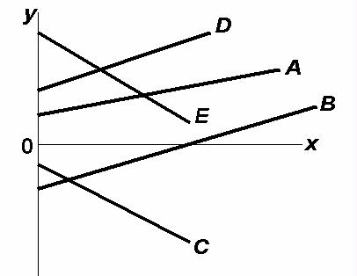

2)According to the figure above, which line(s) show(s) a positive relationship between x and y?
- A only
- Both A and D
- A, B. and D
- Both C and E
3)In the figure above, which line(s) show(s) a negative relationship between x and y?
- A only
- Both A and D
- A, B, and D
- Both C and E

4)In the figure above, which line(s) show(s) a positive vertical intercept?
- A and D only
- B and C only
- A, D, and E
- A, D, and B

5)According to the figure above, which line(s) show(s) a negative vertical intercept?
- C only
- Both C and E
- B, C, and E
- Both B and C

6)Refer to the figure below. The expression of the slope of the line between points A and B equals:
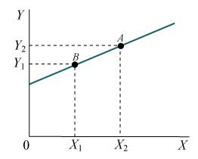

a) 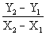 b) 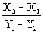 c) 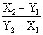 d) 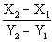 e) 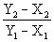

The difference between Y2 and Y1 is the rise, or the change in Y. The difference between X2 and X1 is the run, or the change in X. The ratio of the changes is commonly called “rise over run.”

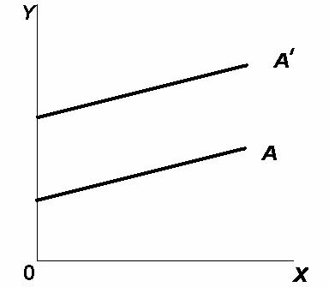
7)In the figure above, the movement from line A to line A' (parallel lines) represents a change in:
- the slope only.

- the intercept only.

- both the slope and the intercept.
- neither the slope nor the intercept.

8)The slope of a curve
- is undefined.
- must be constant along the curve.
- may vary along the curve.
- can never become positive if it initially is negative.

Answer the following 3 questions according to figure below
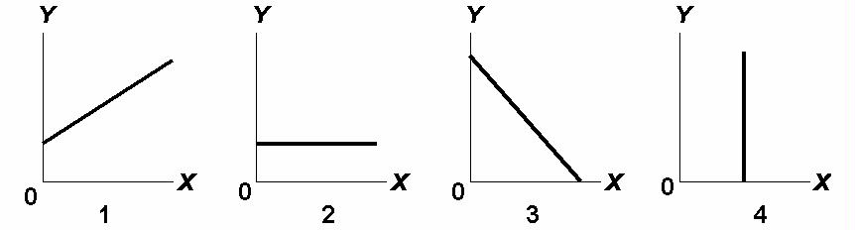

9)According to figure above, the amount of Y is directly related to the amount of X in:
- both 1 and 3.
- Both 1 and 2
- 2 only
- 1 only
10)According to the figure above, the amount of Y is inversely related to the amount of X in:
- 2 only.
- Both 1 and 3
- 3 only
- 1 only

11)According to the figure above, the amount of Y is unrelated to the amount of X in:
a) both 2 and 4.
b)3 only
c)2 only
d)1

12)If price (P) and quantity (Q) are directly related, this means that:
  - a change in Q will alter P, but a change in P will not alter Q.
  - if P increases, Q will decrease.
  - if P increases, Q will also increase.
  - an increase in P will cause Q to change, but the direction in which Q changes cannot be predicted.

13)If price (P) and quantity (Q) are inversely related, this means that:
- a change in Q will alter P, but a change in P will not alter Q.
- if P increases, Q will decrease.
- if P increases, Q will also increase.
- an increase in P will cause Q to change, but the direction in which Q changes cannot be predicted.

14) The slope of a line parallel to the horizontal axis is:
a. zero b.
- one c.
- infinite d.
one-half

15)Assume a household would consume $150 worth of goods and services per week if its weekly income were zero and would spend an additional $80 per week for each $100 additional income. Letting C represent consumption and Y represent income, the equation that summarizes this relationship is:
- C = 150 + 80Y
- C = 80 + 1.5Y
- C = 80 + 150Y
- C = 150 + 0.8Y
- C = 100 + 0.8Y

16) Refer to the figure below. According to this graph, the relationship between hours of study time and points in the exam is as follows:

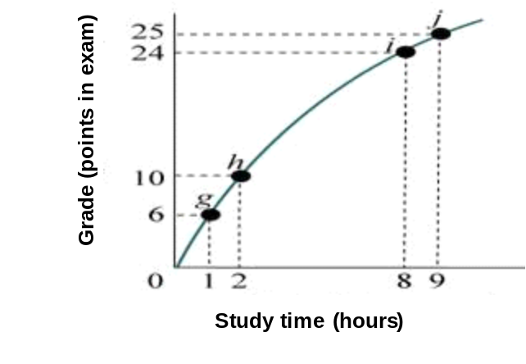

- Negative, because additional study time decreases points obtained in the exam.
- Positive but diminishing.
- The relationship between study time and points on the exam is first positive, and then it turns negative.
- Positive and increasing.
- Nonexistent. There appears to be no relationship between additional hours of study time and a better grade on the exam.

17)The slope of a line parallel to the vertical axis is
- zero b. one c. infinite d. one-half

18) Monthly consumption of goods and services of an household increased 6% during September 2013 compared to previous month’s consumption. In August household consumed 500 TRY worth goods and services. What is the monthly consumption expenditure of this household in September?
- 506 TRY b) 560 TRY c) 530 TRY d) 512 TRY

Answer the following 2 questions according to the figure below
4 8 X
Y

5

2
19)According to the figure above, the slope of the line is:
- +5/4 b. -3/4 c. - 3/2 d. -4/3

20)In the figure above, suppose that the slope of the line were to change to -1. This would imply that
  - the relationship is flatter than before
  - the relationship is steeper than before
  - the relationship could be either steeper or flatter than before
  - the relationship changed signs

21) Refer to the figure below. Which graph shows a negative at a decreasing rate relationship between X and Y?

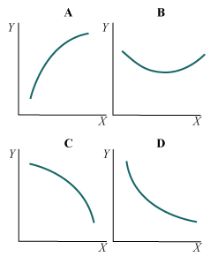

a) C b) D c) B d) A e) None of them.

y
x
A
B
C
D
E
22)In the above figure, the point where the slope=0 is
- A
- B
- C
- D
- E

