METU Department of Economics Fall 2024-2025
ECON 202

Instructor: Pınar Derin Güre
T.A: Pınar Özpala

Discussion Session 4 (Chapter 5)

PART A: LONG QUESTIONS
ESSAY QUESTIONS
- Consider the following stylized economy.
Good Market Financial Market
Goods Demand: Z = C + I + G Money Supply: $\frac{M^{s}}{P}=36$
Consumption: C = 30 + 0.5 Y_{D} Money Demand: $\frac{M^{d}}{P}=0.2Y-240i$
Investment: I = 10 + 0.25Y – 200i
Government Expenditure: G = 30
Solution:
- Assume a balanced budget. Derive the IS relation.
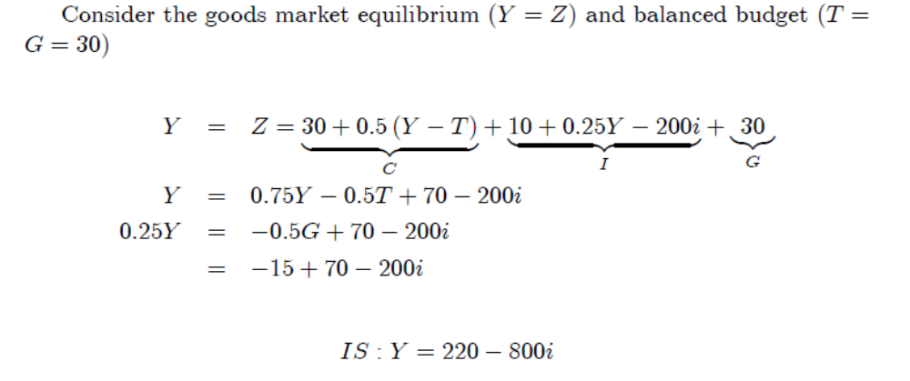

- Derive the LM relation.
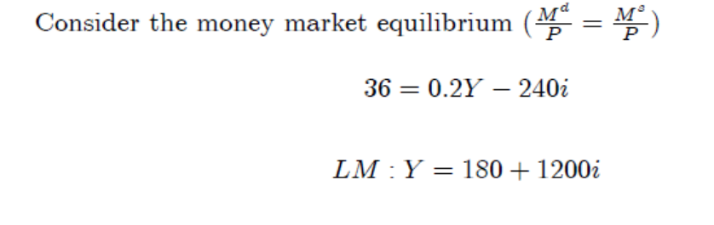
- Solve for the equilibrium interest rate, equilibrium output, equilibrium private consumption, and equilibrium investment.
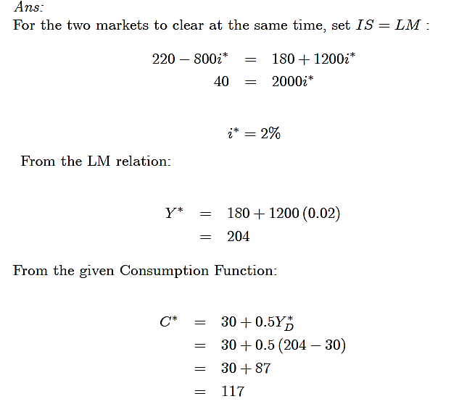
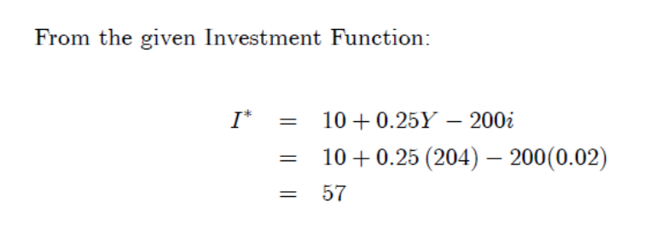

- In a particular economy the real money demand function is:

M^{d}/P= 2800 + 0.1Y - 10,000i.
Assume that M = 6000, P = 2.0.

Solution:

- What is the interest rate i, that clears the asset market when Y = 8000? When Y = 9000? Graph the LM curve.
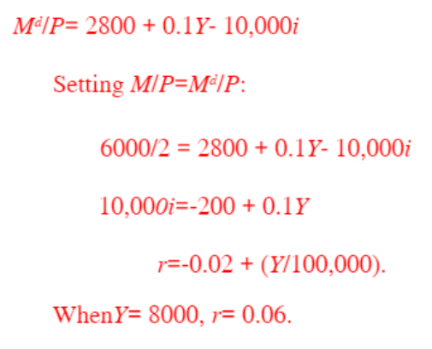
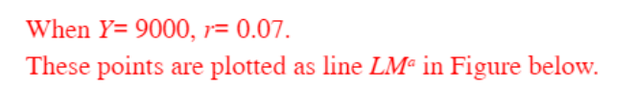
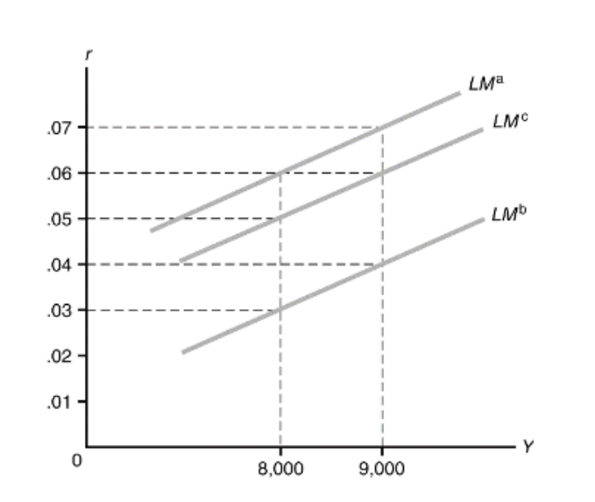

- Repeat Part (a) for M = 6600. How does the LM curve, in this case, compare with the LM curve in Part (a)?
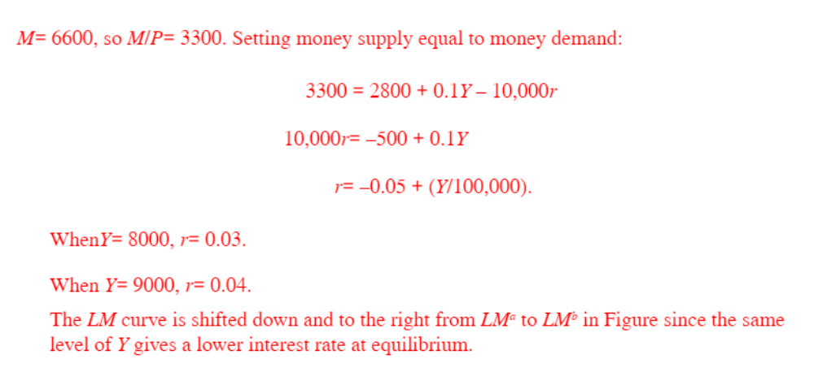
- Assume the following:
- The public holds no currency.
- The ratio of reserves to deposits is 0.1.
- The demand for money is given by

M^{d} = $Y (0.8 − 4i)
Initially, the monetary base is $100 billion, and nominal income is $5 trillion.

Solution:

- What is the demand for central bank money?

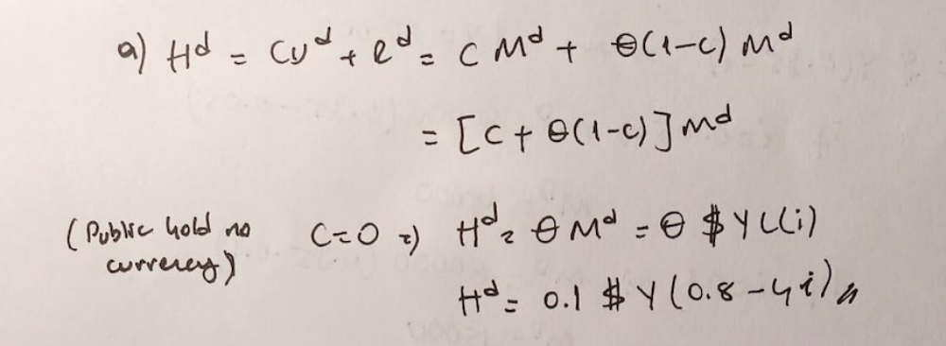
- Find the equilibrium interest rate by setting the demand for central bank money equal to the supply of central bank money.
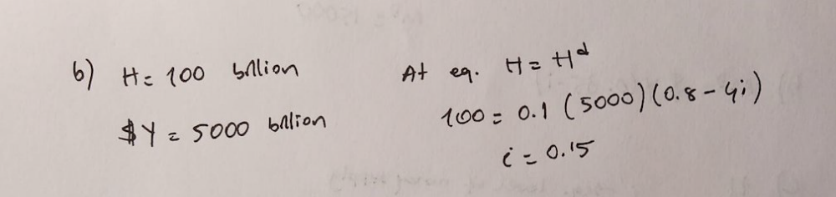

- What is the overall supply of money? Is it equal to the overall demand for money at the interest rate you found in part (b)?
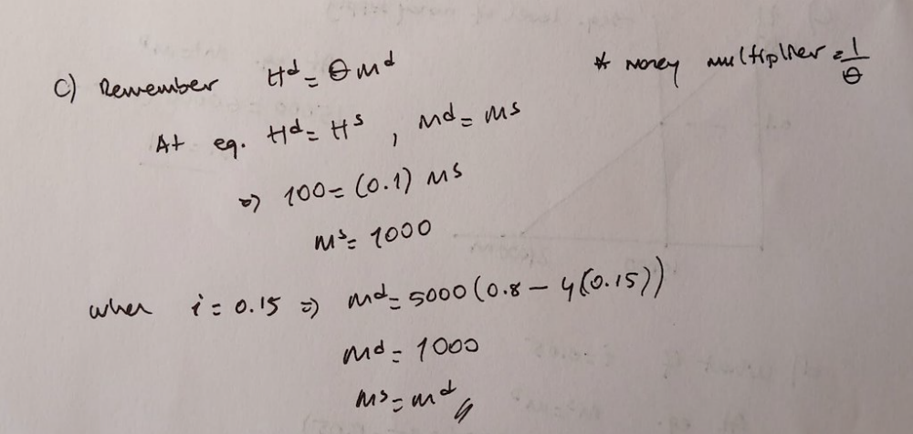

- What will be the level of central bank money if the central bank targets an interest rate of 5%? What will be the overall supply of money in this case?
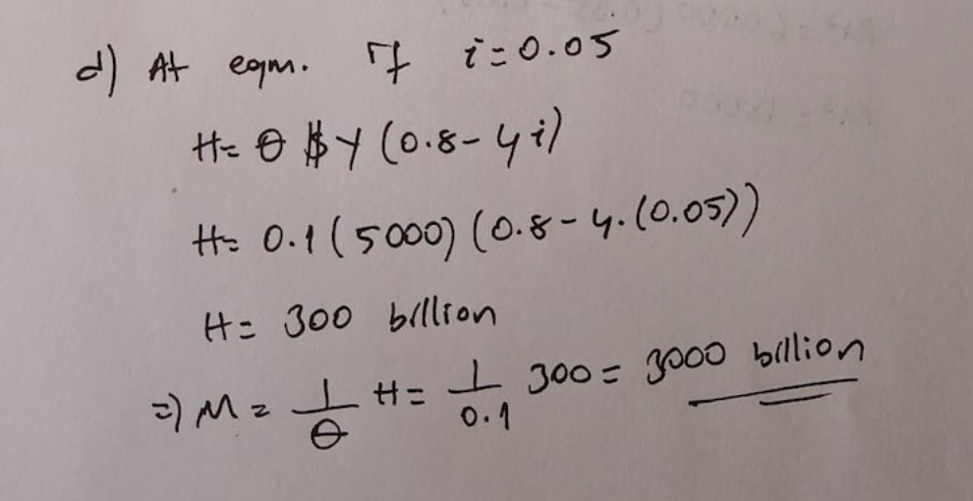
PART B: SHORT QUESTIONS
TRUE/FALSE/UNCERTAIN (Explain it.)
1. Consider an IS-LM model. If consumption depends not just on income but also (negatively) on the interest rate, the slope of the IS curve becomes steeper.

False. It becomes flatter

2. In the IS-LM model, equilibrium output is determined in the goods market, while the equilibrium interest rate is determined in the bond market.
False. In the IS-LM model, both equilibrium output and interest rate are jointly determined by the equilibrium both in the goods and financial (bond) markets.
3. If the investment is very responsive to changes in the interest rate, the IS curve will be relatively flat. This will make a monetary policy very effective in changing the output level.
True. If the investment is very sensitive to changes in the interest rate, a small decrease in the interest rate will cause a large increase in the investment level. Thus, the IS curve will be relatively flat. This will make monetary policy, with its direct impact on interest rates, a very effective tool the government can use to affect the output level.

MULTIPLE CHOICE QUESTIONS
- During 2008 in the United States, consumer confidence fell significantly. Which of the
following will occur as a result of this reduction in consumer confidence?
A) the LM curve will shift up.
B) the LM curve will shift down.
C) the IS curve will shift rightward.
D) the IS curve will shift leftward.
E) the IS curve will shift rightward, and the LM curve will shift up.

- A reasonable dynamic assumption for the IS-LM model is that
A) the economy is always on both the IS and LM curves.
B) the economy is always on the IS curve but moves only slowly to the LM curve.
C) the economy is always on the LM curve but moves only slowly to the IS curve.
D) the money market is quick to adjust, but the bond market adjusts more slowly.
E) adjustment to the new IS-LM equilibrium is instantaneous after an LM shift, but not after an IS shift.

- The government's running of a deficit or a surplus with the objective of affecting the level of output in the economy is called:
A) public finance.
B) fiscal policy.
C) the Ricardian equivalence.
D) sound finance.

- One policy response to the U.S. economic slowdown of 2001 was to increase money growth. This policy response can be represented in the IS-LM model by shifting the ______ curve to the ______.
A) IS; right
B) IS; left
C) LM; right
D) LM; left

- Which of the following will cause a shift of the IS curve?
A) Open market purchase by the central bank
B) Autonomous decline in consumption expenditure
C) Increase in interest rate
D) Increase in output
E) None of the above

- Suppose there is a simultaneous tax cut and open market sale of bonds. Which of the following must occur as a result of this?
A) the interest rate increases
B) output increases
C) both output and the interest rate increase
D) output decreases
E) the interest rate decreases

- Suppose there is a simultaneous increase in reserve requirement ratio by Fed and an increase in taxes. We know with certainty that this combination of policies must cause:
A) Increase in interest rate
B) Decrease in interest rate
C) Increase in output
D) Decrease in output
E) None of the above

- Suppose there is a simultaneous fiscal expansion and monetary expansion. We know with
certainty that
A) output will increase.
B) output will decrease.
C) the interest rate will increase.
D) the interest rate will decrease.
E) both output and the interest rate will increase.

- If the reserve ratio is 0.25 and public does not hold currency, the money multiplier is:
A) 1.3.
B) 4.0.
C) 10.5.
D) 12.5.

- If a deposit of $50 in the banking system can lead to a maximum expansion in bank deposits of $250, using the money multiplier formula, the required reserve ratio must be:
A)0.2
B)0.25
C)0.4
D) 0.5

- Suppose investment spending is NOT very sensitive to the interest rate. Given this information, we know that:
A) the LM curve should be relatively steep.
B) neither the IS nor the LM curve will be affected.
C) the IS curve should be relatively flat.
D) the IS curve should be relatively steep.
E) the LM curve should be relatively flat.

- When the government runs a deficit, the interest rate tends to:
A) rise.
B) fall.
C) remain unchanged.
D) rise or fall, depending on how the deficit is financed.

Explanation: When the government runs a deficit, it does so through selling bonds. To get people to buy these bonds, both government and private bond sellers must offer higher interest rates on them.

- Crowding out would most likely occur when:
A) workers lose jobs as a result of anti-inflationary fiscal policies.
B) the federal government engages in bond sales to finance its budget deficit.
C) Congress enacts budget cuts to balance the budget.
D) tax receipts rise more slowly than anticipated, resulting in the need to cut government spending.

Explanation: Crowding out occurs when government bond sales drive up interest rates and reduce business investment.

- Procyclical fiscal policies:
A) reduce cyclical fluctuations in the economy, but not as effectively as countercyclical fiscal policies.
B) reduce cyclical fluctuations in the economy more effectively than countercyclical fiscal policies.
C) reduce cyclical fluctuations in the economy about as effectively as countercyclical fiscal policies.
D) increase cyclical fluctuations in the economy.

Answer: D
Explanation: Procyclical fiscal policies increase cyclical fluctuations in the economy because they are contractionary when output is falling and expansionary when output is rising.

