METU
Department of Economics
Econ 101: Introduction to Economics I
Section 01-02
Fall 2024
QUIZ 1
(Show your calculation and explanations)
PART A: ESSAY PART
- The market demand and supply functions for a commodity are given as follows:
Q_{D} = 150-3P Q_{S} = -50+2P

- Find the equilibrium price and quantity.

150-3P= - 50+2P P* = 40 Q* = 30

- Calculate and show the Consumer Surplus, Producer Surplus and Deadweight Loss at the equilibrium

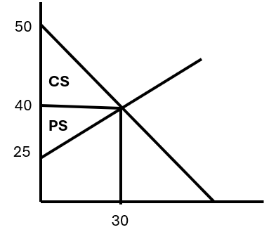

Consumer Surplus = (10*30)/2 =150
Producer Surplus = (15*30)/2 = 225
Total Surplus = 375
No DWL

- Suppose that the government imposes price ceiling at P=30. What will be the quantity exchanged? Calculation and show new consumer and producers surpluses and DWL after price ceiling.

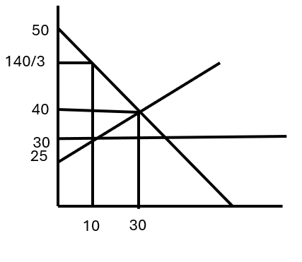
Qs= 10 , Qd= 60, there is excess demand and quantity exchanged is 10.

PS= (5*10)/2=25
CS= ((50-140/3)*10) /2 +(140/3-30)*10= 550 /3
DWL= ((140/3-30)*20)/2= 500/3

Total Area= 1050/3+ 25=375

- If an excise tax of 5 TL for each unit of good was imposed on the producers,
- What is the new equilibrium price and quantity?
Qs’ = –50 + 2(P’-5) => Qs’ = –60 + 2P’ => Qs’= Qd P’* = 42 & Q’* = 24

- What is the tax revenue of the government?

Tax Revenue = 24*5=120

- How much of this tax will be paid by the consumers and producers?
Tax paid by consumers = (42-40)*24= 48 Tax paid by producers = 3*24=72
Consumers paid initially a price of 40 TL and after the imposition of the tax they pay a price of 42 TL. Therefore, consumers are paying 2 TL of tax per unit. Producers received initially a price of 40 TL and now they receive a price of 42 TL minus the tax of 5 TL that they might remit to the government. Therefore, this effectively means that producers are paying 3 TL of tax per unit

- Instead of suppliers, now the government decides to impose the same tax on buyers. How will the total tax revenue of the government and tax incidence change?

It does not matter whether the government imposes the tax on supply or demand. In this case, the equilibrium quantity will be 24 again, and the total tax revenue is 120 TL. Similarly, 48 TL of the revenue will be paid by consumers and 72 TL will be paid by suppliers. The most important determinant of the tax incidence is the relative elasticities of supply and demand functions. As the function becomes more elastic, the incidence of the correspondent will be smaller. The tax incidence formula for buyer is as follows:

$$∈_{D}= \frac{∈_{S}}{∈_{S}+|∈_{D}|}= \frac{2}{2+3}=40\%$$

$$\frac{48}{48+72}=\frac{48}{120}=40\%$$
- Demonstrate graphically and explain verbally the impact of a positive externality on a supply and demand market outcome.

The presence of a positive externality results in not enough of a good being provided at too low a price - when viewed from society's point of view. The reason for this is that the demand curve that represents the marginal private benefit of the good is not the true (complete) marginal social benefit (which includes the benefits derived from the positive externality). In the diagram this is shown by D₁ (marginal social benefit) above D (private social benefit). The market outcome occurs where supply (marginal social benefit) intersects D, giving us quantity Q₀ and price P₀. The socially preferred outcome occurs where supply intersects D₁, giving us quantity Q₁ and price P₁. In comparing the socially desirable outcome to the market outcome we see that output and price are both too low: (Q₀ < Q₁) and (P₀ < P₁), respectively.

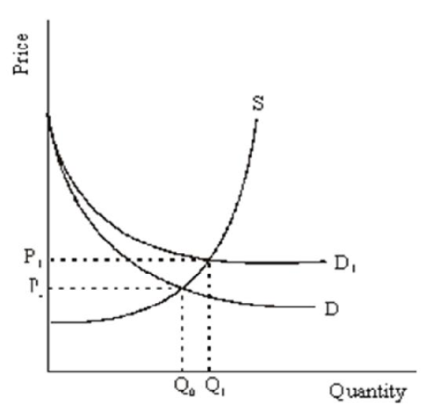
PART B: MULTIPLE CHOICE
- If price is increased by law from a market equilibrium value of $5 to a higher value of $6:
              - both producer surplus and consumer surplus will increase.
              - consumer surplus will decrease and there will be some lost surplus.
              - producer surplus will decrease and there will be some lost surplus.
              - there will be lost surplus, as both producer surplus and consumer surplus decrease.

- There is no deadweight loss if:
              - demand is perfectly inelastic.
              - demand is perfectly elastic.
              - taxes collected are used for societal good.
              - demand shifts the amount of the tax.
- When government imposes a per-unit tax on a product, the net price producers actually receive for the product (after taxation) typically:
              - increases by the amount of the per-unit tax.
              - increases by less than the amount of the per-unit tax.
              - decreases by the amount of the per-unit tax.
              - decreases by less than the amount of the per-unit tax
- If the supply curve is perfectly inelastic, the burden of a tax on suppliers is borne:
              - entirely by the suppliers.
              - entirely by the consumers.
              - mostly by the suppliers and partly by the consumers if the demand curve is inelastic.
              - partly by the suppliers and mostly by the consumers if the demand curve is elastic.

- Suppose that 75 percent of a cigarette tax is borne by consumers. If the supply elasticity is 1, the demand elasticity is equal to:
              - 1.
              - 1/2
              - 1/3
              - 1/4

- When positive externalities exist in the consumption of a good, the marginal social benefit:
              - equals the marginal benefit received by consumers of the good minus the marginal benefit to third parties.
              - equals the marginal cost of producing the good plus the marginal cost to third parties.
              - equals the marginal benefit received by consumers of the good plus the marginal benefit to third parties.
              - could be either greater than or less than the marginal benefit received by consumers of the good depending on the equilibrium price determined in competitive markets.

- Refer to the graph shown. Say that there is a negative externality associated with the production of the good depicted. The marginal social cost from consuming this good at the equilibrium output level is:
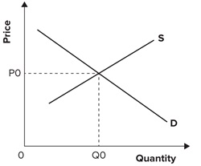
              - either greater than or less than P₀, depending on the elasticities of supply and demand.
              - greater than P₀.
              - less than P₀.
              - equal to P₀.

