CHAPTER 13: PERFECT COMPETITION

Questions and Exercises
- Buyers and sellers must be price takers because if sellers set prices, they would be able to raise them to make a profit and their demand curve would not be horizontal. In a perfectly competitive market, market supply and demand determine the price; both firms and consumers take the market price as given.
- A perfectly competitive market is a market in which economic forces operate unimpeded. For a market to be called perfectly competitive, it must meet some stringent conditions. Some of these conditions include:
- Both buyers and sellers are price takers.
- There are no barriers to entry.
- Firms’ products are identical.
- In perfect competition, the invisible hand of the market is assumed to operate unimpeded, so this model provides a useful reference point and can be used as a starting point for looking at real-world markets. Although perfect competition conditions are generally not met, recent technological developments are making the perfectly competitive model more directly relevant to our economy.
- If both firms are producing where MR = MC and you could buy either for the same amount, you should buy the one with the highest total profit. In other words, you can't know which firm to buy from the information given. Remember, it is total profit, not profit per unit, that is maximized by a firm. If they are perfectly competitive firms, however, eventually both will earn zero economic profits regardless of which you buy.
- Assuming perfect competition, the firm should produce where MR = MC. If the price is $24, then MR is also $24. If MC is three times the quantity, produce 8 units 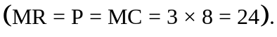

- Typical marginal cost, marginal revenue, and average total cost curves are shown in the accompanying graph. The profit-maximizing level of output is Q*, where MC = MR. As drawn here the firm is earning profit shown by the shaded rectangle. The firm is not in long-run equilibrium since it is earning a profit. Other answers are possible. Specifically, the ATC curve could equal the price at the equilibrium quantity and price in which case it is not earning profits, but it is in long-term equilibrium. Another possibility is that the ATC curve is above the price at the equilibrium quantity and price in which case it is incurring a profit loss and not in long-term equilibrium.
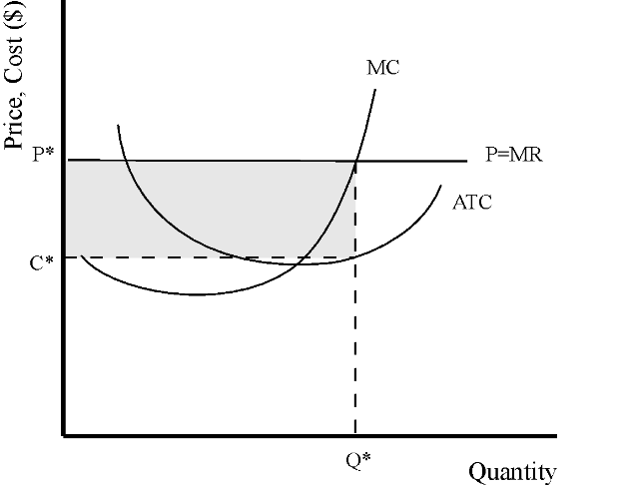

- a. There are two mistakes in this graph: The average total cost curve is mislabeled as the average fixed cost curve. The profit maximizing output level is not where MC = ATC as indicated, but rather where MC = MR.
- The demand curve facing a single firm in a competitive market is perfectly elastic (horizontal) instead of upward sloping. Also, the marginal cost curve is typically upward sloping at the levels of output where the firm would choose to produce.
- As with (b), the demand curve facing a single firm in a competitive market is horizontal instead of downward sloping. Secondly, the profit maximizing level of output is not where MC = AVC, but where MC = P = MR. Third, the MC curve should go through the minimum point of the ATC curve. It currently doesn’t.
- This graph would never represent any real firm since the firm would have shut down if P is below AVC. Output should be zero. Also, the ATC curve cannot be below the AVC curve.
- A technological development shifts the MC curve down and to the right for each firm. Since each firm increases quantity produced, the market supply curve shifts to the right. Market price will fall, and output will rise. Profit for each firm will still be zero because the price will decline sufficiently so that each firm earns zero profit. (Remember, perfectly competitive firms earn no profit.)
- The typical MC, MR, and ATC curves for a firm in long-run equilibrium are shown in the accompanying graph. Because the firm is in long-run equilibrium, it does not earn any economic profit. With no economic profit, average total costs equal equilibrium price.
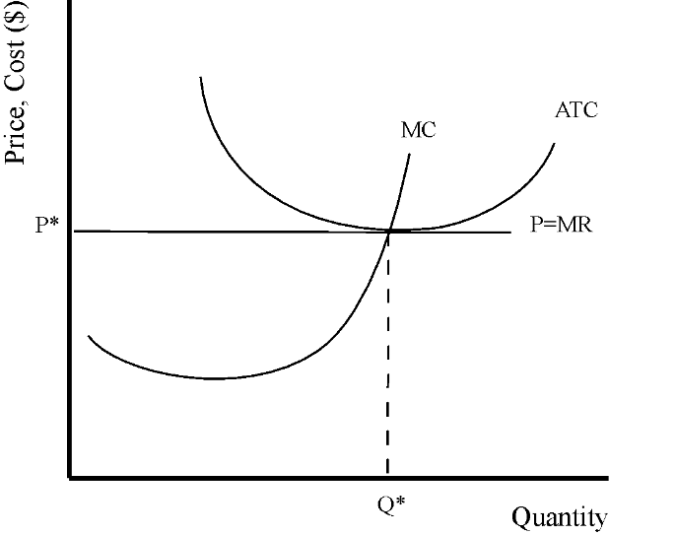

- a. In perfect competition, the price each firm gets for its product is the market price. Because the perfect competitor takes the market price as given, its marginal revenue is also the market price. The market equilibrium price, the price that each firm gets for its product, in this case is $8.
- The market equilibrium quantity is 40 units, where MR = MC ($8 = $8). (Remember that in perfect competition, MR = Market Price.) Since there are 10 firms, each firm produces 1/10 of the quantity, or 4 units.
- Each firm is making a total profit of -$7 (a negative profit is a loss)
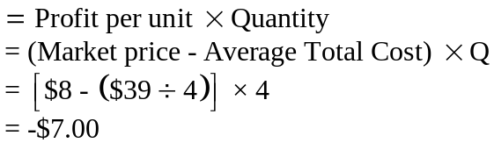
- Firms will begin to exit the market when the price falls below the minimum average total costs, or 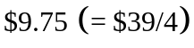.

- Output Q*, shown in the accompanying graph, is the profit-maximizing level of output. The price is P.
- A slightly larger quantity would not be preferred because the marginal cost of the additional output exceeds marginal revenue. Increasing output would lower total profit.
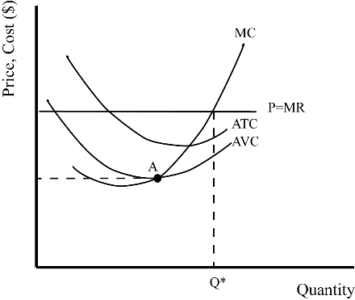

- A slightly smaller quantity would not be preferred because the marginal revenue of the additional output exceeds marginal cost. Increasing output would raise total profit.
- The shutdown point is at the minimum of the AVC curve (where MC = AVC), at point A in the accompanying graph.
- The fact that the permit would be lost if the firm shuts down shifts the AVC curve down because the permit now must be counted as a marginal benefit of remaining in business. Its value will be lost if the firm shuts down. This lowers the price of the shutdown point.
- The sum of all individual firms’ marginal cost curves (above the minimum AVC curve) is the market supply curve.

- The typical ATC, AVC, and MC curves are shown in the accompanying graph. The price at which the firm shuts down temporarily is 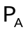, the minimum of the AVC curve. The price at which the firm exits the market in the long run is higher at 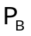, the minimum of the ATC curve
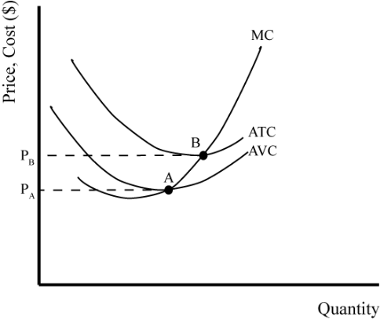

- The shutdown point is the same as the point at which a firm exits a market in the long run when there are no fixed costs—that is, when AVC is the same as ATC.
- a. If this is a profit-maximizing firm in short-run equilibrium, its marginal cost equals price, or $2. Since ATC is $5, it is making a loss, at least in the short run. It is unknown if P > AVC, but you do know that P < ATC. So, the firm should shut down in the long run and would shut down in the short run if P < AVC. The best recommendation you can give is to try to lower its costs to minimize losses and perhaps earn no profit (except normal profit).
- If we now know that AVC = $4, we know that price is less than the average variable cost. If AVC cannot be reduced, the firm should stop producing since it loses more by producing than it would if it shuts down.
- If this situation refers to the output level at which MR = MC, the price covers the AVC of $4, but only half of the AFC; therefore, in the short run, the farmer should still grow wheat. By producing he will lose $2 per unit, but if he did not produce, he would lose $4 per unit. In the long run the farmer will go out of business.
- a. To maximize profits, a competitive firm should produce where MR = MC. This is between 5 and 6.
- The firm is earning losses so the market price will rise in the long run because firms will exit the market, shifting the market supply to the left, which causes market price to rise.
- The long-run market supply curve is upward sloping for an increasing cost industry because as output rises, average total costs shift up. Higher marginal costs increase the price at which firms make zero profit and increase the long-run equilibrium price. As output rises, so does equilibrium price. Thus, the long-run supply curve is upward sloping.
- a. Equilibrium price is where MR = MC, or $70 a pair. At $70 a pair, Zapateria will produce 500 pairs of shoes.
- The total profit that Zapateria will earn is $20 times 500 pairs of shoes, or $10,000.
- Since Zapateria is making an economic profit, it should expect other shoe stores to be enticed to enter the market.
- The long-run equilibrium price is $40 a pair because at $40 a pair price equals average total cost, and all firms earn zero profit.

- a. In the short run, the demand curve shifts to the left. Equilibrium price and quantity decline as shown in the accompanying graph.
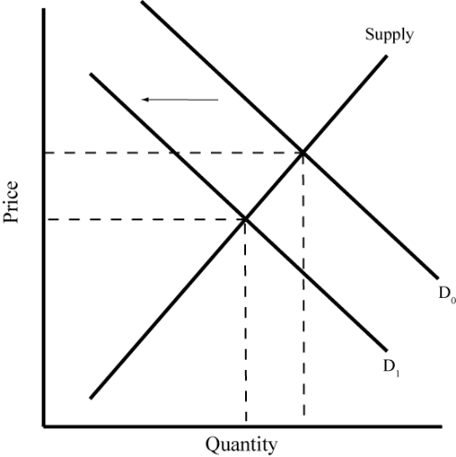
- In the short run, this firm operates at a loss shown by the shaded region in the accompanying graph, though not below the
shutdown point (minimum of the AVC curve). In the long run, price is lower than average variable costs and this firm will go out of business.
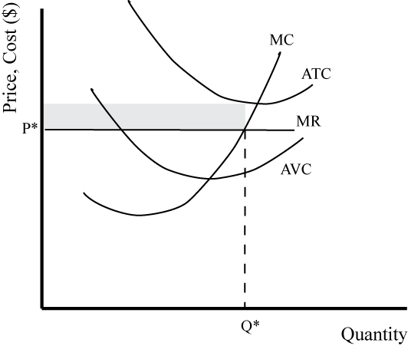

- In the long run, some firms exit the industry, and the supply curve shifts to the left. Because it is a constant-cost industry, a sufficient number of firms exit so that price returns to its previous level (so that MR-MC) at an even smaller equilibrium quantity (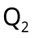) as shown in the accompanying graph.
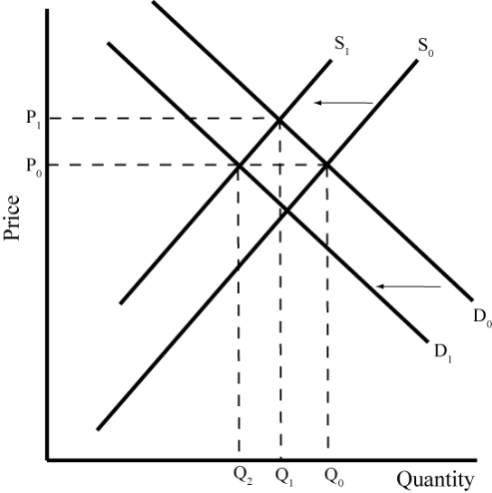

Questions from Alternative Perspectives
- Austrian
- The theory of perfect competition does not reflect the real world, at least not to the satisfaction of Austrians. In fact, the theory’s assumptions of product homogeneity and perfect knowledge preclude much of what actual competition in the real world does. Also, innovation, which is a central aspect of real-world competition, is unexplained by this model.
- If the government has any role at all, it might have a role in establishing and protecting property rights and enforcing contracts.
- The danger of government intervention in the market is that it will likely undermine competition. Individuals will have an incentive to lobby the government to establish and enforce rights to their advantage and the government will have the incentive to serve itself and not the market.
- Feminist
- Given the assumptions of the model, if it costs the firm to discriminate in the form of higher wages or lower productivity, it is difficult for discrimination to persist in a perfectly competitive industry because firms that do so will have higher costs and will not be able to offer their goods at the same low price as their competitors (unless all firms are equally discriminatory). However, if all firms discriminate against African Americans, for example, then the market would not punish those firms that discriminate. That, however, would not be a perfectly competitive industry since characteristics of the buyers and sellers matter, and in perfect competition, they do not.
- In some ways, eliminating discrimination, by reducing costs, will increase economic efficiency because firms that will be better able to assign jobs according to comparative advantage will have a competitive advantage.
- Institutionalist
- As a market structure, perfect competition is only a small percentage (possibly almost zero) of the real-world economy. Most economists believe that the perfectly competitive model serves as a useful reference point to analyze real-world economies, but some see it as making it easy for students to be taught a belief system that free markets are the best of all possible worlds.
- The text spends so much time on perfect competition because the model provides a useful starting point for understanding firm behavior. Students need to be reminded, however, that it is only a starting point and that all the issues that are not brought into the analysis must, at some point, be considered.
- Post-Keynesian
- It is possible that the firm could arrive at that level through trial and error, intuition or luck. Generally, though, unless the firm has complete knowledge of its marginal cost and marginal revenue, it will not produce at the optimum profit-maximizing level of output.
- Firms might follow a strategy based on instrumental or bounded rationality. Once a sustainable outcome is found, even though it might not be the maximum profit outcome, the firm will deem it acceptable.
- Radical
- The Internet has made the economy more competitive in some ways since it has lowered set up and sales more sellers are possible. But the overall marketplace is controlled by large firms, such as Amazon, that take a share of the profits of those firms who sell through Amazon, and who gather information on sales, and decide to enter into the market in those goods themselves when it is beneficial to do so. This disparate access to information means that the Internet itself is not competitive, but is highly oligopolistic. Because of network effects and the advantages to firms who enter the market first, free entry is far from the reality in Internet sales.
- It would be difficult. The need for agreed-upon rules needed to conduct business requires a level of conscious planning that is difficult to organize in industries with many providers and low marginal costs. This makes marginal cost pricing (the equilibrium of a competitive model) unlikely.

Issues to Ponder
- If a perfectly competitive firm is owned by its workers, its output decisions will differ from those of any other perfectly competitive firm because its goal will be to maximize some combination of wages and profit, not profit alone. This will likely cause its decisions to differ from the non-worker-owned firm.
- a. Reconstituted milk can be shipped from low-cost production areas to high-cost production areas, threatening local dairy monopolies through competition. Local dairies are a strong lobby group that keep this from happening through marketing to consumers and political pressure.
- This probably resulted from strong regional lobbies to protect regional markets from other lower-cost regions.
- He is most likely incorrect economically but correct politically. Price supports cause overproduction of milk, and its elimination would most likely cut production. He made this statement because he wanted to get reelected, and his supporters are dairy farmers who benefit from the price supports.
- a. Once the new tomato is generally available, it will likely reduce the price of equal-quality tomatoes in the off-season. The new, higher-quality tomato may well sell for more than the bland ones normally bought in winter but will still put downward pressure even on the price of the bland tomatoes.
- Its effects on farmers depend on what the biotechnology firm charges for its seeds. If the prices for the seeds are high enough to extract the benefit of the better tomato, farmers will be no better off. Further, because the demand for tomatoes is fairly inelastic (quantity demanded is relatively unresponsive to changes in price), the increased supply of good tomatoes (reducing their price) in the off-season will reduce revenues of farmers.
- Tomatoes will likely be grown in areas much farther from their point of sale.
- To the degree that the price of tomatoes falls, tomatoes in the winter will more likely be moved from the rear to the front of the salad bar because they won’t be as expensive for the restaurant to supply.
- a. If the older retail stores had higher costs than the new stores, they would be forced to cut prices below their costs. If that happened, they might stay in business in the short run, assuming they were covering their average variable costs. In the long run, they wouldn’t stay in business.
- If the market remains perfectly competitive, equilibrium price will fall.
- a. Price is at the minimum of the average variable cost curve, as shown in the accompanying graph.
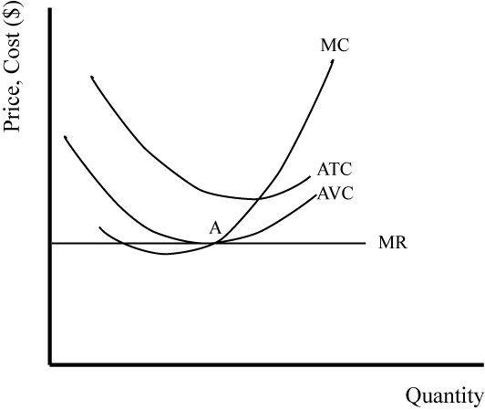

- Assuming the market is perfectly competitive, when The Children’s Place shops closed, the supply curve shifted to the left. This raised the market equilibrium price to a level at which firms in the market no longer earn losses, but rather earn normal profit (zero economic profit). The market supply and demand curves are in the accompanying graph. Because this is a constant-cost industry, the new equilibrium price equals the equilibrium price before conditions led the firms to exit the market.
