METU Department of Economics
ECON102
Section 1&2
Spring 2024
TA: Zeki Oğulcan Şengül
PROBLEM SET 8
1) Suppose the Wonderland government imposes a $0.50 per pound tariff on sugar imports. The figure below shows the demand and supply curves for sugar and the impact of this tariff.
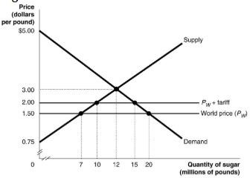

- Assume that the economy is closed. What are the equilibrium price and quantity?
𝑷∗ = $𝟑. 𝟎𝟎 & 𝑸∗ = 𝟏𝟐 𝒎𝒊𝒍𝒍𝒊𝒐𝒏
- Now, assume that the economy OPENS UP. What are the world price and quantity sold by domestic producers? (Be careful, there is no tariff imposition in this question.) WHAT IS THE AMOUNT OF IMPORTS?
𝑷^{𝒘} = $𝟏. 𝟓𝟎
𝒒𝒖𝒂𝒏𝒕𝒊𝒕𝒚 𝒔𝒐𝒍𝒅 𝒃𝒚 𝒅𝒐𝒎𝒆𝒔𝒕𝒊𝒄 𝒑𝒓𝒐𝒅𝒖𝒄𝒆𝒓𝒔 = 𝟕 𝒎𝒊𝒍𝒍𝒊𝒐𝒏
- Following the imposition of the tariff, what is the new price that consumers pay? What is the new quantity demanded?
𝑷𝒓𝒊𝒄𝒆 = $𝟐. 𝟎𝟎 𝒑𝒆𝒓 𝒑𝒐𝒖𝒏𝒅
𝑸𝒖𝒂𝒏𝒕𝒊𝒕𝒚 𝒑𝒖𝒓𝒄𝒉𝒂𝒔𝒆𝒅 = 𝟏𝟓 𝒎𝒊𝒍𝒍𝒊𝒐𝒏 𝒑𝒐𝒖𝒏𝒅𝒔
- Calculate the value of consumer surplus with the tariff in place.
Consumer Surplus = ½* 15 Million*3$ = 22.5 Million
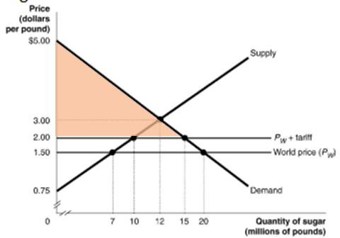
- What is the quantity supplied by domestic sugar producers with the tariff in place?
𝑸𝒖𝒂𝒏𝒕𝒊𝒕𝒚 𝒔𝒖𝒑𝒑𝒍𝒊𝒆𝒅 𝒃𝒚 𝒅𝒐𝒎𝒆𝒔𝒕𝒊𝒄 𝒑𝒓𝒐𝒅𝒖𝒄𝒆𝒓𝒔 =
𝟏𝟎 𝒎𝒊𝒍𝒍𝒊𝒐𝒏 𝒑𝒐𝒖𝒏𝒅𝒔
- Calculate the value of producer surplus received by US sugar producers with the tariff in place.
Producer Surplus to Rice producers= ½*10 million * 1.25 =6.25 million
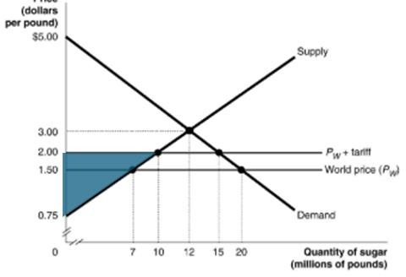
- What is the quantity of sugar imported with the tariff in place?
𝑸𝒖𝒂𝒏𝒕𝒊𝒕𝒚 𝒊𝒎𝒑𝒐𝒓𝒕𝒆𝒅 = 𝟓 𝒎𝒊𝒍𝒍𝒊𝒐𝒏 𝒑𝒐𝒖𝒏𝒅𝒔
- What is the amount of tariff revenue collected by the government?
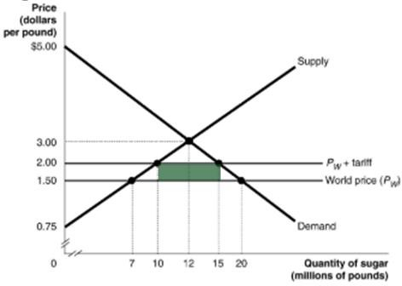
𝑻𝒂𝒓𝒊𝒇𝒇 𝒓𝒆𝒗𝒆𝒏𝒖𝒆 𝒄𝒐𝒍𝒍𝒆𝒄𝒕𝒆𝒅 𝒃𝒚 𝒕𝒉𝒆 𝒈𝒐𝒗𝒆𝒓𝒏𝒎𝒆𝒏𝒕 = 0.5* 5 Million =2.5 Million

ix) The tariff has reduced consumer surplus. Calculate the loss in consumer surplus due to the tariff.
Loss in consumer surplus due to tariff = 15 million*0.5 + ½ 5 million * 0.50 = 8.75 million

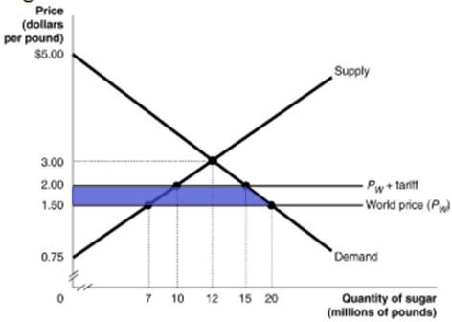
x) What portion of the consumer surplus loss is redistributed to domestic producers? To the government?
Amount redistributed to domestic producers = 7 million × $0. 50 + 1/2 ∗ 3 million ∗ $0. 50 = $4. 25 million
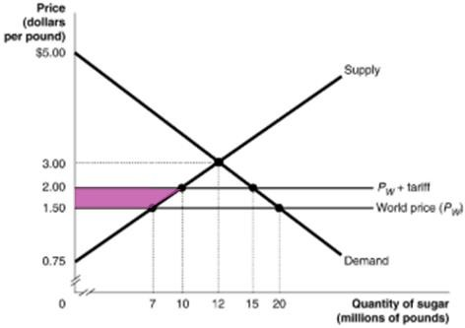

xi) Calculate the deadweight loss due to the tariff.
Deadweight loss due to the tariff =1/2 ∗ 3 million ∗ $0. 50 + ½ ∗ 5 million ∗ $0. 50 = $2 million
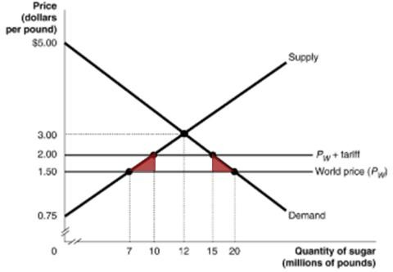
2) The accompanying hypothetical production possibilities tables are for Portugal and Spain. Each country can produce wine and cheese. Plot the production possibilities data for each of the two countries separately. Referring to your graphs, answer the following questions.

Portugal
Product/Production  Alternatives |  | A |  | B |  | C |  | D
Wine | 0 |  | 20 |  | 40 |  | 60
Cheese | 15 |  | 10 |  | 5 |  | 0

Spain
Product/Production  Alternatives |  | R |  | S |  | T |  | U
Wine | 0 |  | 20 |  | 40 |  | 60
Cheese | 60 |  | 40 |  | 20 |  | 0

- What is each country’s OPPORTUNITY cost of producing wine and cheese?

Using the information above, you can write these matrices.

Production Possibilities
 | Portugal | Spain
Wine | 60 | 60
Cheese | 15 | 60

Opportunity cost
 | Portugal | Spain
Wine | 1/4 | 1
Cheese | 4 | 1

Now, you can easily see the opportunity costs in those countries:
Portugal: The opportunity cost of producing 1 wine is 0.25 cheese. That is, for each wine produced, Portugal must give up 0.25 cheese.
The opportunity cost of producing 1 cheese is 4 wine. That is, for each cheese produced Portugal must give up 4 wine.
Spain: The opportunity cost of producing 1 wine in Spain is 1 cheese. That is, for each wine produced, Spain the country must give up 1 cheese.
The opportunity cost of producing 1 cheese in Spain is 1 wine. That is, for each cheese produced, Spain the country must give up 1 wine.
- Which nation should specialize in which product?

The opportunity cost of producing wine in Portugal is lower than Spain’s opportunity cost of producing wine. Therefore, Portugal should produce wine, and Spain should produce cheese.

- Show the trading possibilities lines for each nation if the actual terms of trade are one cheese for two wine. (Plot these lines on your graph.)
Portugal
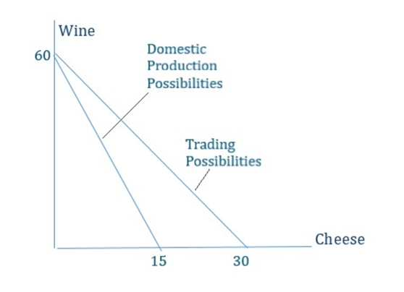
Spain
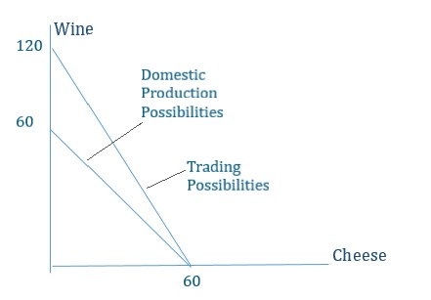

The graphs above show each country's production possibilities schedules with and without trade.

Portugal has a vertical intercept of 60 wine (produceS only wine) and a horizontal intercept of 15 cheese (produceS only cheese). The slope of production possibilities schedule equals -4. This slope is the opportunity cost of producing cheese. That is, for each cheese produced by Portugal they must give up 4 wine.

However, after trade, Portugal's horizontal intercept will be 30 wine. Since the terms of trade are 1 cheese for 2 wine, Portugal could specialize in wine production and trade 2 wine for each cheese (produces 60 wine and receives 30 cheese). The slope of the after-trade production possibilities schedule is -2. Portugal must now only give up 2 wine for each additional cheese consumed.

The same logic applies to Spain. Before trade the vertical intercept is 60 wine and the horizontal intercept 60 cheese. The slope of the production possibilities schedule is -1, which is the opportunity cost of 1 more cheese in terms of wine.

After trade Spain's vertical intercept BECOMES 120 wine and the horizontal intercept remains at 60 cheese. Spain will produce only cheese and can trade now 1 cheese for 2 wine (terms of trade). If they trade all 60 cheese for wine, they will receive 120 wine. The new slope of the production possibilities schedule is -2, which is the opportunity cost of consuming (not trading) 1 more cheese.

- Suppose the optimum product mixes before specialization and trade were alternative B in Portugal and alternative S in Spain. What would be the gains from specialization and trade?

The first step is to determine total production before any trade takes place.
Portugal's optimal product mix before trade is alternative B (given above):
Wine = 20
Cheese = 10

Spain's optimal product mix before trade is alternative S (given above):
Wine= 20
Cheese = 40

Combined, the optimal mix before trade is:
Before Trade Total Wine= 40 (20 Portugal plus 20 Spain)
Before Trade Total Cheese = 50 (10 Portugal plus 40 Spain)

The next step is to determine total production after specialization. Recall Portugal will specialize in wine production and Spain will specialize in cheese production.
After Trade Total Wine = 60 (Portugal alternative D)
After Trade Total Cheese = 60 (Spain alternative R)

The final step is to determine the total gain for each good, which is the difference between total production before trade and total production after trade.
Total Gain Wine = 20 (= 60 - 40)
Total Gain Cheese = 10 (= 60 -50)

3) Answer the following questions refer to the following diagrams, where the vertical axis shows units of chicken and horizontal axis shows units of meat, each country has equal resources.
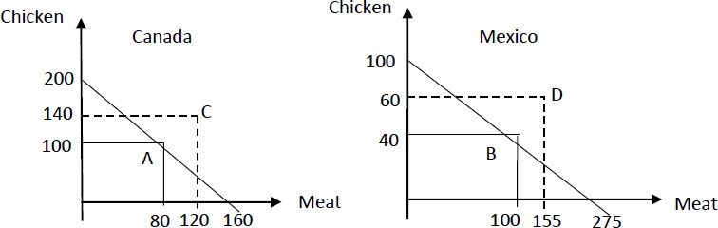

a. Canada’s comparative advantage lies in chicken production, Mexico’s lies in meat.

b. Canada should specialize in chicken production; Mexico should specialize in meat production.

c. Before the trade, Canada produces at point A on its PPF, and Mexico produces at point B. Given complete specialization based on comparative advantage total chicken production in the world has risen by 𝟔𝟎= [𝟐𝟎𝟎 – (𝟏𝟎𝟎 + 𝟒𝟎)] and total meat production has risen by
𝟗𝟓= [𝟐𝟕𝟓 – (𝟏𝟎𝟎 + 𝟖𝟎)].

d. Assume complete specialization. After the trade, Canada is consuming at point C, and Mexico is consuming at point D. Canada is exporting 60 units of chicken, and Mexico is exporting 120 units of meat. Canada is importing 120 units of meat, and Mexico is importing 60 units of chicken.

4) Give an example of the sources of comparative advantage?
- The Heckscher-Ohlin Theorem
The Heckscher-Ohlin theorem ties the theory of comparative advantage to factor endowments. It assumes that products can be produced using different proportions of inputs and that inputs are mobile between sectors in each economy, but that factors are not mobile between economies. According to this theorem, a country has a comparative advantage in the production of a product if that country is relatively well endowed with inputs used intensively in the production of that product.
- Technology
- Climate and Natural Resources
- Economies of Scale
For many products, there are advantages in producing on a large scale; costs become lower as more is produced. When you produce at a lower cost, you can sell them at lower prices than other countries.
- Exchange rate movements
Movements in exchange rates affect the prices of imported and exported goods. For example, if your home currency depreciates, which means foreign currency can buy more of your home currency, then your exports will increase as your goods are cheaper relative to others.

6) Read the following transactions and fill in the blanks in the table below related to these transactions which are all independent from each other.
  - Turkey buys Japanese automobile.
  - Russian investors built a plant in Turkey.
  - A Saudi Arabian corporation receives dividends from a Turkish subsidiary.
  - The Greek Chamber of Commerce holds its annual meetings in İzmir with 25000 members attending.
  - Turkish investors buy Swiss stocks.
  - Turkey sells textiles to Iran.

The transactions above would affect the foreign exchange markets (determine the effects of transactions in FX market in terms of shifts of supply or demand curves), and the value of TL (determine the effects of transactions as appreciation or depreciation).
Transaction | Foreign Exchange Market | Value of TL
A | Demand for FX shift to right | Depreciate
B | Supply of FX shift to right | Appreciate
C | Demand for FX shift to right | Depreciate
D | Supply of FX shift to right | Appreciate
E | Demand for FX shift to right | Depreciate
F | Supply of FX shift to right | Appreciate

7) Suppose that there are two countries; the UK and the US. Explain the effects of an increase in the British overall price level on the foreign exchange market of the UK by using a graph. (Hint: The horizontal axis of the graph is quantity of Dollars). Write down the effects by referring to the changes in foreign trades of the UK and the US.

If there is an increase in the overall price level of the UK, price of the domestically produced goods and also exports (imports), in terms of Pound, will rise (fall). Since exports are relatively more expensive, while exports of UK fall, supply of foreign exchange (in this case Dollar) decline. So, supply curve shifts to left, from S₀ to S₁.

S₀
S₁
D₀
D₁
q₁
e₀
e₁ = e₃
e₂
q₀ = q₂
q₃
Quantity of $
c
b
d
a
In contrast, since imports of UK are relatively cheaper, while imports increase, demand for foreign exchange also increase. Therefore, demand curve of foreign exchange shifts to the right, from D₀ to D₁. Economy was in equilibrium at point a (the intersection point of S₀ and D₀). After the developments as described above, the new equilibrium point is c the intersection point of S₁ and D₁).

8)(PAST EXAM QUESTION) TEXTLAND is under a flexible exchange rate regime. Suppose the currency of TEXTLAND is TL. and in the rest of the world American dollar is used as currency. How each of the following events affect the foreign exchange market? Explain by drawing a graph for each case. Identify clearly if there will be an appreciation or depreciation of TL.

a. (3) A foreign cellular phone company establishes a branch in TEXTLAND.

It causes increase in the supply of foreign currency because of the inflows. Thus, TL should be appreciated.

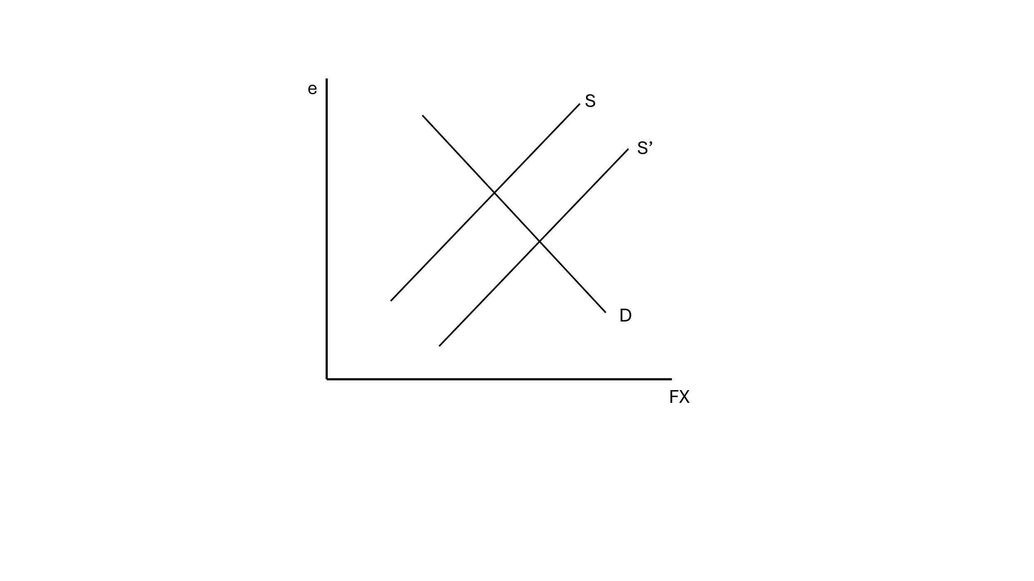
Appreciation of TL./Depreciation of TL.

b. (3) TEXTLAND government sells Treasury bills in foreign countries.
Again, since the supply of foreign currency increases, since they will sell FX in market to buy domestic currency, or they directly purchase the treasury by their currencies, domestic currency will appreciate.

Appreciation of TL./Depreciation of TL.

c. (3) Inflation rate in TEXTLAND is greater than inflation rate in the rest of the world.
As the domestic price level is relatively higher, the trade balance will worsen. Since our goods become more expensive for the foreigners, they don’t want to purchase as much as before, that declines exports. In addition, since foreign goods become cheaper, the imports will also rises. As a result, the demand for foreign currency will increase and domestic currency will depreciate.
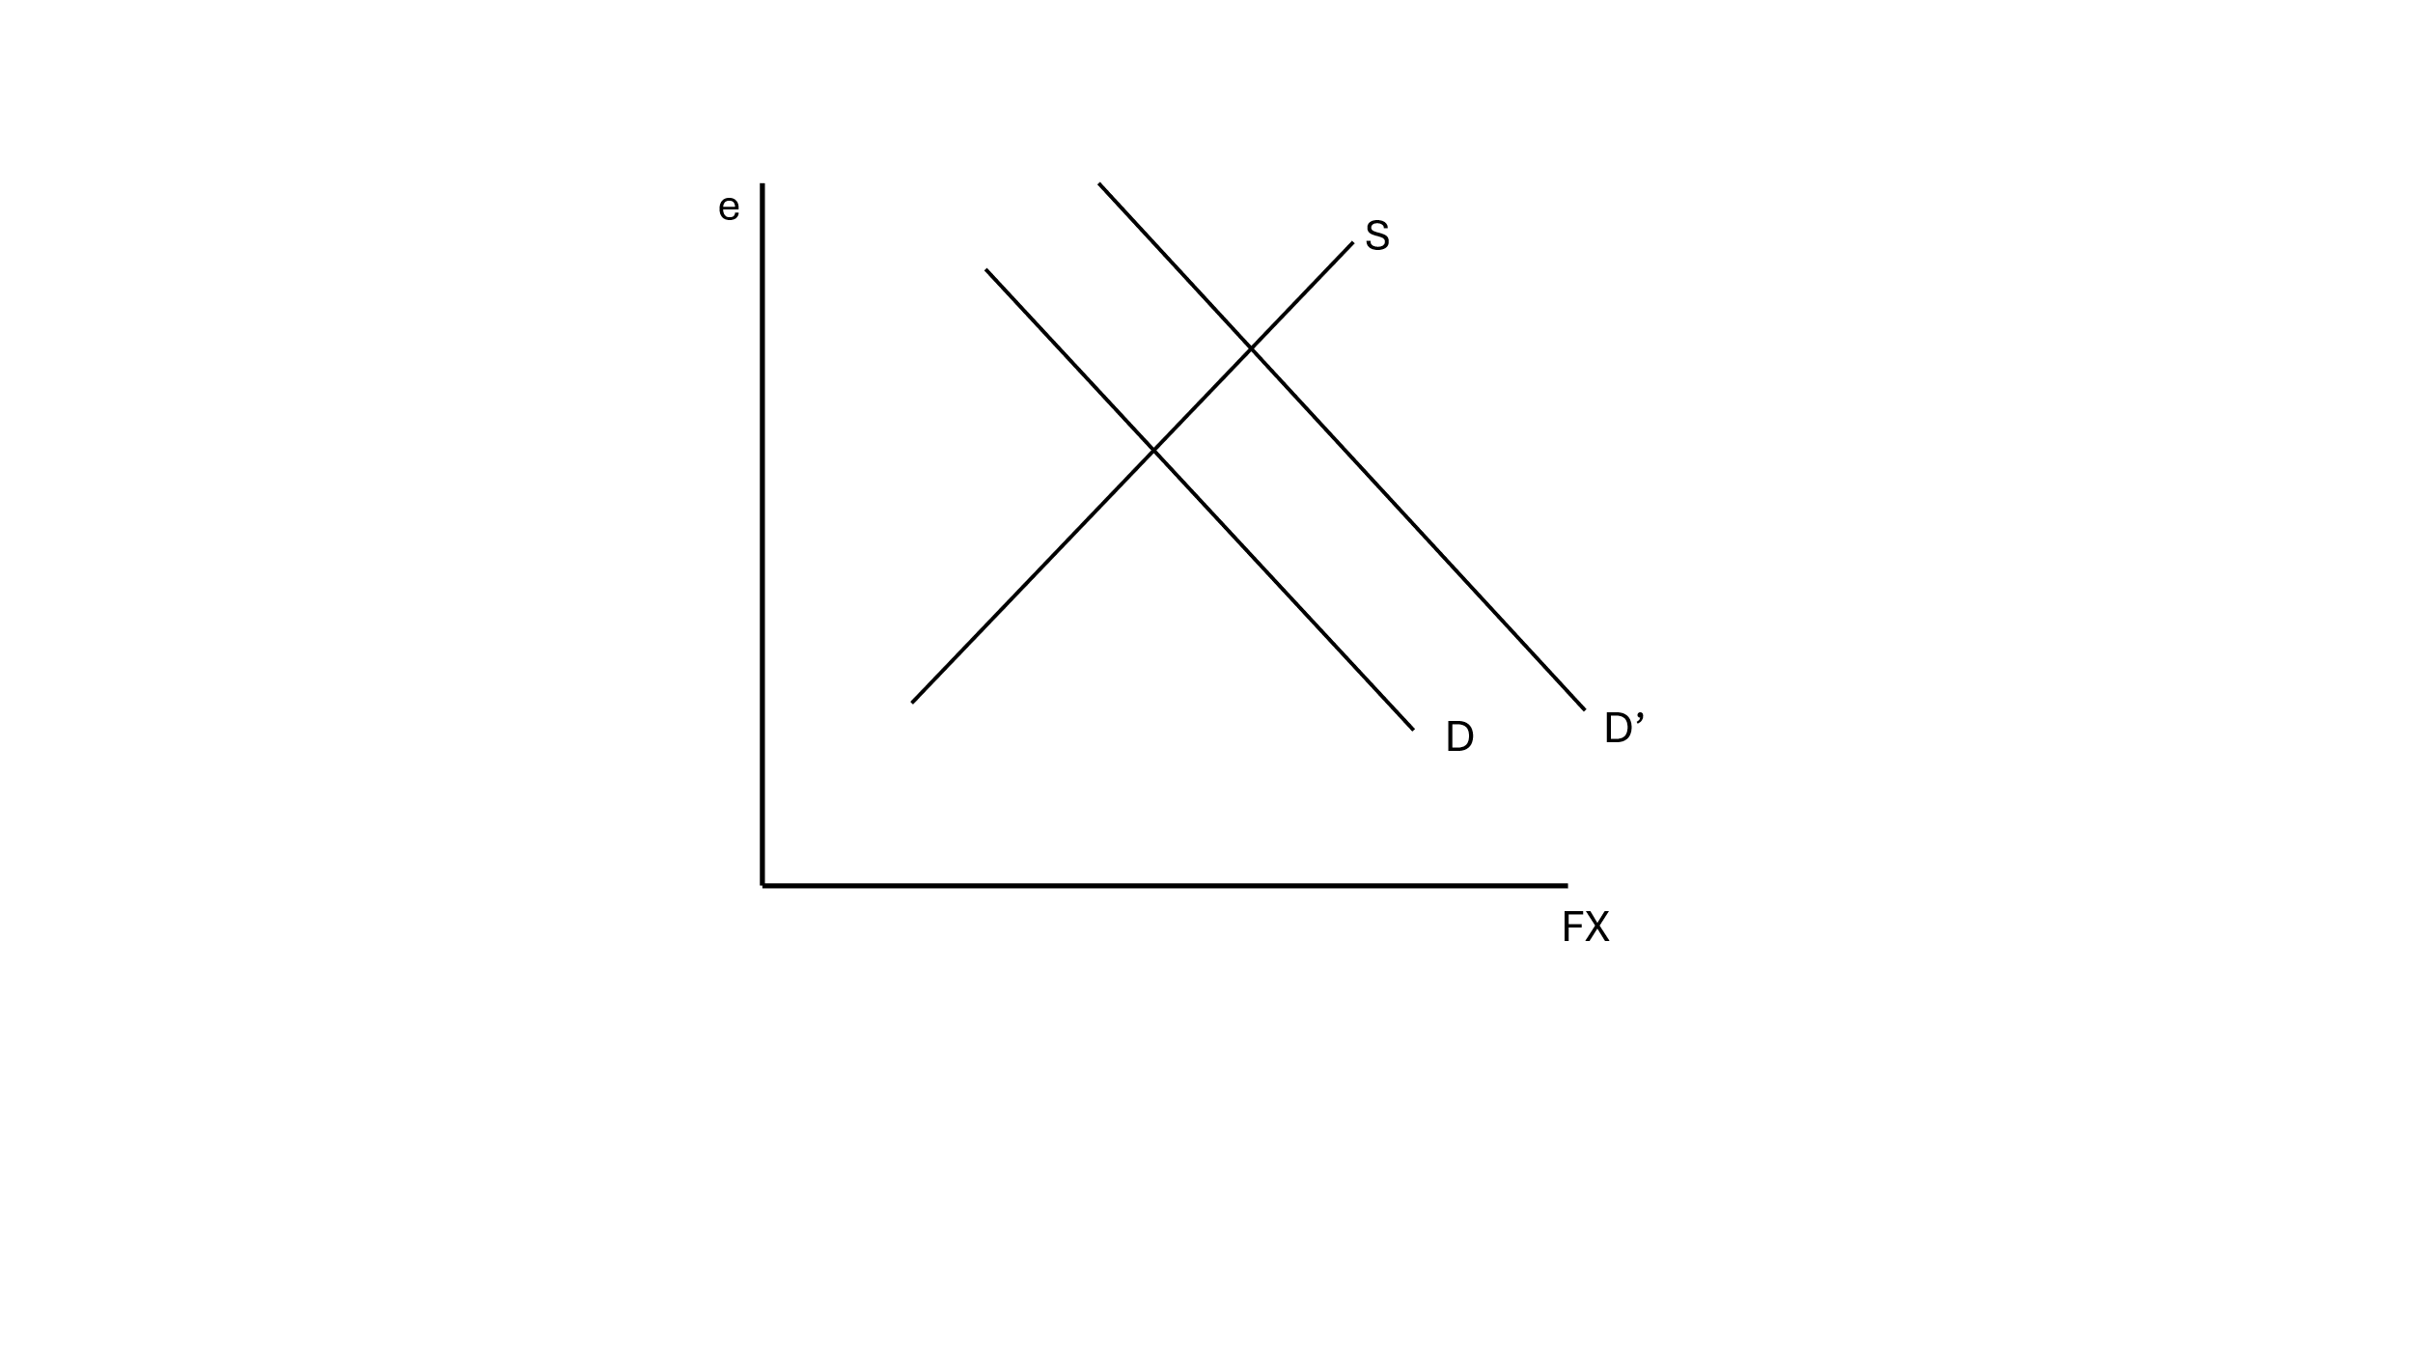
Appreciation of TL./Depreciation of TL.

d.(3) As a result of adverse campaigns the number of foreign tourists coming to TEXTLAND decreases drastically.
This decreases the export of services by Textland offers. As imports decline, this causes Current Account deficit, and country needs extra foreign currency to eliminate it. This causes increase in demand for foreign currency and thereby the depreciation of domestic currency.
Second approach: Total exports decline, supply of FX decreases. As a result, TL depreciates as well. Both are ok.

Appreciation of TL./Depreciation of TL.

e. (3) The interest rates in the United States are increased.
As the foreign interest rate increases, investors want to make investment on that country (both domestic and foreign). As a result, since USD offers more yield, there will be financial outflow from the domestic country and that causes increase in foreign currency and depreciation of domestic currency.

Appreciation of TL./Depreciation of TL.

f. (1) If the Central Bank of TEXTLAND wants to keep the exchange rate constant when the U.S. interest rates are rising, the Central Bank should __SELL____(buy/sell) foreign exchange.

In order to keep the FX rate constant, Central bank should impose a policy that eliminates the excess demand for foreign currency, that is selling FX to the public, which increases the supply of foreign currency.

PART B: MULTIPLE CHOICE
1) The law of one price holds exactly only if
- transaction costs are zero.
- it is impossible for buyers to resell the good.
- buyers have complete information.
- antitrust laws are being enforced.

2) When BMW, a German company, purchases a welding machine that was made PRODUCED in Toronto CANADA, the purchase is
- both a German and a Canadian import.
- a German import and a Canadian export.
- a German export and a Canadian import.
- neither an export nor an import for either country.

3) Absolute advantage is
- the ability to produce more of a good or service than competitors when using the same amount of resources.
- the ability to produce higher quality goods compared to one's competitors.
- the ability to produce a good or service at a higher opportunity cost than one's competitors.
- the ability to produce more of a good or service than competitors that have more resources.

4) is the ability of an individual, a firm, or a country to produce a good or service at a lower opportunity cost than competitors.
- Absolute advantage
- Specialization
- Autarky
- Comparative advantage

Please answer the next four questions referring to the table below.

 | Bathing | Grooming
Linda | 60 | 20
Sandy | 50 | 25

Linda and Sandy own The Suerte Puppy, a dog grooming business. The table above lists the number of dogs Linda and Sandy can each bathe and groom in one week.

5) Select the statement that accurately interprets the data in the table.
- Linda has an absolute advantage in dog bathing and Sandy has an absolute advantage in dog grooming.
- Sandy has an absolute advantage in dog bathing and Linda has an absolute advantage in dog grooming.
- Sandy has an absolute advantage in dog bathing and dog grooming.
- Linda has an absolute advantage in dog bathing and dog grooming.
6) Select the statement that accurately interprets the data in the table.
- Sandy has a greater opportunity cost than Linda for dog grooming.
- Sandy's opportunity cost for dog grooming is less than Linda's.
- Linda has a greater opportunity cost than Sandy for dog bathing.
- Sandy's opportunity cost for dog grooming and dog bathing are both greater than Linda's.

7) Select the statement that accurately interprets the data in the table.
- Sandy has a comparative advantage in dog grooming.
- Linda has a comparative advantage in dog grooming.
- Linda has a comparative advantage in dog grooming and dog bathing.
- Sandy has a comparative advantage in dog bathing.

8) Select the statement that accurately interprets the data in the table.
- Linda has a comparative advantage in dog bathing.
- Sandy has an absolute advantage in dog bathing.
- Sandy has a comparative advantage in dog bathing.
- Linda has a comparative advantage in dog grooming and dog bathing.

9) Assume that China has a comparative advantage in producing corn and exports corn to Japan. We can conclude that
- China also has an absolute advantage in producing corn relative to Japan.
- China has a lower opportunity cost of producing corn relative to Japan.
- Japan has an absolute disadvantage in producing corn relative to China.
- Labor costs are higher for corn producers in Japan than in China.

10) Whenever a buyer and a seller agree to trade,
- the agreement is made based on absolute advantage.
- they must have identical opportunity costs in producing their respective products.
- one party will always be worse off.
- both must believe they will be made better off.

11) In considering the distribution of the gains from trade:
- Smaller countries usually get a larger proportion of the gains from trade.
- Larger countries usually get a larger proportion of the gains from trade.
- The gains are generally split equally between small and large countries.
- No statement can be made about the general nature of the split.

12) The ratio at which a country can trade its exports for imports from other countries is called
- a trade barrier.
- the terms of trade.
- autarky.
- a free trade agreement.

Please answer the next eight questions referring to the table below.

 | Prod’n and Cons’n without  trade |  |  | Production with trade
 | Clocks | Hats |  | Clocks | Hats
Denmark | 900 | 150 |  | 1200 | 0
Finland | 150 | 100 |  | 0 | 400

Denmark and Finland can produce both clocks and hats. The table above shows the production and consumption quantities without trade, and the production numbers with trade.
13) Which country has an absolute advantage in producing clocks?
- Denmark
- Finland
- both countries
- neither country

14) Which country has a comparative advantage in producing clocks?
- Denmark
- Finland
- both countries
- neither country

15) Which country has a comparative advantage in producing hats?
- Denmark
- Finland
- both countries
- neither country

16) Prior to trade, what was the opportunity cost to produce 1 hat in Denmark?
- 1/6 of a clock
- 2/3 of a clock
- 1.5 clocks
- 6 clocks

17) Prior to trade, what was the opportunity cost to produce 1 hat in Finland?
- 1/6 of a clock
- 2/3 of a clock
- 1.5 clocks
- 6 clocks

18) With trade, what is the total gain in hat production?
A) 150
B) 300
C) 400
D) 650

19) With trade, what is the total gain in clock production?
A) 150
B) 300
C) 2,100
D) 2,250

20) All of the following are terms of trade that could possibly benefit both countries except
- 1 hat : 2 clocks
- 1 hat : 4 clocks
- 1 hat : 5 clocks
- 1 hat : 8 clocks

21) Tastes for products such as beer differ. As a result
- we see countries specializing completely in the production of beer.
- consumers of beer have difficulty deciding what type of imported beer to buy.
- the quality of imported beer is less than it could be.
- different countries may each have a comparative advantage in producing different types of beer.

22) Which of the following is not a source of comparative advantage?
- relative abundance of labor and capital
- technology
- climate and natural resources
- a strong foreign currency exchange rate

23) China has developed a comparative advantage in the production of clothing. The source of this comparative advantage is
- a large supply of natural resources.
- a large supply of unskilled workers and relatively little capital.
- investment in capital used to produce clothing.
- superior process technology.

24) Japan has developed a comparative advantage in designing and producing automobiles. The source of its comparative advantage in these products is
- abundant supplies of natural resources.
- a favorable climate.
- a strong central government.
- technology

25) If a country's currency is determined only by the demand and supply for that country's currency, the country is said to have a
- floating exchange rate.
- fixed exchange rate.
- gold standard.
- managed float.
26) An increase in the value of the US dollar will
- reduce Canadian demand for winter homes in Florida.
- increase Canadian demand for winter homes in Florida.
- reduce the cost of homes in Florida for Canadian buyers.
- increase the cost of homes in Florida for American buyers.

27) Purchasing power parity is the theory that, in the long run, exchange rates should be at a level such that equivalent amounts of any country's currency
- will equalize nominal interest rates across countries.
- are valued inversely relative to the size of its GDP.
- should earn the same real rate of return.
- allow one to buy the same amount of goods and services.

28) If the average productivity of Turkish firms is rising more quickly than the average productivity of Argentinean firms, which of the following would you expect to see? (Argentina's currency is the peso.)
- an increase in the value of the peso relative to the TL
- a decrease in the prices of Argentinean products
- a decrease in the quantity demanded of Argentinean products relative to Turkish products
- an increase in the quantity demanded of Argentinean products relative to Turkish products
29) How will the exchange rate (TL per foreign currency) respond to an increase in the relative rate of productivity growth in the Turkey in the long run?
- Exchange rates will rise.
- Exchange rates will fall.
- Exchange rates will be unaffected by changes in the relative rate of productivity growth in the United States, both in the short run and in the long run.
- The exchange rate will be affected in the short run, but not in the long run. Q6) 30)If 30) inflation in Russia is higher than it is in Turkey,
- the purchasing power of the ruble in buying Russian goods will rise relative to the TL.
- the value of the TL will rise in the long run.
- the value of the ruble will rise in the long run.
- Both A and C are correct.
31) You're traveling in Ireland and are thinking about buying a new digital camera. You have decided you would be willing to pay $125 for a new camera, but cameras in Ireland are all priced in euros. If the exchange rate is 0.85 euros per dollar, which is the highest price in euros you would be willing to pay for a camera? ($ is the domestic currency)
- 105 euros
- 106.25 euros
- 110.15 euros
- 147 euros
32) You're traveling in Ireland and are thinking about buying a new digital camera. You have decided you would be willing to pay $125 for a new camera, but cameras in Ireland are all priced in euros. If the camera you are looking at costs 115 euros, under which of the following exchange rates would you be willing to purchase the camera? ($ is the domestic currency and assume that no taxes or duties are associated with the purchase.)
- 0.56 euros per dollar
- 0.89 euros per dollar
- 0.92 euros per dollar
- You would purchase the new camera at any of the above exchange rates.
33) When the market value of the Turkish Lira rises relative to other currencies around the world, we say that
- the TL has appreciated.
- the TL has depreciated.
- the demand for TL has increased.
- the supply of TL has increased.
34) Currency traders expect the value of TL to fall. What effect will this have on the demand for TL and the supply of TL in the foreign exchange market?
- Demand for TL will increase, and the supply of TL will decrease.
- Demand for TL will increase, and the supply of TL will increase.
- Demand for TL will decrease, and the supply of TL will increase.
- Demand for TL will decrease, and the supply of TL will decrease.

