METU Department of Economics
ECON102
Sections 1&2
Spring 2024
TA: Zeki Oğulcan Şengül
PROBLEM SET 3
- In the Keynesian cross, assume that the consumption function is given by
C = 200 + 0.75(Y − T)
Planned investment is 100; government purchases and taxes are both 100.

- Graph planned expenditure as a function of income.
- What is the equilibrium level of income?
- If government purchases increase to 125, what is the new equilibrium income?
- What level of government purchases is needed to achieve an income of 1, 600?
  - Total planned expenditure is P E = C(Y − T) + I + G
Plugging in the consumption function and the values for investment I, government purchases G, and taxes T given in this question, total planned expenditure P E is:
P E = 200 + 0.75(Y − 100) + 100 + 100 = 0.75Y + 325
Graphically,
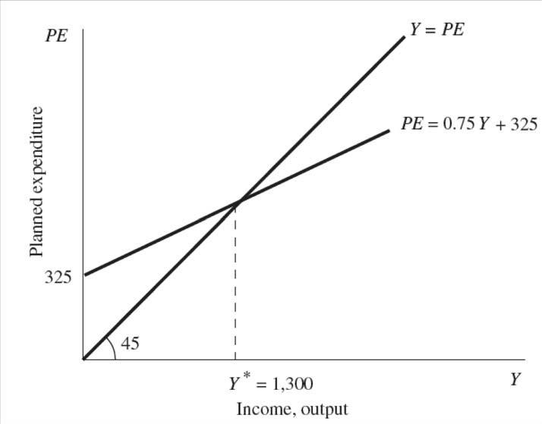

- To find the equilibrium level of income, combine the planned-expenditure equation derived in part (a) with the equilibrium condition Y = P E: Y = 0.75Y + 325 ⇔ Y = 1300.

- If government purchases increase to 125, then the planned expenditure changes to P E = 0.75Y + 350. Equilibrium income increases to Y = 1, 400. Therefore, an increase in government purchases of 25 (i.e. 125 − 100 = 25) increases income by 100. This is what we expect to find, because the formula for the government-purchases multiplier is 1/(1 – MPC), the MPC (marginal propensity to consume) is 0.75, and the government-purchases multiplier therefore has a numerical value of 4.

- An income level of 1, 600 represents an increase in 300 over the original level of income. The government-purchases multiplier is 1/(1 – MPC) the MPC in this example equals 0.75, so the government-purchases multiplier is 4. This means that government purchases must increase by 300/4 = 75 (to a level of 175) for income to increase by 300.

- Suppose that we have a hypothetical economy characterized by following equations:
$$C=c_{0}+c_{1}Y_{d}$$
$$Y_{d}=Y-T$$
$$T=\overline{T}$$
$$I=I_{0}+bY$$
$$G=\overline{G}$$
$$X=\overline{X}$$
$$M=mY$$
- Show endogenous and exogeneous variables.
Endogenous Variables: C, I, M
Exogeneous Variables: T, G, X
The main difference between these two groups is that although endogenous variables are functions of income and that means their values are affected by income, the value of exogeneous variables are determined autonomously.
- Write down the equilibrium condition in goods market and derive the aggregate expenditure function.

The equilibrium condition in goods market is Z (AE) =Y
$$Z= C+I+G$$
$$Z=c_{0}+c_{1}\left(Y-T\right)+I_{0}+bY+G+X-mY$$
$$Z=c_{0}+c_{1}Y-c_{1}T+I_{0}+bY+G+X-mY$$
$$Z=Y\left(c_{1}+b-m\right)+c_{0}-c_{1}T+I_{0}+G+X$$
The part that depends on Y shows the slope of AE function. The rest

- Derive the equilibrium income and multiplier.

The equilibrium condition is Z=Y, thus we can write Y instead of Z.

$$Y=Y\left(c_{1}+b-m\right)+c_{0}-c_{1}T+I_{0}+G+X$$

Let's gather the variables that depend on y on the same side and put them in parenthesis. Then, we have,

$$Y\left(1-c_{1}-b+m\right)=c_{0}-c_{1}T+I_{0}+G+X$$
$$Y^{eq}=\frac{1}{\left(1-c_{1}-b+m\right)}\left[c_{0}-c_{1}T+I_{0}+G+X\right]$$

Value of multiplier is $\frac{1}{\left(1-c_{1}-b+m\right)}$

- For this question, assume that taxes are independent of income (i.e., the income tax rate is zero). Now suppose that fiscal policy makers wish to decrease equilibrium output by 500 billion TL. Further suppose that policy makers can choose one of the following two options: (1) change in government spending; or (2) change in taxes. Compare and explain the relative size of the changes in government spending and taxes needed to obtain this desired change in output.
The change in taxes will be larger because part of any tax increase will cause saving
to fall. So, to cause the same reduction in demand, the size of the tax increase will be higher than the size of any reduction in government spending. To solve this analytically, you need to derive the tax multiplier and the government spending multiplier (as shown below) then compare these two given the desired amount of
change in the output.
$$Y= c_{0}+c_{1}\left(Y-T\right)+I+G$$
$$Y^{eq}=\frac{c_{0}-c_{1}T+I+G}{{1-c}_{1}}$$
$$\frac{∆Y}{∆G}=\frac{1}{{1-c}_{1}}= Government Spending Multiplier$$
$$\frac{∆Y}{∆T}=\frac{{-c}_{1}}{{1-c}_{1}}= Tax Multiplier$$
Given MPC = 0.5, the tax multiplier is -1 whereas the government spending multiplier is 2. This means in order to decrease the output by 500 (Δ𝑌=−500) government can either increase the taxes by 500 (Δ𝑇=500) or decrease the government spending by 250 (Δ𝐺=−250). You can see whether it works by plugging T=1100 or G=1750 into the Y=AE equation.
Important: Make sure that you don’t memorize but learn how to derive the multiplier under different circumstances (open economy, existence of income tax...etc).

- Suppose that an economy is defined by the following equations:
C = 200 + 0.8*Y_{d}
I = 200
T = 50 + 0.25*Y
G = 300
- Calculate the equilibrium level of Y.

Y = C + I + G = 700 + 0.8*(Y – 50 – 0.25*Y)
0.4*Y = 660
Y = 1650
- Calculate the equilibrium levels of C, S, the government budget balance and the trade balance.
T = 50 + 0.25*Y = 462.5
C = 200 + 0.8*Y_{d} = 200 + 0.8*(Y – 462.5) = 200+ 0.8(1187.5) => C = 1150
From leakages and injections approach; S + T = I + G
S + 462.5 = 200 + 300
S = 37.5
Government Budget = G – T = 300 – 450 = – 150
- Calculate the government expenditure and investment multiplier.

$$Y=C_{0}+c(Y-T_{0}-tY)+I_{0}+G_{0}$$
$$Y_{Eq}=\frac{C_{0}-cT_{0}+I_{0}+G_{0}}{1-c+ct}$$
$$\frac{∆Y}{∆G}=\frac{1}{1-c+ct}$$

$$\frac{∆Y}{∆I}=\frac{1}{1-c+ct}$$

- If full employment national income is 1720 TL, there is a(n) _______(recessionary / inflationary) gap of ____. The government should _______ (decrease/ increase) its expenditures, when all other variables stay constant, by ______ to move the economy to full employment level.
Since equilibrium Y (1600) is less than full employment income, there is a recessionary gap. The desired change in Y is 70.
$$\frac{∆Y}{∆G}=\frac{1}{1-c+ct}$$

$$∆G=∆Y*\left(1-c+ct\right)=70*(1-0.8+\left(0.8*0.25\right))=28$$
5) (PAST EXAM QUESTION, 2006 MT) The Survivorland is a small island economy which has no trade relations with the rest of the world. The table below represents the desired expenditures of all agents in billions of TL. in year 1. in Survivorland. Suppose full-employment level of income in this economy is 5500 TL.
Aggregate  Income  (Y) | Net Taxes  (Tn) | Disposable  Income  (Yd) | Planned  Consumption  (C) | Saving  (S) | Planned  Investment  (I) | Planned  Government Purchases (G)
1000 | 200 |  | 1060 |  | 340 | 400
2000 | 200 |  | 1860 |  | 340 | 400
3000 | 200 |  | 2660 |  | 340
4000 | 200 |  |  |  |  | 400
 | 200 |  | 4260 |  | 340 | 400
6000 | 200 |  | 5060 |  | 340

- (3) Fill in the blanks in the table above.
Aggregate  Income  (Y) | Net Taxes  (Tn) | Disposable  Income  (Yd) | Planned  Consumption  (C) | Saving  (S) | Planned  Investment  (I) | Planned  Government Purchases (G)
1000 | 200 | 800 | 1060 | -260 | 340 | 400
2000 | 200 | 1800 | 1860 | -60 | 340 | 400
3000 | 200 | 2800 | 2660 | 140 | 340 | 400
4000 | 200 | 3800 | 3460 | 340 | 340 | 400
5000 | 200 | 4800 | 4260 | 540 | 340 | 400
6000 | 200 | 5800 | 5060 | 740 | 340 | 400

- (2) Consumption as a function of disposable income is: C = 420+0.8Yd .

$$c_{0}+c_{1}800=1060$$
$$c_{0}+c_{1}1800=1860$$
If we solve these two equations, we will find that c₁= 0.8, c₀=420

b. (2) Planned aggregate expenditure function is: AE = 1000+0.8Y .

AE=C+I+G
420+0.8Yd+340+400= 1160+0.8Yd
Yd= Y-T = Y-200
1160+0.8(Y-200) = 1000+0.8Y

c. (2) The equilibrium level of income is: Y = 5000 .

In equilibirium, Aggregate Expenditure equals to income

1000+0.8Y=Y
Y*=5000
d.(2) If planned aggregate expenditure is less than the equilibrium level of income, how the economy would adjust towards equilibirium. Explain briefly.

If planned expenditure is less than income, that is a sign of relatively weak demand. The unsold part of the production will be kept in inventories. As a result of this, the change in inventories will be positive and producers will decline the production.

e. (2) The withdrawals (leakages) function is: W = -260+0.2Y .
Leakages are the withdrawal of income from the flow, such as savings, taxation and imports.. Since we are dealing with closed economy, we have only savings and taxes.

C= 420+0.8Yd → S= -420 +0.2Yd
In terms of income, S= -420 + 0.2(Y-200) = -460 +0.2Y
Taxes =200, Leakages function is = -260+0.2Y
f. (1) Given autonomous planned government purchases and net taxes, if automous investment expenditure rose, private saving would __increases_ (stay constant/ increase/ decrease).

g. (1) Budget (Structural) deficit/surplus in this economy is -200 TL. (Budget Deficit)

h.(6) To attain full employment level of income, the govenment could;
i._Increase (increase/decrease) government expenditure by 100 TL.

OR
ii. Decrease (increase/decrease) autonomous taxes by 125 TL.
j.(4) Is there another alternative policy option for the government to attain full employment level of income without changing the existing budget balance? Explain briefly and make calculations.
Since the value of government expenditure and tax multipliers are not equal and government expenditures has more impact on the economy, we can increase the income by altering both of them at the same amount. Hence, we don’t change the budget balance. In order to calculate how much these two should be changed, we need to calculate budget balance multiplier.
The representation of budget balance multiplier:
$$Y=C_{0}+c(Y-T_{0})+I_{0}+G_{0}$$
$$Y=C_{0}+cY-{cT}_{0}+I_{0}+G_{0}$$
$$∆Y={∆C}_{0}+cY-{c∆T}_{0}+{∆I}_{0}+{∆G}_{0}$$

Since we want budget balance will be the same as the previous one, we change both taxes and the government expenditures at the same amount, that implies, ∆T₀= ∆G₀. We can write G where we see T in the function, and it becomes
$$∆Y={∆C}_{0}+cY-{c∆G}_{0}+{∆I}_{0}+{∆G}_{0}$$
The budget balance multiplier is expressed as:
$$\frac{{∆G}_{0}}{∆Y}=\frac{1-c}{1-c}=1$$

That means, if we increase both government expenditure and the taxes at the same amount ( let say Z), the total change in national income will be exactly the amount of Z.
Turn back in our question, since we want to increase national income by 500 without altering the existing situation in budget, we have to increase both G and T by 500.

k. (3) If tax function also had an induced component; the value of simple multiplier would be _Smaller_(same as/ larger than/smaller than) the original value of multiplier. Explain briefly.
When the tax has induced part, the multiplier becomes
$$\frac{1}{1-c+ct}$$
Which is less than
$$\frac{1}{1-c}$$

$$=C_{0}+c(Y-T_{0}-tY)+I_{0}+G_{0}$$
$$Y_{Eq}=\frac{C_{0}-cT_{0}+I_{0}+G_{0}}{1-c+ct}$$
$$\frac{∆Y}{∆G}=\frac{1}{1-c+ct}$$

l. (4) If tax function were T_{n} = 200 + 0.25Y, calculate the size of the balanced budget multiplier.
In this case, the balanced budget multiplier becomes,
$$\frac{1-c}{1-c+ct}$$
$$\frac{1-0.8}{1-0.8+0.8*0.25}$$
$$\frac{0.2}{0.4}=0.5$$

PART B : MULTIPLE CHOICE

- Which of the following is not a determinant of consumption spending?
- Income
- Wealth
- Unemployment Rate
- Expectations About future
- Private Consumption will certainly increase if
- income increases and wealth decreases
- income increases and interest rates decrease
- interest rates increase and household wealth increases
- interest rates increase and consumer confidence about future strengthens
- The multiplier is defined as
- The ratio of the change in the inventories to the change in interest rate
- The ratio of the change in the equilibrium level of output to the change in an autonomous variable
- The ratio of equilibrium level of output to an autonomous variable
- The ratio of the change in the equilibrium level of output to an autonomous variable
- Consumption function is C = 200 + 0.8*Y_{d}. The saving function is:
- S = 200 – 0.2*Y_{d}; where 200 is autonomous saving and -0.2 is MPS.
- S = – 200 – 0.2*Y_{d}; where – 200 is MPS and – 0.2 is autonomous saving.
- S = – 200 + 0.2*Y_{d}; where – 200 is dissaving and 0.2 is (1 – MPS).
- S = – 200 + 0.2*Y_{d}; where – 200 is dissaving and 0.2 is (1 – MPC).

- Consumption function in a closed economy without government is 100 + 0.8*Y. An increase in investment by 100 would ______ income by_____.
- lower; 500
- raise; 100
- raise; 500
- lower ; 100
- Autonomous expenditures are defined as expenditures that
- Do not depend on income
- occur in equilibrium
- change as income changes
- equal income

- According to the multiplier equation, an increase in the marginal propensity to consume
- increases output because it increases the multiplier.
- increases aggregate expenditure because it increases autonomous expenditure.
- reduces aggregate expenditure because it reduces the multiplier.
- raises output because it leads to an increase in autonomous expenditure.

The figure below belongs to a closed economy without government. Use the figure to answer questions 8-11
45⁰ Line
AE
C
Planned AE
Aggregate Output
1,000
800
4,000
5,000

- The level of investment in this economy is;
- 1000
- 800
- 600
- 200
- The slope of AE function is ______ which is equal to ____ in this case.
- MPC; 0.2
- MPC; 0.5
- MPC; 0.8
- MPS ; 0.8
- The multiplier has a value of
- 10
- 5
- 1.25
- 0.8
- If planned investment increases by 100, equilibrium level of output level will ___ by _____. In equilibrium saving will be equal to _____.
- decrease; 100; 50
- increase; 500; 300
- decrease; 500; 300
- increase; 200; 500
- When government enters the model of national income, which of the following is an expression for planned aggregate expenditure?
- C + I + G
- G – T
- Y − T
- C + S + T

- Consider an economy where C = 100 + .8Yd, I = 100, G = 100, and T = 100. When the level
of output is 1,000, what will happen to inventories?
- Inventories will rise and output will decrease.
- Inventories will fall and output will decrease.
- Inventories will rise and output will increase.
- Inventories will fall and output will increase.
Refer to the figure below and answer the next two questions.
When aggregate output equals $800 billion, which of the following happens?

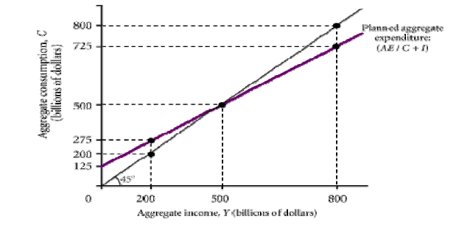
- When aggregate output equals $800 billion, which of the following happens?
- Unplanned inventory is rising, and output will tend to fall.
- Unplanned inventory is falling, and output will tend to fall.
- Unplanned inventory is falling, and output will tend to rise.
- Unplanned inventory is rising, and output will tend to rise.
- When aggregate output equals $200 billion, which of the following happens?
- Unplanned inventory is rising, and output will tend to fall.
- Unplanned inventory is falling, and output will tend to fall.
- Unplanned inventory is falling, and output will tend to rise.
- Unplanned inventory is rising, and output will tend to rise.

