METU
Department of Economics
Econ 101: Introduction to Economics I
Section 01-02
Fall 2023
PROBLEM SET 1 (CH 1&2)
- Draw the graphs of following functions:

- y=8+3x
- y=8-3x
- y=3x+12

- Find the slopes and intercepts of the functions above and explain the relationship between dependent and independent variables.

- Give economic examples of what the variables in equations may be.

- Write the equations of the linear functions whose graph
- has slope 2/3 and intercept (3, 0)
- has slope 4 and intercept (4, 3)
- has slope 6 and passes through the point (5, 2)
- has slope -1/4 and passes through the point (2, -3)
- passes through the points (2, 1) and (3, 5)

- From the graphs below, indicate which graph(s);
- are increasing for all x,
- are decreasing for all x,
- are increasing at a constant rate for all x ,
- are decreasing at a constant rate for all x,
- are increasing at an increasing rate for all x,
- are increasing at a decreasing rate for all x,
- are decreasing at an increasing rate for all x,
- are decreasing at a decreasing rate for all x,

(a) (b)

x x
y y

(c) (d)

x x

y y

x x
(e) (f)

x x

x x

y y
(g) (h)

- Suppose you won $15 on a lotto ticket and decided to spend all the winnings on candy bars and bags of peanuts. Candy bars cost $0.75 each while bags of peanuts cost $1.50 each.

- Construct a table showing the alternative combinations of the two products that are available.

- Plot the data in your table as a budget line in a graph. What is the slope of the budget line? What is the opportunity cost of one more candy bar? Of one more bag of peanuts? Do these opportunity costs rise, fall, or remain constant as additional units are purchased?

- Does the budget line tell you the optimal combination(s) of candy bars and bags of peanuts to buy?
- Suppose that you had won $30 on your ticket, not $15. Show the $30 budget line in your diagram. Has the number of available combinations increased or decreased?

- Below is a production possibilities table for consumer goods (automobiles) and capital goods (forklifts):

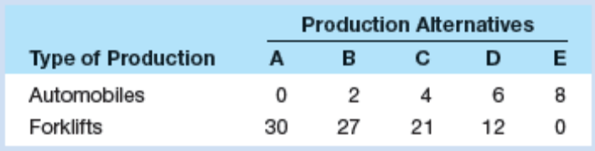

- Show these data graphically. Upon what specific assumptions is this production possibilities curve based?

- If the economy is at point C, what is the cost of one more automobile? Of one more forklift? Which characteristic of the production possibilities curve reflects the law of increasing opportunity costs: its shape or its length?

- If the economy characterized by this production possibilities table and curve were producing 3 automobiles and 20 fork lifts, what could you conclude about its use of its available resources?

- Consider the following equations either increasing or decreasing in x . ( Suppose that x>0)

- y= 3x² + 4x+5
- y= ln3x+ 10

- y= (1/3) x³ + 2.5 x² -14x+25

- The following table contains data on the relationship between saving and income. Rearrange these data into a meaningful order and graph them on the accompanying grid. What is the slope of the line? The vertical intercept? Interpret the meaning of both the slope and the intercept. Write the equation which represents this line. What would you predict saving to be at the $12,500 level of income?
Income  (per year)` | Saving  (per year)
$15,000  0  10,000  5,000  20,000 | $1,000  -500  500  0  1,500

- Table below gives the values of Y in 2010 and 2011 in US dollars.

Year | Y
2010 | 731000$
2011 | 774860$

- Calculate the percentage change in Y from 2010 to 2011.

Formula for calculating percentage change is as follows:

- During 2012, Y grows 2 percent. Find the value of Y in 2012.

PART B: MULTIPLE CHOICE

- If the equation y = 3x + 9 was plotted:
                - the vertical intercept would be 9.
                - the slope would be 3.
                - it would look as an upward sloping line.
                - the horizantal intercept would be – 3.
                - all of the above would be true.

- Refer to the below figure the slope of the line between Points A and B is

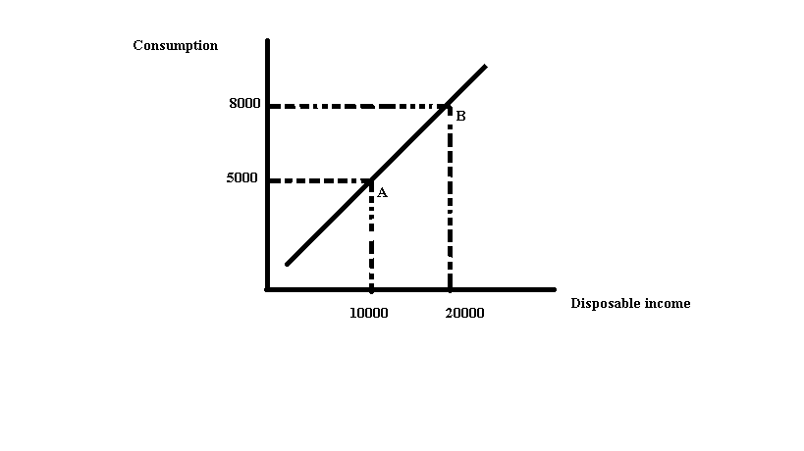
- 0.3
- 2.3
- 3.3
- Indeterminate from this information

- The slope of a vertical line is
- Zero
- Infinite
- Continually changing
- Negative
- The slope of a curve
- Is always positive
- Must first increase then decrease
- Is not constant
- Is constant

- The slope of a horizontal line is
- Negative
- Zero
- Continually changing
- Infinite
- Refer to the figure below. The expression of the slope of the line between points A and B equals:

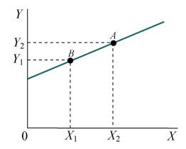
A)
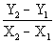

B) 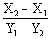

C) 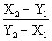

D) 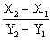

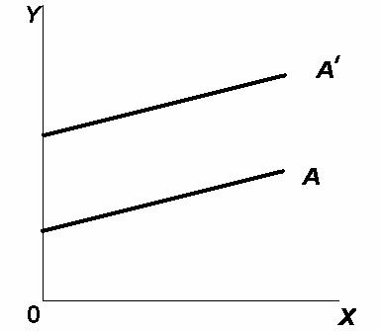

- In the figure above, the movement from line A to line A' (parallel lines) represents a change in:
- the slope only.
- the intercept only.

- both the slope and the intercept.
- neither the slope nor the intercept.

- Assume a household would consume $150 worth of goods and services per week if its weekly income were zero and would spend an additional $80 per week for each $100 additional income. Letting C represent consumption and Y represent income, the equation that summarizes this relationship is:
- C = 150 + 80Y
- C = 80 + 1.5Y
- C = 80 + 150Y
- C = 150 + 0.8Y
- C = 100 + 0.8Y

- Refer to the figure below. According to this graph, the relationship between hours of study time and points in the exam is as follows:

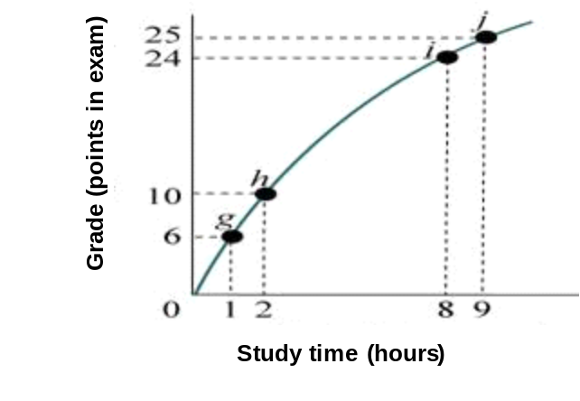
- Negative, because additional study time decreases points obtained in the exam.
- Positive but diminishing.
- The relationship between study time and points on the exam is first positive, and then it turns negative.
- Positive and increasing.
- Nonexistent. There appears to be no relationship between additional hours of study time and a better grade on the exam.

- Suppose you have a $20 iTunes gift card with which you can buy (download) songs or videos. Songs cost $1.00 each and videos cost $2.00 each. The opportunity cost of one video:
- increases as more videos are purchased
- is $1.00
- is constant and equal to ½ song
- is constant and equal to 2 songs

- The negative slope of the production possibilities curve illustrates that:
- some resources are always unemployed
- when resources are fully employed, an economy can produce more of one thing only by producing less of something else
- opportunity costs are constant
- businesses can sell more goods when their prices are low

- Refer to the following production possibilities diagram:

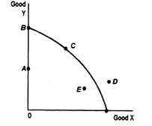

Production of which of the points in the diagram is currently unattainable given the economy's resources?
- Point A
- Point B
- Point C
- Point D

- Which one of the following represents the concept of ''opportunity costs”?
- a decision by your parents to put more of their savings to fund college expenses and less to life insurance.
- public policy in the state of Washington to reduce timber production so that more wildlife species will be preserved.
- a decision by a company to increase advertising expense for a new board game by decreasing its budget for telephone expenses.
- all of the above DO represent the concept of “opportunity costs''
- The concept of scarcity implies ________.
- unlimited human resources and limited producer wants
- unlimited human wants and limited resources
- limited human wants and unlimited resources
- that we can have everything we want

- If the Production Possibility Frontier (curve) is a downward sloping straight line, then ________.
- The opportunity cost is constant
- Production is efficient
- Technological changes have ceased
- Resources are highly specialized, making it difficult to use for alternative uses

- Which of the following will cause the production possibilities curve to shift outward?
- An inefficiency that has been corrected
- A decrease in the size of the capital stock
- An increase in the size of the labor force
- A decrease in the unemployment rate
- England has a relatively cool and cloudy climate that is ill suited for grape growing. It can produce 200 units of wine for every 400 units of cloth. Portugal, in contrast, has a relatively warm and sunny climate that is good for growing grapes. It can produce 200 units of wine for every 100 units of cloth. Which country has the higher opportunity cost of producing cloth?

- Portugal: 2 units of wine for every unit of cloth
- England: 2 units of wine for every unit of cloth.
- Portugal: ½ units of wine for every unit of cloth
- England: ½ unit of wine for every unit of cloth

