METU
Department of Economics
Econ 101: Introduction to Economics I
Section 01-02
Fall 2024
PROBLEM SET 9 (CH 13 and 14)
- What are the conditions for the perfect competitive market structure?
For a market to be called perfectly competitive, it must meet some stringent conditions. Some of them are: Both buyers and sellers are price takers. The number of firms is large. There are no barriers to entry. Firms’ products are identical. There is complete information. Selling firms are profit-maximizing entrepreneurial firms. These and other similar conditions are needed to ensure that economic forces operate instantaneously and are unimpeded by political and social forces.

- What is the major difference between the long run and the short run in a perfectly competitive market? Explain in terms of the number of firms and the flexibility of firms.
In the short run there is no entry or exit of firms in pure competition. The number of firms and plant size are fixed. Firms can either produce or shut down. If they shut down, they do not have time to liquidate their assets or go out of business. In the long run there can be entry and exit of firms into an industry. Firms that shut down in the short run because they are experiencing economic losses will eventually liquidate assets and go out of business if the losses persist over time. Existing firms in the long run can expand or contract their capacity to produce. In the long run, new firms can enter an industry and increase the industry output.
- A profit-maximizing business incurs an economic loss of $10,000 per year. Its fixed cost is $15,000 per year. Should it produce or shut down in the short run? Should it stay in the industry or exit in the long run? Suppose instead that this business has a fixed cost of $6,000 per year. Should it produce or shut down in the short run? Should it stay in the industry or exit in the long run?
In the short run, the business should produce. If it shuts down, the short-run annual loss will be $15,000, its fixed cost; but if it produces, the loss will be only $10,000. In the long run, the business should exit the industry because it is incurring a loss. In the short run, the business should shut down. If it shuts down, the short-run loss will be $6,000, its fixed cost; if it continues to produce, the loss will be $10,000. In the long run, the firm should exit the industry because it is incurring a loss.

4) A perfectly competitive firm has fixed costs of $30 and total costs as indicated in the table below.

Output | Total fixed cost | Total variable cost | Total cost | Average fixed cost | Average variable cost | Average total cost | Marginal cost
0 | 30 | 0 | 30 | - | - | - | -
1 | 30 | 9 | 39 | 30 | 9 | 39 | 9
2 | 30 | 17 | 47 | 15 | 8.5 | 23.5 | 8
3 | 30 | 24 | 54 | 10 | 8 | 18 | 7
4 | 30 | 30 | 60 | 7.5 | 7.5 | 15 | 6
5 | 30 | 37 | 67 | 6 | 7.4 | 13.4 | 7
6 | 30 | 45 | 75 | 5 | 7.5 | 12.5 | 8
7 | 30 | 54 | 84 | 4.29 | 7.71 | 12 | 9
8 | 30 | 65 | 95 | 3.75 | 8.125 | 11.875 | 11
9 | 30 | 78 | 108 | 3.33 | 8.67 | 12 | 13
10 | 30 | 93 | 123 | 3 | 9.3 | 12.3 | 15

a. Fill in the missing values in the table.

b. Graph the curves for total fixed cost, total variable cost, and total cost .
Fixed cost does not change with output. Total variable and total costs are always increasing with output, first at a decreasing rate and then at an increasing rate. This is the case because marginal costs are first decreasing and then increasing.

c. Graph the curves for AFC, AVC, ATC, and MC. Mark the two key points as discussed in class and also in the textbook. Explain why the MC curve intersects both the AVC and ATC curves at their minimums.

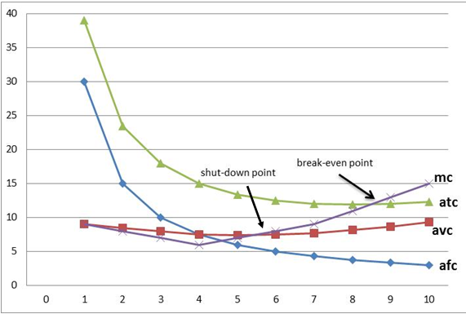

Note that average variable cost is decreasing when marginal cost is less than the average, and it is increasing when marginal cost is higher than the average. So, average variable cost is decreasing till AVC=MC, and it is increasing after AVC=MC.
d. What will happen to the AVC, ATC, and MC if the fixed cost increases by 40.
AVC and MC will not change, while the ATC will be higher for each output level

e. How much will the firm produce if the market price that it faces is $13.5. Will the firm
make profits or losses? How much?
If the market price is $13.5, the perfectly competitive firm will produce 9 units of output (P=MC) and make profits equal to the difference between the total revenue at this price ($121.5) and the total cost for the production of 9 units ($108), thus the profit will be equal to $13.5

f. Answer the questions in part (e) is the price was $8.5.
If the market price is $8.5, the perfectly competitive firm will produce 6 units of output (P=MC) and make losses equal to the difference between the total revenue at this price ($51) and the total cost for the production of 6 units ($75), thus the loss will be equal to $24. The firm will stay in business because it covers its variable costs ($45).

g. Answer the questions in part (e) is the price was $6.
If the market price is $6, the perfectly competitive firm will not produce any output because at this price the loss minimizing output will be 4 units (Loss=$36) and the firm cannot cover even its variable costs ($30).

- Suppose that there are 100 consumers in a perfectly competitive market and individual demand curves of these consumers are identical. Also, assume that there are 10 firms in the industry and these firms are identical as well. The following information is provided about this competitive market:
Individual Demand Curve: $P=100–10Q_{D}$
Total Cost of a Representative (individual) Firm: $TC=20Q+\frac{1}{6}Q^{2}+100$

- Find total variable cost (TVC), total fixed cost (TFC) and marginal cost (MC) functions of the representative firm.

$TVC=20Q+\frac{1}{6}Q^{2}$, TFC = 100, MC=20+($\frac{1}{3}$)Q
- Find average total cost (ATC), average variable cost (AVC), average fixed cost (AFC) functions of the representative firm.

$$ATC=\frac{TC}{Q}=20+\left(\frac{1}{6}\right)Q+\frac{100}{Q}, AVC=\frac{TVC}{Q}=20+\left(\frac{1}{6}\right)Q,$$
$$AFC=TFC/Q=\frac{100}{Q}$$

- What is the market demand function?
To find the market demand we need to horizontally sum the individual demand curves for each of these firms; P = 100 – (1/10) Q

- What is the market supply function?
To find the market supply curve we need to horizontally sum the MC curves for each of these firms. Thus, with each firm’s MC=20+(1/3)Q then P=20+(1/30)Q

- What is the equilibrium price and quantity in this market?
QD=QS
100 – (1/10) Q = 20 + (1/30) Q => Q = 600 units P = 40 TL

- What is the quantity produced by the representative firm?
The representative firm is a price taker and will see the market price of $40 as its marginal revenue curve. It will profit maximize by producing that level of output where MR equals MC. Thus, 40=20+(1/3)Q −> Q = 60 units

- Calculate the level of profits that the representative firm is earning.
Profit = TR – TC = 2400−1900 = 500 TL
TR = 40∗60 = 2400 TL
$$TC=20(60)+(1/6){(60)}^{2}+100=1200+600+100=1900 TL$$

- Holding everything else constant, what do you predict will happen in this industry in the long run? Explain your answer fully with a verbal description rather than a numeric calculation.
Since the representative firm is earning positive economic profit, we can conclude that this is a short-run equilibrium. We know that when the industry is in a long-run equilibrium that the representative firm in the industry will earn zero economic profit. Thus, we can predict that in the long run there will be entry of new firms into this industry. This entry will cause the market supply curve to shift to the right and this shift will result in the market equilibrium quantity increasing while the market equilibrium price will decrease relative to its current levels. There will be more firms in the industry, and each firm will produce an output that is smaller than 60 units.

- This question traces some of the long-run adjustments that take place in a perfectly competitive market in response to a change in demand. Each firm currently in the industry, as well as each potential entrant, has the cost structure depicted in the left panel below. The right panel shows the industry's short-run supply curve and the current market demand curve $D_{0}$.
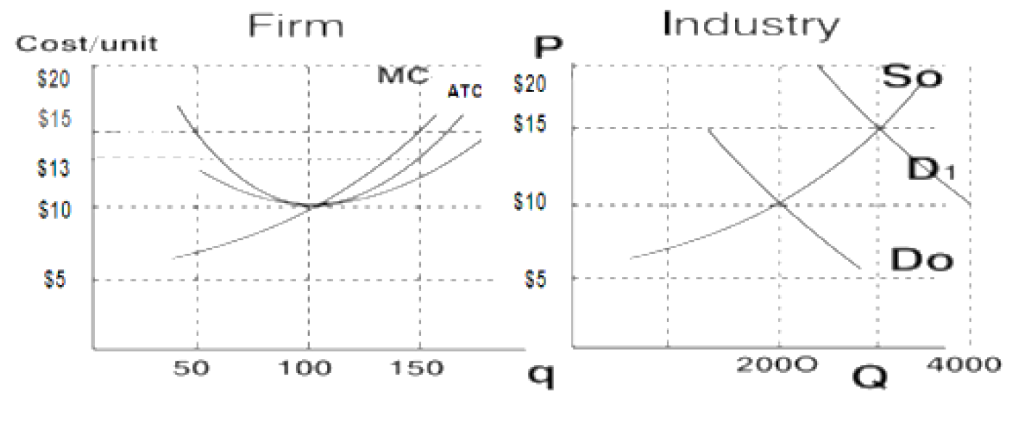

At the initial equilibrium,
- a. What are the equilibrium price and output in the industry?
- $P_{0}=\$10 and Q_{0}=2,000$
- b. What is the output and profit of each firm in the industry?
- 𝑞=100 units and Profit =0
- c. How many firms are operating in this industry?
- # Firms = 𝑄/𝑞=2000/100=20
- d. Is the industry in long-run equilibrium? Explain.
Yes. Economic Profit = 0 -> long-run equilibrium

Suppose demand shifts to $D_{1}$. At the new short-run equilibrium
- e. What are the equilibrium market price and quantity in the industry?
- $P^{S}$=$15 and $Q^{S}$=3000
- f. What is the output of each firm in the industry?
- Each firm increases q from 100 to 150 (where MC = new MR)
- g. What is each firm's profit?
- Profit = 150(15−𝐴𝐶)=150(15−13)=300

- h. Explain the changes in the industry's short-run supply curve after sufficient time has elapsed for entry and exit to occur given a constant cost industry in the long run?
Entry shifts Supply curve right until P = $10 gives zero economic profit and long-run equilibrium is reached.

At the new long-run equilibrium,
- i. What are the market price and quantity?
- P1=10 and 𝑄1=4000
- j. What is the output and associated profit of each firm?
- q= 100 and Economic Profit = 0
- k. How many firms will be active in this industry?
- #Firms = 𝑄/𝑞=4000/100=40

- Consider the following information about bikes, where Q is output, TC is the total cost of production, and p is the price.
- Fill in the remaining columns in the chart.

Q | TC | MC | P | TR | MR | Profits
0 | 2000 |  | 600 | 0 |  | -2000
1 | 2500 | 500 | 575 | 575 | 575
2 | 2800 | 300 | 550 | 1100 | 525
3 | 3000 | 200 | 525 | 1575 | 475
4 | 3160 | 160 | 500 | 2000 | 425
5 | 3340 | 180 | 475 | 2375 | 375 | -965
6 | 3540 | 200 | 450 | 2700 | 325 | -840
7 | 3780 | 240 | 425 | 2975 | 275 | -805
8 | 4080 | 300 | 400 | 3200 | 225 | -880
9 | 4410 | 330 | 375 | 3375 | 175 | -1035
10 | 4770 | 360 | 350 | 3500 | 125
11 | 5190 | 420 | 325 | 3575 | 75
12 | 5760 | 570 | 300 | 3600 | 25

- Graph the firm's demand curve, marginal revenue curve and marginal cost curve
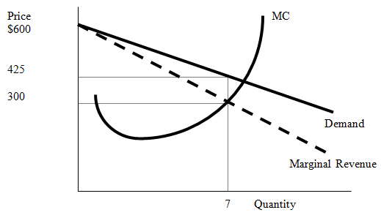
- Where is the marginal revenue curve relative to the firm's demand curve?
The firm’s marginal revenue curve is below the firm’s demand curve and it has twice the slope of the firm’s demand curve.
- Determine the profit maximizing price and quantity. At this price and quantity, calculate this monopoly's economic profits.
Find where MR=MC without MC becoming greater than MR. The profit maximizing quantity is q*=7 with P*=425. The monopoly earns negative economic profits of TR-TC=3780-2975 = -805, which is the best the firm can do in the short run. Notice that if the firm shuts down in the short run due to negative economic profits, it will incur even greater economic losses. The loss if the firm shuts down and produces nothing is –2000. So, the fixed cost of production is $2000.
- Given this firm's level of economic profits, where must the firm's average total cost curve (ATC) and average variable cost curve (AVC) lie?
Because the firm earns negative economic profits, we know ATC>P. However, the firm has enough revenue at q*=7 to cover all of its variable costs and some of its fixed costs. So, P>AVC, which explains why the firm stays in business, producing 7 units in the short run, though negative economic profits are being earned. Shutting down in the short run would result in losses equal to –2000.
- List the causes of monopoly.
Monopolies often exist for one of the following reasons: (i) when only 1 firm has access to a key resource required in the production process; (ii) when the government grants one firm exclusive rights to produce a particular product; (iii) natural monopoly: when the cost of production makes one firm more efficient than a large number of firms.
- What characteristics do monopolies and perfectly competitive firms have in common?
Monopolies and perfectly competitive firms both maximize profits by producing a level of output q* where MC=MR. (We also assume perfect information in both types of markets).

- For a monopoly;
Average revenue function: P = 120 – 2Q
FC = 100
AVC = 60 + 2Q
- Find the total revenue (TR) function.
Since $AR=P, TR=P*Q=(120 – 2Q)*Q=120Q – 2Q^{2}$
- Find the MR and MC function.
$$TC=TFC+TVC=100+AVC*Q => TC=100+60Q+2Q^{2}$$
$$MC=∂TC/∂Q=60+4Q ; MR=∂TR/∂Q=120 – 4Q$$
- Find the quantity that gives the maximum TR.
Total revenue is maximized when its first derivative with respect to quantity (i.e. marginal revenue) is equal to zero. Total revenue is also maximized when elasticity of demand is equal to one; i.e. mid-point of the demand curve. $120 – 4Q=0 => Q=30$
- Find the quantity that gives the minimum AC.
Average cost is minimized when its first derivative with respect to quantity is equal to zero.
$$AC=TC/Q=(100/Q)+60+2Q => ∂AC/∂Q=2 – \left(100/Q^{2}\right)=0 => Q=\sqrt{50}$$
- Determine the profit maximizing level of output and find the profit.
Profit is maximized when marginal revenue and marginal cost is equal to each other.
$$60+4Q=120 – 4Q => Q_{Monopoly}^{*}=7.5$$
$$TR=120Q –2Q^{2}=1575/2 ; TC=100+60Q+2Q^{2}=1325/2$$
$$Profit=TR – TC=125$$
- What would the profit maximizing level of output be if this market is perfectly competitive?
Under perfect competition, profit maximization implies $P=MC.$ To obtain perfectly competitive outcome, $120-2Q=60+4Q => Q_{Perfectly}^{*}=10$.
- What is the cost of monopoly to the society? Show this on a graph.
10
7,5
MC or Supply
D
120
100
60
P
Q
c
a
b
105
90
d

The triangle adb (cdb) is the cost of monopoly paid by consumers (producers) due to under-production. The triangle abc is deadweight loss of the economy and it is equal to
$$DWL=\frac{\left(105-90\right)*2.5}{2}=18.75$$

- A discriminating monopolist can separate his consumers into two distinct markets with the following demand functions:

Market 1: Q₁=16 – 0.2P₁ Corresponding MR function MR₁=80-10Q₁
Market 2: P₂=180 – 20Q₂ Corresponding MR function MR₂=180-40Q₂

Assume that the monopolist’s total cost function takes the form; TC - 20Q – 20 = 0 where Q = Q₁ + Q₂, and that it wishes to maximize profits, calculate;

- the prices the monopolist will charge in each market.
The monopolist will allocate production so that MC = MR in each market.
MC = MR₁ = MR₂
TC – 20Q – 20 =0 or TC = 20Q + 20, then MC is constant at 20.
In market 1,
Q₁ = 16 – 0.2P₁ or P₁ = 80 – 5Q₁
TR₁ = P₁Q₁ = (80 – 5Q₁)*Q₁ = 80Q₁ - 5Q₁²
MR₁ = 80 – 10Q₁
Then 80 – 10Q₁ = 20 and Q₁=6, P₁=50
In market 2,
Q₂=4 and P₂=100
- the monopolist’s profit with price discrimination.
S=(TR₁ + TR₂) – TC = 480

- The diagram below shows the demand and unit cost situation of a monopolist.

Quantity
Price and Cost per unit
A
B
C
MC
ATC
MR
Demand
H
N
J
L
E
G
0

- In order to maximize profits or minimize losses how much should this firm produce and at which price?
Q = 0E, P = 0A
- In equilibrium how much total revenue will the firm collect?
0AJE
- In equilibrium how much total cost will the firm incur?
0BHE
- State whether the firm faces a profit or a loss in the equilibrium.
Profit by AJBH
PART B: MULTIPLE CHOICE QUESTIONS
Refer to Table 1 to answer questions 1 to 3. Table 1 shows the marginal cost, average variable cost, and average total cost of producing various quantities of a commodity by a firm in a perfectly competitive industry.
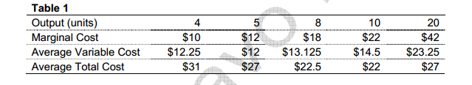
- Refer to Table 1 above. What are the Total Fixed Costs of the firms?
- $36
- $75
- $84
- $96
- None of the above

- Refer to Table 1 above. What are the economic profits of the firm when the firm is in equilibrium at a price of $18?
- -$25
- $36
- $39
- $45
- None of the above

- Refer to Table 1 above. What is the level of output at which the economic losses of the firm are equal to total fixed cost?
- 4
- 5
- 8
- 10
- None of the above

- Consider a perfectly competitive firm in the following position: Output=4000 units, Total Revenue=$4000, Total Fixed Costs=$2000, Total Variable Costs=$3000, and Marginal Cost=$1.10. In the short run, this firm should
- Shut down
- Expand output
- Increase the market price
- Reduce output
- Not change output

- The vertical distance between average total cost and average variable cost curves decreases as output increases because
- it is traditional to draw the curves that way
- it works out that way with the geometry since both curves must reach their minimums on the marginal cost curve
- average fixed cost decreases as output increases
- marginal product first rises and then falls
6. When a firm exits an industry
a. demand decreases and economic profits continue to decline
b. market supply does not change
c. market supply decreases, pushing market price higher
d. market supply decreases, decreasing the firm's output price

7. Refer to Fig.2, when will “firm entry” occur?
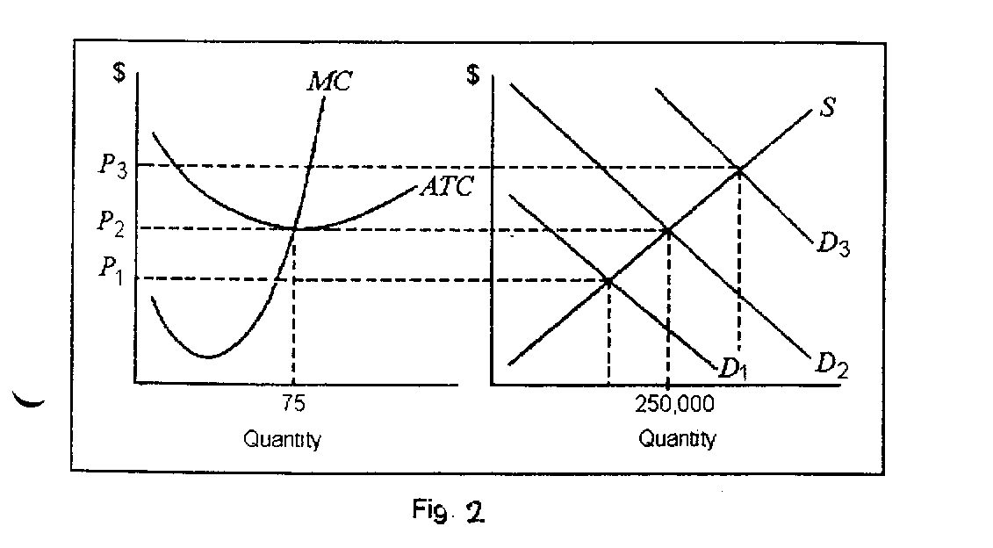
- when price is P₁ or greater
- when demand is at D₃
- when demand is at D₂
- when price is P₂ or less

8. In a perfectly competitive market
- each firm sets its own price.
- when one firm ceases production, the market equilibrium price tends to rise.
- there are a few firms selling unique products.
- None of the above. In a perfectly competitive market, firms sell homogenous products and take the market price as given.

9. The three primary characteristics of a perfectly competitive market are
- the firms' products are homogenous, the firms are price takers and there are barriers to entry into the market.
- the firms' products are unique, they are price takers and there are no barriers to entry in the market.
- the firms' products are homogenous, the firms are price takers and can freely enter and exit the market.
- the firms' products are unique, they set their own price and can freely enter and exit the market

10. The demand curve for a perfectly competitive firm
- slopes downward as the quantity demanded increases as the firm lowers price.
- is a horizontal, perfectly elastic demand curve at the market price.
- is a straight, downward sloping curve that is price elastic at higher prices and price inelastic as price falls and approaches zero.
- Both b and c

11. A firm may decide to shut down in the short run
- if profit maximization occurs at an output level where price is less than average variable cost.
- if profit maximization occurs at an output level where price is less than average total cost.
- if profit maximization occurs at an output level where price is equal to average total cost and the firm does not foresee changes to the market price in the future.
- profit maximization occurs at an output level where price is less than average total cost but greater than average variable cost.

12. The perfectly competitive firm's short run supply curve
- is the portion of the marginal cost curve that lies above the average total cost curve.
- the upward sloping portion of the marginal cost curve.
- the average variable cost curve above the minimum average variable cost.
- is the portion of the marginal cost curve that lies above the average variable cost curve.

13. If the total cost function for a perfectly competitive firm is TC=50+10q-q2+(1/3)q3 and the market price is $130
- the profit maximizing output level q is 12.
- the profit maximizing output level q is 20.
- the profit maximizing output level q is 10.
- there is not enough information given to determine the profit maximizing output level.

  - The reason that the Şok Market has a monopoly on selling seafood dinners in that town is most likely due to
- a government-imposed barrier.
- occupational licensing.
- no competitors apparently found the profit level attractive enough to enter the market.
- the restaurant owned all the fresh seafood in the state.

- A monopoly is a seller of a product
- with many substitutes.
- B) without a close substitute.
- C) with a perfectly inelastic demand.
- D) without a well-defined demand curve.
16. In METU Campus, there are three restarurants: Susam, Ziyafet and Sunshine. While Sunshine remains open until midnight, Susam and and Ziyafet close at 10 pm. Which of the following statements is true?
- Sunshine is a monopoly all day because it produces a service that has no close substitutes.
- Sunshine has a monopoly at midnight but not during the day.
- Sunshine can ignore the pricing decisions of the other two supermarkets.
- Sunshine probably has a higher markup to compensate for its higher cost of production.
17. Which of the following is a characteristic shared by a perfectly competitive firm and a monopoly?
- Each must lower its price to sell more output.
- Each sets a price for its product that will maximize its revenue.
- Each maximizes profits by producing a quantity for which marginal revenue equals marginal cost.
- Each maximizes profits by producing a quantity for which price equals marginal cost.

18. A monopolist's profit maximizing price and output correspond to the point on a graph
- where average total cost is minimized.
- where total costs are the smallest relative to price.
- where marginal revenue equals marginal cost and charging the price on the market demand curve for that output.
- where price is as high as possible.
19. If a monopolist's price is $50 at 63 units of output and marginal revenue equals marginal cost and average total cost equals $43, then the firm's total profit is
- $3,150.
- $2,709.
- $441.
- $7.

Table 15.4
Price per Dose | Quantity Demanded  (dose) | Total Cost of Production  (dollars)
$80 | 0 | $80
72 | 1 | 82
64 | 2 | 88
56 | 3 | 100
48 | 4 | 124
40 | 5 | 164
32 | 6 | 208
24 | 7 | 268
16 | 8 | 340

Çelik Inc. has been granted a patent for its Arnica toothache balm. Table 15-4 shows the demand and the total cost schedule for the firm.
20. Refer to Table 15-4. What is Çelik's profit-maximizing output?
- 4 units
- 5 units
- 6 units
- 7 units
21. Refer to Table 15-4. What is the amount of Çelik's profit?
- $68
- $72
- $124
- $192

22. Refer to Table 15-4. What is the amount of the deadweight loss generated by Çelik when it produces the monopoly output?
- $124
- $42
- $36
- $12
23. Because a monopoly's demand curve is the same as the market demand curve for its product
- the monopoly's marginal revenue equals its price.
- the monopoly is a price taker.
- the monopoly must lower its price to sell more of its product.
- the monopoly's average total cost always falls as it increases its output.
Figure 1
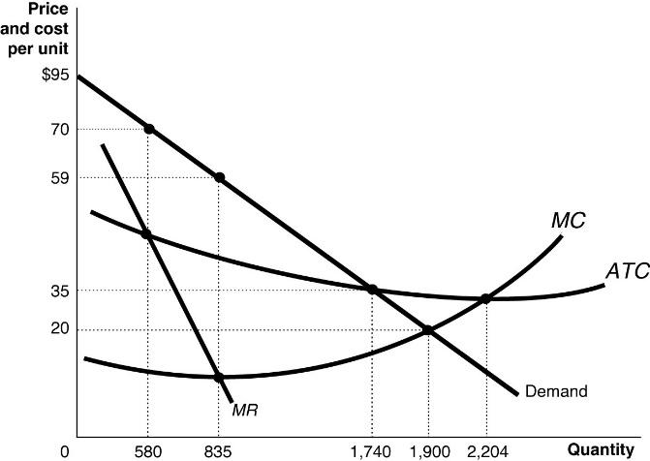

24. Refer to Figure 1. Which of the following statements about the firm depicted in the diagram is true?
- The fact that this firm is a natural monopoly is shown by the continually declining long-run average total cost as output rises.
- The fact that this firm is a natural monopoly is shown by the continually declining market demand curve as output rises.
- The fact that this firm is a natural monopoly is shown by the continually declining marginal revenue curve as output rises.
- The fact that this firm is a natural monopoly is shown by the fact that marginal cost lies below the long-run average total cost where the firm maximizes its profits.
25. A local electricity-generating company has a monopoly that is protected by an entry barrier that takes the form of
- control of a key raw material.
- network externalities.
- economies of scale.
- perfectly inelastic demand curve.

26. A monopolist faces
- a perfectly elastic demand curve.
- a perfectly inelastic demand curve.
- a horizontal demand curve.
- a downward-sloping demand curve.

Figure 3.
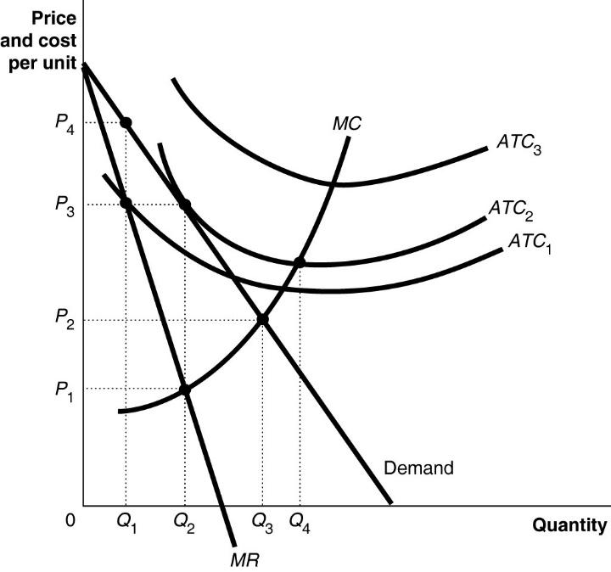
27. Refer to Figure 3. To maximize profit, the firm will produce
- Q1.
- Q2.
- Q3.
- Q4.

28. Refer to Figure 3. The firm's profit-maximizing price is
- P1.
- P2.
- P3.
- P4.
29. Refer to Figure 3. If the firm's average total cost curve is ATC1, the firm will
- suffer a loss.
- break even.
- make a profit.
- face competition.
30. Refer to Figure3. If the firm's average total cost curve is ATC2, the firm will
- suffer a loss.
- break even.
- make a profit.
- face competition.

