METU Department of Economics
ECON202 Macroeconomic Theory I (Sec. 2)
Fall 2025
Instructor: Şirin Saraçoğlu
TA: Zeki Oğulcan Şengül
PROBLEM SET 3
PART A: TRUE/FALSE/UNCERTAIN
- The money multiplier will increase if banks decide to hold fewer reserves per YTL of deposits. This will increase the difference between high powered money and the money supply
True. If θ decreases, the money multiplier increases. The difference between H and M is (R – D); when R decreases relative to D, the difference between H and M will also decrease.
- The opportunity cost of holding a bond is the benefit arising from holding money.
True. The opportunity cost is the benefit foregone when using a resource one way instead of another. People who hold bonds receive a rate of return but they are giving up the utility that holding money provides to them through its role as a medium of exchange. Since different individuals value such utility differently, the opportunity cost of holding a bond varies from one individual to another. Money is also held to protect against capital losses that may occur from a decrease in bond values arising from an increase in interest rates. The avoidance of such a capital loss can be seen as part of the return of holding money.

- Expansionary monetary policy lowers bond prices and interest rates.
F. Expansionary monetary policy causes an excess supply of money, which implies an excess demand for bonds. Thus bond prices increase and interest rate decreases.
- Interest rates will fall when the quantity of money demanded exceeds the quantity of money supplied.
False. Interest rates fall when the quantity of money supplied exceeds the quantity of money demanded.
- An open market purchase raises high-powered money (Central Bank Money).
True. An open market purchase occurs when the CB buys bonds from the private sector in return for currency (or from banks in return for an increase in bank reserves in the form of deposits held at the CB). The stock of high-powered money increases and thus money supply will also increase.
- Eliminating required reserves on bank deposits decreases the Central Bank’s control over the money stock.
It depends on how you approach this issue.
True. If you think that banks hold only required reserves and there is no alternative or change in another policy (ceteris paribus)
False. The CB has a number of policy instruments at its disposal to control the level of bank reserves and thus money supply, particularly through open market operations. The money multiplier will always have a finite value, since banks always hold excess reserves to meet their daily cash needs or for emergencies. But the money multiplier would be larger if there were no required reserves, since banks would choose to voluntarily hold fewer reserves. Thus, open market operations would still enable the CB to exercise great influence over money supply.
- Commercial banks create money when they call back loans.
False. Commercial banks create money when they give out loans

PART B: LONG QUESTIONS

- Consider the following balance sheets of the Central Bank, commercial banks and citizen Ayşe, who has a deposit account at İş Bankası, part of the commercial banking system.

Central Bank Balance Sheet
Assets |  | Liabilities
Bonds | 500TL | Currency | 0
Other Assets | 0 | Reserves | 500

Commercial Banks
Assets |  | Liabilities
Reserves | 500TL | Deposits | 2000
Loans | 1500TL

Ayşe
Assets |  | Liabilities
Deposit | 100TL | Net Worth | 100

Assume that Ayşe does not hold any currency, c=0, and CB does not issue any currency. The reserve required ratio is 0.25. Under these conditions, suppose that CB conducts an open market sale and sells 100TL worth of bonds to the public, citizen Ayşe uses bank deposits to purchase these bonds. Answer the following questions:

- What is the money multiplier in this economy?
H=C+R
= c.M+𝜃(1-c)M
H=M[c+ 𝜃(1-c)]
Money multiplier (k_{m} or mm)= M/H
$$\frac{M}{H}=\frac{1}{c+θ(1-c)}$$
Let’s plug the information given in the question to the formula,
$$\frac{M}{H}=\frac{1}{0+0.25(1-0)}=\frac{1}{0.25}=4$$

- What is the new money supply after the Open Market Sale ?

$$∆M^{s}=mm×∆H$$
In this example, mm=4 and $∆H=-100$, therefore, $∆M^{s}=4×100=-400$
Here, $∆H$ is the change in High powered money or the Central Banbk Money, and the change in H originates from changes in reserves and changes in currency or $∆H=∆C+∆R$. In our case, there is no change in currency, $∆C=0$, and $∆R=-100$ is the volume of open market operation and hence the change in reserves.

- Now, show the effect of this policy action by the Central Bank on the balance sheets, and using the balance sheets calculate the change in money supply. (The final version)

Central Bank Balance Sheet
Assets |  | Liabilities
Bonds | 400TL | Currency | 0
Other Assets | 0 | Reserves | 400

Commercial Banks
Assets |  | Liabilities
Reserves | 400TL | Deposits | 1600
Loans | 1200TL

Ayşe
Assets |  | Liabilities
Deposit | 0TL | Net Worth | 100
Bonds | 100TL

Accordingly, M1 (Before) = C+D =2000
M1(Final)b=C+D= 1600
∆M1=-400

- Suppose that money demand is given by the following function Md=$Y(0.3-i) ($M^{d}=\$Y (0.3-i))$ and that nominal GDP is given by $100. Moreover, assume that the money supply is given by $M^{s}=\$20$. Bonds promise to pay $100 in the future.
- Calculate the interest rate for which the money market is in equilibrium.
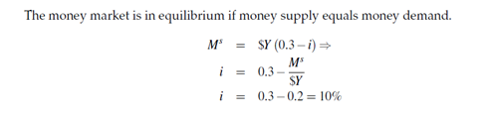
- Suppose the central bank targets an interest rate of 5%. Which money supply must the central bank set in order to achieve this goal?
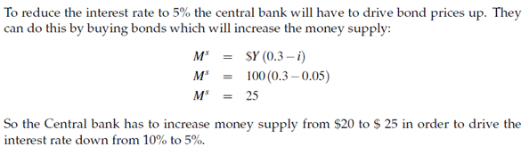
- What money supply is needed in order to achieve an interest rate of 15%?
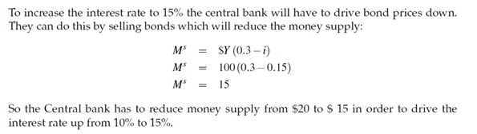
- Suppose the public holds no currency, c=0, the ratio of reserves to deposits is 0.2, and the demand for money function is given by Md=$Y(0.2-0.8i):
${(M}^{d}=\$Y(0.2-0.8i))$:
Initially, the CENTRAL BANK MONEY (high-powered money, H) is $100 billion and nominal income is $5000 billion.
- Determine the equilibrium interest rate.
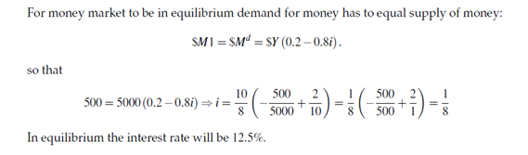
- Determine the impact on the interest rate if the central bank increases the Central Bank Money (H) to $150 billion.
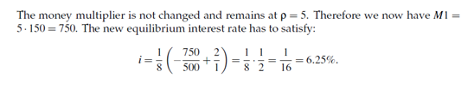
- With the original money supply, determine the impact on the interest rate if nominal income increases from $5000 billion to $6250 billion.

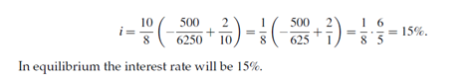
- Assume now that the public wants to hold currency. In particular, assume that the ratio of deposits to currency is 0.43. Determine the value of the money supply when the Central Bank Money (high powered money, H) is $100 billion. What is the value of the multiplier now?
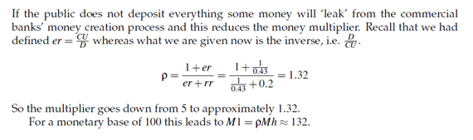
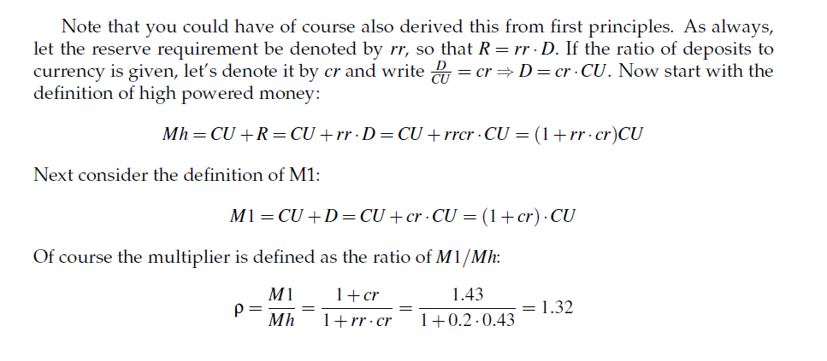
Note that , in the formula , the money multiplier can be written (especially in the lecture notes) as 1/c+𝜃(1-c) and in this formulation cash drain ratio is defined as CU/M (instead of CU/D) if you define c out of money supply you need to use this formula.
- You are given the following information about the economy of Miniland. For each 1YTL increase in GDP, the demand for money increases by 25 kuruş, other things remaining the same. Also, if the interest rate increases by 1 percentage point, the quantity of money demanded falls by 50YTL. If GDP is 1000 YTL:

- Derive the money demand function
From the information given above the Money demand equation can be written as
M^{d} = 0.25$Y – 50i
Since $Y = 1000 YTL, M^{d} = 0.25*1000 – 50i = 250 – 50i
- What is the equilibrium in the money market? Find the equilibrium interest rate, the equilibrium quantity of money demanded and supplied in the money market. Show also graphically.(Money supply is 150)
250 – 50i = 150 → i = 2= (200%) and M_{D} = M_{S} = 150
- If the Bank of Miniland, the Central Bank, wants to lower the interest rate by 100 percentage point ( to 1) , by how much would it have to change the money supply to achieve this objective? If the money multiplier in this economy is 5, by how much would the central bank money have to change to achieve this objective?
250 – 50*1 = 200, so the money supply should be increased by 50 YTL. Then, 250 – 50i = 200 → i =1 (100%)
∆M = 50, and ΔM = (money multiplier)*ΔH
So ∆H = 50/5 = 10 YTL

- (*) A proposal for “100 percent banking” involves a reserve deposit ratio of unity. Such a scheme has been proposed for the United States in order to enhance the Fed’s (the central bank of U.S.) control over the money supply.
- Indicate why such a scheme would help monetary control?
If the reserve deposit ratio is 100%, then banks cannot create any loans and the money multiplier is equal to 1. This means that the CB has total control over the money supply, since it has control over bank reserves.
- Indicate what bank balance sheets would look like under this case?
Since banks would not be able to issue any loans, the assets side would contain only reserves.
- Under 100 percent money, how would banking remain profitable?
Banking could still remain profitable as long as banks were able to generate service charges to cover their operating costs.

- An immigrant arrives in Belgium with 1,200 euros and there is no other money in the economy. The 1,200 euros are put into a bank deposit. All the banks in Belgium have a reserve ratio of 10 per cent and no one in Belgium holds currency.
- What is the initial increase in the quantity of money of Belgium?
Since M = CU + D, when D increases by 1200 euros the quantity of money also increases by 1200 euros. This operation increases the quantity of money because it is newly injected into circulation. If a domestic resident had deposited its money into a bank, this would not increase the quantity of money.
- What is the initial increase in the quantity of bank deposits when the immigrant arrives?
1200 euros.
- How much does the immigrant’s bank lend out?
The bank keeps 1200 euros times 0.10 = 120 euros in reserves, and buys bonds or gives out loans with the rest, 1200 euros times 0.90 = 1080 euros.
- What is the total increase in the quantity of money?
The total increase in money supply is
1200*(1 + 0.9 + 0.9² +….) = 12000 euros.
The money multiplier is
1/0.10 = 10.
- Suppose that, instead of holding no cash, immigrant holds 200 Euros as cash. Recalculate the new money multiplier and the resulting M1.
High Powered Money (Central bank Money): MB = C + R = 1,200. C = 200, R = 0.10D ⇒ 1,200 = 200 + 0.10D (1000) ⇒ D = €10,000
Then:
• Required reserves R = €1,000
• Currency C = €200
• M1 = C + D = €10,200
• Loans L = €9,000
Money multiplier (general form):
c = C/M = 200/10,000 = 1/51
m = 1 / (c + 𝜃(1-c)) = $\frac{1}{\frac{1}{51}+\frac{1}{10}*\frac{50}{51}}$=8.5
Check: m × H = 8.5 × 1,200 = €10,200

- After this change, what happens to M2?
M1 includes currency in circulation plus demand deposits.
• M2 includes M1 plus other near-monies (savings/time deposits).
→ The €200 cash is counted in both M1 and M2.
Since we have no savings/time deposits here, M2 = M1 numerically:
– Part (a): M2 = M1 = €12,000
– Part (b): M2 = M1 = €10,200

- Let the face value of a one-year bond be 100 TL. You buy the bond today for P(b) TL.
a) Derive the formula for the rate of return (or yield) on the bond in one year.
b) Calculate the yield when the bond price is:
• P(b) = 95 TL
• P(b) = 90 TL
c) Explain why there is a negative relationship between the bond price and the interest rate. Use a simple diagram with bond price (P) on the vertical axis and interest rate (i) on the horizontal axis.

a) The rate of return on a one-year bond is given by:
i = (100 - P(b)) / P(b)

b) Substituting values:
• If P(b) = 95 → i = (100 - 95) / 95 = 0.0526 = 5.26%
• If P(b) = 90 → i = (100 - 90) / 90 = 0.1111 = 11.11%

c) When the bond price decreases, the yield (rate of return) rises because the fixed payment (100 TL) is divided by a smaller purchase price. Therefore, bond prices and interest rates move in opposite directions.
Graphically, this relationship is represented by a downward-sloping curve between bond price (P) and interest rate (i).
