CHAPTER 11: PRODUCTION AND COST ANALYSIS I

Questions and Exercises
- Economists include all opportunity costs as costs. This includes not only explicit costs but also implicit costs such as the opportunity costs of factors of production provided by the owners of the business. Accountants don’t include this second item as a cost. Economists include changes in the value of any assets owned by the firm in revenue (implicit revenue) as well as total sales. Accountants include only total sales. An example of implicit revenue is changes in the value of any assets owned by the firm, such as the building and equipment that it owns.
- a. Explicit costs:
Labor $40,000
Rent 10,000
Ingredients 35,000
Utilities 5,000
Total $90,000
Implicit costs:
Opportunity cost of labor $125,000
Opportunity cost of capital
(= $400,000 × 0.01) 4,000
Total $129,000
Explicit plus implicit costs $219,000
Revenue $260,000
Her accounting profit is explicit revenue minus explicit costs: $260,000 − $90,000 = $170,000. Her economic profit is revenue minus explicit and implicit costs: $260,000 − $219,000 = $41,000.
- Peggy-Sue is earning positive economic profit with her current business, which means that she should continue with her current business.
- a. By the accounting definition of cost and profit, Economan is making a profit equal to .
- By the economists' definition of cost and profit, where explicit and implicit costs are included, Economan has a loss of .
Explicit costs:
Labor 45,000
Rent 5,000
Utilities 6,000
Total 56,000
Implicit costs:
Opportunity cost of labor 60,000
Opportunity cost of capital 5,000
Total 65,000
Explicit plus Implicit costs 121,000
Revenue 120,000
Economic Profit −1,000 (a loss)
Accounting Profit 64,000
- The terms short run and long run do not necessarily refer to specific periods of time but rather to the degree of flexibility a firm has in changing the level of output. In the long run a firm can vary its inputs as much as it wants, while in the short run these variations can be so costly that we consider them as fixed. Simply stated, in the short run some inputs are fixed while in the long run all inputs are variable.
- Whenever you see the term "marginal," it implies "additional." Thus, marginal productivity is the additional output that a firm will receive with one additional variable input (workers), assuming all other inputs are constant. Whenever you see "average," you divide by the quantity. Thus, average product is the output divided by the number of workers.
- Assuming you organize your studying reasonably, initially you focus on content that is most likely to show up on the exam and is most likely to raise your grade. Then you study material that will raise your grade, but by less than the original material you studied. At some point, additional studying can have a negative return.
- Total cost is the sum of the fixed and variable costs: TC = FC + VC.
Average total cost (often called average cost) equals total cost divided by the quantity produced: ATC = TC ∕ Q.
Average total cost also can be thought of as the sum of average fixed cost and average variable cost: ATC = AFC + AVC.
Average fixed cost equals fixed cost divided by the quantity produced: AFC = FC∕Q.
Average variable cost equals variable cost divided by the quantity produced: AVC = VC∕Q.
Marginal cost is the increase (decrease) in total cost from increasing (decreasing) the level of output by one unit: MC = Change in TC ∕ Change in Q.
From the data given:
Q | FC | VC | TC | AVC | ATC | MC | AFC
0 | 200 | 0 | 200 | inf | inf | inf | inf
1 | 200 | 20 | 220 | 20.00 | 220.00 | 20 | 200.00
2 | 200 | 30 | 230 | 15.00 | 115.00 | 10 | 100.00
3 | 200 | 35 | 235 | 11.67 | 78.33 | 5 | 66.67
4 | 200 | 50 | 250 | 12.50 | 62.50 | 15 | 50.00
5 | 200 | 80 | 280 | 16.00 | 56.00 | 30 | 40.00
(Note: Marginal costs should be interpreted as between levels of output. Inf = infinite for values that are divided by 0)
- a. Total cost
- Average total cost
- Average fixed cost
- Average variable cost
- Average total cost
- a. To the extent that the firm has a contract with the payroll services company in which the cost of the services is independent of the number of workers (and therefore output), it is a fixed cost. To the extent that payroll services company charges by the number of workers (and therefore output), it is a variable cost.
- To the extent that the lease is for a fixed amount of office space regardless of the number of workers working at the office (and therefore output), leased offices are a fixed cost.
- Company-owned buildings are an example of a fixed cost. The buildings have already been bought; they do not vary with the number of employees hired or level of output.
- Payroll taxes are an example of a variable cost; they vary with the number of employees hired, which, in turn, varies with the level of output.
- Of all the costs discussed in this chapter, marginal cost—the increase in total cost from increasing the level of output by one unit—is the most important for a firm deciding how much to produce. Remember the economic decision rule: If the marginal cost exceeds the marginal benefit, don't do it. If the marginal benefit exceeds the marginal cost, do it.
- a. The increase in hourly pay affects wages is a type of variable cost. It will affect each in the following way:
Average fixed cost curve: no change
Average variable cost curve: shift up
Average total cost curve: shift up
Marginal cost curve: shift up
- The lump-sum tax must be paid no matter the firm’s level of output, therefore it is a fixed cost. It will affect each in the following way:
Average fixed cost curve: shift up
Average variable cost curve: no change
Average total cost curve: shift up
Marginal cost curve: no change
- Because the “stack-tax” varies with the degree of air pollutant emissions, it changes based on a firm’s level of output and is a type of variable cost. It will affect each in the following way:
Average fixed cost curve: no change
Average variable cost curve: shift up
Average total cost curve: shift up
Marginal cost curve: shift up
- The increase in productivity of every worker as a result of the new technology increases output for every worker, and therefore affects costs in the following way:
Average fixed cost curve: no change
Average variable cost curve: shift down
Average total cost curve: shift down
Marginal cost curve: shift down
- See the graph below for the graph of total output.
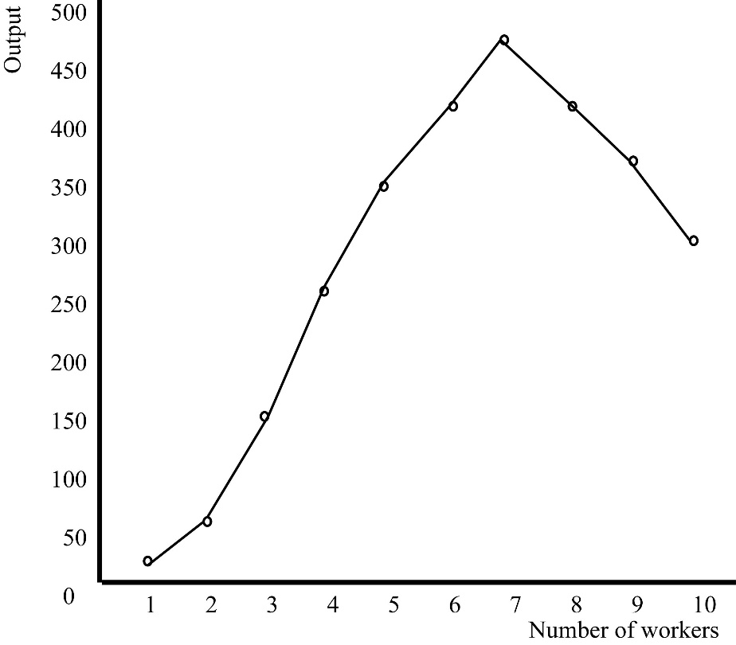
- See the table below. Marginal product is between values. For example, the increase in output from 20 to 60 is 40.
Output | MC | AP
0
20 | 20.00 | 20.00
60 | 40.00 | 30.00
150 | 90.00 | 50.00
260 | 110.00 | 65.00
350 | 90.00 | 70.00
420 | 70.00 | 70.00
455 | 35.00 | 65.00
420 | −35.00 | 52.50
375 | −45.00 | 42.00
300 | −75.00 | 30.00
- See the graph below.
- See the graph below.
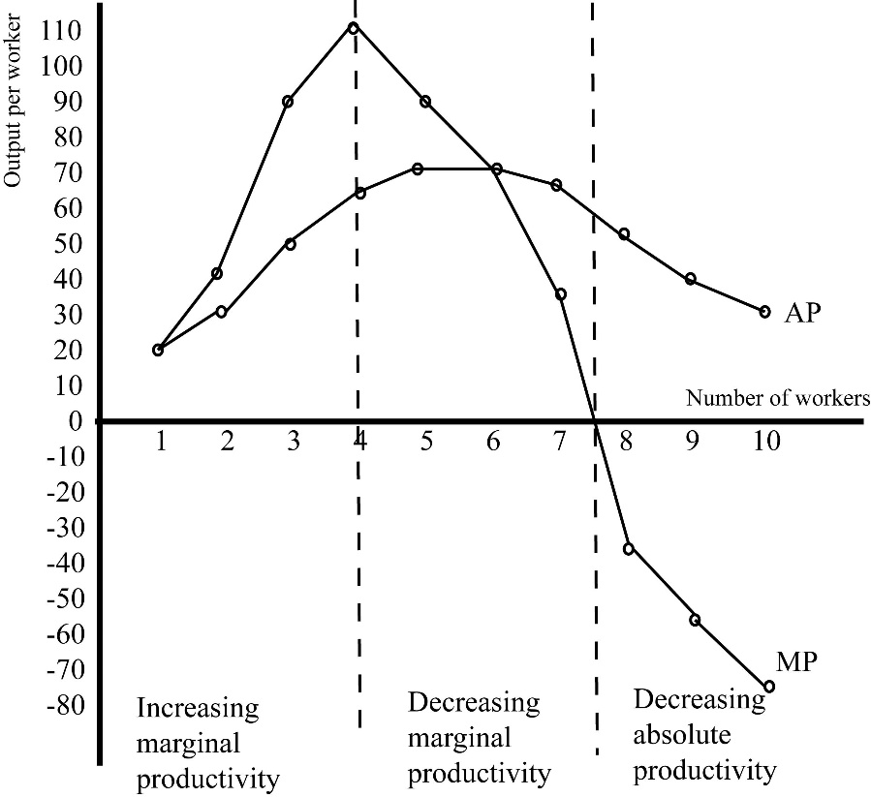
- In the short run, output can be raised only by increasing the variable input. But as more and more of a variable input is added to a fixed input, the law of diminishing marginal productivity enters in. Marginal and average productivities fall. The key insight here is that when marginal productivity falls, marginal cost must rise, and when average productivity falls, average variable cost must rise. So to say that productivity falls is equivalent to saying that cost rises.
- If marginal cost is increasing, average costs could be rising, falling, or constant. The direction of average costs depends upon whether marginal cost is higher or lower than average cost. If marginal cost is lower than average cost, average cost is falling. If marginal cost is higher than average cost, average cost is rising.
- a.
Output | VC | AFC | ATC | AVC | MC
1 | 35 | 100.00 | 135.00 | 35.00 | 35
2 | 75 | 50.00 | 87.50 | 37.50 | 40
3 | 110 | 33.33 | 70.00 | 36.67 | 35
4 | 140 | 25.00 | 60.00 | 35.00 | 30
5 | 175 | 20.00 | 55.00 | 35.00 | 35
6 | 215 | 16.67 | 52.50 | 35.83 | 40
7 | 260 | 14.29 | 51.43 | 37.14 | 45
8 | 315 | 12.50 | 51.88 | 39.38 | 55
9 | 390 | 11.11 | 54.44 | 43.33 | 75

- See the accompanying graph.
- The marginal cost curve intersects the AVC curve at the minimum of the AVC curve. As long as the MC curve is below the AVC curve, the AVC curve is falling. As long as the MC curve is above the AVC curve, the AVC curve is rising.
The marginal cost curve intersects the ATC curve at the minimum of the ATC curve. As long as the MC curve is below the ATC curve, the ATC curve is falling. As long as the MC curve is above the ATC curve, the ATC curve is rising.
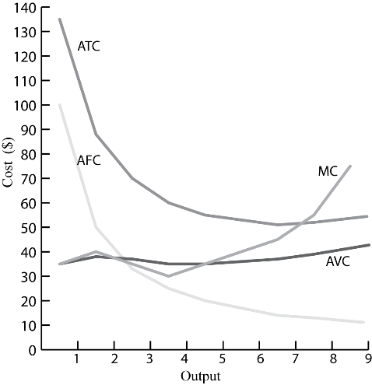
The MC curve intersects the AVC curve at a lower output than at the output it intersects the ATC curve.
- The ATC and AFC curves shift down because they are the only two of the four that include fixed costs. The MC and AVC curves do not shift because they include only variable costs.
- Average cost will not necessarily rise. The general relationships are: If average productivity is falling, average costs must be rising; if marginal productivity is falling, marginal cost must be rising, and marginal cost intersects the average cost curve at the same level of output that the marginal product curve intersects the average product curve.
- a. Given the price of labor at $15 per hour, and the data in the total product table, the following table shows average variable costs
Labor | TP | Total cost | AVC | AP | MP | MC
1 | 5 | 15.00 | 3.00 | 5.00 | 5.00 | 3.00
2 | 15 | 30.00 | 2.00 | 7.50 | 10.00 | 1.50
3 | 30 | 45.00 | 1.50 | 10.0 | 15.00 | 1.00
4 | 36 | 60.00 | 1.67 | 9.00 | 6.00 | 2.50
5 | 40 | 75.00 | 1.88 | 8.00 | 4.00 | 3.75
- The AVC curve is shown in the accompanying graph, and the AP curve is shown below it. You can see that the AVC curve and AP curve are mirror images of each other.
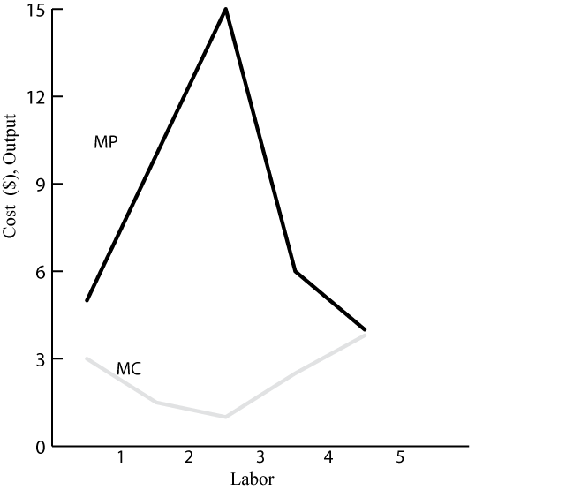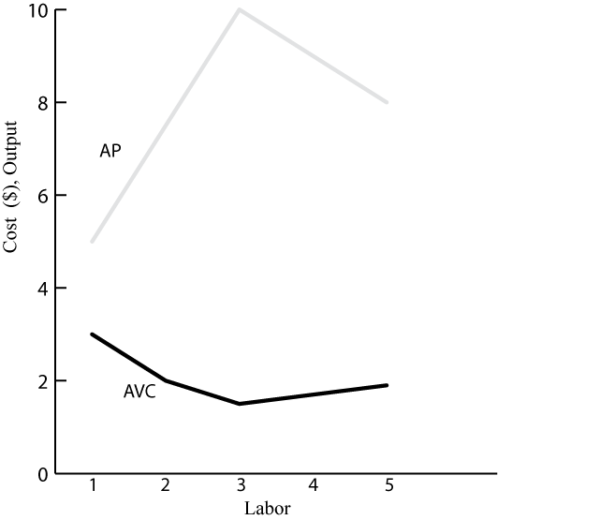
- The MP curve is shown in the graph above.
- As you can see from the graph on the left, the MC curve and the MP curve are approximate mirror images of each other.
- a. See the table below:
Q | Fixed Cost | Variable Cost | Average Fixed Cost | Average Total Cost | Average Variable Cost | Marginal Cost
1 | 100 | 25 | 100 | 125 | 25 | 25
2 | 100 | 50 | 50 | 75 | 25 | 25
3 | 100 | 75 | 33 | 58 | 25 | 25
4 | 100 | 100 | 25 | 50 | 25 | 25
5 | 100 | 125 | 20 | 45 | 25 | 25
6 | 100 | 150 | 17 | 42 | 25 | 25
7 | 100 | 175 | 14 | 39 | 25 | 25
8 | 100 | 200 | 13 | 38 | 25 | 25
9 | 100 | 225 | 11 | 36 | 25 | 25

- The AFC, ATC, AVC, and MC curves are shown in the accompanying graph.
- The AFC curve has its normal shape. Because average variable costs do not change, the marginal cost curve is coincident with the average variable cost as shown. The ATC curve is always falling since the costs are always above the MC curve. The ATC curve asymptotically approaches $25. There would have to be decreasing marginal productivity (a U-shaped MC curve) for the curves to have their "normal" shapes.
- The law of diminishing marginal productivity is not operative.
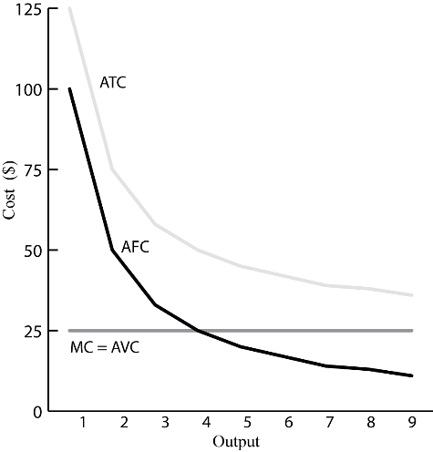
- a. See the table below.
Output | Fixed Cost | Variable Cost | Average Fixed Cost | Average Total Cost | Average Variable Cost | Marginal Cost
1 | 100 | 25 | 100 | 125 | 25 | 25
2 | 100 | 60 | 50 | 80 | 30 | 35
3 | 100 | 105 | 33 | 68 | 35 | 45
4 | 100 | 160 | 25 | 65 | 40 | 55
5 | 100 | 225 | 20 | 65 | 45 | 65
6 | 100 | 300 | 17 | 67 | 50 | 75
7 | 100 | 385 | 14 | 69 | 55 | 85
8 | 100 | 480 | 13 | 73 | 60 | 95
9 | 100 | 585 | 11 | 76 | 65 | 105

- See the accompanying graph.
- Marginal costs would have to decline at first and then rise for the curves to have their “normal” shapes.
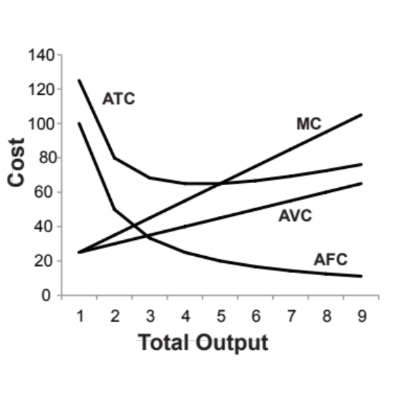

Questions from Alternative Perspectives
- Austrian
- Entrepreneurs generally develop broadly defined business plans, which include expected costs and expected market conditions, before entering a business. These costs and market conditions, however, are highly uncertain; the tables should be seen as simply an exercise. They do not reflect the uncertainty under which real-world decisions are made.
- Ultimately businesses must make decisions based upon highly imperfect knowledge, knowledge that they get by entering the business itself. Models do not show the uncertainty and risk of business, missing an important element of real-world markets.
- Governments have even less information than businesses in making decisions, and government does not gain information by running businesses. The implication is that government should be very hesitant to intervene in the market.
- Religious
- This is an empirical question and can only be answered by empirical evidence. Assuming no prosecution is possible, the standard model would suggest that firms would do so, although doing so would create negative publicity for them, which would limit the amount that they do.
- From most religious perspectives, they should not do this because it is unethical. They should do what is good for society.
- Feminist
- Probably not. There seems to be no objective reason for this. It is possible that women sell men’s underwear because men prefer to buy underwear from women and men sell refrigerators because women perceive men as knowing more about gadgets and therefore trust men (or at least firms believe this to be true). It is also possible that men tend to be given the higher paying jobs, and refrigerator sales come with commissions, because they are perceived as the primary “bread-winner”, whereas women’s income is perceived as supplemental.
- It is possible that because of traditional roles of women and men, women indeed know more about clothing, including underwear, and men know more about appliances, such as refrigerators.
- Institutionalist
To the extent that consumer preferences are shaped by firms, people are maximizing the welfare of the owners of businesses when they make consumption decisions. If consumers, however, perceive their preferences to be real, is there really any difference between maximizing their own welfare and the welfare of the firm?
- Radical
The just-in-time competitive strategy lowers overall costs, which is why Walmart uses it. To some degree, it shifts the fixed costs to Walmart’s suppliers, making them variable costs for Walmart. This allows Walmart to reduce production saving more variable cost than it otherwise would.

Issues to Ponder
- The terms long run and short run do not necessarily refer to specific periods of time independent of the production process. The long run, by definition, is a period in which the firm can vary the inputs as much as it wants; in the long run, all inputs are variable. The question is whether a firm ever really gets this degree of flexibility. It may be true that firms are always constrained with regard to what production decisions they can make, in which case this statement is probably true.
- This is true because the fixed cost will be spread over such a large quantity of output that the average fixed cost, the difference between average variable cost and average total cost, will approach zero.
- a. The marginal cost was zero initially and 35 cents if you were over the allotted minutes. See graph below.
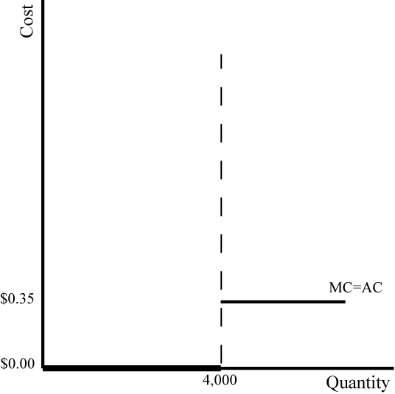
- Zero for minutes 1 to 350 and then rises until it approaches, but never reaches, 35 cents per minute.
- You wouldn’t. It is too difficult. You would guess at it. Companies were expecting that, which is why they offered such plans.
- They were relying on people’s gullibility and bringing them in as customers on the expectation of lower prices than they were getting, then relying on the difficult cost of changing phone companies to keep them customers.
- They were against the portability of phone numbers because portability reduces the cost of change, and thus discourages the practice of offering confusing plans.
- Bandwidth has expanded tremendously, driving the marginal cost of additional minutes to nearly zero.
- If neither factor is fixed, there is no diminishing marginal productivity. However, the quick order premium means that short-run marginal costs are 50% higher than long-run average costs. Assuming constant returns, then both the long run and short-run marginal cost curves are flat. Thus, once you have determined an initial production level, to change in the short run you must use the short-run marginal costs. The average total cost curve will initially be U-shaped, but then it will become asymptotic to the short run marginal cost curve.
- The shapes of the short-run average cost curve and marginal cost curve would be the same as in the more usual case where machines are the fixed factor. Either way you are still adding more and more of a variable factor to a fixed factor and encountering diminishing marginal productivity as a result. The marginal cost and average cost curves would be U-shaped.

