METU
Department of Economics
Econ 101: Introduction to Economics I
Section 01-02
Fall 2023
PROBLEM SET 4 (CH 5,6 and 7)
PART A: PROBLEMS
- Suppose the demand and supply functions of a good are given by $Q_{D}=920-8P$ and $Q_{S}=-120+2P$. For this market,
- Calculate the equilibrium price and quantity
Equilibrium price and quantity is found as follows:
$$Q_{D}=Q_{S}$$
$$920-8P=-120+2P$$
Q_{eqm}=88
P_{eqm}=104
- What is the effect of a price ceiling of P=80 placed on this market? Calculate the amount of excess demand if there occurs any.
When there is a price ceiling at P=80, then there occurs an excess demand.
$$Q_{D}=920-8P$$
$$Q_{S}=-120+2P$$
Set P=80
Q_{D}=280
Q_{S}=40
Excess Demand=280-40=240
- In case of excess demand, how are the buyers determined?
When there is excess demand for a commodity, how the buyers will be determined becomes a problem. Queuing might be a way in which individuals wait in line as a means of distributing commodities. Another way is the seller chooses the customers whom he/she favors. Another solution is ration coupons that entitle individuals to purchase a certain amount of the a given product. When there is an excess demand, it is also highly possible that there occurs a black market which is an illegal trading system

- Suppose that in the market that we have described, a black market takes place and all the output falls in the hands of the blackmarketers. What is the total profit in this black market?
When there is a black market, black marketers purchase all the product available in the market. from the price ceiling.
In our case for P=80, the amount that the suppliers offer is 40 this amount is sold at the price that the consumers are willing to buy.
$$40=920-8P$$
P=110 in our case.
Thus the total profit of the black market is:
$$π=110×40-80×40=1200$$
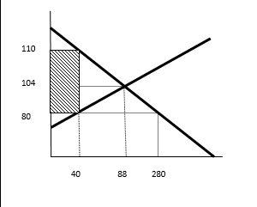

- Consider the market for gasoline. The demand and supply functions for gasoline is

P= 100-Q_{d}
P= Q_{S}/3

a) Calculate the equilibrium price and quantity. At this equilibrium, compute the consumer surplus, producer surplus, and total surplus.

At the equilibrium, we have equal quantities and prices, so it does not matter whether the supply and demand equations are expressed in terms of P or Q .
100-Q= Q/3

Q*= 75, P*=25

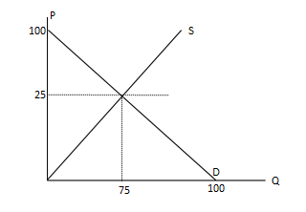
Consumer Surplus: $\frac{75x75}{2}=2812.5$

Producer Surplus: $\frac{25x75}{2}=937.5$

Total Surplus : 2812.5+937.5 = 3750

- Suppose now that the government is concerned because many gas stations are going out of business, so it decides to set a minimum price of p¯ = 30 to help them. What will be the new equilibrium price and quantity with this intervention? Compute the consumer surplus and producer surplus.
The price will be p = 30, and the quantity q = 70

Consumer Surplus: $\frac{70x70}{2}=2450$
Producer Surplus: $\frac{(70/3)x70}{2}+\left(30-\left(\frac{70}{3}\right)\right)*70=1283.3$
Total Surplus: 2450 + 1283.3 = 3733.3

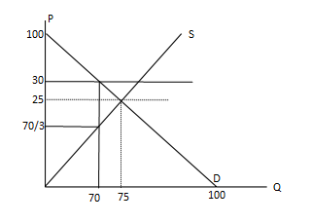
After the price floor policy, the total surplus is decreased.

- How is the total surplus affected? Briefly explain
When the government intervenes in the economy and imposes price ceiling/floors, this action creates deadweight loss. A deadweight loss (DWL) is a cost to society created by market inefficiency, which occurs when supply and demand are out of equilibrium.
The total surplus declineds by 3750-3733.3 = 16,7, which is equals to the value of the deadweight loss.
(You can compute the value of DWL by calculating the area of the shaded area.)

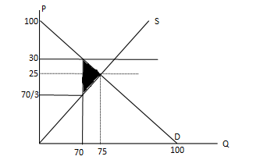

$$\frac{(30-\left(\frac{70}{3}\right))x5}{2}=\frac{50}{3}=16.7$$
3) The market demand and supply function for a commodity is given below:
Q_{D} = 120 – 4P
Q_{S} = -30 + 6P
- Find the equilibrium price and quantity.
120 – 4P = -30 + 6P P* = 15 Q* = 60
- What are the consumer and producer surpluses at the equilibrium price?
CS = ((30 – 15)* 60) /2 = 450
PS = ((15 – 5)* 60) / 2 = 300
Assume that government sets a ceiling price at 10 TL.,
- Will there be an excess supply or excess demand in the market?
At P = 10, Q_{D} = 80 Q_{S} = 30. Since quantity demanded exceeds quantity supplied, there is an excess demand by an amount of 50.
- What will be the quantity exchanged at this new price?
In this case, quantity supplied will be exchanged. So, it is 30.
- How can this quantity exchanged be allocated?
First come first served or sellers’ preferences or queuing or rationing coupons.

- Define the following cenceptss:
i) Price elasticity of demand: The percentage change in quantity demanded divided by the percentage change in price.
ii) Price elasticity of supply: The percentage change in quantity supplied divided by the percentage change in price.
iii) Income elasticity of demand: The percentage change in demand divided by the percentage change in income.
iv) Cross-price elasticity of demand: The percentage change in demand divided by the percentage change in the price of a related good.

- The following table shows the price and quantity of brownie in Gizem Cafe for a semester according to average income.

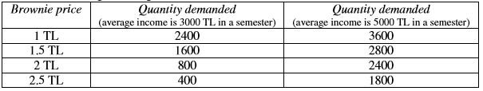

a) Calculate the price elasticity of demand (using the midpoint method) if the price of brownies rises from 1 TL to 1.5 TL, when average income is 3000 TL.
% Change in quantity demanded = (1600 – 2400) / ((1600 + 2400) / 2)*100% = – 40%
% Change in price = (1.5 – 1) / ((1.5 + 1) / 2)*100% = 40%
Price elasticity of demand = ε _{d,p}
= % Change in quantity demanded / % Change in price = – 1
b) Calculate the income elasticity of demand (using the midpoint method) if average income increases from 3000 TL to 5000 TL, when the price of a brownie is 1 TL.
% Change in quantity demanded = (3600 – 2400) / ((3600 + 2400) / 2)*100% = 40%
% Change in income = (5000 – 3000) / ((5000 + 3000) / 2)*100% = 50%
Income elasticity of demand = ε_{d,y}
= % Change in quantity demanded / % Change in income = 4/5 = 0.8

- The market demand and supply functions for a commodity are given as follows:
QD = 100 – 2P QS = – 20 + 4P
a) Find the equilibrium price and quantity.
100 – 2P = – 20+4P P* = 20 Q* = 60
b) Find the point elasticity of demand and supply at the equilibrium.
εD = $\frac{dQD }{dP}$ * $\frac{P }{Q}$= $-2*\frac{20 }{60}$ = –2/3
εS = $\frac{dQS }{dP}$ * $\frac{P }{Q}$= 4*20 / 60 = 4/3
c) Find the price and quantity where price elasticity of demand is unitary.
εD =$\frac{dQD }{dP}$ * $\frac{P }{Q}$ => –1 = –2* P / Q => 2P = QD & 2P+QD = 100
Thus, 4P = 100 => P = 25 & Q = 50

d) If an excise tax of 6 TL for each unit of good was imposed by the government to be collected from the suppliers.
i. What will be the new equilibrium price and quantity?
Qs’ = –20 + 4(P’-6) => Qs’ = –44 + 4P’ => P’* = 24 & Q’* = 52
ii. What will be the tax revenue of the government?
Tax Revenue = 52*6 = 312
iii. How much of this tax will be paid by the consumers and producers?
Tax paid by consumers = 4*52 = 208 Tax paid by producers = 2*52 = 104
İv) Who pays a larger part of the tax? Consumers or producers? Explain why.
A larger part of the tax is paid by consumers because the elasticity of demand in absolute value is less than the elasticity of supply.
- The following table provides information regarding price elasticities, income elasticities and cross-price elasticities of demand.
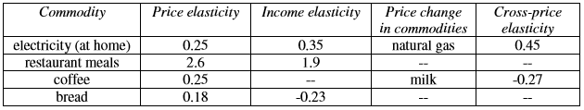

a) Which commodities are normal and which are inferior?
Electricity and restaurant meals are normal; bread is inferior.
b) Which commodities are complements and which are substitutes?
Natural gas and electricity are substitutes; milk and coffee are complements.
c) Which commodities have elastic and which have inelastic demands?
Restaurant meals have elastic demand; electricity, coffee and bread have inelastic demand.
d) What will happen to the total revenue of bread if its price increases?
When price of bread increases, total revenue also increases (due to inelastic demand).
e) What will happen to the quantity demanded of coffee if the price of milk increases by 1%?
Quantity demanded of coffee decreases by 0.27 % if the price of milk increases by 1%
- Suppose when the price of pizza is $4, the quantity demanded of pizza is 60 slices and the quantity demanded of cheese bread is 100 pieces. When the price of pizza is $2, the quantity demanded of pizza is 80 slices and the quantity demanded of cheese bread is 70 pieces.

- Calculate the price elasticity of demand for pizza. (Use midpoint formula)
$$ε=\frac{ΔQpizza}{ΔPpizza}× \frac{\frac{P_{pizza}^{1}+P_{pizza}^{2}}{2}}{\frac{Q_{pizza}^{1}+Q_{pizza}^{2}}{2}}=\frac{20}{-2}×\frac{3}{70}=-\frac{3}{7}$$
- Is the demand for pizza elastic, inelastic or unit elastic? (Use midpoint formula)
Absolute value of the price elasticity is less than 1, and therefore, the demand for pizza is price inelastic.
- Calculate the cross-price elasticity of cheese bread. (Use midpoint formula)
$$ε=\frac{ΔQ_{chees}}{ΔP_{pizza}}×\frac{\frac{P_{pizza}^{1}+P_{pizza}^{2}}{2}}{\frac{Q_{cheese}^{1}+Q_{cheese}^{2}}{2}}=\frac{-30}{-2}×\frac{3}{85}=\frac{9}{17}$$

d) Are these goods substitute or complements ?
Cross­price elasticity of cheese bread is positive; these goods are substitutes for each other.
- The market demand and supply equations for comic books are as follows:
Q = 70-3P and Q = - 30+2P (where P is in TL per unit)

- Find the equilibrium price and quantity.

In equilibrium: 70-3P = -30+2P
Q* = 10 and P* = 20 TL

- What is the equilibrium price and quantity due to a tax of 5 TL per t-shirt on producers?

Tax = 5 TL /unit 70-3P’* = - 30 + 2(P’* – 5) Q’* = 4 and P’* = 22 TL

- What is the elasticity of demand between the initial and after tax equilibria? Is total revenue at the after tax equilibrium higher or lower than at the before tax equilibrium?

Equilibrium before tax: Q* = 10 and P* = 20 TL; Equilibrium after tax: Q’* = 4 and P’* = 22
elasticity of demand = (4-10) / [(4+10) / 2] = -6/(2/3) = -9
(22-20) / [(22+20)/2]

Total Revenue decreases as price rises when demand is elastic.
(Revenue goes from 20*10=200 TL to 4*22=88 TL)

- How much of the tax do consumers pay? How much of the tax do producers pay?

Consumers paid initially a price of 20 TL and after the imposition of the tax they pay a price of 22 TL. Therefore, this effectively means that consumers are paying 2 TL of tax.
Producers received initially a price of 20 TL and now they receive a price of 22 TL minus the tax of 5 TL that they might remit to the government. Therefore, this effectively means that producers are paying 3 TL of tax.

- How would your answers to c) and d) change if the demand curve was vertical? What if horizontal?
Vertical Demand: elasticity of demand = 0 (perfectly inelastic demand curve). Consumers pay the entire tax.
Horizontal Demand: elasticity of demand = infinity (perfectly elastic demand curve). Consumers pay no tax.
The more inelastic the Demand is, the more the consumers pay the tax.

- How would your answers to c) and d) change if the supply curve was vertical? What if horizontal?

Vertical Supply: elasticity of supply = 0 (perfectly inelastic supply curve). Producers pay the entire tax.
Horizontal Supply: elasticity of supply = infinity (perfectly elastic supply curve). Producers pay no tax.
The more inelastic the Supply is, the more the producers pay the tax.

- Consider the hazelnut market. The demand for hazelnut per kg. is given by P = (55 – Q_{D}) / 3 and supply of hazelnut per kg. is given by P = (35 + Q_{S}) / 6.

a) Write the demand and supply equations in terms of price and calculate the equilibrium levels of price and supply.

Q_{D}= 55 – 3P , Q_{S}= – 35 + 6P, then 55 – 3P = – 35 + 6P, P* = 10 , Q* = 25

b) Suppose that the government implements a price support program with the price floor set at 12 TL. Calculate latter final equilibrium and specify the excess demand or supply.

Set P = 12 TL in demand and supply functions. Q_{D} = 19 Q_{S} = 37. Since quantity supplied exceeds quantity demanded, there exists an excess supply by an amount of 18.

c) Calculate the direct cost of the support program. Suppose further that there is a storage cost of 2 TL per kg. Find the total cost of the support program.

Since support program causes an excess supply, there is an amount of 18 that will not be consumed. Since price of good is 12 TL and its storage cost is 2 TL, total cost of one more unit is 14 TL. Therefore, total cost of program is 14*18 = 252 TL

d) Suppose that the government implements a price subsidy program instead of the price support program. The target of the government is holding quantity of supplied at 37. What is the cost of the subsidy program?

The target of the government is holding quantity of supplied at 37. Suppliers are willing to supply 37 units at price 12 TL; but consumers are willing to demand 37 units at price 6 TL. Then, the government pays 6 TL per unit to the producers directly. The cost of this price subsidy program to the government is 37* (12 – 6) = 222 TL.
P
Q
S
B
E
55/3
55
25
37
10
6
12
A

e) What is the impact of the price subsidy program on social welfare?

Since government’s intervention creates an overproduction,
it causes a deadweight loss. It can be shown by
a triangle of (AEB). It implies 36 TL decrease
in overall welfare of the society

PART B: MULTIPLE CHOICE
Answer the questions 1 to 4 accordig to graph below:
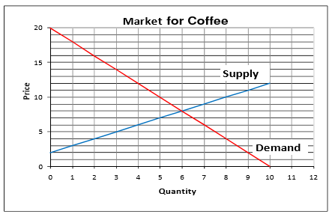
1. Using the graph for the Coffee Market above, at the market equilibrium, the consumers’ surplus is
a. $8 b. $18 c. $36 d. $54
2. Using the graph for the Coffee Market above, at the market equilibrium, producers’ surplus is
a. $8 b. $18 c. $36 d. $24
3. Suppose that government imposes price ceiling of $6. What is the most likely result?
a. The market would reach a new equilibrium at a price of $6
b. There would be no change in the price.
c. There would be excess supply in the market.
d. An underground, or black, market would emerge where this product would be sold at a price above $6.
4. Suppose that production is increased to 8 units. Total deadweight loss to the economy is
a. $12 b. $8 c. $6 d. $18
5. If income increases by 15 percent and the price does not change, the quantity of airplane travel demanded increases by 60 percent, then the income elasticity of demand of airplane travel is _________.
a) 0 b) Negative c) 4.00 d) 0.25
6. If a 10 percent change in the price of a good leads to a 5 percent change in the quantity supplied, then the supply of the good is _______________ and the elasticity of supply is _____________.
a) elastic; -2.0 b) inelastic; -0.5 c) elastic; 2.0 d) inelastic; 0.5
7. Tolga loves carrot cake. As the price of a carrot cake increases from 1 TL to 2 TL to 3 TL, Tolga continues to buy a dozen carrot cake every day. Tolga's demand for carrot cake is __________.
a) elastic b) perfectly inelastic
c) illustrated by a horizontal demand curve d) unit elastic
8. When demand is __________, a decrease in price _____________ total revenue.
a) unit elastic; increases b) elastic; decreases
c) elastic; increases d) inelastic; increases
9. A pizza shop observes that when it raises the price of the large pizza, total revenue from pizza decreases and when they lower the price of the large pizza, total revenue increases. This suggests that
a) the demand for large pizza must be elastic.
b) there are few good substitutes for large pizza.
c) the demand for large pizza must be inelastic.
d) the demand for large pizza is unitary elastic.
10. Along any straight-line demand curve,
a) the price elasticity and slope vary
b) the price elasticity varies, but the slope remains the same
c) the slope varies, but the price elasticity remains the same
d) the price elasticity and the slope remains the same
11. Webster Dictionaries and Oxford Dictionaries are almost perfect substitutes. The cross price elasticity of demand for Webster Dictionaries with respect to Oxford Dictionaries ________.
a) is 1 b) is almost infinity
c) depends on the complements for dictionaries d) is almost zero
12. If the demand for a good is price-elastic, that good is likely to have
a) many close complements b) few close complements
c) many close substitutes d) few close substitutes
13. The price elasticity of demand is equal to the ____________ in the _____________ divided by the ________________ in the ______________.
a) change; price; change; quantity demanded
b) percentage change; price; percentage change; quantity demanded
c) change; quantity demanded; change; price
d) percentage change; quantity demanded; percentage change; price
14. Because toothpaste and toothbrushes are complements, the ____________ elasticity of demand is ______________.
a) income; positive b) cross price; negative
c) cross; positive d) income; negative
15. Haircuts and taxi rides are normal goods, so their ____________________.
a) cross elasticity of demand is negative b) cross elasticity of demand is positive
c) income elasticities of demand are negative d) income elasticities of demand are positive
16. If tea and coffee are substitutes, the cross price elasticity of coffee with respect to the price of tea will be _________ and an increase in the price of tea will _________ the demand for coffee.
a) negative; decrease b) positive; increase
c) negative; increase d) positive; decrease
17. The price elasticity of demand for videos is -3. If the price of a video increased by 3 percent, the quantity demanded will ___________________.
a) decrease by 9 percent b) decrease by 0.9 percent
c) increase by 9 percent d) decrease by 0.9 percent
18. When a good has few close substitutes available, ______________.
a) proportional changes in quantity demanded tend to be greater than proportional changes in price.
b) price elasticity of demand is greater than one.
c) price tends to remain the same, regardless of quantity demanded.
d) change in price has no big effect on the quantity demanded
e) all of the above are true.
19. The government wants to increase the taxes on cigarettes to increase tax revenue. This tax policy would only be effective in raising new tax revenues if the price elasticity of demand is:
a) unity b) elastic c) inelastic d) perfectly elastic.

20. The figure shows the relationship between Angelina's income and the quantity of macaroni that she demands. When her income is less than $350 per month, macaroni ______________________.
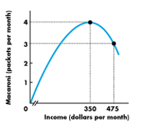
a) is a normal good b) has negative income elasticity
c) has many substitutes d) is an inferior good

21. Refer to the figure below. Demand is:
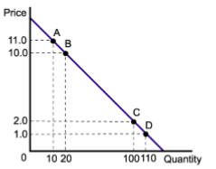
a) Unit elastic. The value of elasticity equals one between any two points throughout the entire range of the demand curve.
b) Elastic throughout the entire range of the demand curve.
c) Elastic between points A and B, and inelastic between points C and D.
d) Inelastic throughout the entire range of the demand curve.
22. Income levels rise by 10 percent, ceteris paribus, causing the quantity demanded for beers to go up by 4 percent. From this information, which one of the following is true?
a) beers are is an inferior goods. b) beer is a normal goods.
c) the income elasticity of demand for beers is 2.5. d) none of the above are true.

23. Two drivers-Tom and Jerry- each drive up a gas station. Before looking at the price, each places an order. Tom says, “I’d like 10 gallons of gas.” Jerry says, “I’d like $10 of gas.” Pick the correct answer from below:
a) Tom has higher price elasticity of demand than Jerry.
b) Tom has higher income elasticity of demand than Jerry.
c) Tom’s price elasticity of demand is zero.
d) Its hard to figure out from the information given.

