METU
Department of Economics
Econ 101: Introduction to Economics I
Section 01-02
Fall 2023
PROBLEM SET 7 (CH 13)
- What are the conditions for the perfect competitive market structure?
For a market to be called perfectly competitive, it must meet some stringent conditions. Some of them are: Both buyers and sellers are price takers. The number of firms is large. There are no barriers to entry. Firms’ products are identical. There is complete information. Selling firms are profit-maximizing entrepreneurial firms. These and other similar conditions are needed to ensure that economic forces operate instantaneously and are unimpeded by political and social forces.

- What is the major difference between the long run and the short run in a perfectly competitive market? Explain in terms of the number of firms and the flexibility of firms.
In the short run there is no entry or exit of firms in pure competition. The number of firms and plant size are fixed. Firms can either produce or shut down. If they shut down, they do not have time to liquidate their assets or go out of business. In the long run there can be entry and exit of firms into an industry. Firms that shut down in the short run because they are experiencing economic losses will eventually liquidate assets and go out of business if the losses persist over time. Existing firms in the long run can expand or contract their capacity to produce. In the long run, new firms can enter an industry and increase the industry output.
- A profit-maximizing business incurs an economic loss of $10,000 per year. Its fixed cost is $15,000 per year. Should it produce or shut down in the short run? Should it stay in the industry or exit in the long run? Suppose instead that this business has a fixed cost of $6,000 per year. Should it produce or shut down in the short run? Should it stay in the industry or exit in the long run?
In the short run, the business should produce. If it shuts down, the short-run annual loss will be $15,000, its fixed cost; but if it produces, the loss will be only $10,000. In the long run, the business should exit the industry because it is incurring a loss. In the short run, the business should shut down. If it shuts down, the short-run loss will be $6,000, its fixed cost; if it continues to produce, the loss will be $10,000. In the long run, the firm should exit the industry because it is incurring a loss.

4) A perfectly competitive firm has fixed costs of $30 and total costs as indicated in the table below.

Output | Total fixed cost | Total variable cost | Total cost | Average fixed cost | Average variable cost | Average total cost | Marginal cost
0 | 30 | 0 | 30 | - | - | - | -
1 | 30 | 9 | 39 | 30 | 9 | 39 | 9
2 | 30 | 17 | 47 | 15 | 8.5 | 23.5 | 8
3 | 30 | 24 | 54 | 10 | 8 | 18 | 7
4 | 30 | 30 | 60 | 7.5 | 7.5 | 15 | 6
5 | 30 | 37 | 67 | 6 | 7.4 | 13.4 | 7
6 | 30 | 45 | 75 | 5 | 7.5 | 12.5 | 8
7 | 30 | 54 | 84 | 4.29 | 7.71 | 12 | 9
8 | 30 | 65 | 95 | 3.75 | 8.125 | 11.875 | 11
9 | 30 | 78 | 108 | 3.33 | 8.67 | 12 | 13
10 | 30 | 93 | 123 | 3 | 9.3 | 12.3 | 15

a. Fill in the missing values in the table.

b. Graph the curves for total fixed cost, total variable cost, and total cost .
Fixed cost does not change with output. Total variable and total costs are always increasing with output, first at a decreasing rate and then at an increasing rate. This is the case because marginal costs are first decreasing and then increasing.

c. Graph the curves for AFC, AVC, ATC, and MC. Mark the two key points as discussed in class and also in the textbook. Explain why the MC curve intersects both the AVC and ATC curves at their minimums.

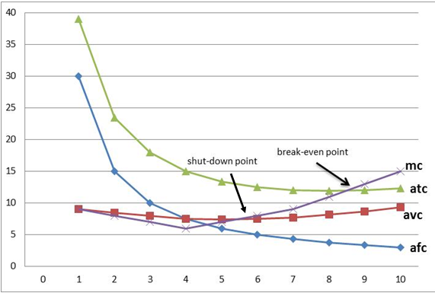

Note that average variable cost is decreasing when marginal cost is less than the average, and it is increasing when marginal cost is higher than the average. So, average variable cost is decreasing till AVC=MC, and it is increasing after AVC=MC.
d. What will happen to the AVC, ATC, and MC if the fixed cost increases by 40.
AVC and MC will not change, while the ATC will be higher for each output level

e. How much will the firm produce if the market price that it faces is $13.5. Will the firm
make profits or losses? How much?
If the market price is $13.5, the perfectly competitive firm will produce 9 units of output (P=MC) and make profits equal to the difference between the total revenue at this price ($121.5) and the total cost for the production of 9 units ($108), thus the profit will be equal to $13.5

f. Answer the questions in part (e) is the price was $8.5.
If the market price is $8.5, the perfectly competitive firm will produce 6 units of output (P=MC) and make losses equal to the difference between the total revenue at this price ($51) and the total cost for the production of 6 units ($75), thus the loss will be equal to $24. The firm will stay in business because it covers its variable costs ($45).

g. Answer the questions in part (e) is the price was $6.
If the market price is $6, the perfectly competitive firm will not produce any output because at this price the loss minimizing output will be 4 units (Loss=$36) and the firm cannot cover even its variable costs ($30).

PART B: MULTIPLE CHOICE QUESTIONS
Refer to Table 1 to answer questions 1 to 3. Table 1 shows the marginal cost, average variable cost, and average total cost of producing various quantities of a commodity by a firm in a perfectly competitive industry.
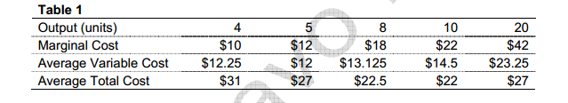
- Refer to Table 1 above. What are the Total Fixed Costs of the firms?
- $36
- $75
- $84
- $96
- None of the above

- Refer to Table 1 above. What are the economic profits of the firm when the firm is in equilibrium at a price of $18?
- -$25
- $36
- $39
- $45
- None of the above

- Refer to Table 1 above. What is the level of output at which the economic losses of the firm are equal to total fixed cost?
- 4
- 5
- 8
- 10
- None of the above

- Consider a perfectly competitive firm in the following position: Output=4000 units, Total Revenue=$4000, Total Fixed Costs=$2000, Total Variable Costs=$3000, and Marginal Cost=$1.10. In the short run, this firm should
- Shut down
- Expand output
- Increase the market price
- Reduce output
- Not change output

- The vertical distance between average total cost and average variable cost curves decreases as output increases because
- it is traditional to draw the curves that way
- it works out that way with the geometry since both curves must reach their minimums on the marginal cost curve
- average fixed cost decreases as output increases
- marginal product first rises and then falls
6. When a firm exits an industry
a. demand decreases and economic profits continue to decline
b. market supply does not change
c. market supply decreases, pushing market price higher
d. market supply decreases, decreasing the firm's output price

7. Refer to Fig.2, when will “firm entry” occur?
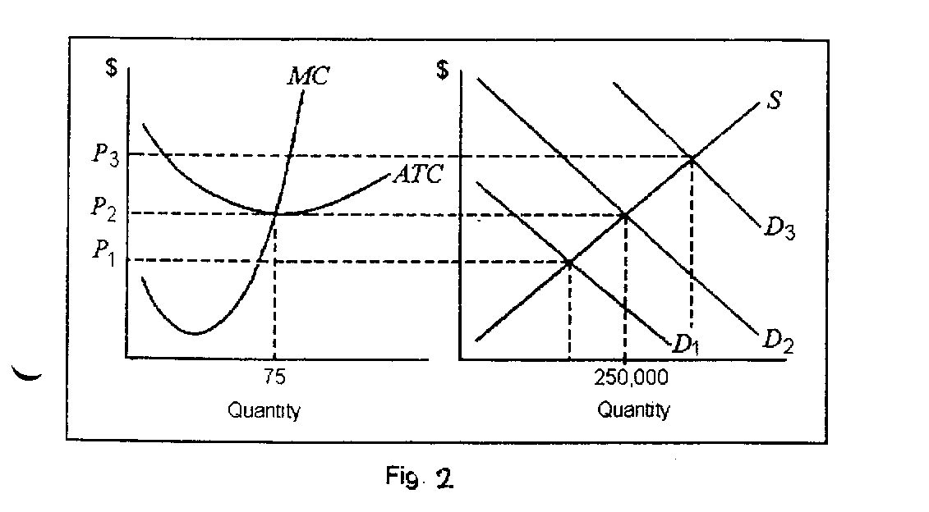
- when price is P₁ or greater
- when demand is at D₃
- when demand is at D₂
- when price is P₂ or less

8. In a perfectly competitive market
- each firm sets its own price.
- when one firm ceases production, the market equilibrium price tends to rise.
- there are a few firms selling unique products.
- None of the above. In a perfectly competitive market, firms sell homogenous products and take the market price as given.

9. The three primary characteristics of a perfectly competitive market are
- the firms' products are homogenous, the firms are price takers and there are barriers to entry into the market.
- the firms' products are unique, they are price takers and there are no barriers to entry in the market.
- the firms' products are homogenous, the firms are price takers and can freely enter and exit the market.
- the firms' products are unique, they set their own price and can freely enter and exit the market

10. The demand curve for a perfectly competitive firm
- slopes downward as the quantity demanded increases as the firm lowers price.
- is a horizontal, perfectly elastic demand curve at the market price.
- is a straight, downward sloping curve that is price elastic at higher prices and price inelastic as price falls and approaches zero.
- Both b and c

11. A firm may decide to shut down in the short run
- if profit maximization occurs at an output level where price is less than average variable cost.
- if profit maximization occurs at an output level where price is less than average total cost.
- if profit maximization occurs at an output level where price is equal to average total cost and the firm does not foresee changes to the market price in the future.
- profit maximization occurs at an output level where price is less than average total cost but greater than average variable cost.

12. The perfectly competitive firm's short run supply curve
- is the portion of the marginal cost curve that lies above the average total cost curve.
- the upward sloping portion of the marginal cost curve.
- the average variable cost curve above the minimum average variable cost.
- is the portion of the marginal cost curve that lies above the average variable cost curve.

13. If the total cost function for a perfectly competitive firm is TC=50+10q-q2+(1/3)q3 and the market price is $130
- the profit maximizing output level q is 12.
- the profit maximizing output level q is 20.
- the profit maximizing output level q is 10.
- there is not enough information given to determine the profit maximizing output level.

