METU Department of Economics Fall 2024-2025
ECON 202

Instructor: Pınar Derin Güre
T.A: Pınar Özpala

Discussion 9 Session 1 (Chapter 8)

PART A: TRUE/FALSE/UNCERTAIN (Explain it.)
a. Workers’ reluctance to take nominal pay cuts offers a feasible explanation of why the Phillips Curve relation breaks down when there is deflation.

TRUE. Workers are very likely to accept cuts in real wages that occur when their nominal wages increase more slowly than inflation. However, they are very likely to fight the same cut in real wages if it is done through cutting nominal wages while price level is decreasing more slowly. In these cases, the Phillips Curve relation between the change in inflation and unemployment may disappear when an economy is close to or below zero inflation.

PART B - ESSAY TYPE QUESTIONS.

- Suppose the Phillips curve is given by (all units are in percentage points):

π_{t}= π_{t}^{e}+10-2u_{t}; π_{t}^{e} =θπ_{t-1}

Assume that in period t-1, the unemployment rate is equal to the natural rate and the inflation rate is zero.

- What is the natural rate of unemployment in the economy?
- Suppose that beginning in period t, the authorities bring the unemployment rate down to 3% and keep it there indefinitely. Determine the rate of inflation in period t+1, t+2, t+3 when θ=0. Then do the same for θ=1
- For which of the two values of θ does u_{t}<u_{n} imply an acceleration of the price level?
- Suppose the authorities do not know what the natural rate of unemployment is. Can they find out what it is, how?
- Assume that 1/3 of the workers sign indexed labor contracts. Redo part (b) under this assumption.
- What if half of the workers sign indexed labor contracts? Compare your answers. What is the effect of wage indexation on the relation between π and u?

Solutions:

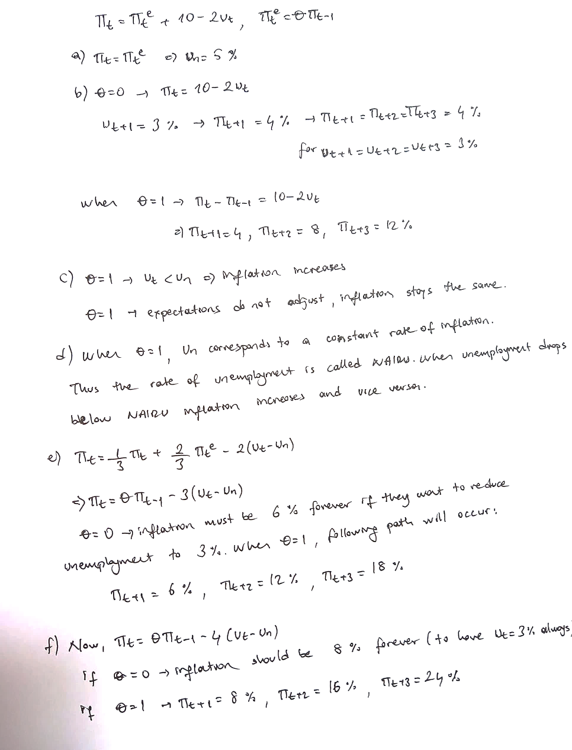

Q 2. Answer the following questions:

- Let’s say in Macronesia inflation rates are very close to 0 in the last 10 years. Using the Philips curve, come up with a convincing argument on why there would be a tradeoff between inflation and unemployment.

- Let’s say that inflation had been constantly high in Macronesia now, and people have adaptive expectations (they make their inflation expectations looking at the previous period inflation rate). If we would like to decrease inflation in this economy, what could be our concern? Explain by writing the modified Philips curve.

- Now let’s say that people don’t have adaptive expectations but have rational expectations (they look at the probable policy changes as well as other forecasts on macroeconomic conditions while making their inflation expectations). Would this country decrease its inflation without increasing unemployment? Show it by using the Philips Curve.

Solution:

a.
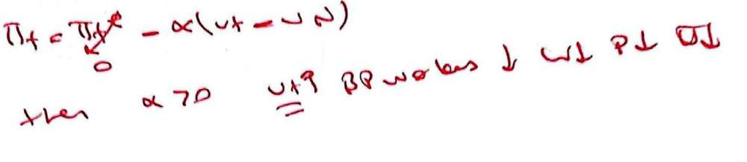
b.

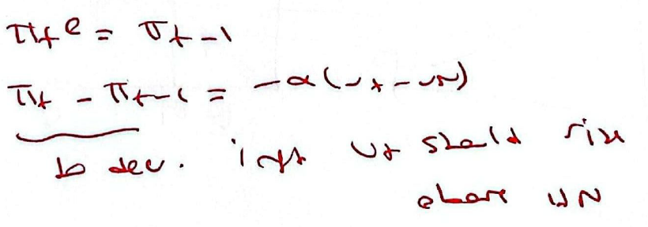
c.

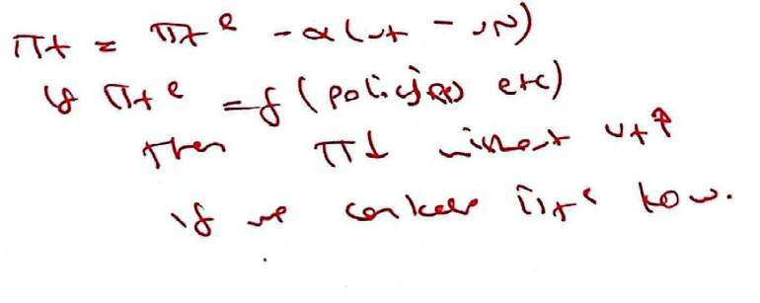
PART C: MULTIPLE CHOICE

- In the Phillips curve equation, which of the following will NOT cause a reduction in the current inflation rate?
A) an increase in the unemployment rate
B) a reduction in the expected inflation rate
C) an increase in the markup
D) all of the above
E) none of the above

- For this question, assume that the Phillips curve equation is represented by the following equation: π_{t} - π_{t-1} = (μ + z) - αu_{t}. Given this information, the natural rate of unemployment will be equal to:
A) (μ + z - α).
B) α(μ + z).
C) 0.
D) μ + z.
E) none of the above

- Suppose the Phillips curve is represented by the following equation: π_{t} - π_{t-1} = 20 - 2u_{t}. Given this information, we know that the natural rate of unemployment in this economy is:
A) 20%.
B) 5%.
C) 6.5%.
D) 10%.
E) none of the above

- Since approximately 1970, the most stable Phillips-type relationship for the United States has been between which of the following?
A) the rate of inflation and the change in the unemployment rate
B) the unemployment rate and the change in the rate of inflation
C) the change in the unemployment rate and the change in the rate of inflation
D) the inverse of the unemployment rate and the rate of inflation
E) the unemployment rate and the rate of inflation

- Use the following Phillips curve equation to answer this question: π_{t} - π_{t-1} = (m + z) - αu_{t}. Which of the following will cause an increase in the natural rate of unemployment?
A) a reduction in expected inflation
B) an increase in z
C) an increase in α
D) a reduction in m
E) none of the above

- What is the main contrast between short run and long run Phillips curve?
A) In the short run there is a positive relationship between inflation and unemployment, and in the long run the relationship is negative.
B) In the short run there is a positive relationship between inflation and unemployment, and in the long run the relationship is constant
C) In the short run these is a negative relationship between inflation and unemployment, and the long run the relationship is positive
D) In the short run there is a negative relationship between inflation and unemployment, and in the long run the relationship is constant.
E) In the short run there is a constant relationship between inflation and unemployment, and in the long run the relationship is negative.

- Assume that expected inflation is based on the following: π^{e}_{t} = θπ_{t-1}. If θ = 1, we know that
A) the Phillips curve illustrates the relationship between the level of inflation rate and the level of the unemployment rate.
B) a reduction in the unemployment rate will have no effect on inflation.
C) low rates of unemployment will cause steadily increasing rates of inflation.
D) the actual unemployment rate will not deviate from the natural rate of unemployment.

- Suppose the Phillips curve is represented by the following equation: π_{t} - π_{t-1} = 20 - 2u_{t}.. Given this information, we know that the natural rate of unemployment in this economy is
A) 10%.
B) 20%.
C) 5%.
D) 6.5%.
E) none of the above

