METU
Department of Economics
Econ 101: Introduction to Economics I
Section 01-02
Fall 2023
PROBLEM SET 9
- The figure below depicts a monopolistically competitive barber shop. Use the diagram to answer the following questions.
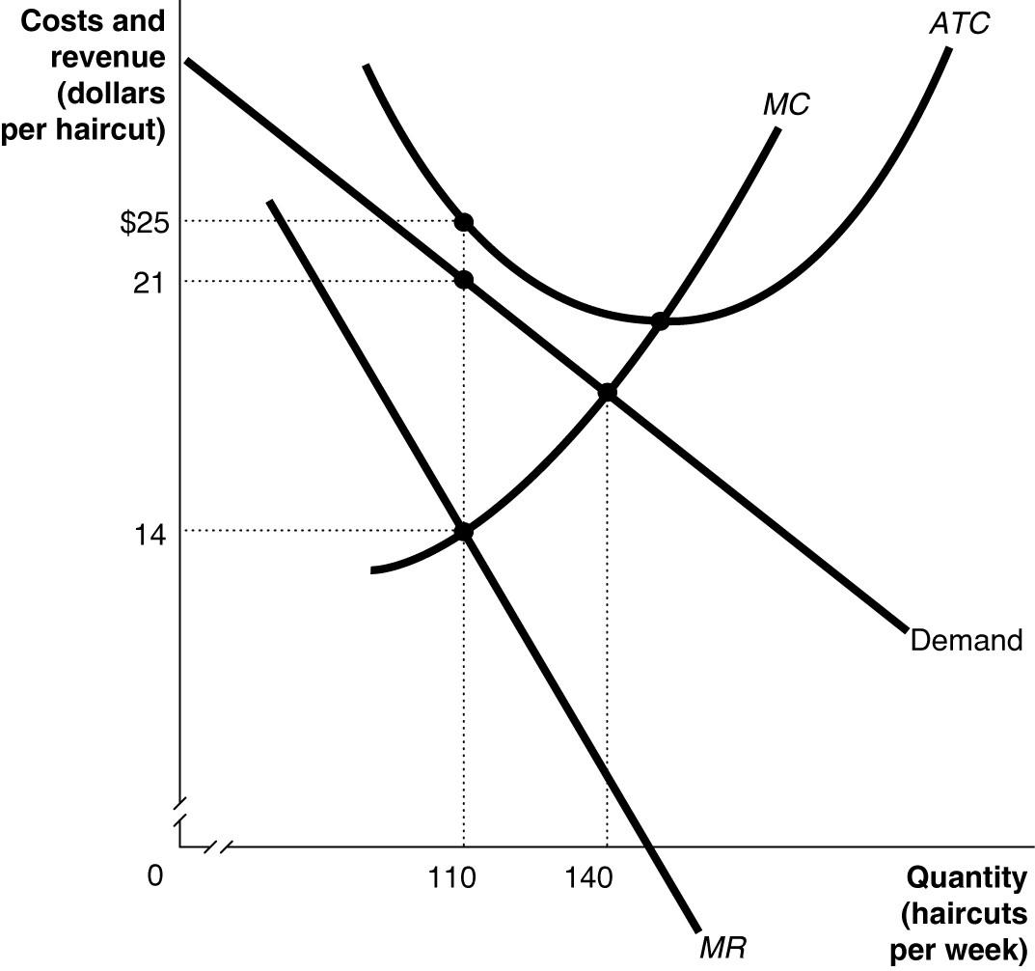
- Suppose the average variable cost of production is $15 when output equals 110 haircuts and $15.25 when output equals 140 haircuts. If the firm wants to maximize its profit or minimize its losses, how many haircuts will it produce and what price should it charge? Explain your answer.
Output = 110, Price = $21 whereby MR = MC. The barber shop will minimize its losses since P > AVC.
- Calculate the firm's profit or loss.
The economic loss = $440 (total revenue = $21 × 110 = $2,310; total cost = $25 × 110 = $2,750).
- What is likely to happen in this industry over time as it moves to its new long-run equilibrium?
Short-run losses will lead some firms to exit the market. As a result, the demand curve for a firm remaining in the market will shift to the right and become less elastic. Exit continues until economic losses are eliminated and each firm breaks even.
- Suppose the barber shop depicted in the diagram remains in the industry. Is this barber shop likely to produce this same quantity of haircuts as in part (a) in the long run?
No, its demand increases and becomes less elastic. It will produce a larger quantity.

- Assume firm A is in a perfectly competitive market and firm B has monopolistic (imperfect) competitors. Both firms are at the long-run equilibrium levels. Draw a diagram for firm A with MC, ATC, MR, AR, and Demand curves on it. Put the price on the vertical axis and the quantity on the horizontal axis. Draw firm B's diagram next to it for the same curves. Show the equilibrium price (P*) and quantities (Q*).
Which firm you would expect to make a higher profit? Show your answer using your graphs.
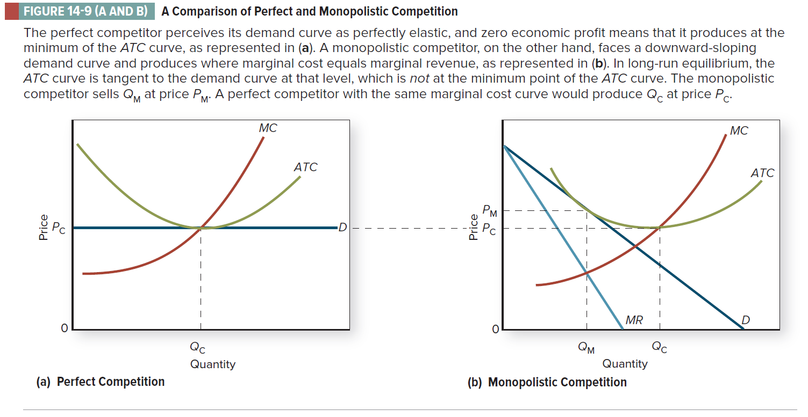

(Colander, D. (2020), “Microeconomics”, 11e, Page.312)

- If monopolistically competitive firms have some control over their prices, why don’t they set price above average total cost so they will realize an economic profit in the long run?

Entry is relatively easy in monopolistic competition. If a representative firm is earning economic profits in the short run, this condition will not persist as new firms enter the industry with the expectation of earning economic profits. As new firms enter, the demand curve faced by the typical firm will fall and become more elastic which tends to cause the disappearance of economic profits. Economic profits might persist in a few cases where product differentiation is very strong, or because some firm has some sort of permanent advantage such as location or especially effective advertising.

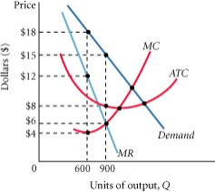
- The following diagram shows the structure of cost and demand facing a monopolistically competitive firm in the short run

- Identify the following on the graph and calculate each one. Profit- maximizing output level
Profit – maximizing price:
Total revenue:
Total cost:
Total profit:
- What is likely to happen in this industry in the long run?

i. Profit- maximizing output level: at 𝑀𝑅 = 𝑀𝐶 ⇒ 900
Profit – maximizing price: $15
Total revenue: 15 ∗ 900 = $13500
Total cost: 8 ∗ 900 = $7200
Total profit: 13500 − 7200 = $6300

ii.
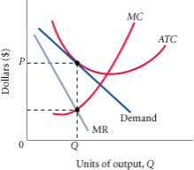
When monopolistically competitive firms make positive profits, new firms enter in search of profits, the demand curve for existing profit-making firms begin to shift to the left, pushing marginal revenue with them as consumers switch to the new close substitutes. This process continues until profits are eliminated, which occurs for a firm when its demand curve is just tangent to its average total cost curve.
- Consider the following version of the prisoner’s dilemma game (Player one’s payoffs are in bold):
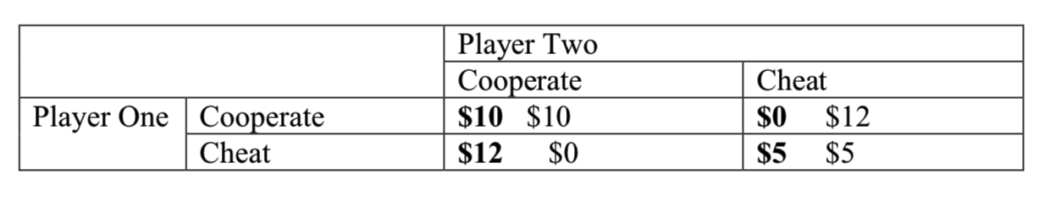

- What is each player’s dominant strategy? Explain the Nash equilibrium of the game.
Start with player one: If player two chooses cooperate, player one should choose cheat ($12 versus $10). If player two chooses cheat, player one should also cheat ($0 versus $5). Therefore, the optimal strategy is to always cheat (for both players) this means that (cheat, cheat) is the only Nash equilibrium.
- Suppose that this game were played three times in a row. Is it possible for the cooperative equilibrium to occur? Explain.
If this game is played multiple times, then we start at the end (the third playing of the game). At the last stage, this is like a one shot game (there is no future). Therefore, on the last day, the dominant strategy is for both players to cheat. However, if both parties know that the other will cheat on day three, then there is no reason to cooperate on day 2. However, if both cheat on day two, then there is no incentive to cooperate on day one.
- Consider the following game. Two criminals are thinking about pulling off a bank robbery.
The take from the bank would be $20,000 each , but the job requires two people (one to rob
the bank and one to drive the getaway car. Each criminal could instead rob a liquor store. The
take from robing a liquor store is only $1000 but can be done with one person acting alone.
Write down the payoff matrix for this game and find Nash equilibria.
 | Bank | Liquor
Bank | 20,000 ; 20,000 | 0 ; 1000
Liquor | 1000; 0 | 1000; 1000

Notice that there are two Nash Equilibria , (Bank, Bank) and (Liquor, Liquor)

7) Consider the curve shown in the figure below, which shows the market demand, marginal cost, and marginal revenue curve for firms in an oligopolistic industry. In this example, we assume firms have zero fixed costs.

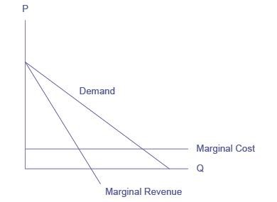
- Suppose the firms collude to form a cartel. What price will the cartel charge? What quantity will the cartel supply? How much profit will the cartel earn?
If the firms form a cartel, they will act like a monopoly, choosing the quantity of output where MR = MC. Drawing a line from the monopoly quantity up to the demand curve shows the monopoly price. Assuming that fixed costs are zero, and with an understanding of cost and profit, we can infer that when the marginal cost curve is horizontal, average cost is the same as marginal cost. Thus, the cartel will earn positive economic profits equal to the area of the rectangle, with a base equal to the monopoly quantity and a height equal to the difference between price (on the demand above the monopoly quantity) and average cost, as shown in the following figure.
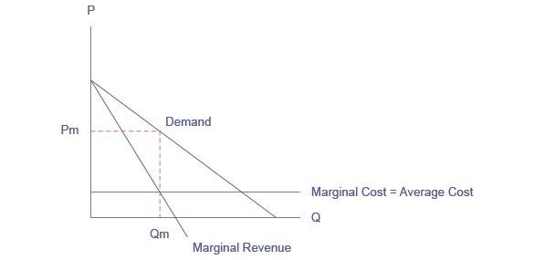
- Suppose now that the cartel breaks up and the oligopolistic firms compete as vigorously as possible by cutting the price and increasing sales. What will the industry quantity and price be? What will the collective profits be of all firms in the industry?

The firms will expand output and cut price as long as there are profits remaining. The long-run equilibrium will occur at the point where average cost equals demand. As a result, the oligopoly will earn zero economic profits due to “cutthroat competition,” as shown in the next figure.
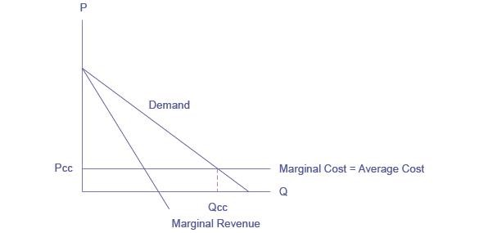
- Compare the equilibrium price, quantity, and profit for the cartel and cutthroat competition outcomes.
P_{c} > P_{cc}. Q_{c} < Q_{cc}. Profit for the cartel is positive and large. Profit for cournot competition is zero

8) Describe the essential features of the kinked-demand model of oligopoly pricing.
In the kinked-demand model, there is no collusion. The demand curve for the oligopolist is “kinked” because when the firm lowers its price, its rivals will lower their prices, and its demand often will be inelastic. When the firm increases its price, its rivals will not follow with price increases and its demand will be elastic. The firm, therefore, hesitates to change its price for fear of decreasing its profits. Two shortcomings of the kinked-demand model are that it does not explain how the going price gets set and prices are not as inflexible as implied by the model
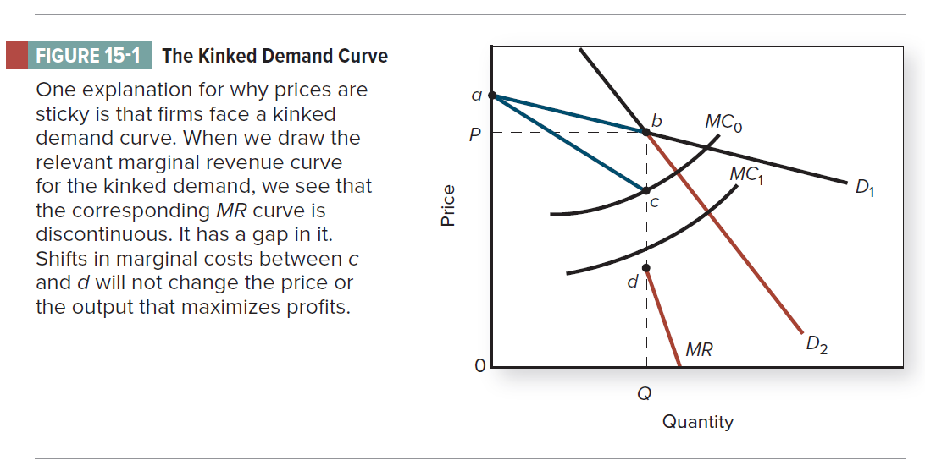

PART B: MULTIPLE CHOICE
1. In the long – run the firm in monopolistic competition will
a. Produce more than the quantity that minimizes ATC
b. Produces less than the quantity that minimizes ATC
c. Produce the quantity that minimizes ATC
d. Earn economic profits

2. Product differentiation may be present in:
a. Purely competitive markets b. Monopolistically competitive markets
c. Oligopolistic markets d. Both (b) and (c)

3. What are the characteristics of monopolistic competition?
a. Few firms, homogeneous product, and barriers to entry.
b. Few firms, differentiated product, and no barriers to entry.
c. Many firms, differentiated product, and no barriers to entry.
d. Many firms, homogeneous product, and barriers to entry.

4. Which of the following statements concerning a monopolistically competitive industry is correct?
a. If there are short-run losses, firms will leave the industry and the demand curves of the remaining firms will shift to the right.
b. If there are short-run economic profits, firms will enter the industry and the demand curves of the existing firms will shift to the right
c. If there are short-run losses, firms will leave the industry and the demand curves of the remaining firms will shift to the left.
d. If there are short-run economic profits, firms will leave the industry and the demand curves of the existing firms will shift to the right
5. Which of the following is true for perfect competition, monopolistic competition and single-price monopoly?
a. Homogenous product
b. Zero long-run economic profits
c. Short-run profit maximizing quantity where MC=MR
d. None of the above
6. Oligopolistic firms:
- may seek to drive competitors out of business for personal reasons, even at great expense.
- would not drive competitors out of business to gain control of the market.
- know that their competitors pay no attention to their pricing decisions and therefore hope to gain market share by lowering price.
- do not pay attention to a competitor's prices because there's nothing they can do about them.
7. Which one of the followings cannot be a reason for the oligopolistic structure of an industry?
a. Existing firms have too much production capacity so that they exhausted all economies of scale in this industry.
b. Existing firms protect most of the necessary knowledge to exist in this industry through patents.
c. Existing firms have agreements with a supplier that provides the most critical scarce input for the industry.
d. Existing firms make too much advertisement to keep their market share.

8. In the short run, a monopolistically competitive firm chooses
a. its quantity but not its price.
b. neither its price nor its quantity.
c. its price but not its quantity.
d. both its price and its quantity.

9. One difference between perfect competition and monopolistic competition is that
a. a perfectly competitive industry has fewer firms.
b. monopolistic competition has barriers to entry.
c. firms in monopolistic competition face a downward-sloping demand curve.
d. in perfect competition, firms produce slightly differentiated products.

Refer to the following figure for questions 10-11:

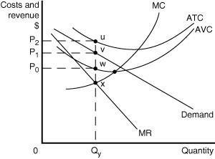
10. Which of the following statements describes the best course of action for the firm depicted in the diagram?

a. The firm should exit the industry because its price is less than its average total cost.
b. The firm should minimize its losses by producing Qy units and charging a price of P₀.
c. The firm should minimize its losses by producing Qy units and charging a price of P₂.
d. The firm should minimize its losses by producing Qy units and charging a price of P₁.

11. Which of the following is the area that represents the profit or loss experienced by the firm?

a. a loss represented by the rectangle P₂uvP₁
b. a loss represented by the rectangle P₂uwP₀
c. a loss represented by the rectangle P₁vwP₀
d. an accounting profit equal to P₁vwP₀

12. Suppose a monopolistically competitive firm's output where marginal revenue equals marginal cost is 66 units and the price corresponding to this quantity is $18. If the average total cost at this output is $16.55, then its total profit is
a. | $1,188.
b. | $1,092.30.
c. | $95.70.
d. | $1.45.
13. Monopolistic competition resembles pure competition because:
- both industries emphasize non-price competition.
- in both instances firms will operate at the minimum point on their long-run average cost curves.
- both industries entail the production of differentiated products.
- barriers to entry are either weak or nonexistent.

14. A conclusion that monopolistic competition will be characterized by excess capacity
- means that the firm produces less than the profit-maximizing level of output
- means that the firm produces more than the profit-maximizing level of output
- means that the firm does not operate its plant at the minimum point of the long-run average cost curve
- means that there are too many firms in the industry

15. Monopolistic competition results in
- Allocative efficiency
- Production efficiency
- Some production inefficiency
- Marginal cost pricing

16. A difference between monopoly and monopolistic competition is
- In monopolistic competition firms have brand loyalty but must still compete with firms that sell close substitutes; a monopoly has the market to itself
- A monopoly faces a downward – sloping demand curve, but a monopolistically competitive firm does not
- A monopoly has some control over price, and a monopolistically competitive firm does not
- All of the answers are correct.
17. A monopolistically competitive firm in long – run equilibrium

- Charges a price equal to the minimum average total cost
- Produces an output level at which price equals marginal cost
- Charges a price equal to average total cost
- Charges a price above average total cost

18. The study of how people make decisions in situations where attaining their goals depends on their interactions with others is called
a. Nash equilibrium.
b. the prisoner's dilemma.
c. game theory.
d. dominant strategy equilibrium.

19. The prisoner's dilemma illustrates
a. how oligopolists engage in implicit collusion under strategic situations.
b. why firms will not cooperate if they behave strategically.
c. why firms have an incentive to cheat on agreements.
d. how cooperation in strategic situations lead to the economically efficient market outcome.

20. Which of the following is not a characteristic of oligopoly?
a. the ability to influence price
b. a small number of firms
c. low barriers to entry
d. interdependent firms

