METU
Department of Economics
Econ 101: Introduction to Economics I
Section 01-02
Fall 2024
PROBLEM SET 3 (CHs 4 and 5)
PART A: PROBLEMS
- Demonstrate graphically and explain the difference between a decrease in the quantity supplied and a decrease in supply. Describe what might have caused each to occur.

A decrease in the quantity supplied refers to moving downward along a supply curve as illustrated by the movement from point B to point A in the diagram below. This movement is caused by a decrease in the price of the item being supplied.

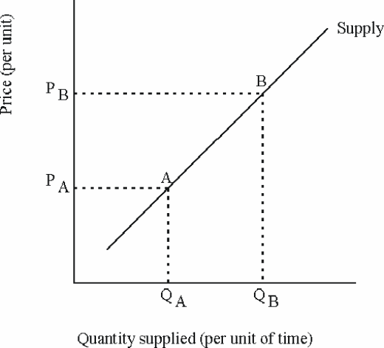

A decrease in supply refers to a leftward shift of the entire supply curve (from S₀ to S₁) as illustrated by the movement from point A to point B at price P₀ in the diagram below. This movement is the result of a change in one of the shift factors. For example, a tax on the sale of a good levied on sellers will cause the supply curve to shift leftward.
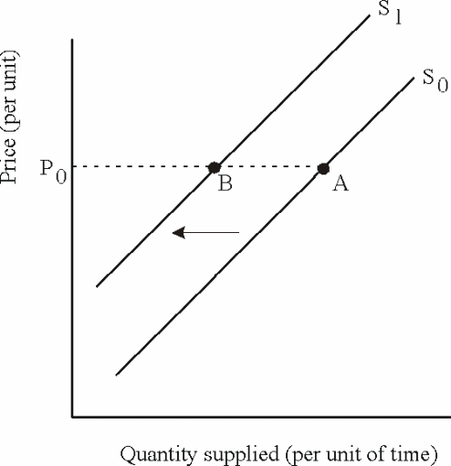

- Define the following terms briefly and give an example for each
    - Equilibrium: A concept in which opposing dynamic forces (such as supply and demand) cancel each other out. (Example: Equilibrium price is the price toward which the invisible hand drives the market.)
    - Excess Supply: A surplus, quantity supplied is greater than quantity demanded. (Example: Number of questions of this PS is more than students demanded.)
    - Excess Demand: A shortage, quantity demanded is greater than quantity supplied. (Example: Number of people willing to stay at METU dorms are more than the dorm rooms available.)
    - Market Demand Curve: The market demand curve is the horizontal summation of all individual demand curves
    - Market Supply Curve: The market supply curve is the horizontal summation of all individual supply curves
- Suppose that Ezginin Günlüğü will give a concert to the METU Students in METU Stadium in the forthcoming days. METU has approximately 25000 students. The percentage distribution of all METU Students in terms of the demand for the concert ticket is as follows:
• 30 % of the students are willing to pay 20 TL or more
• 50 % of the students are willing to pay 15 TL
• 75 % of the students are willing to pay 10 TL
• 90 % of the students are willing to pay 5 TL
• 100 % of the students are willing to pay 1 TL

- Derive the demand schedule.
We need to calculate the quantities demanded that corresponds to the prices are:
0.3*25000=7500,
0.5*25000=12500,
0.75*25000=18750,
0.9*25000=22500,
25000
So, the demand schedule is

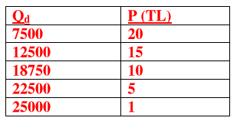

- Carefully draw the demand curve
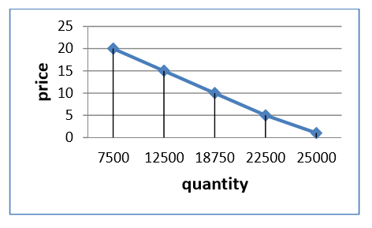

- Explain the meaning of the market demand curve by using the information given in this question.
Market demand curve is the horizontal summation of individual demand curves. In our question it is derived by summing the demand preferences of 25.000 students according to the prices. If there would be new students in the concert market, or some students disappear, the market demand curve might change.

- Consider the supply and demand schedules below to answer the questions that follow:

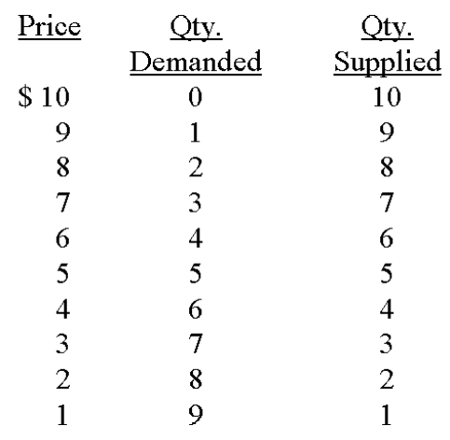

a) In a free market, what will the equilibrium price be?

(b) What will the equilibrium quantity demanded and quantity supplied be?

(c) If price were $2, what would happen? (Discuss in terms of adjustment to equilibrium.)

(d) If price were $7, what would happen? (Discuss in terms of adjustment to equilibrium.)

(e) If price were $5, what would happen? (Discuss in terms of adjustment to equilibrium.)

Answer:
(a) $5.00, where quantity demanded equals quantity supplied.
(b) 5 of each.
(c) At a price of $2, below equilibrium, quantity demanded would exceed quantity supplied. There would be a shortage and suppliers would raise their prices to eliminate the shortage. The price would rise until quantity supplied equaled quantity demanded at $5.
(d) At a price of $7, above equilibrium, quantity supplied would exceed quantity demanded. There would be a surplus and suppliers would lower their prices to eliminate the surplus. The price would decline until quantity supplied equaled quantity demanded at $5.
(e) At a price of $5, quantity supplied equals quantity demanded. Price would not change since quantity supplied equals quantity demanded at $5.

- The demand function for white sugar: $Q_{D}$ = 130 - 20P
The supply function for white sugar: $Q_{S}$ = 10 + 40P
where $Q_{D}$ is tons of white sugar that consumers would like to buy each year; $Q_{S}$ is tons of white sugar that the producers would like to sell each year and P is price per ton of sugar.
- Calculate the equilibrium price and quantity in the market.

At equilibrium $Q_{D}$ = $Q_{S}$

130 – 20P = 10 + 40P P* = 2 Q* = 90

- After a famous researcher warns that brown sugar is better for health since white sugar causes diabetes, which of the following demand functions might be representing the new demand curve for white sugar?
(i) $Q_{D}$ = 150 – 20P (ii) $Q_{D}$= 100 – 20P

This warning will cause a decrease in quantity demanded at all price levels, so that demand will decrease. At the original demand function when P=0, quantity demanded is 130. Put P=0 in functions (1) and (2);
(1) $Q_{D}$ = 150 – 20P, $Q_{D1}$ =150 (2) $Q_{D}$ = 100 – 20P, $Q_{D2}$ =100
Since 100 < 130, the new demand function will be function (2).

- Find the new equilibrium price and quantity after the shift of the demand curve.

At equilibrium $Q_{D}$ = $Q_{S}$
100 – 20P = 10 + 40P P* = 1.5 Q* = 70

- Starting with the demand and supply functions given at the beginning of this question, if the cost of fertilizer used in white sugar production decreases, which of the following might be the new supply curve?
(i) $Q_{S}$= 25 + 40P (ii) $Q_{S}$ = 5 + 40P

If the cost of fertilizer decreases, supply of white sugar increases. At each price level more tons of white sugar will be supplied. At the original supply function when P=0, quantity supplied is 10. Put P=0 in functions (3) and (4);
(3) $Q_{S}$= 25 + 40P, $Q_{S3}$=25 (4) $Q_{S}$ = 5 + 40P, $Q_{S4}$ = 5
Since 25 > 10, the new supply function will be function (3).

- Find the new equilibrium price and quantity after the shift of the supply curve.

At equilibrium $Q_{D}$ = $Q_{S}$
With the original demand curve, equilibrium is
130 – 20P = 25 + 40P P* = 1.75 Q* = 95

With the new demand curve, equilibrium is
100-20P=25+40P
60P=75
P= 1.25

- For each of the following, draw a diagram that illustrates the likely effect on the market for cupcakes. Indicate the impact on equilibrium price and equilibrium quantity in each case.

a) A surgeon general warns that cupcake is a high-cholesterol food and they cause heart attacks.
b) The price of coffee, a complementary product, decreases.
c) An increase in the price of sugar used in the production of cupcakes.
d) A technological improvement, invention of electric mixer, occurred in cupcake production.
e) The price of devil’s food cake, a substitute product, increases and the number of stores producing cupcake decreases.
f) Income of a person who likes consuming cupcake, a normal good, decreases and cacao harvesters go on strike due to poor working conditions.

- Demand for cupcakes decreases. It leads both equilibrium price and quantity to decrease.
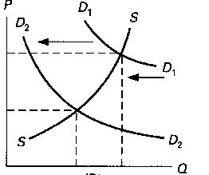

- Demand for cupcakes increases. It causes both equilibrium price and quantity to increase.
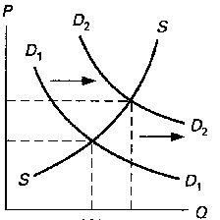
- Supply of cupcakes decreases. It results in equilibrium price increase whereas equilibrium quantity decreases.
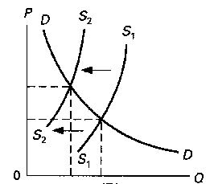
- Supply of cupcakes increases. It leads to a decrease in equilibrium price and increase in equilibrium quantity.
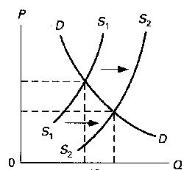
- Demand for cupcakes increases and supply of cupcakes decreases. It is certain that equilibrium price increases but how does equilibrium quantity change is ambiguous.

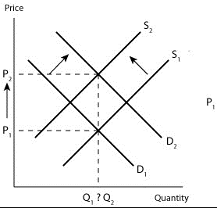

- Demand for cupcakes decreases and supply of cupcakes decreases. It is clear that equilibrium quantity decreases but their impact on equilibrium price is ambiguous.

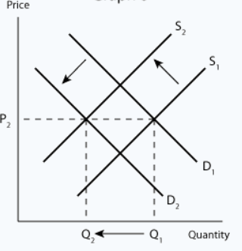

- Suppose the pizza industry is made up of three firms: The Mark Company, Mike, Inc., and Bill Enterprises. Use the information in the following table to construct the market supply curve for pizzas.
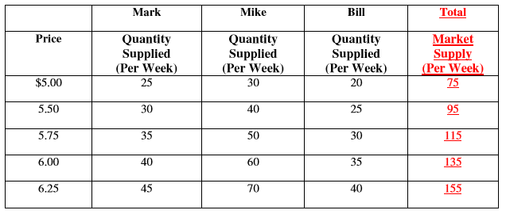

Market supply curve can be reached by horizantal summation of quantity supplied of all of the firms at each price level
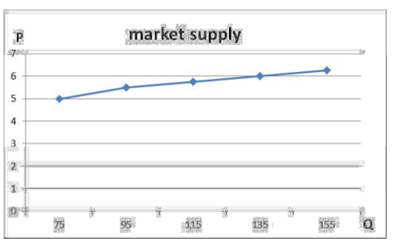

- Suppose the demand and supply functions of a good are given by $Q_{D}=920-8P$ and $Q_{S}=-120+2P$. For this market,
- Calculate the equilibrium price and quantity
Equilibrium price and quantity is found as follows:
$$Q_{D}=Q_{S}$$
$$920-8P=-120+2P$$
Q_{eqm}=88
P_{eqm}=104
- What is the effect of a price ceiling of P=80 placed on this market? Calculate the amount of excess demand if there occurs any.
When there is a price ceiling at P=80, then there occurs an excess demand.
$$Q_{D}=920-8P$$
$$Q_{S}=-120+2P$$
Set P=80
Q_{D}=280
Q_{S}=40
Excess Demand=280-40=240
- In case of excess demand, how are the buyers determined?
When there is excess demand for a commodity, how the buyers will be determined becomes a problem. Queuing might be a way in which individuals wait in line as a means of distributing commodities. Another way is the seller chooses the customers whom he/she favors. Another solution is ration coupons that entitle individuals to purchase a certain amount of the a given product. When there is an excess demand, it is also highly possible that there occurs a black market which is an illegal trading system

- Suppose that in the market that we have described, a black market takes place and all the output falls in the hands of the blackmarketers. What is the total profit in this black market?
When there is a black market, black marketers purchase all the product available in the market. from the price ceiling.
In our case for P=80, the amount that the suppliers offer is 40 this amount is sold at the price that the consumers are willing to buy.
$$40=920-8P$$
P=110 in our case.
Thus the total profit of the black market is:
$$π=110×40-80×40=1200$$

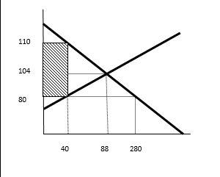

PART B: MULTIPLE CHOICES

- When an economist says that the demand for a product has increased, this means that:
A) quantity demanded is greater at each possible price
B) firms make less of the product available for sale
C) consumers respond to a lower price by buying more
D) the demand curve becomes steeper

- If consumer incomes increase, the demand for product Y which is an inferior good:
A) will necessarily remain unchanged
B) will shift to the right
C) will shift to the left
D) will move along the curve
- When drawing demand and supply curves, economists are assuming that the primary influence on production and purchasing decisions is:
A) price
B) the cost of production
C) the overall state of the economy
D) consumer incomes

- A decrease in the price of a product will increase the amount of quantity demanded because:
A) supply curves are upward-sloping
B) the lower price will decrease real incomes
C) the lower price induces consumers to use this product instead of other products
D) firms produce more at lower prices

- "Because of unusually good growing conditions, the supply of strawberries has substantially increased." This statement indicates that:
A) the demand for strawberries will necessarily rise
B) the equilibrium quantity of strawberries will fall
C) the amount of strawberries that will be available at various prices has increased
D) the price of strawberries will rise

- An improvement in production technology for a specific good will cause a(n):
A) increase in demand and an increase in price
B) increase in demand and a drop in price
C) increase in supply and drop in prices
D) increase in supply and an increase in price

- The following data show the supply and demand schedule for a competitively produced good.
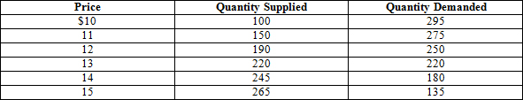
Refer to the above data. The quantity exchanged in this market will be:
A) 190
B) 220
C) 245
D) 250

- Suppose an economist says that ''Ceteris paribus, the lower the price of Wheaties, the larger the amount of Wheaties purchased.'' This statement indicates that
A) the quantity of Wheaties purchased determines the price of Wheaties
B) all factors other than the price of Wheaties (for example, consumer tastes and Incomes) are assumed to be constant
C) economists can conduct controlled laboratory experiments
D) one cannot generalize about the relationship between the price of Wheaties and the quantity purchased

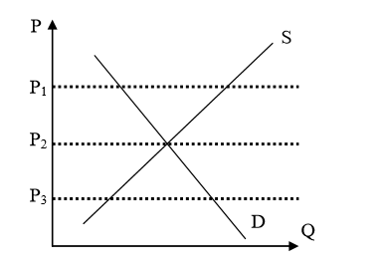
- A price at which there would be a surplus of this product is
A) P1 B) P2 C) both P2 and P3 D) P3

- The price at which there would be a shortage of this good is
A) P1 B) P2 C) both P2 and P3 D) P3

- If supply were to increase, we would predict
A) an increase in both P and Q B) a decrease in both P and Q
C) an increase in P and a decrease in Q D) a decrease in P and an increase in Q

- If demand were to increase, we would predict
A) An increase in both P and Q B) a decrease in both P and Q
C) an increase in P and a decrease in Q D) a decrease in P and an increase in Q

- What might cause a supply function to shift to the left?
A) A decrease in prices of required inputs
B) A decrease in price of a substitute good
C) Technical progress in the production of that good
D) An increase in the price of a required input

- The phrase "demand has decreased" means that
A) A demand curve has shifted to the left.
B) There has been an upward movement along a demand curve.
C) There has been a downward movement along a demand curve.
D) A demand curve has shifted to the right.

- If the price of gasoline decreases, what will be the impact on the market for public transportation?
A) The demand curve for public transportation shifts to the right.
B) The quantity of public transportation demanded increases.
C) The demand curve for public transportation shifts to the left.
D) The quantity of public transportation demanded decreases.

- If, in the market for oranges, the supply has increased then
A) The supply curve for oranges has shifted to the right.
B) The supply curve for oranges has shifted to the left.
C) There has been a movement upwards along the supply curve for oranges.
D) There has been a movement downwards along the supply curve for oranges.

- One would speak of a change in the quantity of a good supplied, rather than a change in supply, if
A) Supplier expectations about future prices change.
B) The price of the good changes.
C) The cost of producing the good changes.
D) Prices of substitutes in production change.

- In October 2005, the U.S. Fish and Wildlife Service banned the importation of beluga caviar, the most famous and used of caviars, from the Caspian Sea. What happened in the market for caviar in the U.S.?
A) The supply curve shifted to the left.
B) The supply curve shifted to the right.
C) The demand curve shifted to the right.
D) The demand curve shifted to the left.

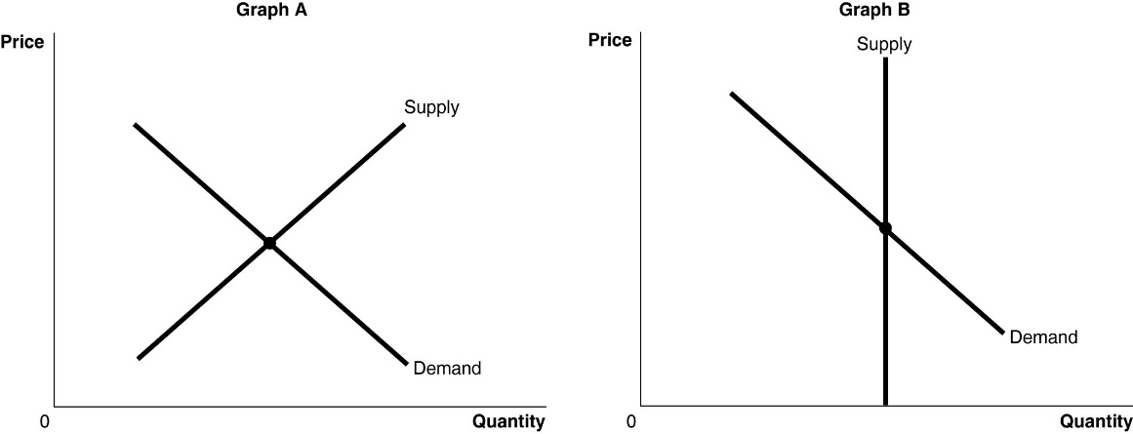

- The figure above shows the supply and demand curves for two markets: the market for original Picasso paintings and the market for designer jeans. Which graph most likely represents which market?
A) Graph B represents the market for original Picasso paintings and Graph A represents the market for designer jeans.
B) Graph A represents the market for original Picasso paintings and Graph B represents the market for designer jeans.
C) Graph A represents both the market for original Picasso paintings and designer jeans.
D) Graph B represents both the market for original Picasso paintings and designer jeans.

- Assume there is a shortage in the market for digital music players. Which of the following statements correctly describes this situation?
A) The demand for digital music players is greater than the supply of digital music players.
B) Some consumers will be unable to obtain digital music players at the market price and will have an incentive to offer to buy the product at a higher price.
C) The price of digital music players will rise in response to the shortage; as the price rises the quantity demanded will increase and the quantity supplied will decrease.
D) the shortage will cause an increase in the equilibrium price of digital music players.

- Which of the following would cause both the equilibrium price and equilibrium quantity of cotton to increase? Assume that cotton is a normal good.
A) An increase in consumer income
B) A drought that sharply reduces cotton output
C) A decrease in consumer income
D) Unusually good weather that results in a bumper crop of cotton

- Which of the following would cause a decrease in the equilibrium price and an increase in the equilibrium quantity of salmon? Assume that salmon is a normal good.

A) A decrease in demand and an increase in supply
B) An increase in supply
C) An increase in supply and an increase in demand greater than the increase in supply
D) A decrease in demand and a decrease in supply

Answer the following 4 questions accordig to graph below
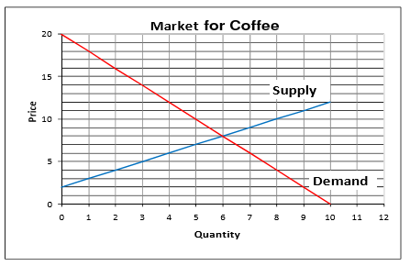

- Using the graph for the Coffee Market above, at the market equilibrium, the consumers’ surplus is
a. $8 b. $18 c. $36 d. $54
- Using the graph for the Coffee Market above, at the market equilibrium, producers’ surplus is
a. $8 b. $18 c. $36 d. $24
- Suppose that government imposes price ceiling of $6. What is the most likely result?
a. The market would reach a new equilibrium at a price of $6
b. There would be no change in the price.
c. There would be excess supply in the market.
d. An underground, or black, market would emerge where this product would be sold at a price above $6.
- Suppose that production is increased to 8 units. Total deadweight loss to the economy is
a. $12 b. $8 c. $6 d. $18
- Refer to the graphs shown. Assume the graph reflects demand in the egg market. Which arrow best captures the impact of increased consumer concern about cholesterol on the egg market?

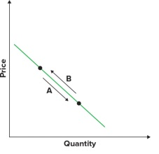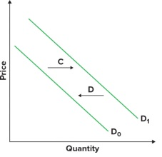
              - A
              - B
              - C
              - D
- Assume the graph shown reflects demand in the automobile market. Which arrow best captures the impact of increased consumer income on the automobile market?
              - A
              - B
              - C
              - D

- Which of the following is NOT held constant along a supply curve?
                - Expected future prices.
                - The number of sellers.
                - The price of the good itself.
                - Prices of resources used in production.

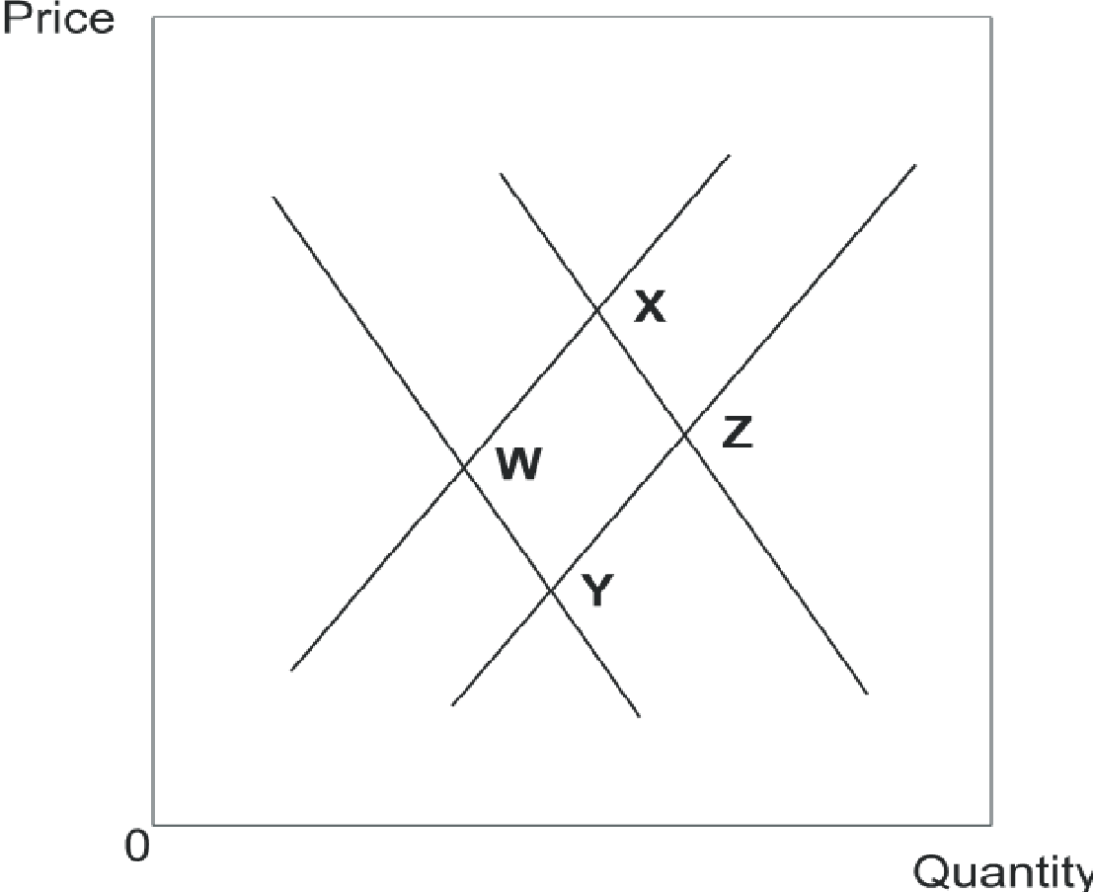
- In the figure above, assume the market is originally at point W. Movement to point X is a combination of
                - an increase in supply and an increase in quantity demanded.
                - an increase in supply and a decrease in quantity demanded.
                - an increase in quantity supplied and an increase in demand.
                - an increase in supply and an increase in demand.

