METU Department of Economics Fall 2024-2025
ECON 202

Instructor: Pınar Derin Güre
T.A: Pınar Özpala

Discussion Session 6 (Chapter 6-7)
PART A: LONG QUESTIONS
- Suppose that the markup of the prices of products over wage cost, z, is 10%, and that the wage-setting equation is
W = P (1 - 2m + z)
where m is the unemployment rate and z is the unemployment benefit/minimum wage.

a. What is the real wage, as determined by the price-setting equation?
b. Solve for the natural rate of unemployment.
c. What happens to the natural rate of unemployment if z falls from 10% to 5%? Explain your answer.

Solution:

a. W/P = 1/(1 + μ)
b. W/P = (1 - 2u + z)
(1 - 2u + z) = 1/(1 + μ)
1 - 2u + 0.10 = 1/(1.1)
u = 0.095
c. W/P = (1 - 2u + z)
(1 - 2u + z) = 1/(1 + μ)
1 - 2u + 0.05 = 1/(1.1)
u = 0.070

- In a certain economy, output is $Y=AN$ where $A>1$ and labor force is $L$. Wages are set according to following equation:

$$W=APz(1-u)$$

Where $W$ is wages, $P$ is prices, $u$ is unemployment rate and $z$captures other factors involved in wage setting.

Price are set:
$$P=(1+μ)\frac{W}{A}$$

Where m is markup of price over cost. Use the $WS$ and $PS$ relations to solve for equilibrium unemployment rate, real wage and output.

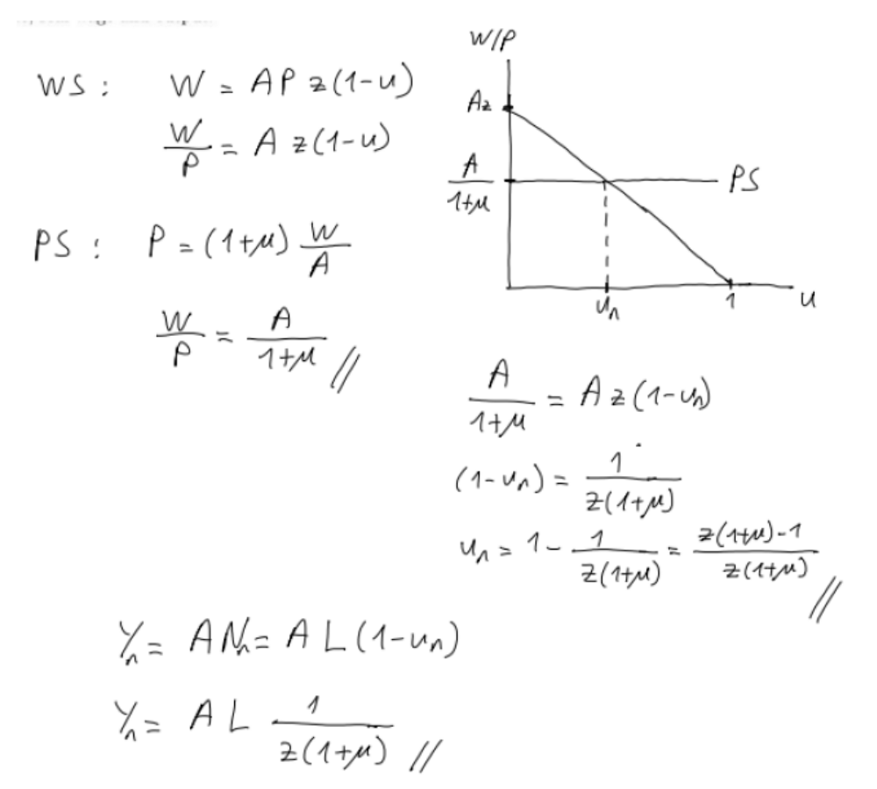

- Assume that the following is true about the economy:
C = 82+0.1(Y-T)
I = 60− 160i +0.1Y
G =20
T =20
M^{d}=PY+120-1000i
M^{s}= 200
Assume the following wage setting relation:
W= P^{e} (z-20u) where
z = $\frac{28}{10}$ is a parameter that represents the workers bargaining power and u is the unemployment rate.
The following is the price setting relation:
P = (1+μ ) W where µ = 0.25 is the markup.
The economy production function: Y = N
The labor force: L = 200.

- Derive the equation that characterizes the AS curve.
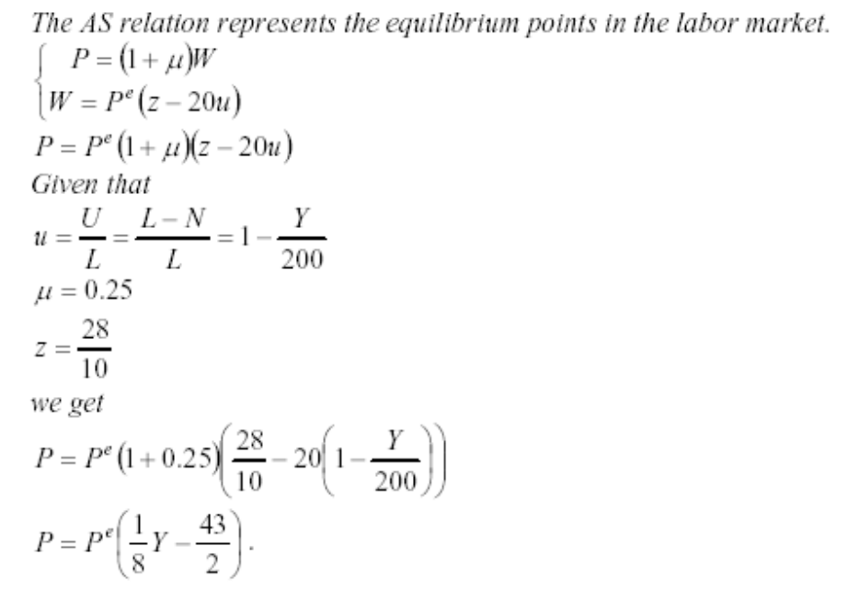
- Derive the equation that characterizes the AD curve.
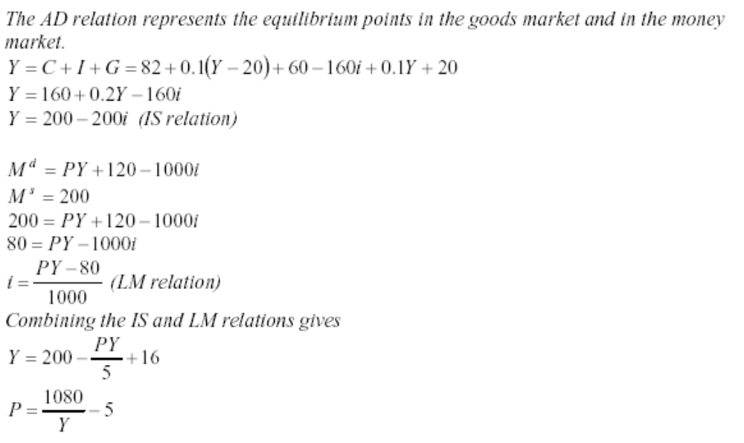
- Compute the medium run equilibrium values for Y_{n} (the natural rate of output), u_{n} (the natural rate of unemployment), P and i.
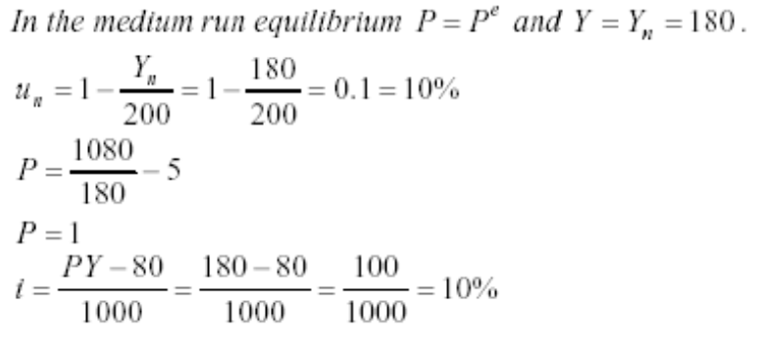
- On a graph in the {P, Y} space draw the AS and AD curves and their intersection, showing the values of the equilibrium points on the two axes.
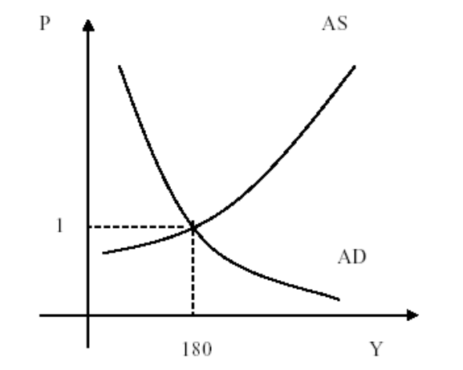
Now consider the effect of an increase in both G and T from 20 to 28.
- Calculate the new medium run levels of Y_{n}, u_{n}, P and i.
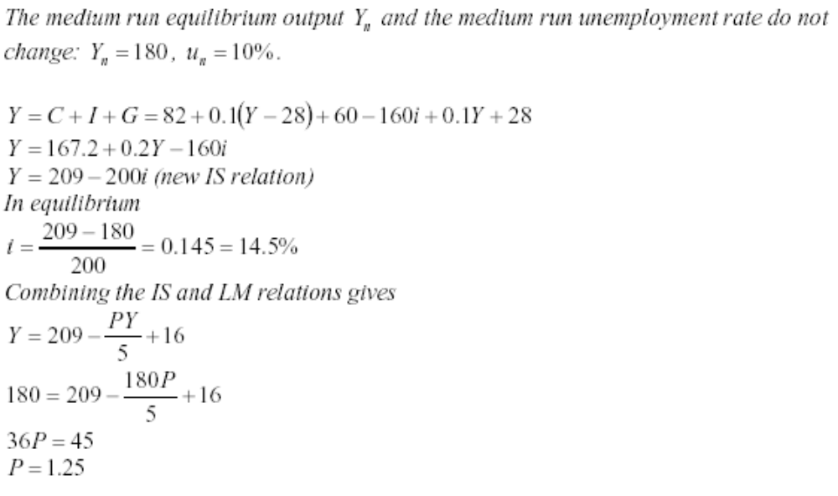
- Graph the dynamics that bring the economy to the new equilibrium. Label all curves (AS_{MR1}, AS_{SR,} AS_{MR2} and AD_{MR1,} AD_{SR,} AD_{MR2}) where MR1 and MR2 stand for initial and new medium run equilibrium, respectively and SR stands for the short run. Label the initial and new equilibrium with associated values on the axes.
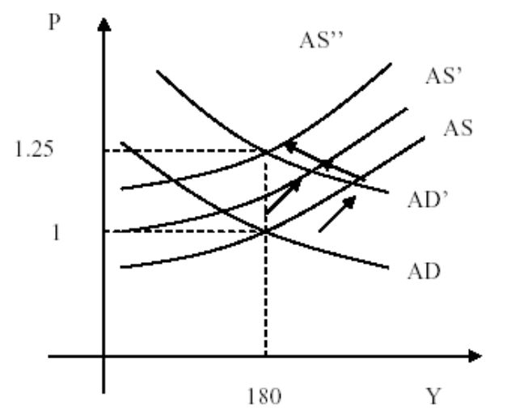
- How does the composition of GDP have changed compared to part (c)?
In the composition of GDP, ΔC=−0.8ΔC=−0.8, ΔI=−7.2ΔI=−7.2, and ΔG=8ΔG=8.
- Would you get the same results as in part (g) following a change in monetary, rather than fiscal policy? Explain your answer.
No. Monetary policy is neutral in the medium run. It cannot change II, CC, and ii.
In the medium run, real money stock is the same as before the policy due to the increase in PP. This implies that the medium-run nominal interest rate is equal to the original one. Thus, investment is the same as before. Consumption, which depends on the natural level of output, is also the same as before. Hence, monetary policy has no compositional effect.

PART B: SHORT QUESTIONS
TRUE/FALSE/UNCERTAIN (Explain it.)
- The greater the interest sensitivity of investment, the flatter the aggregate demand curve.

TRUE. If investment is very sensitive to the interest rate, then a change in the real money stock due to a price decrease has a strong effect on the output demanded. As prices decrease, real money balances increase and the LM curve shifts to the right. This translates into a movement along the AD-curve. If investment becomes more sensitive to changes in the interest rate, the IS curve becomes flatter and income increases more as the LM curve shifts to the right due to the decrease in the price level. The AD curve therefore also becomes flatter.

- If monetary policy accommodates an adverse supply shock, it will worsen any inflationary effects in the medium run.

TRUE. An adverse supply shock shifts the AS curve to the left. There is excess demand for goods and services at the original price level and prices start to rise, leading to lower real balances, higher interest rates, and lower output in the short-run. If no policy is implemented, the expectations will be revised downward and the equilibrium will be restored at its original position. If the government views this adjustment process as too slow, it can respond by implementing expansionary policies. Accommodating the supply shock in this way shifts the AD curve to the right and a new equilibrium can be reached in the medium run but only at the cost of a higher price level.

- Fiscal Policy cannot affect investment in the medium run because output always returns to its natural level.

FALSE. The fiscal policy affects the interest rates. The output level returns to the natural level, but investments will change as the interest rates change.

- Consider the peak oil argument (oil production will reach a peak in the near future and will start to decrease that will result in an increase in price of oil). If price of oil rises in the future because of neutrality of this change output level will not change but price level might rise in US in the medium run.

FALSE. The natural rate of output falls so medium run output levels falls as well.

PART B - MULTIPLE CHOICE

1) Consider the wage-setting and price-setting equations we studied in class. Suppose the markup, μ, equals 0.25, and F(u,z) = 1-u. What is the natural rate of unemployment in this economy?
- 0.2
- 0
- 0.25
- 0.1
- 0.5

2) The natural level of output is the level of output that occurs when:
- the markup (m) is zero.
- there are no discouraged workers in the economy.
- the goods market and financial markets are in equilibrium.
- the unemployment rate is zero.
- the economy is operating at the unemployment rate consistent with both the wage-setting and price-setting equations
3) When using AD/AS analysis to illustrate changes within an economy, which of the following would NOT need to be considered when looking at changes to economic growth?
A) Increased labour productivity
B) More efficient use of the capital stock
C) Increased availability of social capital
D) Developing a more efficient capital and finance sector

4) Using the model of AD and AS, what happens to real GDP, the price level, and unemployment with more consumption spending(C)?
A) Real GDP increases, Price level decreases, Unemployment decreases
B) Real GDP decreases, Price level increases, Unemployment increases
C) Real GDP increases, Price level increases, Unemployment decreases
D) Real GDPdecreases, Price level decreases, Unemployment decreases
E) Real GDP decreases, Price level decreases, Unemployment increases

5) Stagflation most likely results from
A) Increasing AD with constant AS
B) decreasing AS with constant AD
C) decreasing AD with constant AS
D) a decrease in both AD and AS
E) an increase in both AD and AS

6) When a government reduces its deficits by increasing taxes, in the medium run,

A) interest rate is higher.
B) IS curve shifts inward to the left.
C) output increases.
D) output returns to potential.

7) The aggregate demand (AD) curve presented in the textbook has its particular shape because of which of the following explanations?

A) An increase in the money supply (M) will cause a reduction in the interest rate, an increase in investment, and an increase in output
B) An increase in the aggregate price level (P) will cause an increase in the interest rate and a reduction in output.
C) As P decreases in a closed economy, goods and services become relatively cheaper and individuals respond by increasing the quantity demanded of goods and services.
D) An increase in P will cause a reduction in the real wage, an increase in employment, and an increase in output
E) none of the above

