METU
Department of Economics
Econ 101: Introduction to Economics I
Section 01-02
Fall 2023
PROBLEM SET 8 (CH 13 and 14)
- You are given the following information about industry of X-netbook:
- Long-run average costs:
Labour cost: 3 TL per unit of output; Capital cost: 4 TL per unit of output
- The industry is in long-run equilibrium.
- Industry is perfectly competitive: with each of 50 firms producing the same amount of output
- Total industry output = 8000 units

- Show the current conditions by drawing two diagrams: one showing the industry (demand and supply) and one showing a representative firm (short-run and long-run costs). Mark clearly the prevailing price in the market in both of the diagrams.
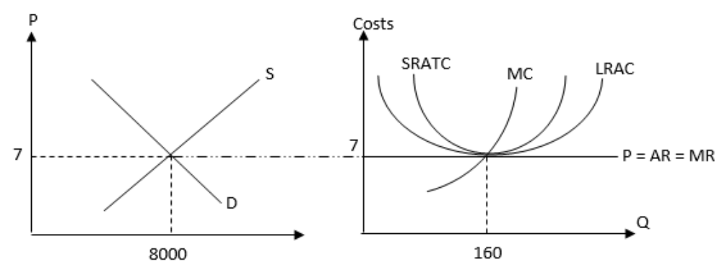
ii) Indicate the profit/loss level of the representative firm on the diagram.

Profit = TR – TC = 0 since Average Total Cost=Average Revenue.

Now assume that, the demand of X-netbook is expected to grow rapidly over the next few years to a level of twice as high it is now. But due to short-run diminishing returns the existing firms in the industry could only increase the quantity supplied by % 50.

iii) Show and explain the effect of the above developments on the industry in the short-run by using the diagram you have drawn in part (i) as your initial point.

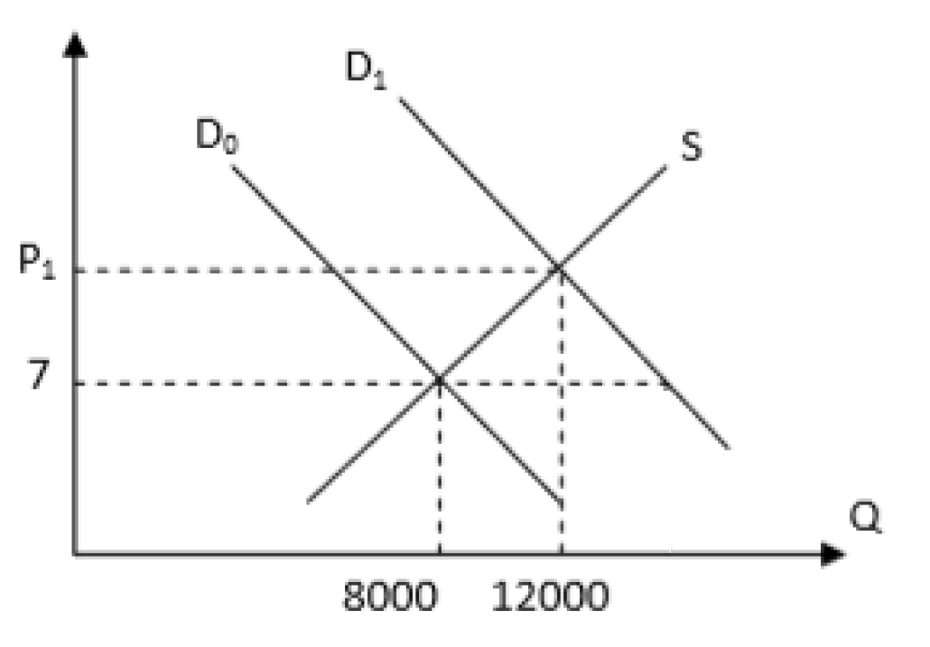
As demand doubled, we move from D0 to D1. But on the same supply curve, equilibrium quantity supplied increases to 12000; ($8000 + 50\%*8000$). So, as demand increases, price also increases.
iv) Show the effect of the above developments on a typical firm in the short-run by using the short-run and long-run cost curves. Use the diagram you have drawn in part (i) as your initial point. Also show the level of profits/losses in your diagram.

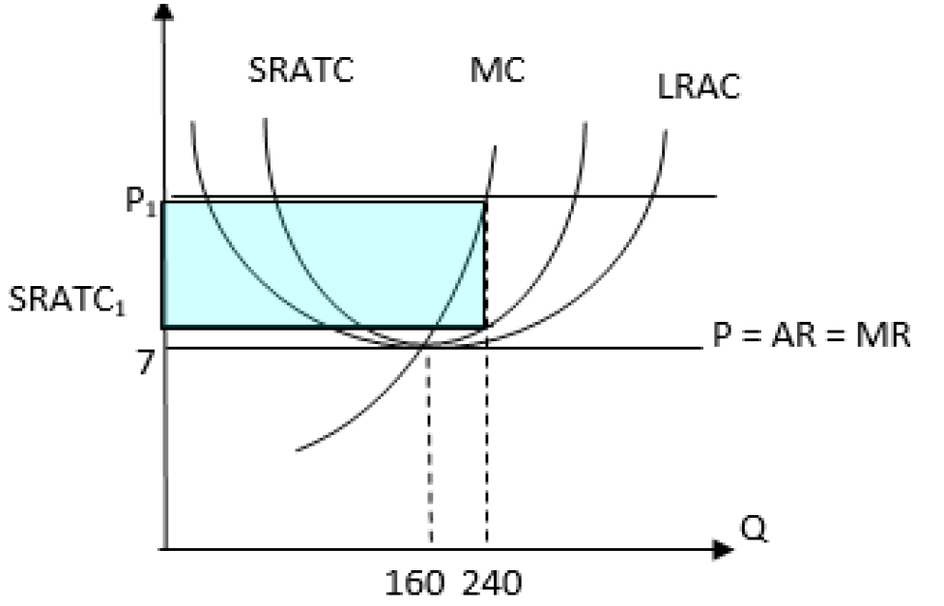
v) Explain how the typical firm and the industry as a whole will move to the new long-run equilibrium.

Since profit is positive, the number of firms that entered to the market will increase. So, as quantity supplied increases, price will go down and profits will be zero.

vi) Show the final long-run equilibrium of the industry after all the adjustments have taken place assuming that long-run equilibrium price is the same as initial long-run equilibrium.

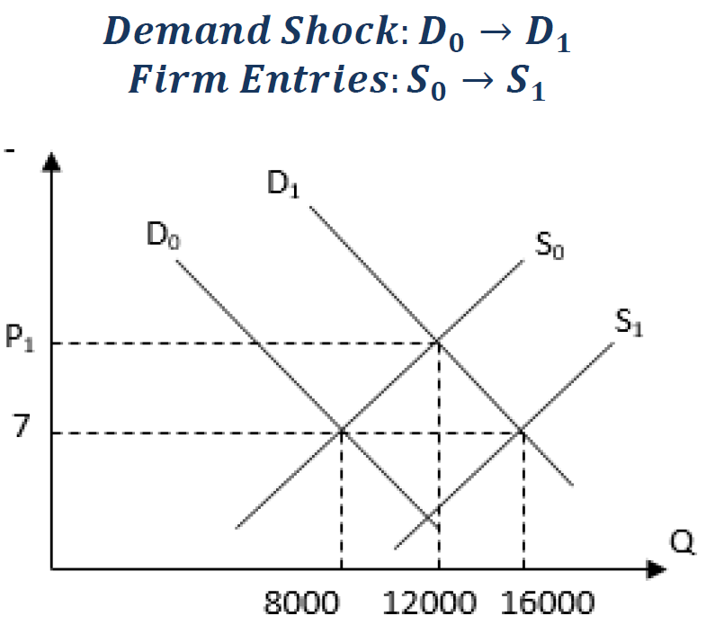

2) Suppose that there are 100 consumers in a perfectly competitive market and individual demand curves of these consumers are identical. Also, assume that there are 10 firms in the industry and these firms are identical as well. The following information is provided about this competitive market:
Individual Demand Curve: $P=100–10Q_{D}$
Total Cost of a Representative (individual) Firm: $TC=20Q+\frac{1}{6}Q^{2}+100$

- Find total variable cost (TVC), total fixed cost (TFC) and marginal cost (MC) functions of the representative firm.

$TVC=20Q+\frac{1}{6}Q^{2}$, TFC = 100, MC=20+($\frac{1}{3}$)Q
- Find average total cost (ATC), average variable cost (AVC), average fixed cost (AFC) functions of the representative firm.

$$ATC=\frac{TC}{Q}=20+\left(\frac{1}{6}\right)Q+\frac{100}{Q}, AVC=\frac{TVC}{Q}=20+\left(\frac{1}{6}\right)Q,$$
$$AFC=TFC/Q=\frac{100}{Q}$$

- What is the market demand function?
To find the market demand we need to horizontally sum the individual demand curves for each of these firms; P = 100 – (1/10) Q

- What is the market supply function?
To find the market supply curve we need to horizontally sum the MC curves for each of these firms. Thus, with each firm’s MC=20+(1/3)Q then P=20+(1/30)Q

- What is the equilibrium price and quantity in this market?
QD=QS
100 – (1/10) Q = 20 + (1/30) Q => Q = 600 units P = 40 TL

- What is the quantity produced by the representative firm?
The representative firm is a price taker and will see the market price of $40 as its marginal revenue curve. It will profit maximize by producing that level of output where MR equals MC. Thus, 40=20+(1/3)Q −> Q = 60 units

- Calculate the level of profits that the representative firm is earning.
Profit = TR – TC = 2400−1900 = 500 TL
TR = 40∗60 = 2400 TL
$$TC=20(60)+(1/6){(60)}^{2}+100=1200+600+100=1900 TL$$

- Holding everything else constant, what do you predict will happen in this industry in the long run? Explain your answer fully with a verbal description rather than a numeric calculation.
Since the representative firm is earning positive economic profit, we can conclude that this is a short-run equilibrium. We know that when the industry is in a long-run equilibrium that the representative firm in the industry will earn zero economic profit. Thus, we can predict that in the long run there will be entry of new firms into this industry. This entry will cause the market supply curve to shift to the right and this shift will result in the market equilibrium quantity increasing while the market equilibrium price will decrease relative to its current levels. There will be more firms in the industry, and each firm will produce an output that is smaller than 60 units.

- This question traces some of the long-run adjustments that take place in a perfectly competitive market in response to a change in demand. Each firm currently in the industry, as well as each potential entrant, has the cost structure depicted in the left panel below. The right panel shows the industry's short-run supply curve and the current market demand curve $D_{0}$.
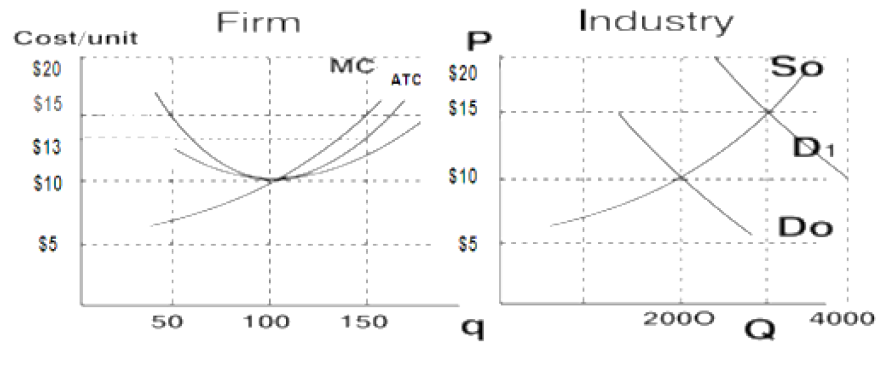

At the initial equilibrium,
- a. What are the equilibrium price and output in the industry?
- $P_{0}=\$10 and Q_{0}=2,000$
- b. What is the output and profit of each firm in the industry?
- 𝑞=100 units and Profit =0
- c. How many firms are operating in this industry?
- # Firms = 𝑄/𝑞=2000/100=20
- d. Is the industry in long-run equilibrium? Explain.
Yes. Economic Profit = 0 -> long-run equilibrium

Suppose demand shifts to $D_{1}$. At the new short-run equilibrium
- e. What are the equilibrium market price and quantity in the industry?
- $P^{S}$=$15 and $Q^{S}$=3000
- f. What is the output of each firm in the industry?
- Each firm increases q from 100 to 150 (where MC = new MR)
- g. What is each firm's profit?
- Profit = 150(15−𝐴𝐶)=150(15−13)=300

- h. Explain the changes in the industry's short-run supply curve after sufficient time has elapsed for entry and exit to occur given a constant cost industry in the long run?
Entry shifts Supply curve right until P = $10 gives zero economic profit and long-run equilibrium is reached.

At the new long-run equilibrium,
- i. What are the market price and quantity?
- P1=10 and 𝑄1=4000
- j. What is the output and associated profit of each firm?
- q= 100 and Economic Profit = 0
- k. How many firms will be active in this industry?
- #Firms = 𝑄/𝑞=4000/100=40

4) Consider the following information about bikes, where Q is output, TC is the total cost of production, and p is the price.
- Fill in the remaining columns in the chart.

Q | TC | MC | P | TR | MR | Profits
0 | 2000 |  | 600 | 0 |  | -2000
1 | 2500 | 500 | 575 | 575 | 575
2 | 2800 | 300 | 550 | 1100 | 525
3 | 3000 | 200 | 525 | 1575 | 475
4 | 3160 | 160 | 500 | 2000 | 425
5 | 3340 | 180 | 475 | 2375 | 375 | -965
6 | 3540 | 200 | 450 | 2700 | 325 | -840
7 | 3780 | 240 | 425 | 2975 | 275 | -805
8 | 4080 | 300 | 400 | 3200 | 225 | -880
9 | 4410 | 330 | 375 | 3375 | 175 | -1035
10 | 4770 | 360 | 350 | 3500 | 125
11 | 5190 | 420 | 325 | 3575 | 75
12 | 5760 | 570 | 300 | 3600 | 25

- Graph the firm's demand curve, marginal revenue curve and marginal cost curve
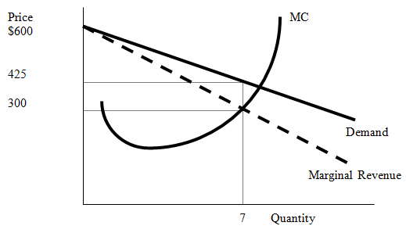
- Where is the marginal revenue curve relative to the firm's demand curve?
The firm’s marginal revenue curve is below the firm’s demand curve and it has twice the slope of the firm’s demand curve.
- Determine the profit maximizing price and quantity. At this price and quantity, calculate this monopoly's economic profits.
Find where MR=MC without MC becoming greater than MR. The profit maximizing quantity is q*=7 with P*=425. The monopoly earns negative economic profits of TR-TC=3780-2975 = -805, which is the best the firm can do in the short run. Notice that if the firm shuts down in the short run due to negative economic profits, it will incur even greater economic losses. The loss if the firm shuts down and produces nothing is –2000. So, the fixed cost of production is $2000.
- Given this firm's level of economic profits, where must the firm's average total cost curve (ATC) and average variable cost curve (AVC) lie?
Because the firm earns negative economic profits, we know ATC>P. However, the firm has enough revenue at q*=7 to cover all of its variable costs and some of its fixed costs. So, P>AVC, which explains why the firm stays in business, producing 7 units in the short run, though negative economic profits are being earned. Shutting down in the short run would result in losses equal to –2000.
- List the causes of monopoly.
Monopolies often exist for one of the following reasons: (i) when only 1 firm has access to a key resource required in the production process; (ii) when the government grants one firm exclusive rights to produce a particular product; (iii) natural monopoly: when the cost of production makes one firm more efficient than a large number of firms.
- What characteristics do monopolies and perfectly competitive firms have in common?
Monopolies and perfectly competitive firms both maximize profits by producing a level of output q* where MC=MR. (We also assume perfect information in both types of markets).

- For a monopoly;
Average revenue function: P = 120 – 2Q
FC = 100
AVC = 60 + 2Q
- Find the total revenue (TR) function.
Since $AR=P, TR=P*Q=(120 – 2Q)*Q=120Q – 2Q^{2}$
- Find the MR and MC function.
$$TC=TFC+TVC=100+AVC*Q => TC=100+60Q+2Q^{2}$$
$$MC=∂TC/∂Q=60+4Q ; MR=∂TR/∂Q=120 – 4Q$$
- Find the quantity that gives the maximum TR.
Total revenue is maximized when its first derivative with respect to quantity (i.e. marginal revenue) is equal to zero. Total revenue is also maximized when elasticity of demand is equal to one; i.e. mid-point of the demand curve. $120 – 4Q=0 => Q=30$
- Find the quantity that gives the minimum AC.
Average cost is minimized when its first derivative with respect to quantity is equal to zero.
$$AC=TC/Q=(100/Q)+60+2Q => ∂AC/∂Q=2 – \left(100/Q^{2}\right)=0 => Q=\sqrt{50}$$
- Determine the profit maximizing level of output and find the profit.
Profit is maximized when marginal revenue and marginal cost is equal to each other.
$$60+4Q=120 – 4Q => Q_{Monopoly}^{*}=7.5$$
$$TR=120Q –2Q^{2}=1575/2 ; TC=100+60Q+2Q^{2}=1325/2$$
$$Profit=TR – TC=125$$
- What would the profit maximizing level of output be if this market is perfectly competitive?
Under perfect competition, profit maximization implies $P=MC.$ To obtain perfectly competitive outcome, $120-2Q=60+4Q => Q_{Perfectly}^{*}=10$.

- What is the cost of monopoly to the society? Show this on a graph.
10
7,5
MC or Supply
D
120
100
60
P
Q
c
a
b
105
90
d

The triangle adb (cdb) is the cost of monopoly paid by consumers (producers) due to under-production. The triangle abc is deadweight loss of the economy and it is equal to
$$DWL=\frac{\left(105-90\right)*2.5}{2}=18.75$$

- A discriminating monopolist can separate his consumers into two distinct markets with the following demand functions:

Market 1: Q₁=16 – 0.2P₁ Corresponding MR function MR₁=80-10Q₁
Market 2: P₂=180 – 20Q₂ Corresponding MR function MR₂=180-40Q₂

Assume that the monopolist’s total cost function takes the form; TC - 20Q – 20 = 0 where Q = Q₁ + Q₂, and that it wishes to maximize profits, calculate;

- the prices the monopolist will charge in each market.
The monopolist will allocate production so that MC = MR in each market.
MC = MR₁ = MR₂
TC – 20Q – 20 =0 or TC = 20Q + 20, then MC is constant at 20.
In market 1,
Q₁ = 16 – 0.2P₁ or P₁ = 80 – 5Q₁
TR₁ = P₁Q₁ = (80 – 5Q₁)*Q₁ = 80Q₁ - 5Q₁²
MR₁ = 80 – 10Q₁
Then 80 – 10Q₁ = 20 and Q₁=6, P₁=50
In market 2,
Q₂=4 and P₂=100
- the monopolist’s profit with price discrimination.
S=(TR₁ + TR₂) – TC = 480

- The diagram below shows the demand and unit cost situation of a monopolist.

Quantity
Price and Cost per unit
A
B
C
MC
ATC
MR
Demand
H
N
J
L
E
G
0

- In order to maximize profits or minimize losses how much should this firm produce and at which price?
Q = 0E, P = 0A
- In equilibrium how much total revenue will the firm collect?
0AJE
- In equilibrium how much total cost will the firm incur?
0BHE
- State whether the firm faces a profit or a loss in the equilibrium.
Profit by AJBH

PART B: MULTIPLE CHOICE
1) The reason that the Şok Market has a monopoly on selling seafood dinners in that town is most likely due to
A) a government-imposed barrier.
B) occupational licensing.
C) no competitors apparently found the profit level attractive enough to enter the market.
D) the restaurant owned all the fresh seafood in the state.

2) A monopoly is a seller of a product
A) with many substitutes.
B) without a close substitute.
C) with a perfectly inelastic demand.
D) without a well-defined demand curve.
3 In METU Campus, there are three restarurants: Susam, Ziyafet and Sunshine. While Sunshine remains open until midnight, Susam and and Ziyafet close at 10 pm. Which of the following statements is true?
A) Sunshine is a monopoly all day because it produces a service that has no close substitutes.
B) Sunshine has a monopoly at midnight but not during the day.
C) Sunshine can ignore the pricing decisions of the other two supermarkets.
D) Sunshine probably has a higher markup to compensate for its higher cost of production.
4) Which of the following is a characteristic shared by a perfectly competitive firm and a monopoly?
A) Each must lower its price to sell more output.
B) Each sets a price for its product that will maximize its revenue.
C) Each maximizes profits by producing a quantity for which marginal revenue equals marginal cost.
D) Each maximizes profits by producing a quantity for which price equals marginal cost.
5) A monopolist's profit maximizing price and output correspond to the point on a graph
A) where average total cost is minimized.
B) where total costs are the smallest relative to price.
C) where marginal revenue equals marginal cost and charging the price on the market demand curve for that output.
D) where price is as high as possible.
6) If a monopolist's price is $50 at 63 units of output and marginal revenue equals marginal cost and average total cost equals $43, then the firm's total profit is
A) $3,150.
B) $2,709.
C) $441.
D) $7.

Table 15.4
Price per Dose | Quantity Demanded  (dose) | Total Cost of Production  (dollars)
$80 | 0 | $80
72 | 1 | 82
64 | 2 | 88
56 | 3 | 100
48 | 4 | 124
40 | 5 | 164
32 | 6 | 208
24 | 7 | 268
16 | 8 | 340

Çelik Inc. has been granted a patent for its Arnica toothache balm. Table 15-4 shows the demand and the total cost schedule for the firm.
7) Refer to Table 15-4. What is Çelik's profit-maximizing output?
A) 4 units
B) 5 units
C) 6 units
D) 7 units
8) Refer to Table 15-4. What is the amount of Çelik's profit?
A) $68
B) $72
C) $124
D) $192
9) Refer to Table 15-4. What is the amount of the deadweight loss generated by Çelik when it produces the monopoly output?
A) $124
B) $42
C) $36
D) $12
10) Because a monopoly's demand curve is the same as the market demand curve for its product
A) the monopoly's marginal revenue equals its price.
B) the monopoly is a price taker.
C) the monopoly must lower its price to sell more of its product.
D) the monopoly's average total cost always falls as it increases its output.
Figure 1
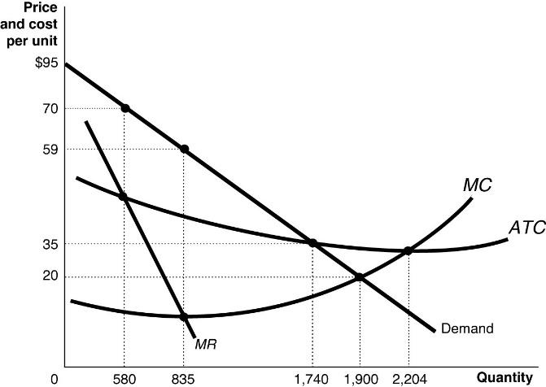

11) Refer to Figure 1. Which of the following statements about the firm depicted in the diagram is true?
A) The fact that this firm is a natural monopoly is shown by the continually declining long-run average total cost as output rises.
B) The fact that this firm is a natural monopoly is shown by the continually declining market demand curve as output rises.
C) The fact that this firm is a natural monopoly is shown by the continually declining marginal revenue curve as output rises.
D) The fact that this firm is a natural monopoly is shown by the fact that marginal cost lies below the long-run average total cost where the firm maximizes its profits.
12) A local electricity-generating company has a monopoly that is protected by an entry barrier that takes the form of
A) control of a key raw material.
B) network externalities.
C) economies of scale.
D) perfectly inelastic demand curve.
13) A monopolist faces
A) a perfectly elastic demand curve.
B) a perfectly inelastic demand curve.
C) a horizontal demand curve.
D) a downward-sloping demand curve.

Figure 3.
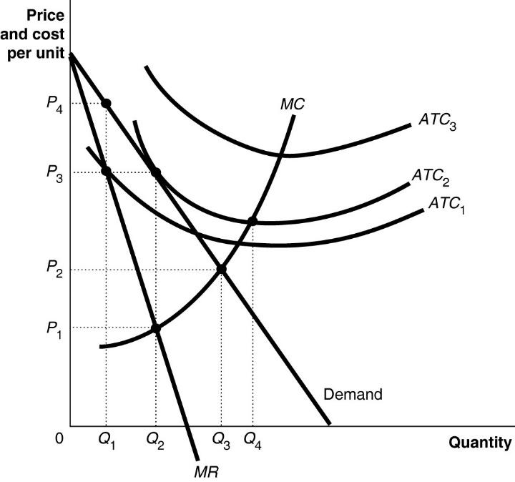
14) Refer to Figure 3. To maximize profit, the firm will produce
A) Q1.
B) Q2.
C) Q3.
D) Q4.

15) Refer to Figure 3. The firm's profit-maximizing price is
A) P1.
B) P2.
C) P3.
D) P4.
16) Refer to Figure 3. If the firm's average total cost curve is ATC1, the firm will
A) suffer a loss.
B) break even.
C) make a profit.
D) face competition.
17) Refer to Figure3. If the firm's average total cost curve is ATC2, the firm will
A) suffer a loss.
B) break even.
C) make a profit.
D) face competition.

