METU Department of Economics Fall 2024-2025
ECON 202

Instructor: Pınar Derin Güre
T.A: Pınar Özpala

Discussion Session 6 (Chapter 6-7)
PART A: LONG QUESTIONS
- In a faraway country, the total population is 1000 people (all of them non – institutional civilian people), 564 are working and 36 are looking for a job.

- What is the size of the labor force? What are the participation rate and unemployment rate?
In this economy, the labor productivity is 2. And the wage setting process is described by W/P^{e} = Z - 200u where Z is the unemployment insurance provided by the government and u is the unemployment rate.

- What is the price setting equation for a mark-up level μ=1.

- For P^{e}=P, what is the natural unemployment rate, natural level of employment and natural level of output if Z = 10? Use math and show the results qualitatively with a graph.

- Analyze the implications of a three dollar increase in the unemployment insurance on natural unemployment rate. Show the results qualitatively with a graph and provide intuition.

- Analyze the implications of a decrease in unemployment–sensitivity of the real wage on the natural level of output, natural unemployment rate and natural level of employment. Show the results qualitatively with a graph and provide intuition. Finally, recognize that prices may turn out to be different from what was expected.

Solution:

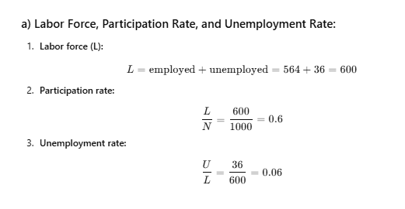
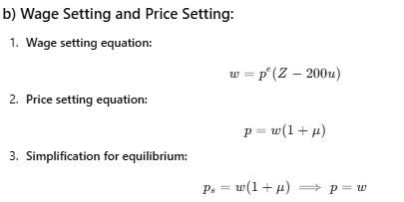

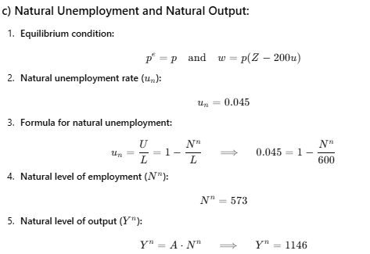
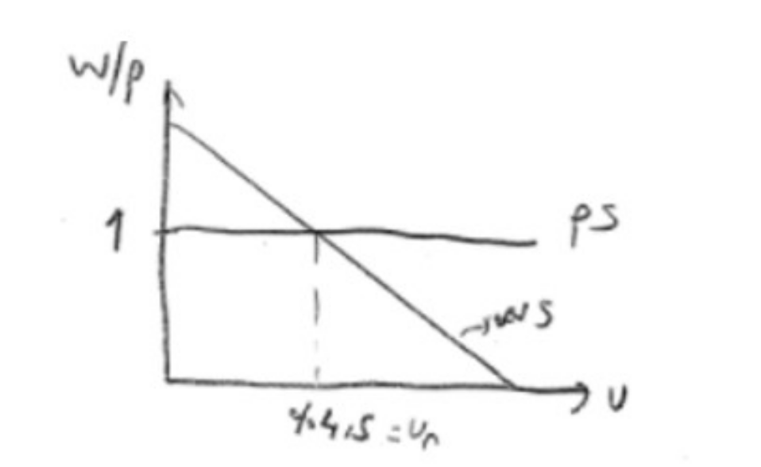
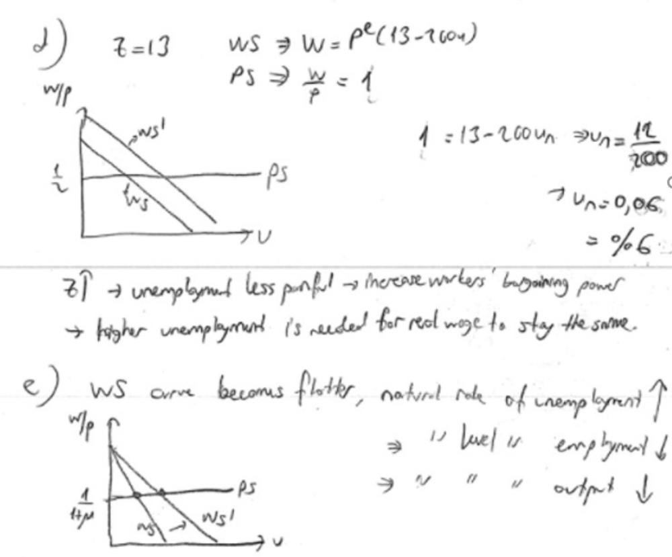

- Goods Market, IS-LM and AS-AD
Consider an economy of the following description
Consumption demand is given by: C= 4 + 0.3Y (no taxes)
Investment demand is given by I = 0.2Y - i
Government spending is G = 0
Money demand is given by: M = P (Y – i)
Money supply is constant: M = 1
Wage setting is described by: W=Pe (1 – u)
The production function is Y = N, and the markup is 25%
The labor force is 10, and in the above description i is stated in percentage (%).

  - Assume that Pe = P. Write down equations for the equilibrium in each of the three markets (goods market, money market and labor market).
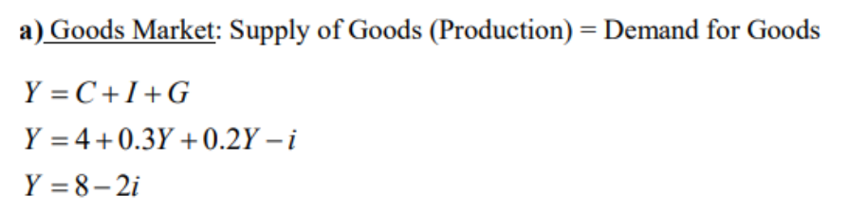
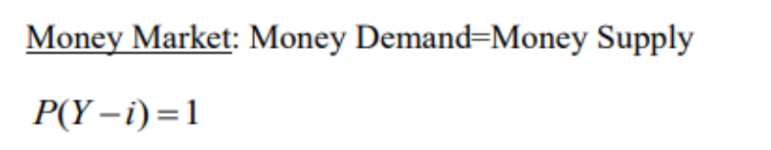
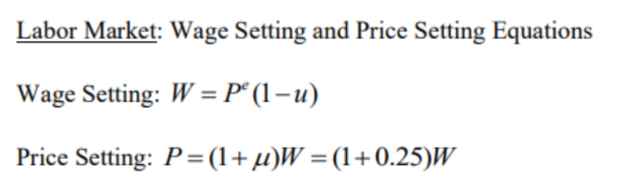
- Assume that in the very short run P is constant, if G expenditures increase by 70 (from 0 to 70) how much do goods market equilibrium income rises/ falls? (Use the concept of multiplier)

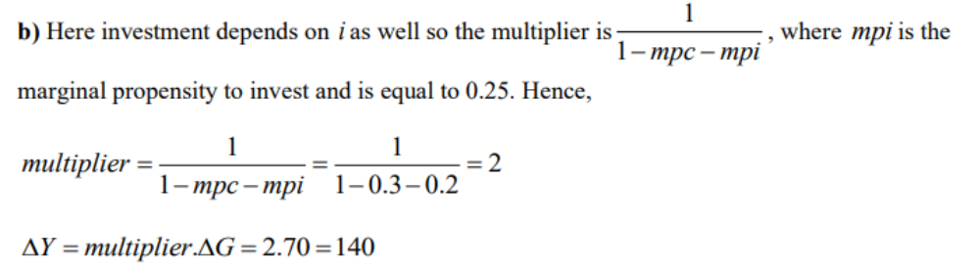

- Now relax Pe = P
Write down the equation for the AS curve.
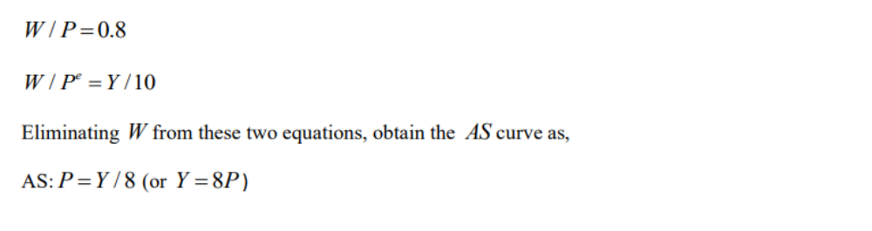
- Write down the IS and LM equations. Explain what each equation shows.
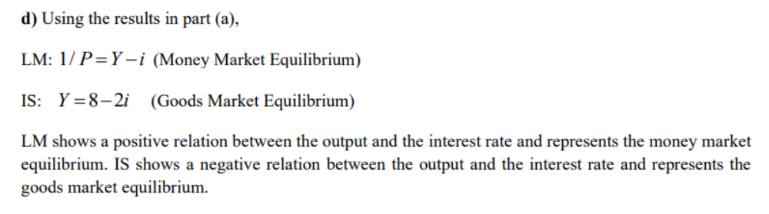

- Derive the AD equation and then solve for the short-run equilibrium values for Y, P, and i if Pe = 1. (Hint: solve for P first when you try to find the SR equilibrium values for Y and i)
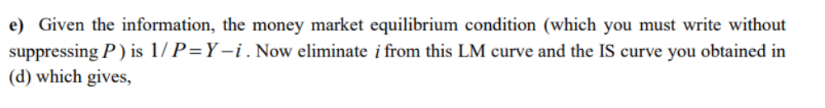
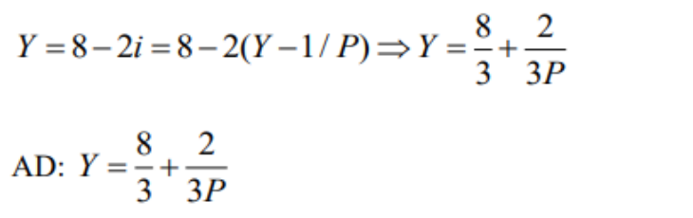
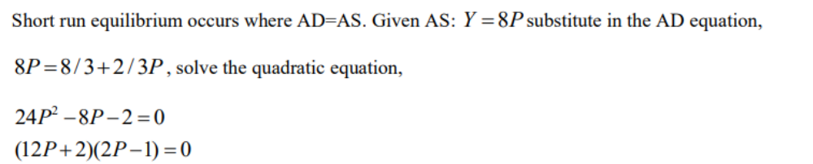
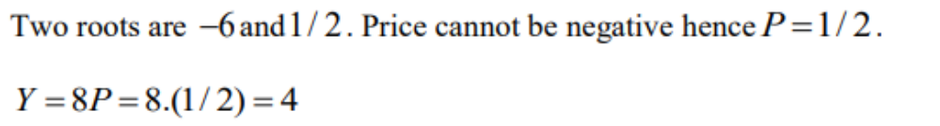

- Solve for the medium-run equilibrium values for Y, P, and i:

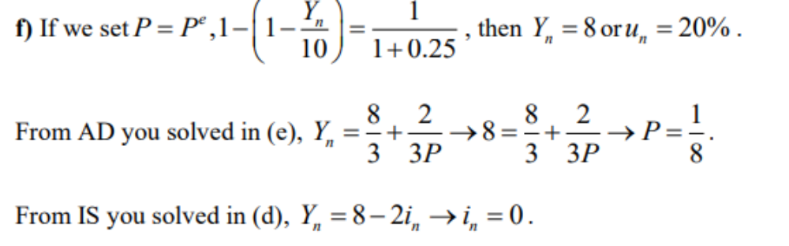
- Explain in words and using AS-AD and IS-LM curves, how the economy goes from the short-run equilibrium to the medium-run equilibrium. Can a monetary expansion help the adjustment? If so, how?

Since the short-run equilibrium involves an output level lower than the natural level and a price level higher than the medium-run equilibrium price, the economy, if left to itself, will adjust to the medium-run equilibrium through successive downward shifts in the AS curve and falling prices. There will be no shifts in the AD curve. Monetary expansion can certainly help the adjustment. If the policy maker wishes to move the economy from the short-run equilibrium to the medium-run equilibrium all at once, then she needs to increase the money supply appropriately. The “all at once” part of the previous statement means that the AS curve will not shift. Instead, the monetary expansion will shift the AD curve just enough so that it intersects with the original AS curve you found in (c) at the natural rate of output, but at a higher price. If, on the other hand, the policy maker wants to move the economy to the medium-run equilibrium without price increasing from its short-run level, then she needs to wait for the AS curve to shift enough and then expand the money supply so that the new AD intersects the new AS curve at the natural level of output and the same level of price as in the initial short-run equilibrium.
- Explain the recent developments in Turkish economy. Why did the Central Bank of Turkey increase the interest rates? What would be the short run and long run effects of this in Turkish economy (output, consumption, investments, interest rates, and price level)? Make use of graphs (money demand and supply, IS-LM, AD-AS)
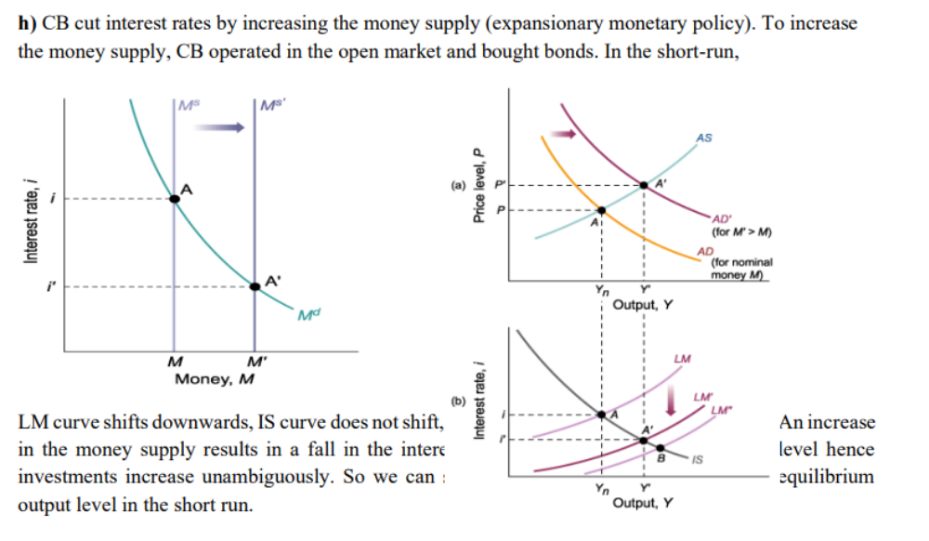
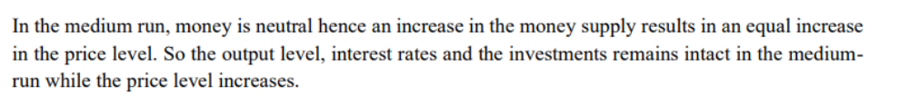
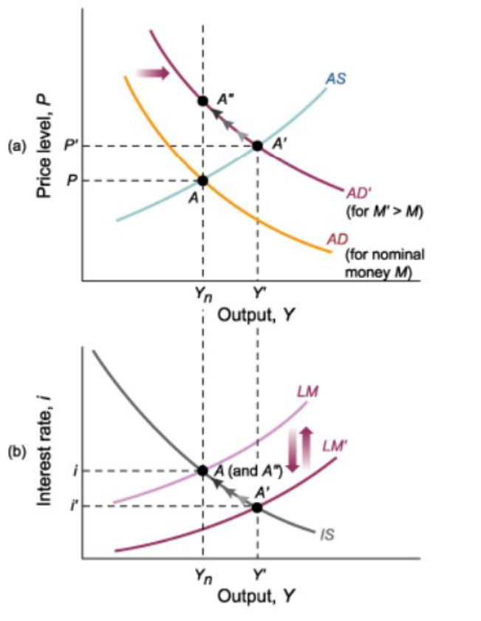

PART B: SHORT QUESTIONS
TRUE/FALSE/UNCERTAIN (Explain it.)

- In an economy where product markets are note perfectly competitive (that is firms can charge prices higher than the marginal cost), it is always optimal for a profit maximizing firm to choose a combination of price P and markup m such that $\frac{P}{(1+μ)}=W$= reservation wage.

False: As the efficiency wage theories explain, sometimes firms may want to pay more than the reservation wage in order to motivate workers to be more productive.

- An increase in the workers’ bargaining power leads to an increase in the equilibrium nominal wage; however, the equilibrium real wage stays constant.

True: In our setting, the real wage is fully determined by the price setters. The nominal wage increases if workers' bargaining power goes up, but the price level also increases.

- In the AS-AD model, higher competition among producers leads to a medium run equilibrium with higher output, lower interest rate, and lower price level.

TRUE. The effect of higher competition among producers can be analyzed through a decrease in μ. A decrease inμ leads to a higher natural level of output. The AS curve shifts down initially to a new short run equilibrium with lower output and a lower price level. As long as wage setters update their expectations on prices, the AS curve keeps moving down along the AD curve until it reaches the new medium run natural level of output. The decrease in the price level leads to an increase in the real money supply. The LM curve keeps shifting down along the IS curve as long as the AS curve shifts down along the AD curve. The new medium run equilibrium corresponds to the point defined by the natural level of output and a lower interest rate.

- In medium run, output and price level always return to the same level.

FALSE: the price level does not return to the same level.

- Expansionary monetary policy has no effect on the level of output in the medium run.

TRUE: because of the neutrality of money, as money supply increases, price level rises by the same percentage, leaving the output level constant.

PART B - MULTIPLE CHOICE

1) Consider the wage-setting and price-setting equations we studied in class. Suppose the markup, μ, equals 0.25, and F(u,z) = 1-u. What is the natural rate of unemployment in this economy?
- 0.2
- 0
- 0.25
- 0.1
- 0.5

2) The natural level of output is the level of output that occurs when:
- the markup (m) is zero.
- there are no discouraged workers in the economy.
- the goods market and financial markets are in equilibrium.
- the unemployment rate is zero.
- the economy is operating at the unemployment rate consistent with both the wage-setting and price-setting equations
3) When using AD/AS analysis to illustrate changes within an economy, which of the following would NOT need to be considered when looking at changes to economic growth?
A) Increased labour productivity
B) More efficient use of the capital stock
C) Increased availability of social capital
D) Developing a more efficient capital and finance sector
4) Using the model of AD and AS, what happens to real GDP, the price level, and unemployment with more consumption spending(C)?
A) Real GDP increases, Price level decreases, Unemployment decreases
B) Real GDP decreases, Price level increases, Unemployment increases
C) Real GDP increases, Price level increases, Unemployment decreases
D) Real GDPdecreases, Price level decreases, Unemployment decreases
E) Real GDP decreases, Price level decreases, Unemployment increases

5) Stagflation most likely results from
A) Increasing AD with constant AS
B) decreasing AS with constant AD
C) decreasing AD with constant AS
D) a decrease in both AD and AS
E) an increase in both AD and AS

7) What is the major reason for oil prices to go up in the 1970s?
A) fast of growth of emerging economies
B) new energy
C) higher demand from the US
D) formation of the OPEC

8) In the short run, an increase in the price of oil will cause
A) an increase in the interest rate.
B) an increase in output.
C) a reduction in the price level.
D) all of the above
E) none of the above

