METU Department of Economics Fall 2024-2025
ECON 202

Instructor: Pınar Derin Güre
T.A: Pınar Özpala

Discussion 9 Session 2 (Chapter 8)

PART A: TRUE/FALSE/UNCERTAIN (Explain it.)
a. The Phillips curve implies that when unemployment rate is high, inflation is low, and vice versa. Therefore, we may experience either high inflation or high unemployment, but we will never experience both together.

FALSE. In the 1970s, we experienced high inflation and high unemployment. The expectations-augmented Phillips curve is a relationship between inflation and unemployment conditional on the natural rate and inflation expectations. Given inflation expectations, when the natural rate of unemployment increases (i.e., when there is an increase in z or ), there is also an increase in both the actual unemployment rate and the inflation rate. In addition, increases in inflation expectations imply higher inflation for any level of unemployment. In the 1970s, both the natural rate and expected inflation increased, so both unemployment and inflation were relatively high.

PART B - ESSAY TYPE QUESTIONS.

- Macroland’s economy is based on coconut production (it is also the only consumption good of macrolanders). Firms charge a price per coconut which is equal to one plus a markup times the cost of paying a Macrolander to climb up a tree and collect a coconut. Let the markup be 1. The wage is set as following: W= P_{e} (1-4u). Macrolanders believe the government will stop inflation every year, and expect an inflation rate of zero percent.
a. Derive the original Phillips curve for Macroland.
b. What is the NAIRU rate for Macroland? Why is it called NAIRU?
c. Assume that π_{t}^{e} = π_{t-1}.Write down the other form of Phillips curve that represents the relation between change in inflation and unemployment rates.
d. Suppose that u_{t}=30%, π_{t-1}=40%. Find π_{t}. Is the result surprising?
e. Suppose that the government wants to reduce the inflation to 2% in three years by following the targeted levels as 15%; 9% and 2%. What is the cost or benefit of this policy on unemployment?

Solutions:

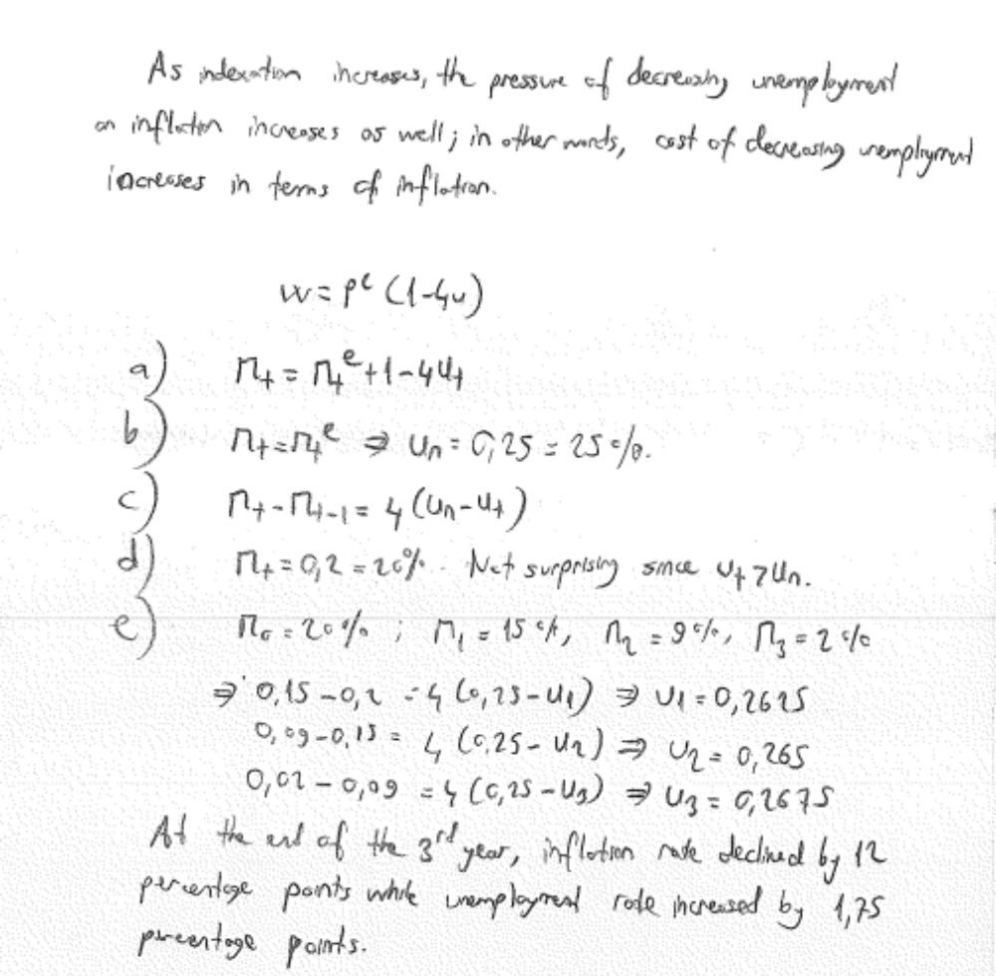
Q 2. Suppose that the Phillips curve is given by
π_{t}= π_{t}^{e}+0.1 -2u_{t}; π_{t}^{e} =π_{t-1}

Suppose that inflation in year t - 1 is zero. In year t, the authorities decide to keep the unemployment rate at 4% forever.
a. Compute the rate of inflation for years t, t + 1, t + 2, and t + 3. Now suppose that half the workers have indexed labor contracts.
b. What is the new equation for the Phillips curve?
c. Based on your answer to part (b), recompute your answer to part (a).
d. What is the effect of wage indexation on the relation between p and u?
Solution:
- This will move the model of expected inflation so that
π t = π t-1 - 2(ut - .05) = π t-1 + 2%=2%
π t = 2%; π t+1 = 4%; π t+2 = 6%; π t+3 = 8%.
- π t = 0.5 π t + 0.5 π t-1 - 2(ut - .05)
or, π t = π t-1 - 4(ut - .05)
- π t = 4%; π t+1 = 8%; π t+2 = 12%; π t+3 = 16%
- As indexation increases, inflation becomes more sensitive to the difference between the unemployment rate and the natural rate.

PART C: MULTIPLE CHOICE

- For this question, assume that the Phillips curve equation is represented by the following equation: π_{t} - π_{t}-1 = (μ + z) - αu_{t}. Given this information, the natural rate of unemployment will be equal to:
A) (μ + z - α).
B) α(μ + z).
C) 0.
D) μ + z.
E) none of the above

- Suppose the Phillips curve is represented by the following equation: π_{t} - π_{t-1} = 20 - 2u_{t}. Given this information, we know that the natural rate of unemployment in this economy is:
A) 20%.
B) 5%.
C) 6.5%.
D) 10%.
E) none of the above

- Which of the following is one possible explanation for the change in the natural rate of unemployment in the United States during the 1970s?
A) contractionary fiscal policy
B) an increase in the proportion of labor contracts that were indexed
C) contractionary monetary policy
D) all of the above
E) none of the above

- Assume that expected inflation is based on the following: π_{t}^{e} = θπ_{t-1}. If θ = 0, we know that
A) high rates of unemployment will cause steadily declining rates of inflation.
B) low rates of unemployment will cause steadily increasing rates of inflation.
C) the Phillips curve illustrates the relationship between the level of inflation rate and the level of the unemployment rate.
D) a reduction in the unemployment rate will have no effect on inflation.

- If the Phillips Curve is vertical in the long run, then an increase in the money supply from year to year will _______ the unemployment rate and will _________inflation rate.
A) increase; increase
B) increase; not change
C) not change; increase
D) not change; not change

- What is the main contrast between short run and long run Phillips curve?
A) In the short run there is a positive relationship between inflation and unemployment, and in the long run the relationship is negative.
B) In the short run there is a positive relationship between inflation and unemployment, and in the long run the relationship is constant
C) In the short run these is a negative relationship between inflation and unemployment, and the long run the relationship is positive
D) In the short run there is a negative relationship between inflation and unemployment, and in the long run the relationship is constant.
E) In the short run there is a constant relationship between inflation and unemployment, and in the long run the relationship is negative.

- For this question, assume that the Phillips curve equation is represented by the following equation π_{t} - π_{t-1} = (m + z) - αu_{t}. A reduction in the unemployment rate will cause
A) a reduction in the markup over labor costs (i.e., a reduction in m).
B) an increase in the markup over labor costs.
C) a decrease in the inflation rate over time.
D) an increase in the inflation rate over time.
E) none of the above

- For this question, assume that the Phillips curve equation is represented by the following:
π_{t} - π_{t-1} = (m + z) - αu_{t}. Which of the following will not cause an increase in the natural rate
of unemployment?
A) an increase in α
B) a reduction in m
C) an increase in the expected rate of inflation
D) a reduction in z
E) all of the above

