METU
Department of Economics
Econ 101: Introduction to Economics I
Section 01-02
Fall 2024
PROBLEM SET 11
- Define the following terms:

  - Implicit price collusion: Multiple firms make the same pricing decisions even though they have not explicitly consulted with one another. They “just happen” to come to a collective decision.

  - Cartel: A combination of firms that acts as if it were a single firm, a shared monopoly. Oligopolies acting as if they were monopolists that have assigned output quotas to individual member firms of the oligopoly so that total output is consistent with joint profit maximization.

  - Contestable market model: A model of oligopoly in which barriers to entry and barriers to exit, not the structure of the market, determine a firm’s price and output decisions. Without barriers to entry or exit, the price an oligopolist sets will be equal to the competitive price.

  - Interdependence among oligopoly firms: The decisions and business strategies of each firm having a significant impact on the decisions, strategies, and profits of the other firms in the industry.

  - Concentration ratio: The value of sales by the top firms of an industry stated as a percentage of total industry sales.

- The market shares of firms in three different industries are listed in the table below. Use this information to calculate the Herfindahl index for each industry.
Firms | Industry 1 | Industry 2 | Industry 3
1 | 65 | 70 | 35
2 | 15 | 15 | 35
3 | 10 | 10 | 30
4 | 5 | 5 | -
5 | 5 | - | -

- Which industry is has the greatest market power? The least?
Industry 2 has the greatest market power with a Herfindahl rating of 0.52. Industry 3 has the lowest market power with a Herfindahl rating of 0.33.

- Based on your findings, is the number of firms in the industry a good predictor of the competitiveness of an industry? Why or why not?
The number of firms in an industry is not a good predictor of the competitiveness of that industry. In this problem, Industry 3 had the least number of firms but was most competitive. This is due to the fact that although there are a small number of firms, the market is spread relatively evenly among the firms, resulting in greater competition. In the other industries, market shares were unevenly skewed, so the Herfindahl rating was higher. Thus, the market power ultimately depends on not only the number of firms, but the way the market share is distributed among them.

- Consider the following version of the prisoner’s dilemma game (Player one’s payoffs are in bold):
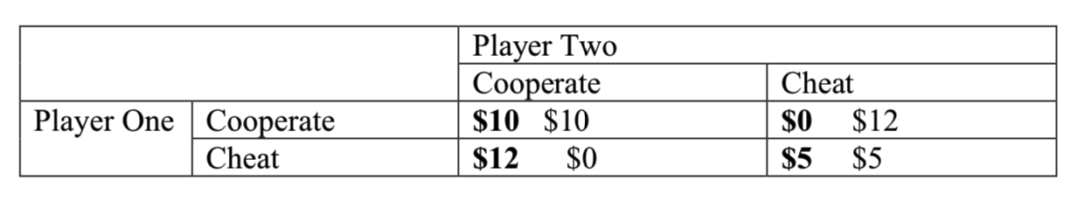

- What is each player’s dominant strategy? Explain the Nash equilibrium of the game.
Start with player one: If player two chooses cooperate, player one should choose cheat ($12 versus $10). If player two chooses cheat, player one should also cheat ($0 versus $5). Therefore, the optimal strategy is to always cheat (for both players) this means that (cheat, cheat) is the only Nash equilibrium.
- Suppose that this game were played three times in a row. Is it possible for the cooperative equilibrium to occur? Explain.
If this game is played multiple times, then we start at the end (the third playing of the game). At the last stage, this is like a one shot game (there is no future). Therefore, on the last day, the dominant strategy is for both players to cheat. However, if both parties know that the other will cheat on day three, then there is no reason to cooperate on day 2. However, if both cheat on day two, then there is no incentive to cooperate on day one.
- Consider the following game. Two criminals are thinking about pulling off a bank robbery.
The take from the bank would be $20,000 each , but the job requires two people (one to rob
the bank and one to drive the getaway car. Each criminal could instead rob a liquor store. The
take from robing a liquor store is only $1000 but can be done with one person acting alone.
Write down the payoff matrix for this game and find Nash equilibria.
 | Bank | Liquor
Bank | 20,000 ; 20,000 | 0 ; 1000
Liquor | 1000; 0 | 1000; 1000

Notice that there are two Nash Equilibria , (Bank, Bank) and (Liquor, Liquor)

- Consider the curve shown in the figure below, which shows the market demand, marginal cost, and marginal revenue curve for firms in an oligopolistic industry. In this example, we assume firms have zero fixed costs.

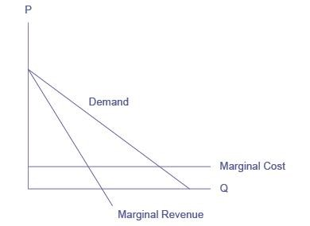
- Suppose the firms collude to form a cartel. What price will the cartel charge? What quantity will the cartel supply? How much profit will the cartel earn?
If the firms form a cartel, they will act like a monopoly, choosing the quantity of output where MR = MC. Drawing a line from the monopoly quantity up to the demand curve shows the monopoly price. Assuming that fixed costs are zero, and with an understanding of cost and profit, we can infer that when the marginal cost curve is horizontal, average cost is the same as marginal cost. Thus, the cartel will earn positive economic profits equal to the area of the rectangle, with a base equal to the monopoly quantity and a height equal to the difference between price (on the demand above the monopoly quantity) and average cost, as shown in the following figure.
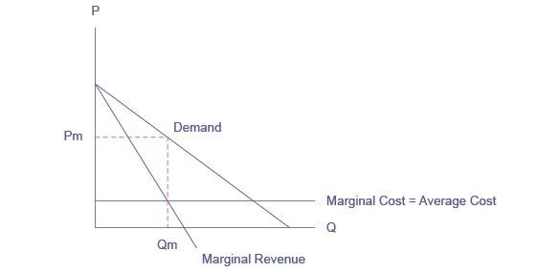
- Suppose now that the cartel breaks up and the oligopolistic firms compete as vigorously as possible by cutting the price and increasing sales. What will the industry quantity and price be? What will the collective profits be of all firms in the industry?

The firms will expand output and cut price as long as there are profits remaining. The long-run equilibrium will occur at the point where average cost equals demand. As a result, the oligopoly will earn zero economic profits due to “cutthroat competition,” as shown in the next figure.
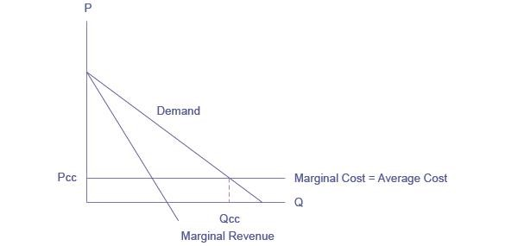
- Compare the equilibrium price, quantity, and profit for the cartel and cutthroat competition outcomes.
P_{c} > P_{cc}. Q_{c} < Q_{cc}. Profit for the cartel is positive and large. Profit for cournot competition is zero

- Describe the essential features of the kinked-demand model of oligopoly pricing.
In the kinked-demand model, there is no collusion. The demand curve for the oligopolist is “kinked” because when the firm lowers its price, its rivals will lower their prices, and its demand often will be inelastic. When the firm increases its price, its rivals will not follow with price increases and its demand will be elastic. The firm, therefore, hesitates to change its price for fear of decreasing its profits. Two shortcomings of the kinked-demand model are that it does not explain how the going price gets set and prices are not as inflexible as implied by the model
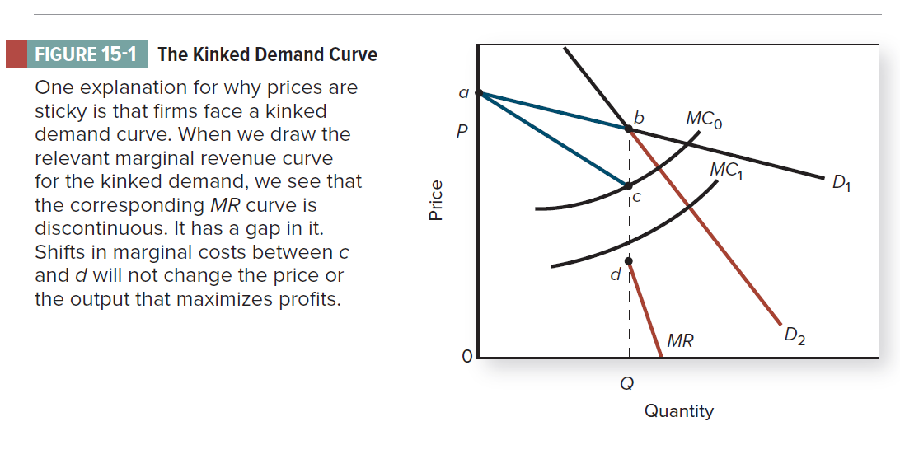

- Consider the following arguments and correct them if false.
- The oligopoly model is the only model that explicitly considers how the pricing and output decisions of one firm affect other firms.
- true
- false

- The central element of the oligopoly model is that each firm produces a differentiated product.
- true
- false

- The cartel model of oligopoly assumes that firms jointly behave as a monopolist in order to maximize joint profits.
- true
- false

- Implicit collusion occurs when oligopolistic firms negotiate a common price.
- true
- false
- The higher an industry's concentration ratio is, the more competitive the industry is.
- true
- false

          - TRUE
Firms act independently in monopolistically competitive and perfectly competitive industries. In monopolized industries, there are no rivals to be concerned about.

          - FALSE
The central element of the oligopoly model is interdependence. Firms in an oligopolistic market may produce either identical or differentiated products.

          - TRUE
Cartels implicitly or explicitly collude in their pricing decisions in an attempt to maximize industry profits.

          - FALSE
Implicit collusion involves no explicit communication between firms.
          - FALSE
The concentration ratio represents the combined market share of the top firms in an industry. The larger the market share, the less competitive the industry.

MULTIPLE CHOICE
- Strategic decision making is most likely to occur in which market structure?
              - Monopolistic competition
              - Oligopoly
              - Perfect competition
              - All firms engage in strategic decision making.

- When the FTC investigated whether firms conspired to fix prices of computer memory called dynamic random-access memory (DRAM) chips, Samsung, Micron Technology, Hynix Semiconductor, and Infineon controlled more than 75 percent of the market for DRAM chips. The market for these chips is most likely:
              - monopolistic.
              - perfectly competitive.
              - monopolistically competitive.
              - oligopolistic.

- Under oligopoly:
              - there are many sellers in the industry.
              - there are only a few sellers in the industry.
              - the demand for each firm's output is perfectly elastic.
              - there are no barriers to entry.

- Firms base decisions on the decisions of other firms in the market in:
              - a monopolistic industry.
              - an oligopolistic industry.
              - a monopolistically competitive industry.
              - a perfectly competitive industry.
- In the cartel model of oligopoly, the firms would decide how much to produce where:
              - marginal cost equals marginal revenue.
              - marginal cost equals price.
              - marginal cost equals average total cost.
              - the kink in the demand curve is.

- From society's perspective, a possible benefit of a cartel is that it could:
              - provide incentives for firms to cooperate in setting price and output.
              - not earn economic profits.
              - minimize average total costs.
              - provide incentives for the introduction of superior products by competitors.

- Suppose an oligopolistic firm assumes that its rivals will ignore a price increase but match a price cut. In this case, the firm perceives its demand curve to be:
              - kinked, being steeper above the going price than below.
              - kinked, being steeper below the going price than above.
              - linear, being less elastic at lower prices.
              - linear, being more elastic at higher prices.
- Refer to the graph shown. If a firm operating as if it were faced with a kinked demand curve believes that if it lowers price from P₂ to P₄, its rival will match the price cut, then:
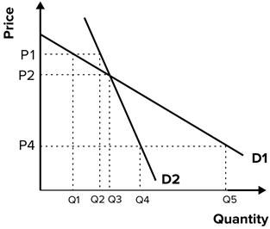
              - the demand curve used by the firm for decision making is highly elastic.
              - it probably will lower price, since doing so will increase sales.
              - it probably won't lower price, since the percentage decline in price will exceed the percentage increase in quantity sold.
              - D₁ is the relevant demand curve.

- Refer to the graph shown, which shows an oligopolist facing a kinked demand curve. The firm will not increase price when marginal costs fluctuate between which two points?
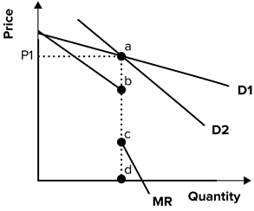
              - a and b
              - b and c
              - c and d
              - a and d

- Refer to the graph shown. The oligopolist shown currently charges a price P₁. It believes that rival firms will:
              - gain market share if it lowers price.
              - lose market share if it lowers price.
              - raise price if it raises price.
              - lower price if it lowers price.

- The top four firms in the industry have 10 percent, 8 percent, 8 percent, and 6 percent of the market. The Herfindahl index of this market is closest to which of the following?
              - 8
              - 32
              - 66
              - 264

- The top four firms in the industry have 15 percent, 15 percent, 10 percent, and 7 percent. The Herfindahl index of this market is at least?
              - 599
              - 15
              - 47
              - 225

- Suppose an industry has a four-firm concentration ratio of 20 percent and a Herfindahl index of 600. According to the cartel model, the industry would be more likely to have:
              - a monopolistic price.
              - a competitive price.
              - either a monopolistic or a competitive price, depending on barriers to entry and exit.
              - a price war.

- The concentration ratio is defined as the:
              - percentage of industry output produced by a specific firm.
              - percentage of total industry output produced by the top firms.
              - squared value of the market shares of all the firms in an industry.
              - squared value of the market shares of the largest four firms in the industry.

- The higher the concentration ratio in a given industry, the:
              - closer the industry is to a perfectly competitive market structure.
              - larger the market shares of the smallest four firms in the industry.
              - closer the industry is to an oligopolistic or monopolistic type of market structure.
              - smaller the market shares of the largest four firms in the industry.
- Formal economic reasoning applied to situations in which decisions are interdependent is called:
              - economic decision making.
              - monopolistic decision making.
              - competitive decision making.
              - game theory.

- Game theory is designed to study situations in which each agent's decisions are:
              - interdependent.
              - independent.
              - constrained.
              - uninformed.

- Game theory:
              - is more restrictive than the standard supply/demand model.
              - is more flexible than the standard supply/demand model.
              - replaces the standard supply/demand model.
              - replaces the monopoly model.

- Game theory:
              - is the best model for perfect competition.
              - replaces the standard supply/demand model.
              - is the best model for monopoly.
              - complements the standard supply/demand model.

- Consider the following payoff matrix facing Harry and Sally when each chooses to go to the coffee shop listed. Both Harry and Sally would like to meet each other but are shy about asking the other out on a date.
 | Harry
 |  | Starbucks | Dunkin' Donuts
Sally | Starbucks | H: 1, S: 1 | H: 0, S: 0
Sally | Dunkin' Donuts | H: 0, S: 0 | H: 1, S: 1
If Harry and Sally go to the coffee shop every day, what is Harry's best strategy?
              - Harry has no best strategy.
              - Choose one shop to go to and keep going to it.
              - Randomly choose between the two shops and hope Sally will end up there too.
              - Stay at home.

