METU
Department of Economics
Econ 101: Introduction to Economics I
Section 01-02
Fall 2024
PROBLEM SET 5 (CH7)

- Demonstrate graphically and explain verbally how the size of a surplus created by a price floor is related to the elasticity of the supply and demand curves.

Answer:
The more elastic the supply and demand curves the greater the surplus will be. This is illustrated in the diagrams below in which a price floor of PF is imposed. Diagram 1 shows a case where both supply and demand are relatively elastic; the surplus (QS > QD) is large. Diagram 2 shows a case where both supply and demand are relatively inelastic; the surplus (QS > QD) is small.

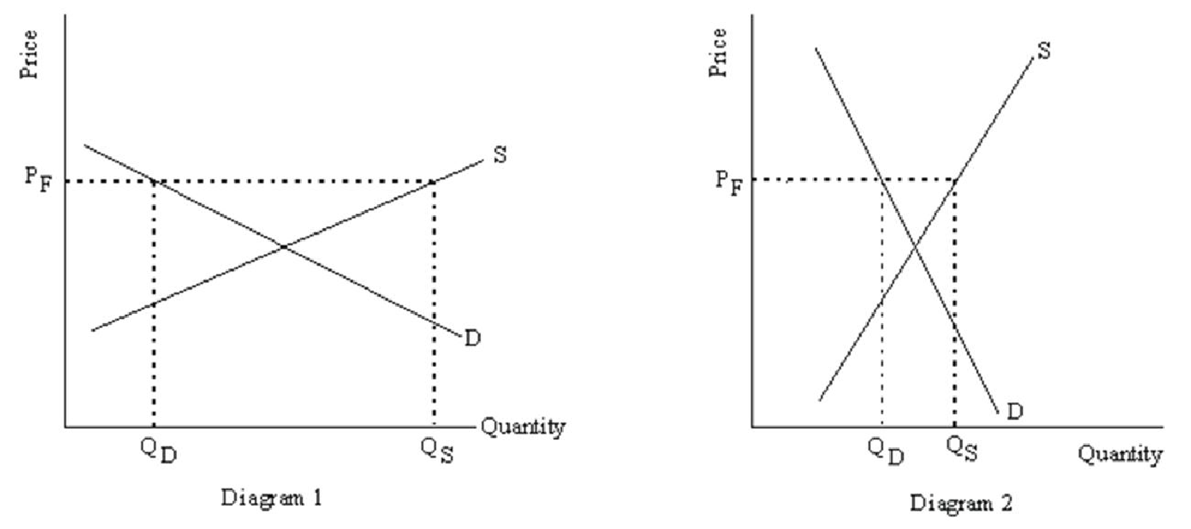

- Use the graph for the following:
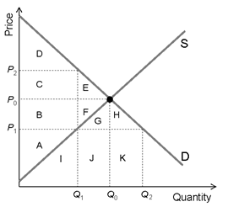
i. What is the consumer surplus when the economy at the equilibrium?

ii. What is the producer surplus when the economy at the equilibrium?

- What is the total surplus when the economy at the equilibrium?

- What area represents the deadweight loss that would result from a price ceiling of 𝑃₁?

- Producer surplus with a price ceiling of 𝑃₁?

- Consumer surplus from a price ceiling of 𝑃₁?

- What is the area that represents the surplus that would be transferred from producers to consumers from a price ceiling of 𝑃₁?

- Does a price ceiling of 𝑃₁ create a shortage or surplus? What is the size of that shortage or surplus?

ANSWER

Part i & Part ii & Part iii

CS = C + D + E PS = A + B + F
Total Surplus = CS + PS = A + B + C + D + E + F

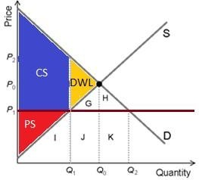
Part iv & Part v & Part vi Deadweight loss: Area (E +F ) Producer Surplus: Area (A)
Consumer Surplus: Area (𝐵 + 𝐶 + 𝐷)

Part vii

Initially, the consumer surplus is (𝐶 + 𝐷 + 𝐸). Consumers lost area (𝐸) as the deadweight loss. Consumers gained area (𝐵). So, area (𝐵) is transferred from producers to consumers.

Part viii

The price ceiling creates a shortage.

𝑠ℎ𝑜𝑟𝑡𝑎𝑔𝑒 = 𝑄2 − 𝑄1

- Suppose that the government imposes an excise tax of 3 TL for every pack of cigarette sold. Before the tax, the price of a pack of cigarette is 7 TL. Consider the following five after-tax scenarios. In each case:
- use an elasticity concept to explain the scenario.
- determine who bears relatively more of the burden of the tax : producers or consumers?
- illustrate your answer with a diagram.

- the price of cigarette paid by consumers rises to 10 TL per packet. Assume that the demand curve is downward sloping.
In this case all of the tax is paid by consumers (new eq. price – old eq. price = 10- 7=3). Producers pay no tax. For this case, supply curve must be perfectly elastic (horizontal supply) while we assume that the demand curve is downward sloping.
P
Q
Q₂ Q₁
10 7
S
D
S+tax

- the price paid by consumers remains at 7 TL per package. Assume that the supply curve is upward sloping.
In this case all of the tax are paid by producers. Consumers pay no tax (new eq. price – old eq. price =7-7=0). For this case, demand curve must be perfectly elastic (horizontal demand) while we assume that the supply curve is upward sloping.
P
Q
Q₂ Q₁
7
4
S
D
S+tax

c) the price of cigarette paid by consumers rises to 9.5 TL per pack.
In this case the part of the tax which are paid by consumer is 2.50 TL (new eq. price – old eq. price =9.5- 7=2.50). Producers pay the other part of the tax (3-2.50=0.50). For this case, consumers bear relatively more of the burden of the tax. This is because supply curve is more elastic than the demand curve.

P
Q
Q₂ Q₁

S
9.5

7
6.5
S+tax

d) the price of cigarette paid by consumers rises to 8 TL per pack.
In this case the part of the tax which are paid by consumer is 1 TL (new eq. price – old eq. price =8-7=1). Producers pay the other part of the tax (3-1=2). For this case, producers bear relatively more of the burden of the tax. This is because demand curve is more elastic than the supply curve.
P
Q
Q₂ Q₁

S
8
7

5
S+tax

e) the price of cigarette paid by consumers rises to 8.5 TL per pack.
In this case the part of the tax which are paid by consumer is 1.5 TL (new eq. price – old eq. price =8.5-7=1.5). Producers pay the other part of the tax (3-1.5=1.5). For this case, producers and consumers bear equally the burden of the tax. This is because demand and supply curves have same elasticity.
P
Q
Q₂ Q₁

S
8.5
7
5.5
S+tax

- A student makes the following statement: “If the federal government raises the sales tax on gasoline by $0.25, then the price of gasoline will rise by $0.25. Consumers can’t get by without gasoline, so they have to pay the whole amount of any increase in the sales tax.” Under what circumstances will the student’s statement be true? Use a graph of the market for gasoline to illustrate your answer.

ANSWER
This problem is about tax incidence. If the demand curve is a vertical line like the graph below, consumers will pay all of an increase in a sales tax only. Then the students’ statement can be true. However, it is very unlikely that the demand for gasoline would look like this because we expect that for every good, an increase in price will cause a decrease in the quantity demanded. Because the demand curve for gasoline is not a vertical line, the statement is incorrect.

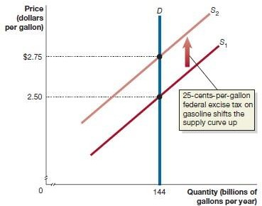

- Consider a market for a good. Qs=4P and Qd=300-2p. According to that information:

  - Calculate the equilibrium price and quantity, consumer and producer surplus.

Qs=4P, Qd=300-2P
In eqb., $Qs=Qd => 4P=300-2P => P_{eq}=50, Q_{eq}=200$
$$CS= (150-50)*200*(1/2)=10000$$
$$PS= 50*200*(1/2)=5000$$

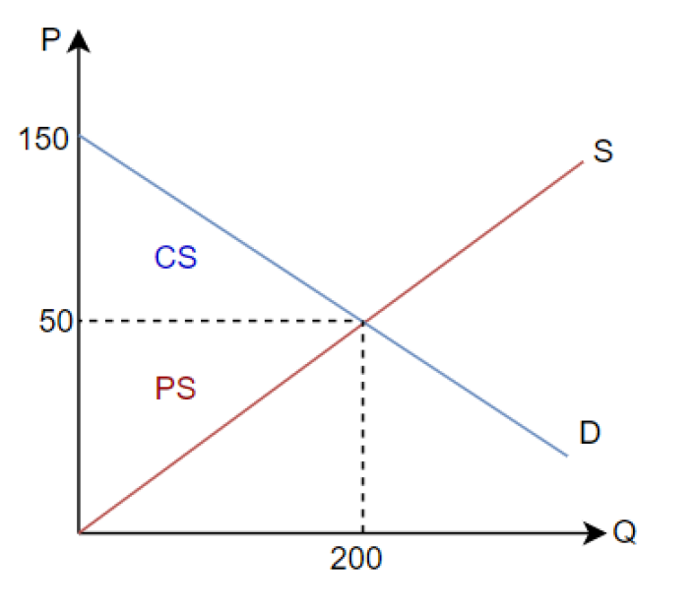

  - Assume that the government imposes a tax on suppliers, that is 30 TL per unit of the good. Calculate the new equilibrium price and quantity, consumer surplus, producer surplus, deadweight loss and total tax revenues.
$$P^{S}=P^{B}-Tax=P^{B}-30=>300-2P^{B}=4\left(P^{B}-30\right)$$
$$P^{B}=70, P^{S}=40$$
$$Q^{t}\left(equilibrium quantity after tax\right)=300-2*70=160$$

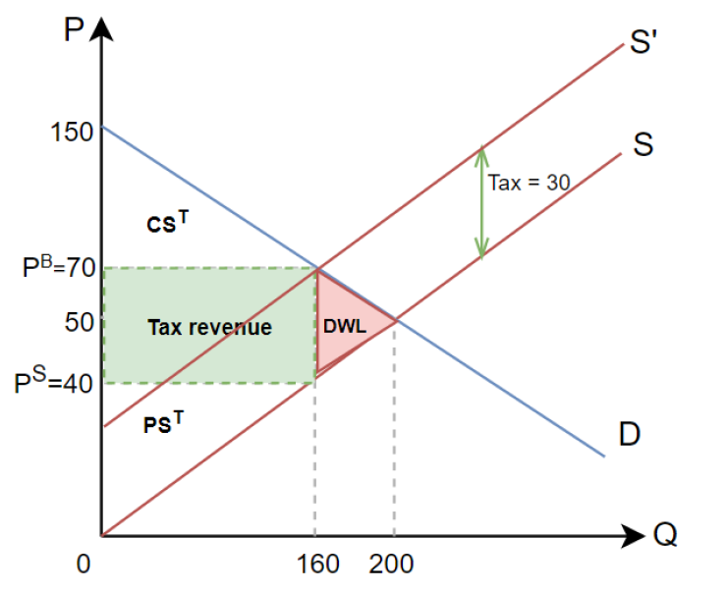

$${CS}^{t}\left(CS after tax\right)=\left(150-70\right)*\left(\frac{160}{2}\right)=6400$$
$${PS}^{t}(PS after tax)=\left(40\right)*\left(\frac{160}{2}\right)=3200$$
$$Tax Rev. =30*160=4800$$
$$DWL=(70-40)*\frac{(200-160)}{2}=600$$
Buyer’s burden $=\left(70-50\right)*160=3200$
Seller’s burden $=\left(50-40\right)*160=1600$
Buyers pay more because demand is more inelastic than supply.

PART B: MULTIPLE CHOICE

- If the minimum that the Smith family would be willing to sell their house for is $185,000, but they in fact sell it for $210,000, they will receive:
              - producer surplus in the amount of $210,000.
              - producer surplus in the amount of $25,000.
              - consumer surplus in the amount of $210,000.
              - consumer surplus in the amount of $25,000.

- The distance between the demand curve and the price the consumer has to pay for a product (given quantity demanded) is referred to as:
              - market surplus.
              - market shortage.
              - consumer surplus.
              - producer surplus.

- Total producer surplus is measured as the area:
              - between the demand curve and the supply curve.
              - above the supply curve.
              - beneath the demand curve and above the market price.
              - beneath the market price and above the supply curve.

- Refer to the graph shown. In equilibrium, consumer surplus is equal to:
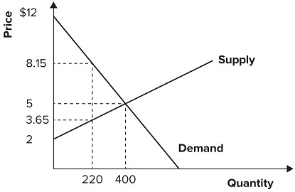
              - 600.
              - 1,200.
              - 1,400.
              - 2,000.

- Refer to the graph shown. In equilibrium, producer surplus is equal to:
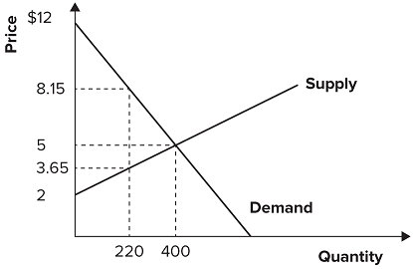
              - 600.
              - 1,200.
              - 1,400.
              - 2,000.
- Refer to the graph shown. If the price were somehow held at $8.15 per unit, consumer surplus would then equal:
              - 1,400.
              - 600.
              - 423.5.
              - 1,171.5.

- Refer to the graph shown. When the market is in equilibrium, producer surplus is area:
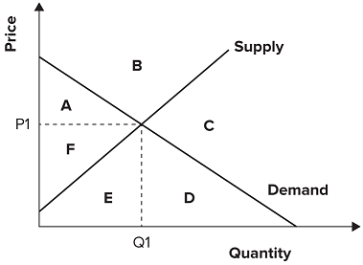
              - A.
              - F.
              - A plus area F.
              - D plus area E plus area F.

- Graphically, deadweight loss is shown by the:
              - welfare loss rectangle.
              - welfare loss triangle.
              - tax revenue rectangle.
              - Consumer surplus loss triangle.
- When government imposes a per-unit tax on a product, the net price producers actually receive for the product (after taxation) typically:
              - increases by the amount of the per-unit tax.
              - increases by less than the amount of the per-unit tax.
              - decreases by the amount of the per-unit tax.
              - decreases by less than the amount of the per-unit tax.
- Refer to the graph shown. Assume the market is initially in equilibrium at point b in the graph but the imposition of a per-unit tax on this product shifts the supply curve up from S₀ to S₁. The effect of the tax is to raise equilibrium price from:
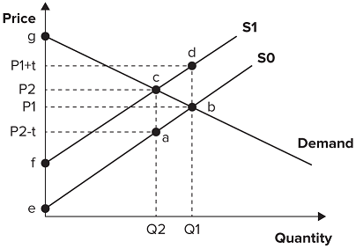
              - P₁ to P₁ + t.
              - P₁ to P₂.
              - P₂ − t to P₂.
              - P₂ − t to P₁ + t.
- Refer to the graph shown. Assume that the market is initially in equilibrium at a price of $10 and a quantity of 500 units. If the government imposes a $4 per-unit tax on this product, the equilibrium price will change to:
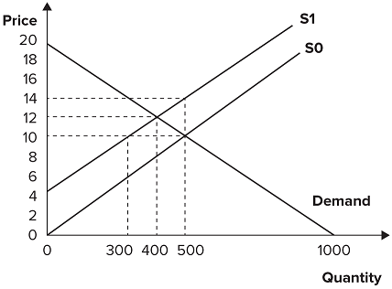
              - $4.
              - $8.
              - $12.
              - $14.
- Refer to the graph shown. Initially, the market is in equilibrium with price equal to $3 and quantity equal to 100. Government imposes a tax on suppliers of $1 per unit. The effect of the tax is to:
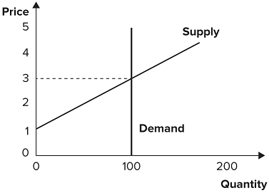
              - give government tax revenues of $100.
              - give government tax revenues of $400.
              - reduce producer surplus by $100.
              - reduce producer surplus by $400.
- If the demand curve is perfectly elastic, the burden of a tax on suppliers is borne:
              - entirely by the suppliers.
              - entirely by the consumers.
              - mostly by the suppliers and partly by the consumers if the supply curve is inelastic.
              - partly by the suppliers and mostly by the consumers if the supply curve is elastic.
- Given a constant supply elasticity of 1.0, the burden of a 10 percent tax on suppliers would be greatest on consumers within what price range?
Price | Quantity
$ 2.00 | 26
4.00 | 22
6.00 | 18
8.00 | 14
10.00 | 10
              - $6 and $8
              - $8 and $10
              - $4 and $6
              - $2 and $4

- Suppose that 75 percent of a cigarette tax is borne by consumers. If the supply elasticity is 1, the demand elasticity is equal to:
              - 1.

