METU
Department of Economics
Econ 101: Introduction to Economics I
Section 01-02
Fall 2023
PROBLEM SET 2 (CH 2&3)
PART A: ESSAY QUESTIONS
- Draw the production possibility frontier and fill in the blanks according to the table.
(Put the amount of meat on the x-axis and the amount of fish on the y-axis)
Combination | A | B | C | D | E | F | G | H | K | L
Fish | 0 | 13 | 23 | 32 | 40 | 47 | 52 | 56 | 59 | 60
Meat | 108 | 102 | 95 | 87 | 78 | 67 | 53 | 36 | 19 | 0

- The production possibilities frontier for this isle will be shaped concave.
- The slope (in absolute value) along this production possibilities frontier increases at an increasing rate as more meats (placed on the X-axis) are produced.
- The slope of this production possibilities frontier varies at each point.
- When the economy moves from point C to F, the opportunity cost of an additional fish, in terms of meat, is 7 / 6 meat(s).
- The opportunity cost of each additional fish in terms of meat ________.
- falls as more fish is produced.
- increases as more fish is produced
- remains constant
- is meaningless because the cost of fish cannot be expressed in terms of meat(s).
- The opportunity cost of each additional meat in terms of fish ________.
- is meaningless because the cost of fish cannot be expressed in terms of meat(s)
- remains constant
- falls as more fish is produced.
- increases as more meat is produced
g) When the economy moves from point K to D, the opportunity cost of a piece additional meat, in terms of fish, is 27 / 68 fish.

- According to the information given below:
Combination | Meat (units) | Wheat (units)
A | 0 | 2000
B | 200 | 1800
C | 400 | 1500
D | 600 | 1100
E | 800 | 600
F | 1000 | 0

  - Draw the production possibility frontier (PPF) (put meat on the x-axis)
Wheat
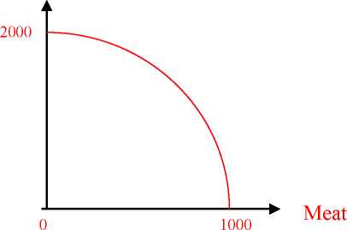

  - The production possibilities frontier is concave to the origin. (concave /convex)
  - Can this economy produce 200 units of meat and 1500 units of wheat? Yes, but it is inefficient or some resources are unemployed.
  - Can this economy produce 200 units of meat and 2200 units of wheat? No it is unattainable
  - What is the opportunity cost of increasing meat production from 200 units to 400 units (i.e. if the economy moves from combination B to combination C)? 300 units of wheat. What is the opportunity cost per unit of meat? 3/2 (=300/200) units of wheat
  - What is the opportunity cost of increasing meat production from 400 units to 600 units (i.e. if the economy moves from combination C to D)? 400 units of wheat. What is the opportunity cost per unit of meat? 2 (= 400/200) units of wheat.
  - Does the principle of “increasing opportunity cost” hold in this economy?
Based on the answers to parts e and f, we can conclude that the principle of increasing opportunity cost applies in this economy. The opportunity cost of each additional unit of meat in terms of wheat increases as more units of meat are produced.
- How do the following events affect the production possibility frontier (PPF) of a country, which produces only two goods food (F) and smart devices (S)? Show the shifts on the PPF graph. (Suppose that food is on the y axis and smart phones are on x axis.)
a) Rising sea levels causes floods damaging the buildings of some coastal cities.
Assuming the coastal cities were are contributing same amount to both sectors

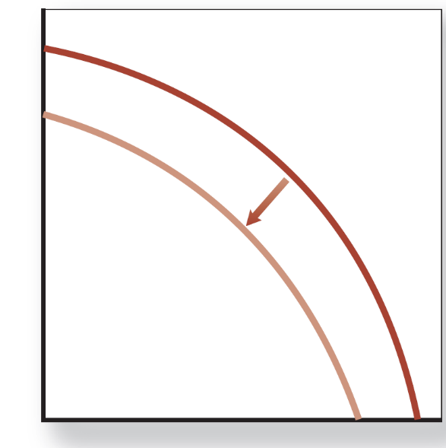
b) Block chain design increases the productivity of the electronics industry.
The increase in the electronics positively affects the smart devices and has no effects on food.
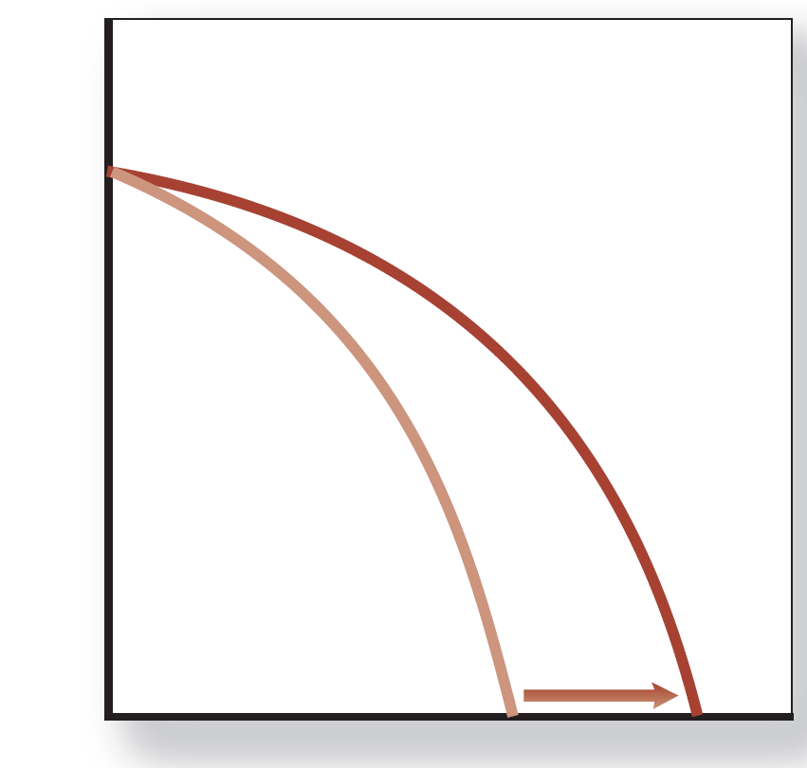

c) Suppose that the government imposed a subsidy to farmers to support agriculture and livestock sectors.
It affects only the food sector positively.

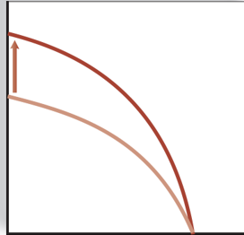
4) Define the following terms briefly and give an example for each.
    - Market failure: Situations in which the market does not lead to a desired result. (Example: Unregulated financial markets in the USA caused the 2008 global crisis.)
- Positive externalities: A positive effect of a decision on a third party not taken into account by the decision maker. (Example: Education. When someone educates herself or himself, all society benefits, since better-educated people usually make better citizens and are better equipped to figure out new approaches to solving problems—approaches that benefit society as a whole.)
Negative externalities: A negative effect of a decision on a third party not taken into account by the decision maker. (Example: Burning of coal, which puts sulfur dioxide, carbon dioxide, and fine particulates into the air. Sulfur dioxide contributes to acid rain, carbon dioxide contributes to global warming, and fine particulates damage people’s lungs. This means that burning coal has an externality associated with it—an effect of an action that is not taken into account by market participants.)
- Public good: good that if supplied to one person must be supplied to all and whose consumption by one individual does not prevent its consumption by another individual. (Example: National defense, which, if supplied to one, will also protect others. In order to supply defense, governments must require people to pay for it with taxes, rather than leaving it to the market to supply it.)
- Demerit goods or activities: Goods or activities that government believes are bad for people even though they choose to use the goods or engage in the activities. (Example: Cigarettes are a demerit good and using addictive drugs is a demerit activity.)
- Merit goods or activities: Goods and activities that government believes are good for you even though you may not choose to engage in the activities or to consume the goods. (Example: Government may believe that going to the theatre or donating blood to Kızılay is a good activity. But in Turkey only a small percentage of people go to the theatre, and not everyone in the Turkey donates blood. Similarly, government may believe that whole-wheat bread is more nutritious than white bread. But many consumers prefer white bread.)

- What are the specific roles for government in the economy?

In today’s world, governments act as both and actor and referee in the economy. The major roles of the government are:
- Providing a stable set of institutions and rules: A basic role of government is to provide a stable institutional framework that includes the set of laws specifying what can and cannot be done as well as a mechanism to enforce those laws. (Colander, D. C., 2019).
- Promote Effective and workable competition: In a market economy, the pressure to monopolize—for one firm to try to control the market—and competition are always in conflict; the government must decide what role it is to play in protecting or promoting competition. Thus, when Microsoft gained monopolistic control of the computer operating system market with Windows, the U.S. government took the company to court and challenged that monopoly. (Colander, D. C., 2019).
- Correct for Externalities: When two people freely enter into a trade or agreement, they both believe that they will benefit from the trade. But unless they’re required to do so, traders are unlikely to take into account any effect that an action may have on a third party. Economists call the effect of a decision on a third party not taken into account by the decision maker an externality. An externality can be positive (in which case society as a whole benefit from the trade between the two parties) or negative (in which case society as a whole is harmed by the trade between the two parties). When there are externalities, there is a potential role for government to adjust the market result through taxes, subsidies, or regulation. Throughout this book we will be considering the advantages and disadvantages of each. (Colander, D. C., 2019).
- Ensure Economic Stability and Growth: In addition to providing general stability, government has the potential role of providing economic stability. Most people would agree that if it’s possible, government should prevent large fluctuations in the level of economic activity, maintain a relatively constant price level, and provide an economic environment conducive to economic growth. (Colander, D. C., 2019).
- Provide Public Goods: As we discussed in the previous question, A public good is a good that if supplied to one person must be supplied to all and whose consumption by one individual does not prevent its consumption by another individual. An example of a public good is national defense, which, if supplied to one, will also protect others. In order to supply defense, governments must require people to pay for it with taxes, rather than leaving it to the market to supply it. (Colander, D. C., 2019).
- Adjust for Undesirable Market Results: Government redistributes income, taking it away from some individuals and giving it to others whom it sees as more deserving or more in need. In doing so, it attempts to see that the outcomes of trades are fair. Determining what’s fair is a difficult philosophical question that economists can’t answer.
(Colander, D. C., 2019).
- A market economy can be divided into three sectors: businesses, households and governments. Define the factor markets and goods markets and explain their relationship with these sectors using a diagram.
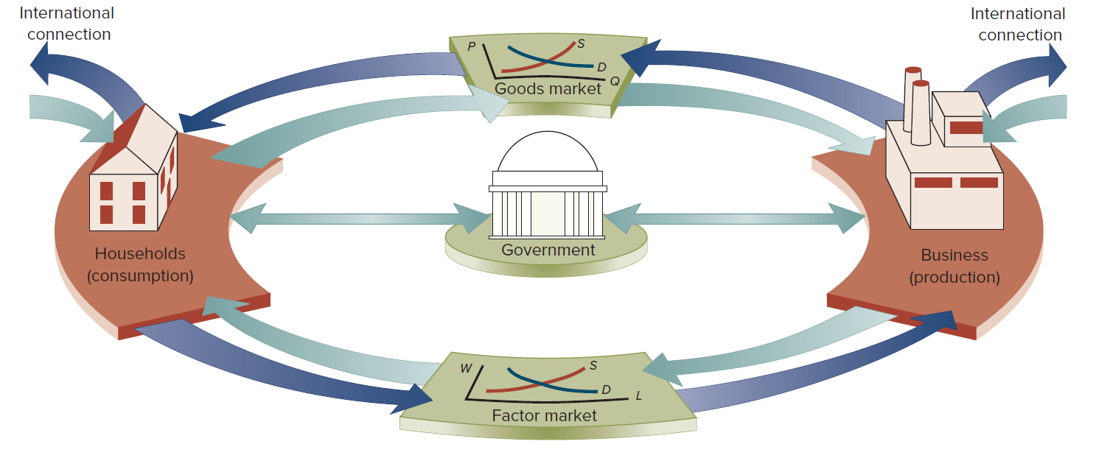
The market where households supply factors of production (land, labor, capital, and entrepreneurial ability) to businesses and are paid by businesses is called a factor market. The market where businesses produce goods and services and sell them to households and government is called the goods market. Moreover, the entire economy is interconnected with the world economy with the flows of goods and services (exports and imports) and money (capital flows). Finally, consider the arrows connecting government with households and business. Government taxes business and households. It buys goods and services from business and buys labor services from households. Then, with some of its tax revenue, it provides services (for example, roads and education) to both business and households and gives some of its tax revenue directly back to individuals. In doing so, it redistributes income. But government also serves a second function. It oversees the interaction of business and households in the goods and factor markets (Colander, D. C., 2019).

PART B: MULTIPLE CHOICE

- The Production Possibilities Frontier (PPF) depicts the fact that
- When a society combines its resources efficiently, it cannot produce more of one good without producing less of the other good.
- When a society combines its resources efficiently, it cannot produce more of one good without producing more of the other good.
- Some resources are always idle in a democratic society
- All points inside the curve are preferred to all points on the curve in terms of efficiency
- The demand for goods always exceeds the supply
- The opportunity cost of producing good A is defined as
- The money cost of the factors of production used in good A
- The retail price of good A
- The cheapest method of producing good A
- What must be the additional production cost get an additional unit of A
- The cost of having the best alternative in place of good A
- On the diagram of a PPF, the concept of scarcity is illustrated by
- the points on the curve
- the area within the curve
- the distance from origin to the curve
- the negative slope of the curve
- the unattainable points outside the curve
- Suppose that 1 unit of labor can produce either 5 units of wool or 2 pineapples. What is the opportunity cost of producing 1 pineapple?
- 5 units of wool
- 2 units of wool
- 2/5 units of wool
- 5/2 units of wool
- Zero

Refer to the graph below.
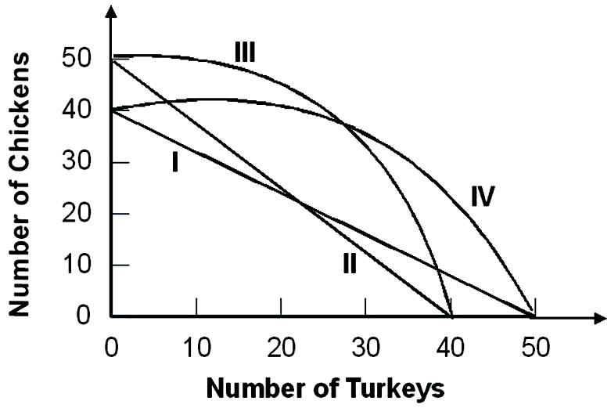
Suppose that the opportunity cost of producing 10 chickens is always 8 turkeys. Given this, the relevant production possibility curve must be:
  - I
  - II
  - III
  - IV
  - None of the above

- Refer to the graph below
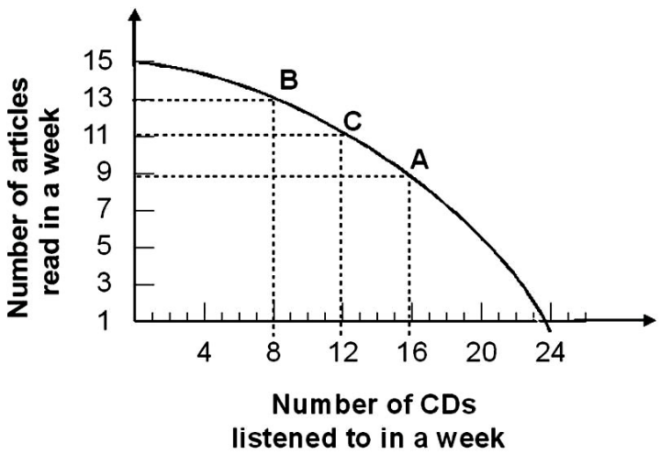

Given the production possibility curve, the opportunity cost of reading 2 more articles when you are already reading 11 articles is on average:
- ½ CD per article
- 2 CDs per article
- 2/3 CDs per article
- 3 CDs per article
- 3/2 CDs per article
- The principle of increasing opportunity costs states that the initial opportunity costs are:
- high but decrease the more you concentrate on the activity.
- low but increase the more you concentrate on the activity.
- high but increase the more you concentrate on the activity.
- low but decrease the more you concentrate on the activity.
- In a free market economy, the allocation of resources is decided by
- Central authorities only
- Central authorities and firms only
- Firms and households acting independently
- Political parties and firms only
- Individuals only
- In the economic theory, it is typically assumed that households and firms, respectively maximize
- Income and sales
- Savings and profits
- Wages and revenues
- Utility and profits
- Expenditures and profits
- Economic theory shows that in the private sector of a market economy, the price system allocates resources
- In goods market only
- In factor markets only
- In and equitable manner
- Better than they could be allocated by another allocation system
- In both goods and factor markets
- The circular flow of economic activity
- Illustrates the relationship between wants and resources
- Illustrates the relationship between financial system and government
- Shows why income flows do not balance the expenditure flows
- Illustrates the relationship between consumers and business
- Illustrates the relationship government, households and firms

- Markets coordinate economic activity through:
- the price mechanism.
- commanding individuals what to do.
- asking individuals what to do.
- the legal mechanism.
- The government intervention
- In the simple circular flow model, the government .
A) Has little influence over the markets
B) Influences both the input and output markets through taxes and regulations
C) Only siphons out income from the model through taxes
D) Increases the amount of income in the economy

- Which of the following is not an example of government's role as a referee?
- Equal opportunity and labor laws that restrict businesses' freedom to hire and fire whomever they want.
- Regulations governing safety in the workplace, wages, overtime, and hours of work
- Laws prohibiting businesses from meeting to fix prices
- Laws that require states and the federal government to balance their budgets

- The government serves as an actor in the economy when it
- alters anti-trust laws.
- increases defense spending
- reduces the minimum wage.
- improves health and safety standards for certain industries.

