METU Department of Economics
ECON102
Sections 1&2
Spring 2024
TA: Zeki Oğulcan Şengül
PROBLEM SET 6

- Suppose that Suerte Insurance Company buys a Treasury Bill from the Central Bank of Turkish Republic for 10,000 TL. It pays for the bill by writing a check on its account with Türkiye İş Bankası. The T-account below shows the initial situation.

Türkiye İş Bankası
Assets |  | Liabilities
Reserves | 100,000 TL | Deposits | 1,000,000 TL
Loans | 900,000 TL

a) If the reserve requirement ratio is 10%, what are the İşbank’s required reserves initially? Does it have excess reserves initially?

𝑹𝒆𝒒𝒖𝒊𝒓𝒆𝒅 𝑹𝒆𝒔𝒆𝒓𝒗𝒆𝒔 = 𝒓𝒓 ∗ 𝒅𝒆𝒑𝒐𝒔𝒊𝒕𝒔 = 𝟎. 𝟏 ∗ 𝟏, 𝟎𝟎𝟎, 𝟎𝟎𝟎 = 𝟏𝟎𝟎, 𝟎𝟎𝟎 𝑻𝑳 The bank has no excess reserves, and its reserves are equal to required reserves.
b) Show the immediate effect of the withdrawal from İşbank in the T-account above.

Türkiye İş Bankası (after the withdrawal by Suerte)
Assets |  | Liabilities
Reserves | 90,000 TL | Deposits | 990,000 TL
Loans | 900,000 TL

c) What is the status of İşbank’s reserves after the withdrawal? Are they sufficient to meet requirements?
𝒓𝒆𝒒𝒖𝒊𝒓𝒆𝒅 𝒓𝒆𝒔𝒆𝒓𝒗𝒆𝒔 = 𝟎. 𝟏 ∗ 𝟗𝟗𝟎, 𝟎𝟎𝟎 = 𝟗𝟗, 𝟎𝟎𝟎 𝑻𝑳
No, actual reserves are less the required reserves.
d) İşbank reacts by calling in a loan it had made to Ms. Geller equal to the amount of its reserve deficiency. Ms. Geller repays the loan with funds she has just received from her grandmother’s estate. She received those funds as a check drawn on YapıKredi, whose T-account is shown below. Show the effects of these transactions on those two banks.

YapıKredi (initial situation)
Assets |  | Liabilities
Reserves | 50,000 TL | Deposits | 500,000 TL
Loans | 450,000 TL

YapıKredi (After a check from grandma clears)
Assets |  | Liabilities
Reserves | 41,000 TL | Deposits | 491,000 TL
Loans | 450,000 TL

Türkiye İş Bankası (after receiving loan payment)
Assets |  | Liabilities
Reserves | 99,000 TL | Deposits | 990,000 TL
Loans | 891,000 TL

e) After this transaction, does İşbank have sufficient reserves? What about YapıKredi?
İş𝒃𝒂𝒏𝒌: 𝑹𝒆𝒒𝒖𝒊𝒓𝒆𝒅 𝑹𝒆𝒔𝒆𝒓𝒗𝒆𝒔 = 𝟎. 𝟏 ∗ 𝟗𝟗𝟎, 𝟎𝟎𝟎 = 𝟗𝟗, 𝟎𝟎𝟎 𝑻𝑳.
Yes, actual reserves are equal to required reserves.
𝒀𝒂𝒑𝚤𝑲𝒓𝒆𝒅𝒊: 𝑹𝒆𝒒𝒖𝒊𝒓𝒆𝒅 𝑹𝒆𝒔𝒆𝒓𝒗𝒆𝒔 = 𝟎. 𝟏 ∗ 𝟒𝟗𝟏, 𝟎𝟎𝟎 = 𝟒𝟗, 𝟏𝟎𝟎 𝑻𝑳.
No, actual reserves are less than required reserves. (41,000<49,100)
f) After all banks meet their reserve requirements, how much does this initial transaction of Suerte Insurance company change the money supply in the market? (Assume that there is no change in currency in circulation.)

𝚫𝒊𝒏 𝒎𝒐𝒏𝒆𝒚 𝒔𝒖𝒑𝒑𝒍𝒚 = 𝚫 𝒊𝒏 𝒅𝒆𝒑𝒐𝒔𝒊𝒕𝒔 + 𝚫 𝒊𝒏 𝒄𝒖𝒓𝒓𝒆𝒏𝒄𝒚 𝒊𝒏 𝒄𝒊𝒓𝒄𝒖𝒍𝒂𝒕𝒊𝒐𝒏

𝚫𝒊𝒏 𝒎𝒐𝒏𝒆𝒚 𝒔𝒖𝒑𝒑𝒍𝒚 = 𝚫 𝒊𝒏 𝒅𝒆𝒑𝒐𝒔𝒊𝒕𝒔 + 𝚫 𝒊𝒏 𝒄𝒖𝒓𝒓𝒆𝒏𝒄𝒚 𝒊𝒏 𝒄𝒊𝒓𝒄𝒖𝒍𝒂𝒕𝒊𝒐𝒏

$$∆in deposits= -10, 000 * \frac{1}{0.1}=-100.000$$

$$∆in money supply= -100.000+0= -100.000$$

- Consider an economy described by the following equations:
Money Supply : Ms = 200 Money Demand : Md = 150 – 500*i + 0.42*Y + 0.8*P
Consumption : C = 200 + 0.25*Yd Net Taxes : T = – 40 + 0.2*Y
Investment : I = 100 – 5000*i Government expenditures: G = 100
(Assume that inflationary expectations are zero) where r is the real interest rate, i is the nominal interest rate, Y is the output level, P is the price level and Y_{d} is disposable income. Derive the aggregate demand curve.

First note that the aggregate demand curve represents the price-output pairs at which both the goods and the money markets are at equilibrium. In the money market, a change in the price level causes the money demand to shift. Given money supply, the change in money demand leads to a change in the equilibrium interest rate which, in turn, affects aggregate expenditure and thus total demand via investment.
Y = AE => Goods Market Equilibrium
Y = C + I + G = 200 + 0.25*Y_{d} + 100 – 5,000*r + 100 => r = 0.082 – 0.00016*Y
M_{s} = M_{d} => Money Market Equilibrium
200 = 150 – 500*i + 0.42*Y + 0.8*P => i = – 0.1+0.00084*Y+0.0016*P
Since inflationary expectations are assumed zero; i=r
In the equilibrium, the same interest rate holds for both the money market and the goods market:
– 0.1+0.00084*Y+0.0016*P = 0.082 – 0.00016*Y
P = 113.75 – 0.625*Y => the aggregate demand (AD) curve which represents the relationship between price level and national income. Note that the AD curve has a negative slope, confirming that there is an inverse relationship between the price level and the total demand for goods and services.

- Suppose that Turkish economy is initially in long-run equilibrium. For each of the changes listed below, analyze short-run and long-run effects on:
- the equilibrium level of real GDP;
- the equilibrium level of nominal GDP; and
- the equilibrium level of unemployment.
In each case, draw a diagram and include an explanation as to why the curves shift as they do.
- Consumers, coming to fear that the government will not provide for them in their old age, increase their saving.
This will cause a decrease in consumption, which will shift the AD curve to the left as shown below, from AD₁ to AD₂. In the short run, this means that both the equilibrium level of real GDP (Y) and the price level decrease along the initial short-run aggregate supply curve, SRAS₁. This is the movement from A to B on the diagram.
- Real GDP, Y, falls from its initial (natural) rate Y_{N} to Y₂.
- We know that nominal GDP is just real GDP (Y) multiplied by the price level, so when both Y and P fall, then nominal GDP must fall as well.
- We also know that if the level of output has fallen, and nothing has happened to productivity (which it hasn’t in this case) then it must be true that we are employing fewer factors of production, of which labor is the one that varies most readily. If we are employing less labor, then unemployment must have increased.
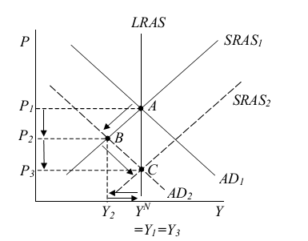
In the long run, the fact that GDP is below its natural rate (Y₂<Y_{N}) means that expected prices and therefore wages fall, causing the short-run aggregate supply curve to shift down over time and the equilibrium to move along its intersection with AD₂. This continues until long-run equilibrium is restored at point C, where a new short-run aggregate supply curve, SRAS₂ crosses AD₂ along the (unchanged) long-run aggregate supply curve LRAS.

The price level has fallen still further, to P₃, while real GDP has risen back to its natural rate, Y₃=Y_{N}. Thus in the long run, compared to the initial equilibrium before all this happened,
- Real GDP is unchanged at Y_{N} (having first fallen and then risen);
- Nominal GDP is reduced, since Y is unchanged but P has fallen (we can’t tell whether nominal GDP rises or falls from point B to point C, since Y rises but P falls); and
- Unemployment is unchanged at its natural rate u_{N} (having first risen and then fallen).

- Optimism about future economic performance causes businesses to increase domestic fixed investment.
This is an increase in investment, a component of aggregate demand, which we know causes the AD curve to shift to the right. An increase in investment also adds over time to the economy’s capital stock, which expands the output that can be produced at the natural rate of unemployment and therefore increases the natural rate of output as well. It is customary in using the AD-AS model not to consider such even longer-run effects, but it would not be incorrect to include them here since the question did not explicitly rule them out. Therefore the diagram shows both cases. (It does not show any position for the SRAS curve after its initial position, even though over time it presumably shifts up as expectations change and also to the right as the natural rate of output changes.) Thus, in the short run aggregate demand shifts to the right, to AD₂, and the economy moves from point A to point B, with the price level and real GDP rising to P₂ and Y₂ respectively:
- Real GDP rises;
- Nominal GDP also rises, since P and Y both rise;
- Unemployment falls, as more workers are needed to produce the higher output.
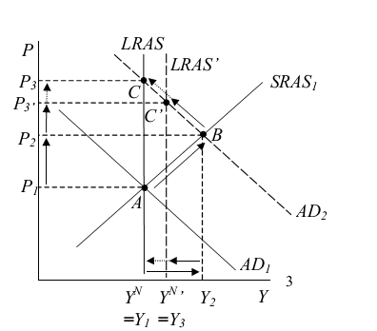
Over time, since output is now above its natural rate, expected prices and therefore wages rise, shifting the short-run aggregate supply curve upward. This shift is not shown in the diagram, to reduce clutter, but it moves the equilibrium along the new aggregate demand curve AD₂, eventually to point C’ or C, depending on whether or not we allow for the rightward shift of long-run aggregate supply to LRAS’, due to the increased capital stock. Real GDP therefore falls back toward its original level, reaching it if we ignore the increased capital stock, or settling above it at Y₃ if we do not ignore this. Thus in the long run;

- Real GDP either remains unchanged if we consider only the effect of investment as aggregate demand, or it rises if we allow for its very long run effect on the capital stock (having first risen and then fallen over time in both cases);
- Nominal GDP rises either way, since the price level rises; and
- The unemployment rate falls.

- In a quest for re-election, the president pushes for more tax cuts.
A reduction in taxes increases households’ disposable income. Therefore, we’d expect consumption to increase. Because C is a component of aggregate demand, the increase in C shifts the AD curve to the right. (For simplicity we ignore the long run effects of an induced increase in the real interest rate: C, I, and NX would decrease – shifting AD to the left –)
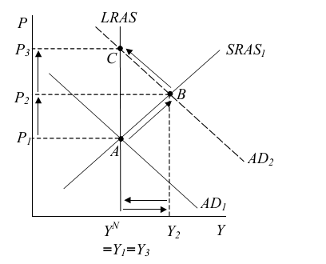
That is, in the short run:
i) Real output rises;
ii) Nominal GDP also rises, since P and Y both rise
iii) Unemployment falls.
In the long run:
i) Real output falls back to its natural rate;
ii) Nominal GDP remains above its initial level, since P has risen; and
iii) Unemployment rises back to its natural rate.

- An increase in the price of oil used in production.
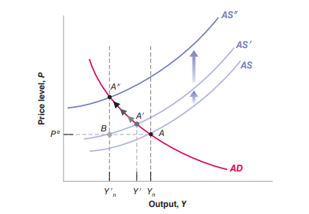
In the short run, only the AS shifts. The economy therefore moves along the AD curve, from A to A. Output decreases from Yn to Y. The increase in the price of oil leads firms to increase their prices. This increase in the price level then decreases demand and output. What happens over time? Although output has fallen, the natural level of output has fallen even more: At point A, output Y is still above the new natural level of output Y n, so the aggregate supply curve continues to shift up. The economy therefore moves over time along the aggregate demand curve, from A to A. At point A, output Y is equal to the new lower natural level of output Y n, and the price level is higher than before the oil shock: Shifts in aggregate supply affect output not only in the short run but in the medium run as well. To summarize: Increases in the price of oil decrease output and increase prices in the short run. If the increase in the price of oil is permanent, then output is lower not only in the short run, but also in the medium run

- (PAST EXAM QUESTION) Suppose you are the economic advisor to the government of SURVIVORLAND, a small island. In this economy there is a deep recession and soaring unemployment. At the same time budget deficit and the interest rate are high. To cure these, the prime minister asks you to prepare a report about the possible effects of implementing a contractionary fiscal policy and an expansionary monetary policy simultaneously on the major macroeconomic variables (such as the national income, the interest rate, the level of investments, the level of consumption, the budget balance etc.) Your essay should also explain the meaning and tools of those policies cited above. Explain the sequence of events (i.e. how these policies affect various variables) after these policies are implemented.

- National Income (Recession, unemployment and consumption)

The effect of contractionary fiscal policy (decrease in government spending or increase in taxes) on AD curve is to shift the curve on leftwards, on the other hand, expansionary monetary policy causes AD curve to shift to rightwards. Overall, since the effect of these two policies offsets each other, it will not cause any change in AD curve or solve the recession problem. In addition, since there is no such increase in the country's production, the unemployment will not decline as well. Consumption is not affected from the income channel.

Effect of Expansionary Monetary Policy
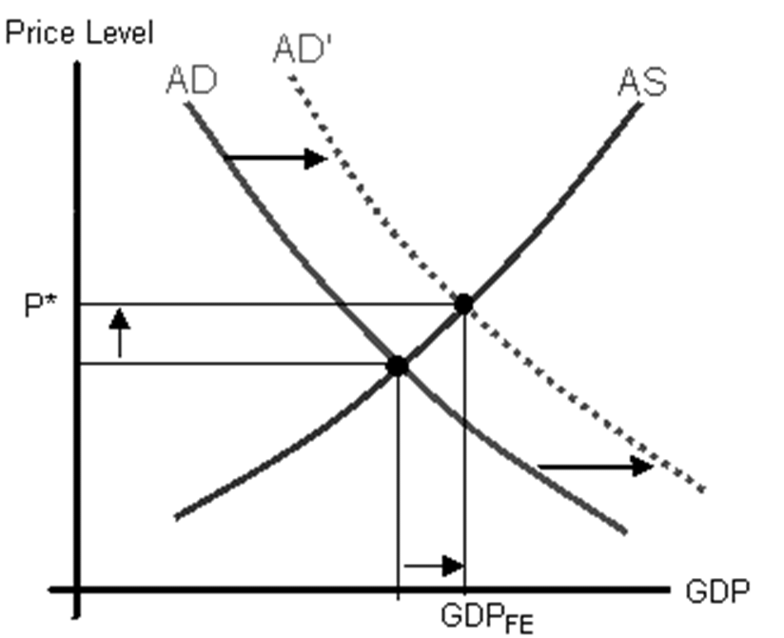

Contractionary fiscal Policy
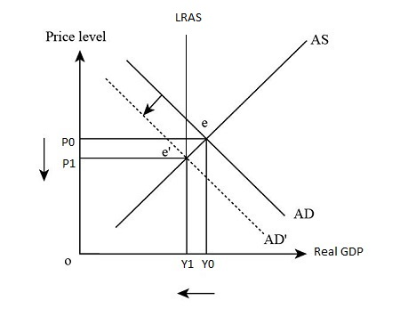
- Interest Rate and
The interest rate is determined in the money market. Thus, we will examine only the effect of monetary policy in this case.

The expansionary monetary policy, that is, an increase in the total money supply in the economy by the central bank, causes interest rates to decrease. As a result of this policy, the high interest rate problem can be solved. In addition, since the relationship between interest rate and investment is negative, the decrease in interest rate will cause investments to rise.

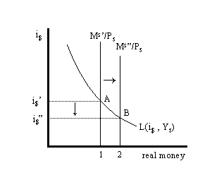

- Budget Balance
Budget Balance is about the fiscal policy. Since we are conducting contractionary fiscal policy, we expect that the budget deficit will be either eliminated or declined since, by definition, contractionary fiscal policy is the decline of government expenditure or an increase in taxes.

In conclusion, the government cannot reach all of its targets due to this policy mix. Among these, although the high-interest rates and budget deficit problems will be solved by contractionary fiscal policy and expansionary monetary policy, because of the offsetting effects of these two policies, the economy will not go away from the recession, not create new employment opportunities and decrease unemployment.
- In 1993 there was a severe drought in Maldavia. As a result of the drought, approximately two-thirds of the country's agricultural crops were destroyed. Using an AS/AD diagram, indicate what effect this drought would have on the overall price level and the equilibrium level of output. The Maldavian government is considering a number of policies to counter the effects of the drought on the economy. For each of the following policies, draw a graph that indicates the effects of the drought and then indicate how the policy would affect the overall price level and level of equilibrium aggregate output in Maldavia.
The drought would cause the aggregate supply curve to shift to the left. This would increase the overall price level and reduce the equilibrium level of output.
AD

AS

AS’

Y

P

- The government is considering reducing net taxes.
A reduction in net taxes would increase both the overall price level and the equilibrium level of aggregate output.
AD

AD’

AS

AS’

Y

P

- The government is considering reducing public investment in agriculture and not spending that money on any other projects.
A reduction of public investment in agriculture will cause both aggregate demand and aggregate supply to decrease. Output will fall further than if there were no policy action, but the price level increase will be smaller.

AD

AD’

AS

AS’

Y

P

PART B: MULTIPLE CHOICE

- As the price level increases, the quantity of money demanded
- increases and thus quantity of aggregate demanded goods and services increases.
- increases and thus quantity of aggregate demanded goods and services decreases.
- decreases and thus quantity of aggregate demanded goods and services decreases.
- decreases and thus quantity of aggregate demanded goods and services increases.

- The SRAS curve is upward sloped because;
- AD increases at higher levels of national income.
- Inputs become more expensive at higher levels of output.
- Unit costs fell at higher levels of output.
- Unit costs rises at higher levels of output.

- The AS curve is likely to be nearly vertical for output levels close to capacity because
- the additional cost of producing more output is likely to be very high
- aggregate demand is high
- the additional cost of producing more output is likely to be very low
- prices and wages are above their equilibrium levels

- If major labor unions succeed in increasing wages; this will cause;
- SRAS to shift upward (to the left) and then return immediately to its original position.
- Both the SRAS and AD curves to shift in opposite directions.
- The SRAS curve to shift upward (to the left) , increasing the price level.
- The SRAS curve to shift upward (to the left), reducing the price level.

- When a shift in AD occurs, the effect will be divided between a change in output and a change in price level. How the effect is divided depends on
a) the position of the AE curve b) the slope of the SRAS curve
c) the amount of inflation in the economy d) the size of the multiplier

- Increased wealth
- does not affect consumption because the increase is always expected.
- does not affect consumption because consumption is a function of disposable income only.
- tends to lead, ceteris paribus, an upward shift in the consumption function.
- tends to lead, ceteris paribus, a downward shift in the consumption function.

- In the short-run, an increase in AD will increase ______ (price level / output / price level and output) and in the long run will increase ______ (price level / output / price level and output).
a) price level and output; price level b) price level and output; output
c) price level; price level d) output; price level and output
- Suppose that the economy is expanding, so actual output exceeds the potential output. Inflationary pressures are increasing. An appropriate fiscal policy would most likely result in;
- A reduction in government’s budget surplus.
- An increase in government’s budget deficit.
- An increase in the government’s budget surplus or at least a reduction in its deficit.
- Either an increase in the government’s budget deficit or a decrease in its surplus, depending on whether taxes increased or spending decreased.

- If the Central Bank increases the money supply, we would expect interest rates to _____; thus the AE curve shifts ______ and the AD curve shifts ______.
a) rise / upwards / rightwards b) fall / upwards / rightwards
c) fall / upwards/ leftwards d) fall / downwards / leftwards

- A decrease in the level of real GDP in the economy leads to a _______ the money demand curve.
a) leftward shift of b) rightward shift of c) leftward movement along d) rightward movement along

- A technological improvement will shift;
- Both the SRAS and AD curves to the right.
- Both the SARS curve and LRAS curves to the right.
- The SRAS curve to the right but leave the LRAS curve unchanged.
- The LRAS to the right but leave the SRAS curve unchanged.

- Monetary policy is most likely to result in high GDP growth when the AS curve is;
- Horizontal and the Central Bank lowers the required reserve ratio.
- Vertical and the Central Bank lowers the discount rate.
- Vertical and the Central Bank raises the reserve requirement.
- Horizontal and the Central Bank sells securities.

- An increase in oil prices, such as the oil shocks in the 70s, cause a ______ shift of _______ curve, move the economy along _____ curve causing a ______ inflation.
a) leftward / AD / SRAS / cost-push b) leftward / SRAS / AD / demand-pull
c) rightward / AD / SRAS / demand-pull d) leftward / SRAS / AD /cost-push

- If LRAS curve is vertical, _______ has (have) an effect on the aggregate output in the long run.
- sometimes monetary and / or fiscal policy (i.e. it depends)
- neither monetary policy nor fiscal policy
- monetary policy does not but fiscal policy does
- both monetary policy and fiscal policy.

- If AD shifts out and AS shifts down,
- Both income and the price level must rise
- Income will rise but the price level may fall or rise
- The price level must fall and income level must increase
- The price level will not change and the impact on income is uncertain

- The downward slope of the AD curve demonstrates
- the negative relationship between the interest rate and equilibrium output because (ceteris paribus) a rise in the price of bonds causes a fall in the interest rates
- the positive relationship between the price level and equilibrium output because (ceteris paribus) a rise in the price level raises the quantity of money demanded
- the negative relationship between the price level and equilibrium output because (ceteris paribus) a rise in the price level raises the quantity of money demanded and thus raises the interest rate
- the negative relationship between the price level and equilibrium output because (ceteris paribus) a rise in the price level raises the quantity of money demanded and thus lowers the interest rate
Real National Income
Y
Price Level
2.6
2
1
500
800
1000
AD₀
AD₁
SRAS₀
i
f
g
h
P
Answer the following 5 questions according to graphs below.

500
AE₁
500
45⁰
250
AE₂
AE₀
Y
c
d
b
800
1000
e
a
Desired Expenditure
Real National Income

- The horizontal distance fg represents
- The increase in real national income if the price level varies
- The increase in aggregate demand due to an increase in autonomous expenditures
- The macroeconomic equilibrium consistent with SRAS₀
- The value of simple multiplier

- Assuming that input prices do not change, the new short – run macroeconomic equilibrium as a result of the increase in autonomous expenditure will be
- At point f, where the autonomous expenditure is completely offset
- At point i, with real output of 800 and a price level of 2.0
- At point g, with real output of 1,000 and a price level of 2.0
- At point h, with real output of 800 and a price level of 2.6

- Assuming that AE curve shifts upward from AE₀ to AE₁ but the price level remains constant at its initial level, we can say that,
- autonomous expenditures must have increased by 250
- equilibrium real national income increases by 500
- the AD curve shifts to the right, Y’ = 1,000 at the price level 2 and an excess demand for goods emerges
- all of the above are correct

- The value of simple multiplier is
a) 5.0 b) 0.5 c) 2.0 d) 4.0

- The movement from point g to h implies
- The AE₁ curve shifts downward to intersect the 45⁰ line at an output 800, as at point c
- The AE₁ curve shifts downward to intersect the 45⁰ line at an output 500, as at point a
- The economy moves along the AE₁ curve until it reaches an output of 800, as at point c
The economy moves along the AE₀ curve until it reaches an output of 800, as at point

