METU
Department of Economics
Econ 101: Introduction to Economics I
Section 01-02
Fall 2023
PROBLEM SET 8 (CH 13 and 14)
- You are given the following information about industry of X-netbook:
- Long-run average costs:
Labour cost: 3 TL per unit of output; Capital cost: 4 TL per unit of output
- The industry is in long-run equilibrium.
- Industry is perfectly competitive: with each of 50 firms producing the same amount of output
- Total industry output = 8000 units

- Show the current conditions by drawing two diagrams: one showing the industry (demand and supply) and one showing a representative firm (short-run and long-run costs). Mark clearly the prevailing price in the market in both of the diagrams.

ii) Indicate the profit/loss level of the representative firm on the diagram.
Now assume that, the demand of X-netbook is expected to grow rapidly over the next few years to a level of twice as high it is now. But due to short-run diminishing returns the existing firms in the industry could only increase the quantity supplied by % 50.

iii) Show and explain the effect of the above developments on the industry in the short-run by using the diagram you have drawn in part (i) as your initial point.

iv) Show the effect of the above developments on a typical firm in the short-run by using the short-run and long-run cost curves. Use the diagram you have drawn in part (i) as your initial point. Also show the level of profits/losses in your diagram.
v) Assume that the industry is a constant cost industry.Explain how the typical firm and the industry as a whole will move to the new long-run equilibrium.
vi) Show the final long-run equilibrium of the industry after all the adjustments have taken place assuming that long-run equilibrium price is the same as initial long-run equilibrium.
2) Suppose that there are 100 consumers in a perfectly competitive market and individual demand curves of these consumers are identical. Also, assume that there are 10 firms in the industry and these firms are identical as well. The following information is provided about this competitive market:
Individual Demand Curve: $P=100–10Q_{D}$
Total Cost of a Representative (individual) Firm: $TC=20Q+\frac{1}{6}Q^{2}+100$

- Find total variable cost (TVC), total fixed cost (TFC) and marginal cost (MC) functions of the representative firm.

- Find average total cost (ATC), average variable cost (AVC), average fixed cost (AFC) functions of the representative firm.

- What is the market demand function?

- What is the definition of market supply function?

- What is the equilibrium price and quantity in this market if market supply is P=20+(1/30)Q ?

- What is the quantity produced by the representative firm?

- Calculate the level of profits that the representative firm is earning.
- Holding everything else constant, what do you predict will happen in this industry in the long run? Explain your answer fully with a verbal description rather than a numeric calculation.

- This question traces some of the long-run adjustments that take place in a perfectly competitive market in response to a change in demand. Each firm currently in the industry, as well as each potential entrant, has the cost structure depicted in the left panel below. The right panel shows the industry's short-run supply curve and the current market demand curve $D_{0}$.
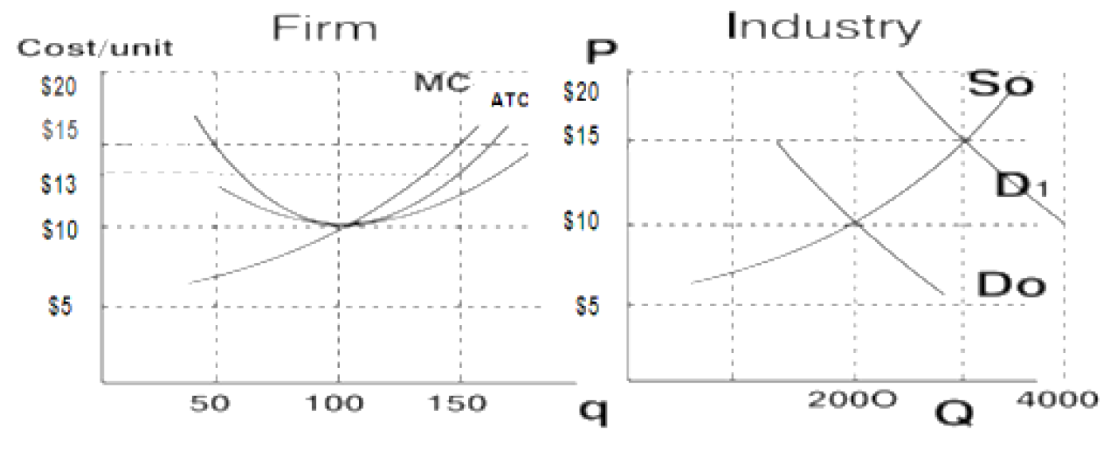

At the initial equilibrium,
- a. What are the equilibrium price and output in the industry?
- b. What is the output and profit of each firm in the industry?
- c. How many firms are operating in this industry?
- d. Is the industry in long-run equilibrium? Explain. (Hint: For long-run equilibrium, each company must also have its LRAC at its minimum.)

- Suppose demand shifts to $D_{1}$. At the new short-run equilibrium

- e.What are the equilibrium market price and quantity in the industry?
- f. What is the output of each firm in the industry?
- g. What is each firm's profit?
- h. Explain the changes in the industry's short-run supply curve after sufficient time has elapsed for entry and exit to occur given a constant cost industry in the long run?

At the new long-run equilibrium,
- i. What are the market price and quantity?
- j. What is the output and associated profit of each firm?
- k. How many firms will be active in this industry?

4) Consider the following information about bikes, where Q is output, TC is the total cost of production, and p is the price.
- Fill in the remaining columns in the chart.
Q | TC | MC | P | TR | MR | Profits
0 | 2000 |  | 600
1 | 2500 |  | 575
2 | 2800 |  | 550
3 | 3000 |  | 525
4 | 3160 |  | 500
5 | 3340 |  | 475
6 | 3540 |  | 450
7 | 3780 |  | 425
8 | 4080 |  | 400
9 | 4410 |  | 375
10 | 4770 |  | 350
11 | 5190 |  | 325
12 | 5760 |  | 300

- Graph the firm's demand curve, marginal revenue curve and marginal cost curve

- DESCRIBE THE POSITION OF the marginal revenue curve relative to the firm's demand curve?
- Determine the profit maximizing price and quantity. At this price and quantity, calculate this monopoly's economic profits.
- Given this firm's level of economic profits, where must the firm's average total cost curve (ATC) and average variable cost curve (AVC) lie?
- List the causes of monopoly.
- What characteristics do monopolies and perfectly competitive firms have in common?

- For a monopoly;
Average revenue = Demand function: P = 120 – 2Q
FC = 100
AVC = 60 + 2Q
- Find the total revenue (TR) function.
- Find the MR and MC function.
- Find the quantity that gives the maximum TR.
- Find the quantity that gives the minimum AC.
- Determine the profit maximizing level of output and find the profit.
- What would the profit maximizing level of output be if this market was perfectly competitive?
- What is the cost of monopoly to the society? Show this on a graph.

- A discriminating monopolist can separate his consumers into two distinct markets with the following demand functions:

Market 1: Q₁=16 – 0.2P₁ Corresponding MR function MR₁=80-10Q₁
Market 2: P₂=180 – 20Q₂ Corresponding MR function MR₂=180-40Q₂

Assume that the monopolist’s total cost function takes the form; TC - 20Q – 20 = 0 where Q = Q₁ + Q₂, and that it wishes to maximize profits, calculate;

- the prices the monopolist will charge in each market.
- the monopolist’s profit with price discrimination.
- The diagram below shows the demand and unit cost situation of a monopolist.

Quantity
Price and Cost per unit
A
B
C
MC
ATC
MR
Demand
H
N
J
L
E
G
0

- In order to maximize profits or minimize losses how much should this firm produce and at which price?
- In equilibrium how much total revenue will the firm collect?
- In equilibrium how much total cost will the firm incur?
- State whether the firm faces a profit or a loss in the equilibrium.

PART B: MULTIPLE CHOICE
1) The reason that , Şok market has a monopoly on selling goods in the campus is most likely due to
A) a government-imposed barrier.
B) occupational licensing.
C) no competitors apparently found the profit level attractive enough to enter the market.
D) the restaurant owned all the fresh seafood in the state.

2) A monopoly is a seller of a product
A) with many substitutes.
B) without a close substitute.
C) with a perfectly inelastic demand.
D) without a well-defined demand curve.
3) In METU Campus, there are three restarurants: Susam, Ziyafet and Sunshine. While Sunshine remains open until midnight, Susam and and Ziyafet close at 10 pm. Which of the following statements is true?
A) Sunshine is a monopoly all day because it produces a service that has no close substitutes.
B) Sunshine has a monopoly at midnight but not during the day.
C) Sunshine can ignore the pricing decisions of the other two supermarkets.
D) Sunshine probably has a higher markup to compensate for its higher cost of production.
4) Which of the following is a characteristic shared by a perfectly competitive firm and a monopoly?
A) Each must lower its price to sell more output.
B) Each sets a price for its product that will maximize its revenue.
C) Each maximizes profits by producing a quantity for which marginal revenue equals marginal cost.
D) Each maximizes profits by producing a quantity for which price equals marginal cost.
5) A monopolist's profit maximizing price and output correspond to the point on a graph
A) where average total cost is minimized.
B) where total costs are the smallest relative to price.
C) where marginal revenue equals marginal cost and charging the price on the market demand curve for that output.
D) where price is as high as possible.
6) If a monopolist's price is $50 at 63 units of output and marginal revenue equals marginal cost and average total cost equals $43, then the firm's total profit is
A) $3,150.
B) $2,709.
C) $441.
D) $7.

Table 15.4
Price per Dose | Quantity Demanded  (dose) | Total Cost of Production  (dollars)
$80 | 0 | $80
72 | 1 | 82
64 | 2 | 88
56 | 3 | 100
48 | 4 | 124
40 | 5 | 164
32 | 6 | 208
24 | 7 | 268
16 | 8 | 340

Çelik Inc. has been granted a patent for its after shave cologne. Table 15-4 shows the demand and the total cost schedule for the firm.
7) Refer to Table 15-4. What is Çelik's profit-maximizing output?
A) 4 units
B) 5 units
C) 6 units
D) 7 units
8) Refer to Table 15-4. What is the amount of Çelik's profit?
A) $68
B) $72
C) $124
D) $192
9) Refer to Table 15-4. What is the amount of the deadweight loss generated by Çelik when it produces the monopoly output?
A) $124
B) $42
C) $36
D) $12
10) Because a monopoly's demand curve is the same as the market demand curve for its product
A) the monopoly's marginal revenue equals its price.
B) the monopoly is a price taker.
C) the monopoly must lower its price to sell more of its product.
D) the monopoly's average total cost always falls as it increases its output.
Figure 1
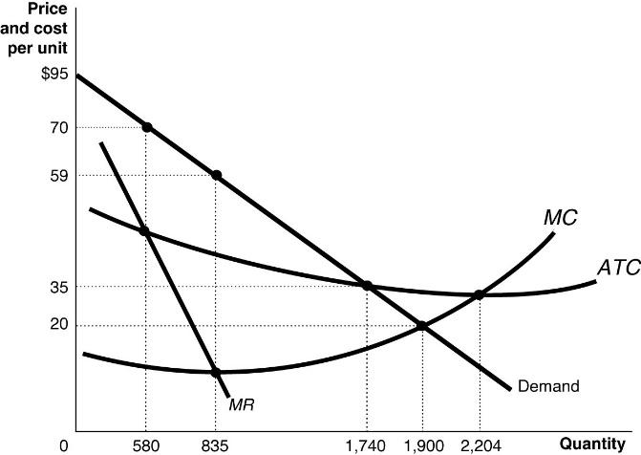

11) Refer to Figure 1. Which of the following statements about the firm depicted in the diagram is true?
A) The fact that this firm is a natural monopoly is shown by the continually declining long-run average total cost as output rises.
B) The fact that this firm is a natural monopoly is shown by the continually declining market demand curve as output rises.
C) The fact that this firm is a natural monopoly is shown by the continually declining marginal revenue curve as output rises.
D) The fact that this firm is a natural monopoly is shown by the fact that marginal cost lies below the long-run average total cost where the firm maximizes its profits.
12) A local electricity-generating company has a monopoly that is protected by an entry barrier that takes the form of
A) control of a key raw material.
B) network externalities.
C) economies of scale.
D) perfectly inelastic demand curve.
13) A monopolist faces
A) a perfectly elastic demand curve.
B) a perfectly inelastic demand curve.
C) a horizontal demand curve.
D) a downward-sloping demand curve.

Figure 3.
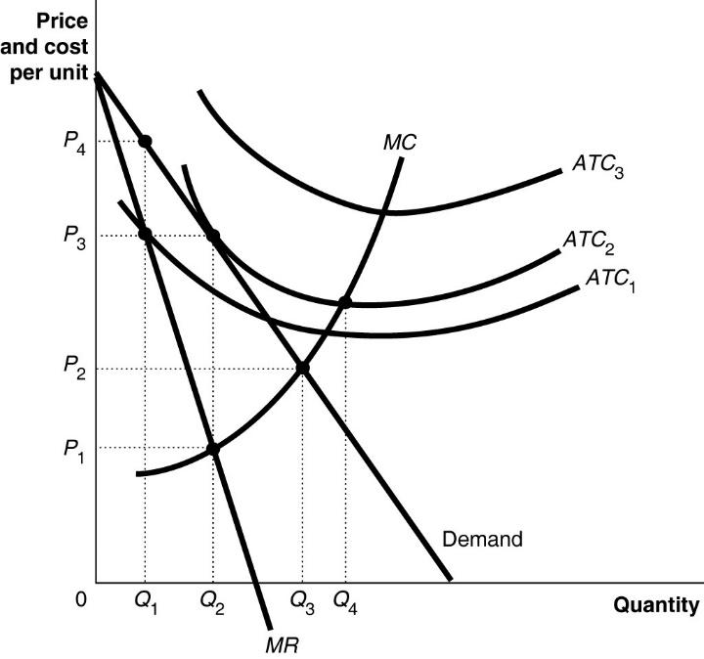
14) Refer to Figure 3. To maximize profit, the firm will produce
A) Q1.
B) Q2.
C) Q3.
D) Q4.
15) Refer to Figure 3. The firm's profit-maximizing price is
A) P1.
B) P2.
C) P3.
D) P4.
16) Refer to Figure 3. If the firm's average total cost curve is ATC1, the firm will
A) suffer a loss.
B) break even.
C) make a profit.
D) face competition.
17) Refer to Figure3. If the firm's average total cost curve is ATC2, the firm will
A) suffer a loss.
B) break even.
C) make a profit.
D) face competition.

