METU
Department of Economics
Econ 101: Introduction to Economics I
Section 01-02
Fall 2024
PROBLEM SET 8 (CH 11 & 12)
- What is the relationship of marginal cost and marginal productivity of workers? Why marginal cost curve always goes through the minimum level of average cost curves?
The average and marginal productivity of workers are the mirror images of average and marginal costs. In other words, rise of the marginal productivity of workers diminishes marginal costs.
Marginal cost curve decides the slope of average cost. When it is less than the average cost (MC < AC), then AC is falling. When it is more than the average cost (MC >AC), then AC is rising. As a result, when they are equal (MC = AC), then AC is at its lowest point.
- Is a process technically efficient if it is economically efficient?
Economic efficiency implies technical efficiency but, technical efficiency does not necessarily imply economic efficiency.
Technical efficiency means that a production process uses as few inputs as possible to produce a given level of output. When there are multiple inputs, many different production processes can be technically efficient, but only cheapest option is economically efficient. For example, say that to produce 100 grams of wheat, one production process uses 10 workers and 1 machine and another production process uses 1 worker and 10 machines; say also that these are the lowest number of inputs you can use with those production processes. Which of these two production techniques is more efficient? Both are technically efficient since neither involves less of both inputs. (A production process that uses 1 workers and 1 machine would be technically more efficient.) But that doesn’t mean that both of these production processes are equally economically efficient. If the price of a worker is 10 times cheaper than price of a machine, second process would cost more than 9 times of the first process. Then, first process would be economically more efficient.
- What is the difference between economies of scope and economies of scale?
Economies of scale are economies that occur because of increases in the amount of one good a firm is producing. Economies of scope occur when producing different types of goods lowers the cost of each of those goods.
- The table below represents the annual income statement of Mazlum’s Hardware Store. Mazlum worked full time at the store. He used $25,000 of his savings to furnish and stock the store (included in costs). He was recently offered a $20,000 annual salary to work in an advertisement agency.

Annual Income Statement
Revenues | Costs
Sales of Merchandise $90,000 | Wholesale purchases $60,000
Service Revenues 5,000 | Store Supplies 2,000
 | Labor Costs 10,000
 | Utilities 1,000
 | Rent 5,000
 | Depreciation on fixtures 2,000
Total revenues $95,000 | Total Costs $80,000

- Calculate the accounting profits for Mazlum’s Hardware Store.
$95,000-$80,000=$15,000
- What are some imputed costs to be taken into account?
Mazlum should include costs of annual interest rate on $25,000 investment (assuming he could recover it); and $20,000 opportunity cost for his own salary.
- If annual interest rate is 10%, what are the total costs of this business?
Total costs would be accounting costs of $80,000 plus interest of $2,500 and $20,000 salary.
- Calculate the economic profits of Mazlum’s Hardware Store.
A loss of $7,500 is indicated for the past year ($15,000 – $2,500 –$20,000

- Suppose we have three firms combining capital and labor in various ways to produce 1 unit of output. For all firms, the price of a unit of capital is 10 TL and the price of labor is 5 TL. The following data represents the marginal productivities.

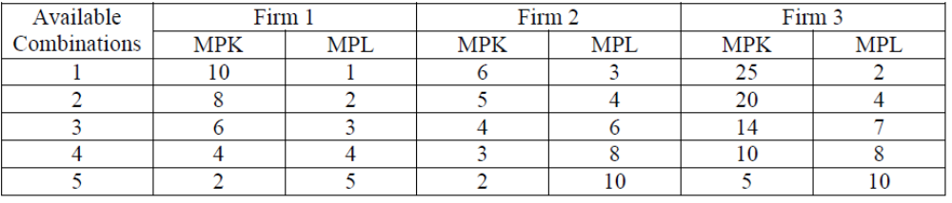

a) Firm 1 is currently using combination 3, Firm 2 is using combination 2, and Firm 3 is using combination 1. Which firm is minimizing costs?

A firm minimizes its cost if (MPK / MPL) = (PK / PL). Since price ratio of unit factors of production is 2, the firm which have a production function that satisfies (MPK / MPL) = 2 is cost minimizing firm.
Firm 1 Firm 2 Firm 3
(MPK / MPL) (6/3)=2 (5/4)=1.25 (25/2)=12.5
Therefore, only firm 1 is minimizing costs.

b) How would the firms that are not minimizing their costs have to alter their use of capital and labor to do so?

To minimize costs, firms try to equalize the ratio of marginal products to 2. In other words, firm 2 must increase (decrease) its marginal product of capital (labor), firm 3 must increase (decrease) its marginal product of labor (capital). To do that, Firm 2 should hire more labor and/or hire less capital, and firm 3 should employ more capital and/or less labor to minimize costs.

c) By doing your answer in b), can firm 2 and firm 3 find the combination in the table satisfying their cost minimized? If so, what are the minimizing cost combinations for those two firms, respectively?

By doing so, Firm 2 should hire more labor and/or hire less capital (i.e. should have less MPL and/or more MPK), and firm 3 should employ more capital and/or less labor (i.e. should have more MPL and/or less MPK) to minimize costs. Then, yes they can find the minimizing cost combinations, i.e. combination 1 for firm 2, combination 3 for firm 3, which are satisfying (MPK / MPL) = (PK / PL).

- Refer to table below. Suerte Toys manufactures merry-go-round music boxes. The table above shows estimates of fixed cost per period and average variable cost for three possible plant sizes.
 | Fixed Costs | Average Variable Cost
Small Plant | $10,000 | $2.00
Medium Plant | 15,000 | 1.30
Large Plant | 25,000 | 0.50
- You are employed as the company's cost accountant and have been asked to prepare cost estimates for various output levels for each of the three possible plant sizes. Record your calculations in the table below. (please calculate average cost of productions for these units for small, medium, and large plant sizes separately.)
Average Cost of Production
 | 5,000 units | 8,000 units | 20,000 units
Small Plant | $4.00 | $3.25 | $2.50
Medium Plant | 4.30 | 3.18 | 2.05
Large Plant | 5.50 | 3.63 | 1.75

- For each of the three output levels, which plant size will generate the lowest average total cost of production?
For an output of 5,000 units, the lowest average cost is achieved with a small plant size. For an output of 8,000 units, the lowest average cost is achieved with a medium plant size and for output 20,000 units the lowest average cost is achieved with a large plant size.
- Suppose the firm currently sells 8,000 units of merry-go-round music boxes per period (using the optimal plant size for this output level). Now, however, it has just secured a long-term contract to supply 20,000 merry-go-round music boxes per period. In the short run, what is the average total cost of producing 20,000 units of merry-go-round music boxes? Provide a numerical value based on your answer in part i
The firm currently has a medium-sized plant. In the short run, average total cost of producing 20,000 units is $2.05.
- What happens to average total cost of production in the long run? Provide a numerical value based on your answer in part i.
In the long run, when it can build a larger plant, the average total cost will fall to $1.75.
- Answer the following questions:
a) Complete the following table describing the cost situation for a firm producing X

OUTPUT | TFC | TVC | TC | AFC | AVC | AC | MC
0 | 16 | 0 | 16 | - | - | - | -
1 | 16 | 8 | 24 | 16 | 8 | 24 | 8
2 | 16 | 14 | 30 | 8 | 7 | 15 | 6
3 | 16 | 18 | 34 | 5,3 | 6 | 11,3 | 4
4 | 16 | 20 | 36 | 4 | 5 | 9 | 2
5 | 16 | 22 | 38 | 3,2 | 4,5 | 7,6 | 2
6 | 16 | 27 | 43 | 2,7 | 4,5 | 7,2 | 5
7 | 16 | 33 | 49 | 2,3 | 4,7 | 7 | 6
8 | 16 | 41 | 57 | 2 | 5,1 | 7,1 | 8
9 | 16 | 53 | 69 | 1,8 | 5,9 | 7,7 | 12
10 | 16 | 73 | 89 | 1,6 | 7,3 | 8,9 | 20
11 | 16 | 105 | 121 | 1,5 | 9,5 | 11 | 32

b) Plot fixed cost, total variable cost, and total cost.
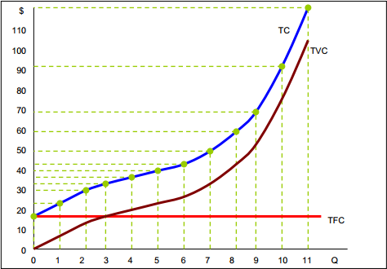

c) Plot marginal cost, average fixed cost, average variable cost, and average cost on another diagram. (Locate the marginal cost points midway between integral outputs, i.e., 1.5, 2.5, etc. For example, treat the difference between the total cost of producing 1 unit and the total cost of producing 2 units as marginal cost at an output of 1.5 units.)
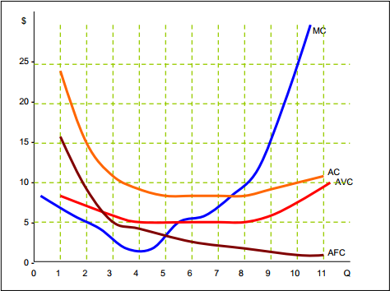

- The lines shown in the diagram below are isocost lines.

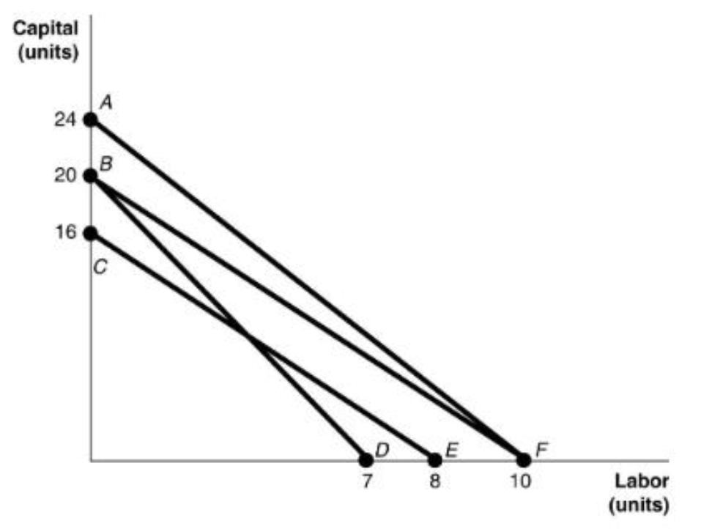
a) Demonstrate following changes using the given diagram. (Start from BF)
- An increase in the price of labor while the price of capital remains unchanged?
Isocost curve rotates from BF to BD.
- A decrease in the price of capital while the price of labor remains unchanged?
Isocost curve rotates from BF to AF
- An increase in the firm's total cost while the price of labor and capital remain unchanged?
Isocost curve may shift from BF to CE (Notice they are parallel to each other). It means isocost line is contracting due to cost increase.
b) When does a movement from CE to BD occurs?
It occurs when the price of capital decreases while the price of labor increases.
c) What is the total cost along the isocost AF, given the price of labor is $50 per unit?
$500
d) What is the price of capital along the line CE, given the price of labor is $10 per unit?
$5 per unit
- Suppose a chair manufacturer is producing in the short run (with its existing plant and equipment). The manufacturer has observed the following levels of production corresponding to different numbers of workers:
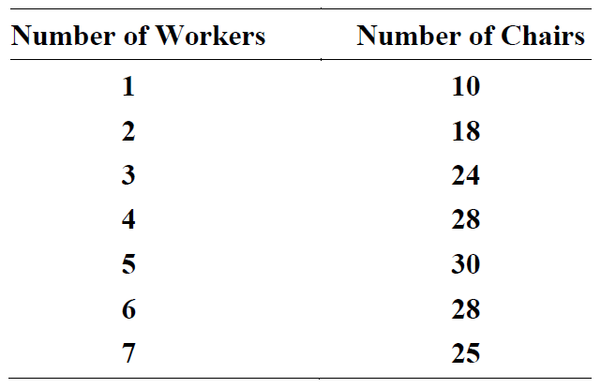

- Calculate the marginal and average product of labor for this production function.
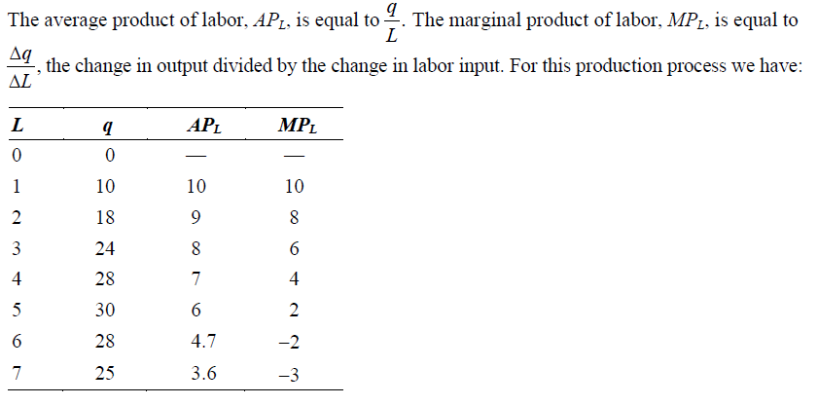
- Does this production function exhibit diminishing returns to labor? Explain.
Yes, this production function exhibits diminishing returns to labor. The marginal product of labor, the extra output produced by each additional worker, diminishes as workers are added,
and this starts to occur with the second unit of labor.

- Explain intuitively what might cause the marginal product of labor to become negative.
Labor’s negative marginal product for L > 5 may arise from congestion in the chair manufacturer’s factory. Since more laborers are using the same fixed amount of capital, it is possible that they could get in each other’s way, decreasing efficiency and the amount of output. Firms also have to control the quality of their output, and the high congestion of labor may produce products that are not of a high enough quality to be offered for sale, which can contribute to a negative marginal product.

PART B: MULTIPLE CHOICE
1. The average product for six workers is 15. If the marginal product for the seventh worker is 18,
a. marginal product is rising
b. marginal product is falling.
c. average product is rising
d. average product is falling.
e. marginal product is rising and average product is falling.

2. The first, second, and the third workers employed by a firm add 24, 18 and 9 units to total product respectively. On the basis of this information we can say that:
a. The marginal product of the first worker is 24
b. The total product of the three workers is 51
c. The average product of the two workers is 21
d. All of the above are true

3. Which of the following is correct?
a. Marginal product rises faster than average product and also falls faster than average product.
b. When total product is rising, both average product and marginal product must also be rising.
c. When marginal product is falling, total product must be falling.
d. When marginal product is falling, average product must also be falling.

4. The law of diminishing returns requires the assumption that
a. technology remains fixed
b. there be at least one fixed input
c. beyond some point, there will be decreasing returns to scale
d. (a) and (b)

5. A graph that shows all the combinations of labor and capital that can be used to produce a given amount of output is called
a. an indifference curve
b. an isocost line.
c. an isoquant curve
d. an average cost curve
6. The slope of the isoquant tells the firm how much
a. output increases when labor increases by one unit
b. output increases when capital and labor are doubled
c. capital must decrease to keep output constant when labor increases by one unit
d. a unit of capital costs relative to the cost of labor

7. When marginal product of labor is less than the average product of labor is;
a. the average product of labor is increasing
b. the firm is experiencing diminishing returns
c. the marginal product of labor is increasing
d. the total product curve is negatively sloped

8. To economists the main difference between the short run and the long run is that:
a. The law of diminishing returns applies in the long run, but not in the short run
b. In the long run all resources are variable, while in the short run at least one resource is fixed.
c. Fixed costs are more important to decision making in the long run than they are in the short run.
d. In the short run all resources are fixed, while in the long run all resources are variable.

9. Which one of the following statement is not true?
a. Isocost line is a graph that shows all combinations of capital and labor that can be used to produce a given amount of output.
b. Profit maximizing firms will minimize costs by producing their chosen level of output with the technology represented by the point at which the isoquant is tangent to an isocot line.
c. Isocost line is a graph that shows all the combinations of capital and labor that are available for a given total cost.
d. Slope of the isocost line is –(TC/PK)/(TC/PL) or –PL/PK

10. A line joining the origin and a point on the total product curve is bound to be steepest when
a. The line is tangent to the total product curve.
b. The average product is a maximum
c. The average product is equal to the marginal product.
d. All of the above are true

11. The law of diminishing returns can be used to explain why total product curves
- have positive slopes
- have negative slopes
- become flatter as quantity increases
- become steeper as quantity increases

12. The marginal rate of technical substitution is
a. the rate at which a producer is able to exchange, without affecting the quantity of output produced, a little bit of one input for a little bit of another input.
b. the rate at which a producer is able to exchange, without affecting the total cost of inputs, a little bit of one input for a little bit of another input.
c. the rate at which a producer is able to exchange, without affecting the total inputs used, a little bit of one output for a little bit of another output.
d. a measure of the ease or difficulty with which a producer can substitute one technique of production for another.

- The following graph shows average fixed costs, average variable costs, average total costs, and marginal costs of production.
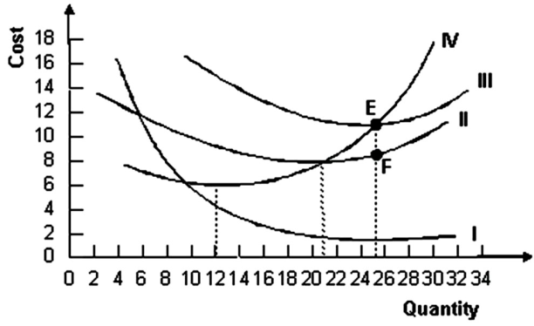
Refer to the graph shown. Why does the distance between curves II and III get smaller as quantity increases?
a. Marginal cost is increasing.
b. Average variable cost is increasing.
c. Average fixed cost is decreasing.
d. Average fixed cost is increasing.

- Refer to the following graph.

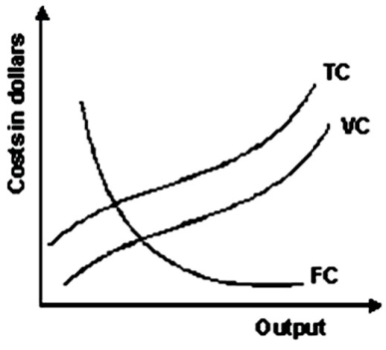
The set of cost curves are
a. Correct.
b. Wrong since the total cost and variable cost curves are reversed.
c. wrong because the fixed cost curve is drawn incorrectly.
d. wrong because the total cost and variable cost curves are actually the average total cost and average variable cost curves.

15. The marginal cost curve:
a. first rises and then declines.
b. rises when the average total cost curve lies above the average variable cost curve.
c. rises when the point of diminishing marginal productivity is reached.
d. declines until average total cost increases.

For the following questions, consider the table below

Acres of Land | Tanks of Fertilizer | Truckloads of Potatoes
20 | 0 | 0
20 | 1 | 40
20 | 2 | 105
20 | 3 | 135
20 | 4 | 152
20 | 5 | 141
- Refer to Table 1. What can be observed about the given resources?
A) Land is variable but fertilizer is fixed.
B) Land and fertilizer are both fixed.
C) Land and fertilizer are both variable.
D) Land is fixed but fertilizer is variable.

- Refer to Table 1. Increasing the tanks of fertilizer from 3 to 4 will increase the truckloads of potatoes by
A) 152.
B) 35.
C) 17.
D) 11.

- Refer to Table 1 The principle of diminishing returns sets in with the addition of the ________ tank of fertilizer.
A) second
B) third
C) fourth
D) fifth

