METU
Department of Economics
Econ 101: Introduction to Economics I
Section 01-02
Fall 2024
PROBLEM SET 4 (CH 5,6 and 7)
PART A: PROBLEMS

- (NOT IN THE FIRST MIDTERM) Consider the market for gasoline. The demand and supply functions for gasoline is

P= 100-Q_{d}
P= Q_{S}/3

a) Calculate the equilibrium price and quantity. At this equilibrium, compute the consumer surplus, producer surplus, and total surplus.

At the equilibrium, we have equal quantities and prices, so it does not matter whether the supply and demand equations are expressed in terms of P or Q .
100-Q= Q/3

Q*= 75, P*=25

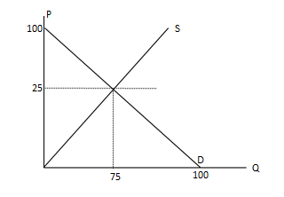
Consumer Surplus: $\frac{75x75}{2}=2812.5$

Producer Surplus: $\frac{25x75}{2}=937.5$

Total Surplus : 2812.5+937.5 = 3750

- Suppose now that the government is concerned because many gas stations are going out of business, so it decides to set a minimum price of p¯ = 30 to help them. What will be the new equilibrium price and quantity with this intervention? Compute the consumer surplus and producer surplus.
The price will be p = 30, and the quantity q = 70

Consumer Surplus: $\frac{70x70}{2}=2450$
Producer Surplus: $\frac{(70/3)x70}{2}+\left(30-\left(\frac{70}{3}\right)\right)*70=1283.3$
Total Surplus: 2450 + 1283.3 = 3733.3

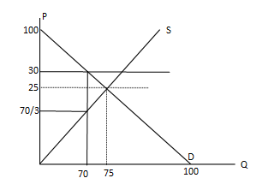
After the price floor policy, the total surplus is decreased.

- How is the total surplus affected? Briefly explain
When the government intervenes in the economy and imposes price ceiling/floors, this action creates deadweight loss. A deadweight loss (DWL) is a cost to society created by market inefficiency, which occurs when supply and demand are out of equilibrium.
The total surplus declineds by 3750-3733.3 = 16,7, which is equals to the value of the deadweight loss.
(You can compute the value of DWL by calculating the area of the shaded area.)

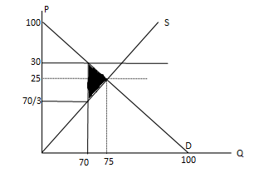

$$\frac{(30-\left(\frac{70}{3}\right))x5}{2}=\frac{50}{3}=16.7$$
- (NOT IN THE FIRST MIDTERM) The market demand and supply function for a commodity is given below:
Q_{D} = 120 – 4P
Q_{S} = -30 + 6P
- Find the equilibrium price and quantity.
120 – 4P = -30 + 6P P* = 15 Q* = 60
- What are the consumer and producer surpluses at the equilibrium price?
CS = ((30 – 15)* 60) /2 = 450
PS = ((15 – 5)* 60) / 2 = 300
Assume that government sets a ceiling price at 10 TL.,
- Will there be an excess supply or excess demand in the market?
At P = 10, Q_{D} = 80 Q_{S} = 30. Since quantity demanded exceeds quantity supplied, there is an excess demand by an amount of 50.
- What will be the quantity exchanged at this new price?
In this case, quantity supplied will be exchanged. So, it is 30.
- How can this quantity exchanged be allocated?
First come first served or sellers’ preferences or queuing or rationing coupons.

- Define the following cenceptss:
i) Price elasticity of demand: The percentage change in quantity demanded divided by the percentage change in price.
ii) Price elasticity of supply: The percentage change in quantity supplied divided by the percentage change in price.
iii) Income elasticity of demand: The percentage change in demand divided by the percentage change in income.
iv) Cross-price elasticity of demand: The percentage change in demand divided by the percentage change in the price of a related good.

- The following table shows the price and quantity of brownie in Gizem Cafe for a semester according to average income.

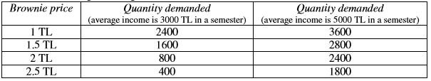

a) Calculate the price elasticity of demand (using the midpoint method) if the price of brownies rises from 1 TL to 1.5 TL, when average income is 3000 TL.
% Change in quantity demanded = (1600 – 2400) / ((1600 + 2400) / 2)*100% = – 40%
% Change in price = (1.5 – 1) / ((1.5 + 1) / 2)*100% = 40%
Price elasticity of demand = ε _{d,p}
= % Change in quantity demanded / % Change in price = – 1
b) Calculate the income elasticity of demand (using the midpoint method) if average income increases from 3000 TL to 5000 TL, when the price of a brownie is 1 TL.
% Change in quantity demanded = (3600 – 2400) / ((3600 + 2400) / 2)*100% = 40%
% Change in income = (5000 – 3000) / ((5000 + 3000) / 2)*100% = 50%
Income elasticity of demand = ε_{d,y}
= % Change in quantity demanded / % Change in income = 4/5 = 0.8

- The market demand and supply functions for a commodity are given as follows:
QD = 100 – 2P QS = – 20 + 4P
a) Find the equilibrium price and quantity.
100 – 2P = – 20+4P P* = 20 Q* = 60
b) Find the point elasticity of demand and supply at the equilibrium.
εD = $\frac{dQD }{dP}$ * $\frac{P }{Q}$= $-2*\frac{20 }{60}$ = –2/3
εS = $\frac{dQS }{dP}$ * $\frac{P }{Q}$= 4*20 / 60 = 4/3
c) Find the price and quantity where price elasticity of demand is unitary.
εD =$\frac{dQD }{dP}$ * $\frac{P }{Q}$ => –1 = –2* P / Q => 2P = QD & 2P+QD = 100
Thus, 4P = 100 => P = 25 & Q = 50

d) (NOT IN THE FIRST MIDTERM) If an excise tax of 6 TL for each unit of good was imposed by the government to be collected from the suppliers.
i. What will be the new equilibrium price and quantity?
Qs’ = –20 + 4(P’-6) => Qs’ = –44 + 4P’ => P’* = 24 & Q’* = 52
ii. What will be the tax revenue of the government?
Tax Revenue = 52*6 = 312
iii. How much of this tax will be paid by the consumers and producers?
Tax paid by consumers = 4*52 = 208 Tax paid by producers = 2*52 = 104
İv) Who pays a larger part of the tax? Consumers or producers? Explain why.
A larger part of the tax is paid by consumers because the elasticity of demand in absolute value is less than the elasticity of supply.
- The following table provides information regarding price elasticities, income elasticities and cross-price elasticities of demand.
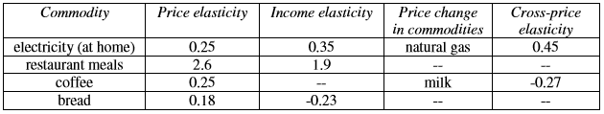

a) Which commodities are normal and which are inferior?
Electricity and restaurant meals are normal; bread is inferior.
b) Which commodities are complements and which are substitutes?
Natural gas and electricity are substitutes; milk and coffee are complements.
c) Which commodities have elastic and which have inelastic demands?
Restaurant meals have elastic demand; electricity, coffee and bread have inelastic demand.
d) What will happen to the total revenue of bread if its price increases?
When price of bread increases, total revenue also increases (due to inelastic demand).
e) What will happen to the quantity demanded of coffee if the price of milk increases by 1%?
Quantity demanded of coffee decreases by 0.27 % if the price of milk increases by 1%
- Suppose when the price of pizza is $4, the quantity demanded of pizza is 60 slices and the quantity demanded of cheese bread is 100 pieces. When the price of pizza is $2, the quantity demanded of pizza is 80 slices and the quantity demanded of cheese bread is 70 pieces.

- Calculate the price elasticity of demand for pizza. (Use midpoint formula)
$$ε=\frac{ΔQpizza}{ΔPpizza}× \frac{\frac{P_{pizza}^{1}+P_{pizza}^{2}}{2}}{\frac{Q_{pizza}^{1}+Q_{pizza}^{2}}{2}}=\frac{20}{-2}×\frac{3}{70}=-\frac{3}{7}$$
- Is the demand for pizza elastic, inelastic or unit elastic? (Use midpoint formula)
Absolute value of the price elasticity is less than 1, and therefore, the demand for pizza is price inelastic.
- Calculate the cross-price elasticity of cheese bread. (Use midpoint formula)
$$ε=\frac{ΔQ_{chees}}{ΔP_{pizza}}×\frac{\frac{P_{pizza}^{1}+P_{pizza}^{2}}{2}}{\frac{Q_{cheese}^{1}+Q_{cheese}^{2}}{2}}=\frac{-30}{-2}×\frac{3}{85}=\frac{9}{17}$$

d) Are these goods substitute or complements ?
Cross­price elasticity of cheese bread is positive; these goods are substitutes for each other.
- Use the following demand curve to show that elasticity is related, but not the same as slope.
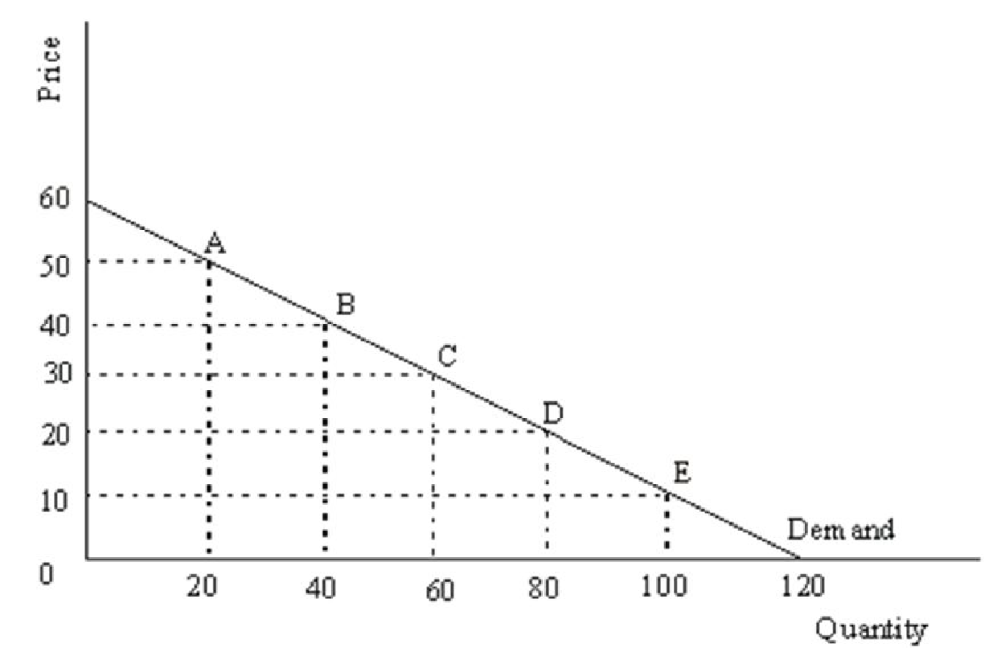

To see that elasticity and slope are different it is sufficient to show that while the slope is constant at all points on the demand curve elasticity is not. Since the demand curve is linear it has a constant slope, the slope of the demand curve above is –½. Elasticity varies at all points along the demand curve. For example, compute the point elasticity for points B and C.

Elasticity at point B:
percentage change in quantity = [(60 – 20)/40] × 100 = 1
percentage change in price = [(50 – 30)/40] × 100 = 1/2
elasticity = 1/(1/2) = 2.0

Elasticity at point C:
percentage change in quantity = [(80 – 40)/60] × 100 = 2/3
percentage change in price = [(40 – 20)/30] × 100 = 2/3
elasticity = (2/3)/(2/3) = 1.0

Since elasticity is different at points B and C but slope is the same we can see that slope and elasticity are not the same.

- Consider the following demand curve for Starbucks coffee.
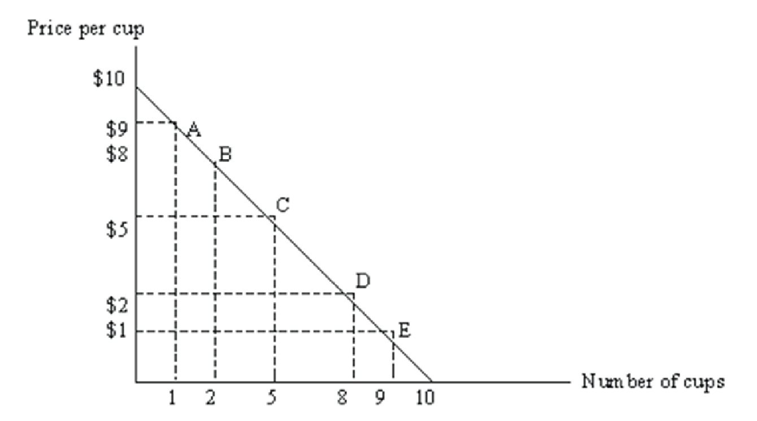
(a) Suppose the current price is $8 per cup. Using elasticity of demand, explain why Starbucks should not increase the price in order to increase total revenue.

(b) Suppose the current price is $2 per cup. Using elasticity of demand, explain why Starbucks should not lower the price in order to increase total revenue.

Answer:
(a) At this range on the demand curve, demand is elastic. Demand elasticity between points A and B is (1/1.5)/(1/8.5) = 5.67. If demand is elastic, Starbucks must lower the price in order to increase total revenue. Note that total revenue at $8 a cup is $16. If price increases to $9 a cup, total revenue decreases to only $9.
(b) At this range on the demand curve, demand is inelastic. Demand elasticity between points D and E is (1/8.5)/(1/1.5) = 0.17. If demand is inelastic, Starbucks must increase the price in order to increase total revenue. Note that total revenue at $2 a cup is $16. If price decreases to $1 a cup, total revenue decreases to only $9.

PART B: MULTIPLE CHOICE
- Refer to the following graphs.
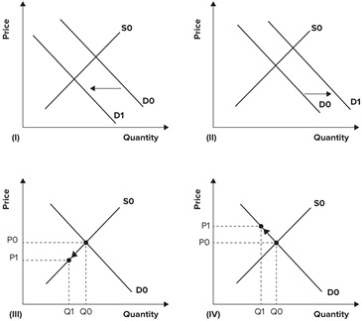

A recent report indicates that the device known as the right heart catheter used to diagnose heart conditions poses more risks than previously thought. The effect of the report on the market for right heart catheters is best shown by which of the graphs?
              - I
              - II
              - III
              - IV
- Suppose that there is a renewed interest in eating caviar at the same time that the supply of Russian caviar shrinks. What would be the most likely effect of these events on the price and quantity of caviar sold?
              - Price rose and quantity sold fell.
              - Price rose and the effect on the quantity of caviar sold is ambiguous.
              - Price fell and the effect on the quantity of caviar sold is ambiguous.
              - Price fell and quantity sold rise.

- Helped by desktop publishing, the number of vintage baseball card forgeries has flooded the market for vintage baseball cards. Dealers left the market for fear of purchasing a phony. What was the effect on the market for vintage baseball cards assuming phonies could not be detected?
              - Demand shifted to the left, supply did not change, price declined, and quantity traded declined.
              - Supply shifted to the right, demand did not change, price declined, and quantity traded rose.
              - Supply shifted to the right, demand shifted to the left, and price rose.
              - Supply shifted to the right, demand shifted to the left, and price declined.
- A Wall Street Journal headline reads: "Cigar Shortage Draws New Brands into Market." The shortage resulted from a renewed interest in smoking cigars. What best describes facts behind the headline?
              - Supply has shifted to the right. Price has fallen somewhat, but not enough to equilibrate supply and demand.
              - Demand has shifted to the right. Price has risen somewhat, increasing quantity supplied, but not enough to equal quantity demanded.
              - Demand has shifted to the right and price has risen to equilibrate supply and demand.
              - Supply has shifted to the left. Price has risen somewhat, but not enough to equilibrate supply and demand.
5. If income increases by 15 percent and the price does not change, the quantity of airplane travel demanded increases by 60 percent, then the income elasticity of demand of airplane travel is _________.
a) 0 b) Negative c) 4.00 d) 0.25
6. If a 10 percent change in the price of a good leads to a 5 percent change in the quantity supplied, then the supply of the good is _______________ and the elasticity of supply is _____________.
a) elastic; -2.0 b) inelastic; -0.5 c) elastic; 2.0 d) inelastic; 0.5
7. Tolga loves carrot cake. As the price of a carrot cake increases from 1 TL to 2 TL to 3 TL, Tolga continues to buy a dozen carrot cake every day. Tolga's demand for carrot cake is __________.
a) elastic b) perfectly inelastic
c) illustrated by a horizontal demand curve d) unit elastic
8. When demand is __________, a decrease in price _____________ total revenue.
a) unit elastic; increases b) elastic; decreases
c) elastic; increases d) inelastic; increases
9. A pizza shop observes that when it raises the price of the large pizza, total revenue from pizza decreases and when they lower the price of the large pizza, total revenue increases. This suggests that
a) the demand for large pizza must be elastic.
b) there are few good substitutes for large pizza.
c) the demand for large pizza must be inelastic.
d) the demand for large pizza is unitary elastic.
10. Along any straight-line demand curve,
a) the price elasticity and slope vary
b) the price elasticity varies, but the slope remains the same
c) the slope varies, but the price elasticity remains the same
d) the price elasticity and the slope remains the same
11. Webster Dictionaries and Oxford Dictionaries are almost perfect substitutes. The cross price elasticity of demand for Webster Dictionaries with respect to Oxford Dictionaries ________.
a) is 1 b) is almost infinity
c) depends on the complements for dictionaries d) is almost zero
12. If the demand for a good is price-elastic, that good is likely to have
a) many close complements b) few close complements
c) many close substitutes d) few close substitutes
13. The price elasticity of demand is equal to the ____________ in the _____________ divided by the ________________ in the ______________.
a) change; price; change; quantity demanded
b) percentage change; price; percentage change; quantity demanded
c) change; quantity demanded; change; price
d) percentage change; quantity demanded; percentage change; price
14. Because toothpaste and toothbrushes are complements, the ____________ elasticity of demand is ______________.
a) income; positive b) cross price; negative
c) cross; positive d) income; negative
15. Haircuts and taxi rides are normal goods, so their ____________________.
a) cross elasticity of demand is negative b) cross elasticity of demand is positive
c) income elasticities of demand are negative d) income elasticities of demand are positive
16. If tea and coffee are substitutes, the cross price elasticity of coffee with respect to the price of tea will be _________ and an increase in the price of tea will _________ the demand for coffee.
a) negative; decrease b) positive; increase
c) negative; increase d) positive; decrease
17. The price elasticity of demand for videos is -3. If the price of a video increased by 3 percent, the quantity demanded will ___________________.
a) decrease by 9 percent b) decrease by 0.9 percent
c) increase by 9 percent d) decrease by 0.9 percent
18. When a good has few close substitutes available, ______________.
a) proportional changes in quantity demanded tend to be greater than proportional changes in price.
b) price elasticity of demand is greater than one.
c) price tends to remain the same, regardless of quantity demanded.
d) change in price has no big effect on the quantity demanded
e) all of the above are true.
19. The government wants to increase the taxes on cigarettes to increase tax revenue. This tax policy would only be effective in raising new tax revenues if the price elasticity of demand is:
a) unity b) elastic c) inelastic d) perfectly elastic.
20. The figure shows the relationship between Angelina's income and the quantity of macaroni that she demands. When her income is less than $350 per month, macaroni ______________________.
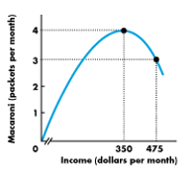
a) is a normal good b) has negative income elasticity
c) has many substitutes d) is an inferior good

21. Refer to the figure below. Demand is:
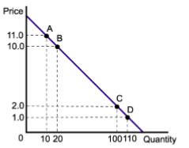
a) Unit elastic. The value of elasticity equals one between any two points throughout the entire range of the demand curve.
b) Elastic throughout the entire range of the demand curve.
c) Elastic between points A and B, and inelastic between points C and D.
d) Inelastic throughout the entire range of the demand curve.
22. Income levels rise by 10 percent, ceteris paribus, causing the quantity demanded for beers to go up by 4 percent. From this information, which one of the following is true?
a) beers are is an inferior goods. b) beer is a normal goods.
c) the income elasticity of demand for beers is 2.5. d) none of the above are true.

23. Two drivers-Tom and Jerry- each drive up a gas station. Before looking at the price, each places an order. Tom says, “I’d like 10 gallons of gas.” Jerry says, “I’d like $10 of gas.” Pick the correct answer from below:
a) Tom has higher price elasticity of demand than Jerry.
b) Tom has higher income elasticity of demand than Jerry.
c) Tom’s price elasticity of demand is zero.
d) Its hard to figure out from the information given.

- A price elasticity of demand for a good or service of 1.8 tells us that:
              - the price changes by $1.80 when quantity changes by 1 unit.
              - quantity demanded falls by 1.8 percent when price rises by 1 percent.
              - the price rises by 1.8 percent when quantity demanded falls by 1 percent.
              - quantity demanded falls by 1.8 units when price changes by $1.

- It has been estimated that the price elasticity of demand for attending baseball games is 0.23. Other things held constant, a 10 percent increase in attendance can be explained by a:
              - 43.48 percent fall in the price of a ticket.
              - 43.48 percent rise in the price of a ticket.
              - 23 percent fall in the price of a ticket.
              - 23 percent rise in the price of a ticket.

- Refer to the graph shown. Calculate the approximate elasticity of demand for the line segment CD.
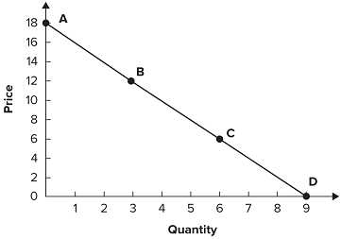
              - -3
              - -⅓
              - -⅕
              - -5

- Refer to the following table to answer the question. Demand is most elastic between:
Price | Quantity Demanded
$ 2.00 | 26
$ 4.00 | 22
$ 6.00 | 18
$ 8.00 | 14
$ 10.00 | 10
              - $2 and $4.
              - $4 and $6.
              - $6 and $8.
              - $8 and $10.

- Refer to the graph shown. Which of the following curves demonstrates a perfectly inelastic demand curve?
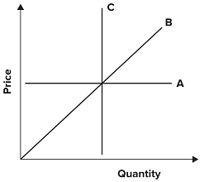
              - A
              - B
              - C
              - None of the curves
- Which of the following statements is true about a downward-sloping demand curve that is a straight line?
              - The slope and the elasticity are the same at all points.
              - The slope remains the same, but elasticity rises as you move down the demand curve.
              - The slope remains the same, but elasticity falls as you move down the demand curve.
              - The slope and the elasticity fall as you move down the demand curve.
- Refer to the graph shown. Which supply curve is inelastic?
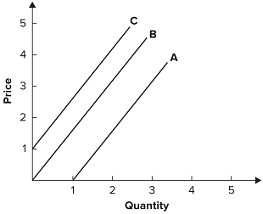
              - A
              - B
              - C
              - None of the answers is correct.

