METU
Department of Economics
Econ 101: Introduction to Economics I
Section 01-02
Fall 2023
PROBLEM SET 2 (CH 2&3)
PART A: ESSAY QUESTIONS
- The table below is a production possibility table for the fictional country of Myopia. Use it to construct the corresponding production possibility curve in the quadrant below. (Label the axes.)

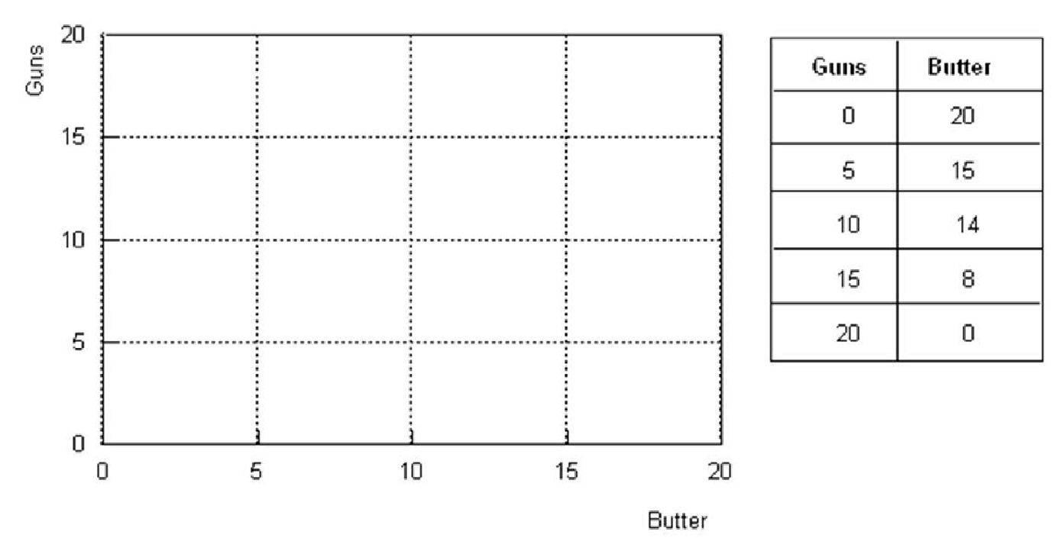
- Explain the meaning of a production possibilities curve.

- What is assumed to be constant when we draw that curve?

- How is a point on the curve different from (1) a point inside the curve or (2) a point outside the curve?

- How does this curve illustrate the concept of opportunity cost?

- How does it illustrate the principle of increasing marginal opportunity cost?

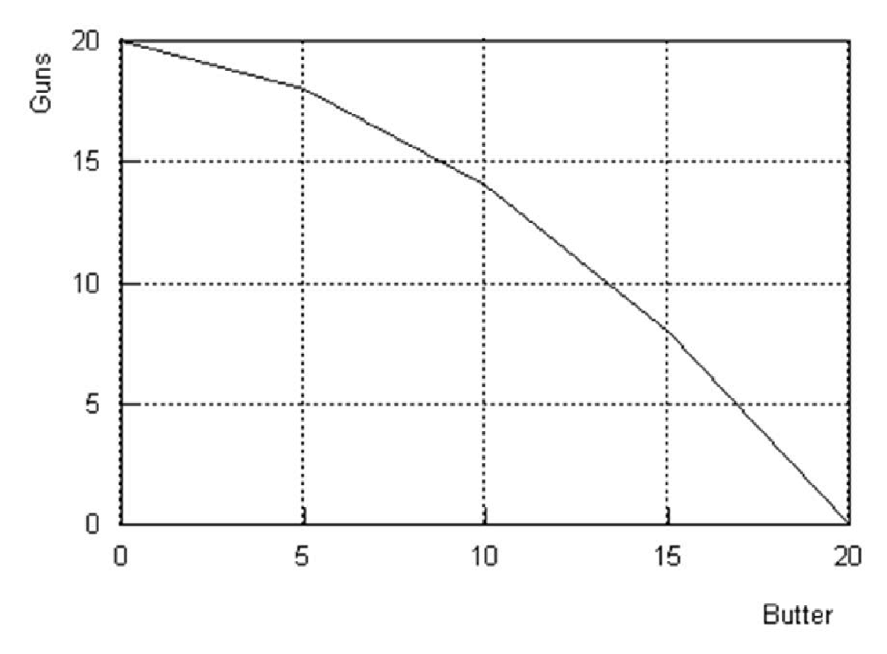
(a) A production possibilities curve is a curve measuring the maximum combination of outputs that can be obtained from a given number of inputs - using a given technology.
(b) When we draw the production possibility curve, the amount of inputs and the state of technology are assumed to be fixed
(c) A point on the production possibility curve is efficient because it corresponds to the maximum amount of butter for any given amount of guns. (1) A point inside the production possibility curve is inefficient because for any given amount of guns, it would be possible to produce more butter. (2) Any point that lies outside the curve is simply not attainable given the available resources and technology.
(d) The negative slope of the curve illustrates the notion of opportunity cost. In order to get more butter, it is necessary to give up some guns. The amount of guns given up is the opportunity cost of the additional units of butter.
(e) The increasing slope of the production possibility curve illustrates the principle of increasing marginal opportunity cost. Thus, the cost of the first five units of guns is only two units of butter; but the cost of the last five units of guns is eight units of butter

- Draw the production possibility frontier and fill in the blanks according to the table.
(Put the amount of meat on the x-axis and the amount of fish on the y-axis)

Combination | A | B | C | D | E | F | G | H | K | L
Fish | 0 | 13 | 23 | 32 | 40 | 47 | 52 | 56 | 59 | 60
Meat | 108 | 102 | 95 | 87 | 78 | 67 | 53 | 36 | 19 | 0

- The production possibilities frontier for this isle will be shaped concave.
- The slope (in absolute value) along this production possibilities frontier increases at an increasing rate as more meats (placed on the X-axis) are produced.
- The slope of this production possibilities frontier varies at each point.
- When the economy moves from point C to F, the opportunity cost of an additional fish, in terms of meat, is 7 / 6 meat(s).
- The opportunity cost of each additional fish in terms of meat ________.
- falls as more fish is produced.
- increases as more fish is produced
- remains constant
- is meaningless because the cost of fish cannot be expressed in terms of meat(s).
- The opportunity cost of each additional meat in terms of fish ________.
- is meaningless because the cost of fish cannot be expressed in terms of meat(s)
- remains constant
- falls as more fish is produced.
- increases as more meat is produced
g) When the economy moves from point K to D, the opportunity cost of a piece additional meat, in terms of fish, is 27 / 68 fish.

- According to the information given below:
Combination | Meat (units) | Wheat (units)
A | 0 | 2000
B | 200 | 1800
C | 400 | 1500
D | 600 | 1100
E | 800 | 600
F | 1000 | 0

  - Draw the production possibility frontier (PPF) (put meat on the x-axis)

Wheat
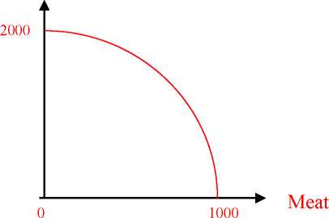

  - The production possibilities frontier is concave to the origin. (concave /convex)
  - Can this economy produce 200 units of meat and 1500 units of wheat? Yes, but it is inefficient or some resources are unemployed.
  - Can this economy produce 200 units of meat and 2200 units of wheat? No it is unattainable
  - What is the opportunity cost of increasing meat production from 200 units to 400 units (i.e. if the economy moves from combination B to combination C)? 300 units of wheat. What is the opportunity cost per unit of meat? 3/2 (=300/200) units of wheat
  - What is the opportunity cost of increasing meat production from 400 units to 600 units (i.e. if the economy moves from combination C to D)? 400 units of wheat. What is the opportunity cost per unit of meat? 2 (= 400/200) units of wheat.
  - Does the principle of “increasing opportunity cost” hold in this economy?
Based on the answers to parts e and f, we can conclude that the principle of increasing opportunity cost applies in this economy. The opportunity cost of each additional unit of meat in terms of wheat increases as more units of meat are produced.
- How do the following events affect the production possibility frontier (PPF) of a country, which produces only two goods food (F) and smart devices (S)? Show the shifts on the PPF graph. (Suppose that food is on the y axis and smart phones are on x axis.)
a) Rising sea levels causes floods damaging the buildings of some coastal cities.
Assuming the coastal cities were are contributing same amount to both sectors

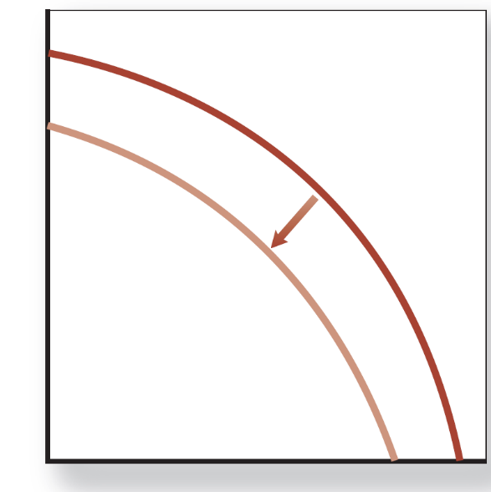
b) Block chain design increases the productivity of the electronics industry.
The increase in the electronics positively affects the smart devices and has no effects on food.
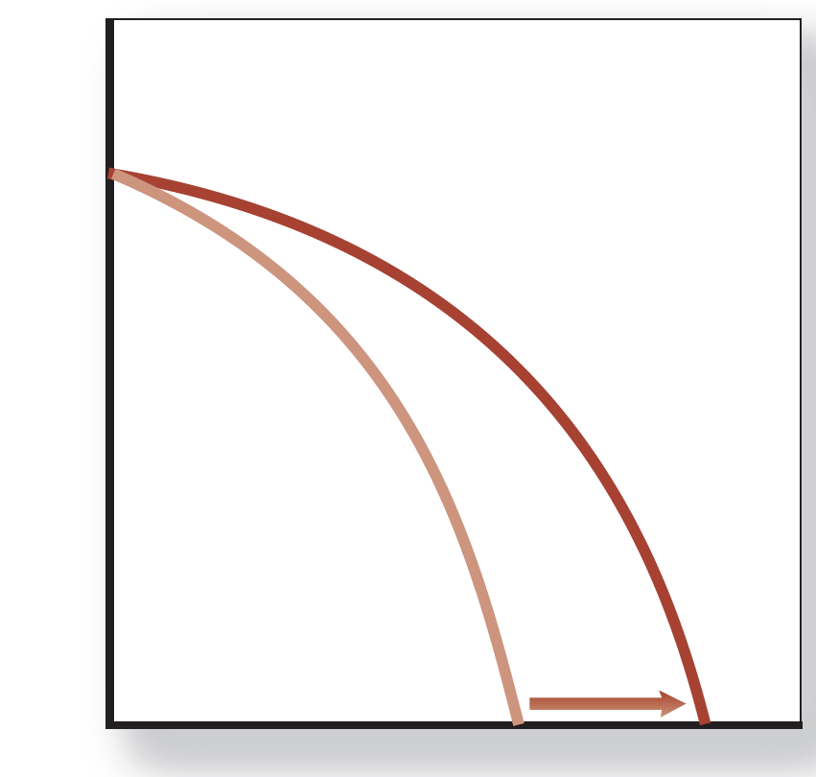

c) Suppose that the government imposed a subsidy to farmers to support agriculture and livestock sectors.
It affects only the food sector positively.

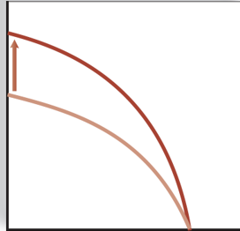
- Define the following terms briefly and give an example for each.
    - Market failure: Situations in which the market does not lead to a desired result. (Example: Unregulated financial markets in the USA caused the 2008 global crisis.)
- Positive externalities: A positive effect of a decision on a third party not taken into account by the decision maker. (Example: Education. When someone educates herself or himself, all society benefits, since better-educated people usually make better citizens and are better equipped to figure out new approaches to solving problems—approaches that benefit society as a whole.)
Negative externalities: A negative effect of a decision on a third party not taken into account by the decision maker. (Example: Burning of coal, which puts sulfur dioxide, carbon dioxide, and fine particulates into the air. Sulfur dioxide contributes to acid rain, carbon dioxide contributes to global warming, and fine particulates damage people’s lungs. This means that burning coal has an externality associated with it—an effect of an action that is not taken into account by market participants.)
- Public good: good that if supplied to one person must be supplied to all and whose consumption by one individual does not prevent its consumption by another individual. (Example: National defense, which, if supplied to one, will also protect others. In order to supply defense, governments must require people to pay for it with taxes, rather than leaving it to the market to supply it.)
- Demerit goods or activities: Goods or activities that government believes are bad for people even though they choose to use the goods or engage in the activities. (Example: Cigarettes are a demerit good and using addictive drugs is a demerit activity.)
- Merit goods or activities: Goods and activities that government believes are good for you even though you may not choose to engage in the activities or to consume the goods. (Example: Government may believe that going to the theatre or donating blood to Kızılay is a good activity. But in Turkey only a small percentage of people go to the theatre, and not everyone in the Turkey donates blood. Similarly, government may believe that whole-wheat bread is more nutritious than white bread. But many consumers prefer white bread.)

- What are the specific roles for government in the economy?

In today’s world, governments act as both and actor and referee in the economy. The major roles of the government are:
- Providing a stable set of institutions and rules: A basic role of government is to provide a stable institutional framework that includes the set of laws specifying what can and cannot be done as well as a mechanism to enforce those laws. (Colander, D. C., 2019).
- Promote Effective and workable competition: In a market economy, the pressure to monopolize—for one firm to try to control the market—and competition are always in conflict; the government must decide what role it is to play in protecting or promoting competition. Thus, when Microsoft gained monopolistic control of the computer operating system market with Windows, the U.S. government took the company to court and challenged that monopoly. (Colander, D. C., 2019).
- Correct for Externalities: When two people freely enter into a trade or agreement, they both believe that they will benefit from the trade. But unless they’re required to do so, traders are unlikely to take into account any effect that an action may have on a third party. Economists call the effect of a decision on a third party not taken into account by the decision maker an externality. An externality can be positive (in which case society as a whole benefit from the trade between the two parties) or negative (in which case society as a whole is harmed by the trade between the two parties). When there are externalities, there is a potential role for government to adjust the market result through taxes, subsidies, or regulation. Throughout this book we will be considering the advantages and disadvantages of each. (Colander, D. C., 2019).
- Ensure Economic Stability and Growth: In addition to providing general stability, government has the potential role of providing economic stability. Most people would agree that if it’s possible, government should prevent large fluctuations in the level of economic activity, maintain a relatively constant price level, and provide an economic environment conducive to economic growth. (Colander, D. C., 2019).
- Provide Public Goods: As we discussed in the previous question, A public good is a good that if supplied to one person must be supplied to all and whose consumption by one individual does not prevent its consumption by another individual. An example of a public good is national defense, which, if supplied to one, will also protect others. In order to supply defense, governments must require people to pay for it with taxes, rather than leaving it to the market to supply it. (Colander, D. C., 2019).
- Adjust for Undesirable Market Results: Government redistributes income, taking it away from some individuals and giving it to others whom it sees as more deserving or more in need. In doing so, it attempts to see that the outcomes of trades are fair. Determining what’s fair is a difficult philosophical question that economists can’t answer.
(Colander, D. C., 2019).
- Draw a production possibilities curve that indicates how you might divide up 10 hours of study time between your economics and accounting midterm exams. Put expected grade in economics on the horizontal axis and expected grade in accounting on the vertical axis. If you don't study at all, you expect to make a 70 on both exams. For every one additional hour of studying economics, your exam grade rises by 3 points. The same is true for accounting.

a. What is the opportunity cost of studying one extra hour for your economics exam?

b. What is the opportunity cost of studying one extra hour for your accounting exam?

c. Can the production possibility curve shift? Explain.
The diagram below

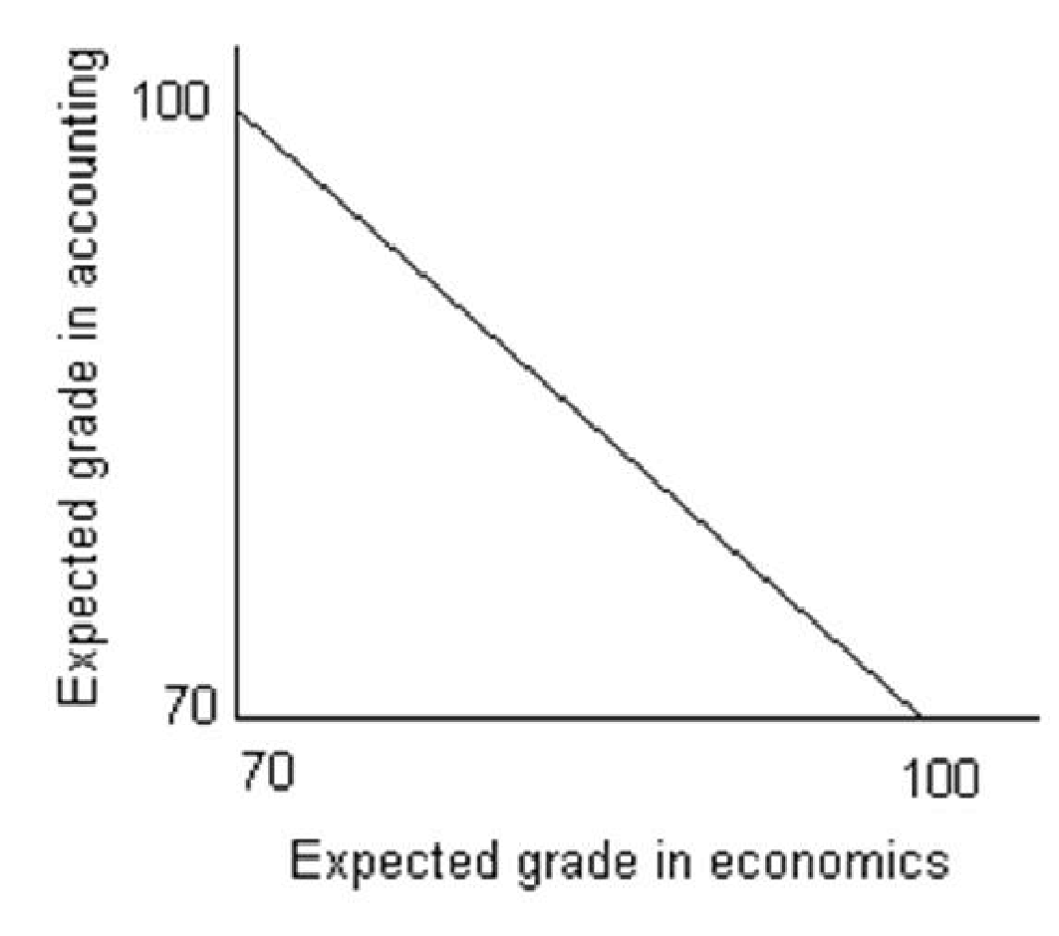

If you allocate all available studying time for economics, you will make a 100 on the test (70 + 3 times 10). Similarly, if you don't study economics and allocate all your time to accounting, you will make a 100 on the accounting exam. Therefore, the shape of the production possibilities curve is as shown above.
(a) The opportunity cost of one hour of studying economics is one hour of studying accounting, which means the loss of 3 points on the accounting exam.
(b) The opportunity cost of one hour of studying accounting is one hour of studying economics, which means the loss of 3 points on the economics exam.
(c) Yes, the production possibilities curve may shift. If you allocate more time to studying or if you developed a method that would make your studying time more productive, the curve will shift in such a way that it might be possible to get 100 in both courses. In this case, it would not be a parallel shift.
- For each of the following events, show the shift in the demand curve and/or supply curve that results from the event, and the change in equilibrium price and quantity.
a) Medical reports show that apples do not reduce cholesterol, contrary to earlier beliefs. What happens to the demand and/or supply curves for apples? What happens to the equilibrium price and quantity of apples sold?
Since some people were probably eating apples because of this alleged characteristic, they will quit eating it and the demand curve will shift leftward (a decrease in demand). There is no change in the supply curve. Both the equilibrium price and the quantity of apples sold will be lower.
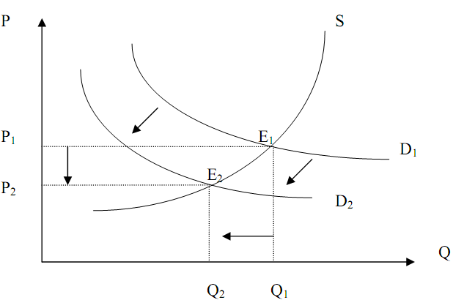
b) The price of water sold to agricultural producers is raised. What happens to the demand and/or supply curves for vegetables? What happens to the equilibrium price and quantity of vegetables sold?
This event causes an increase in the cost of producing vegetables. For each quantity produced, agricultural producers will require a higher price (to cover the higher cost) in order to be induced to supply that quantity. Because of this, the supply curve will shift upward (a decrease in supply). There is no change in the demand curve. The equilibrium price will rise and the quantity of vegetables sold will decrease.
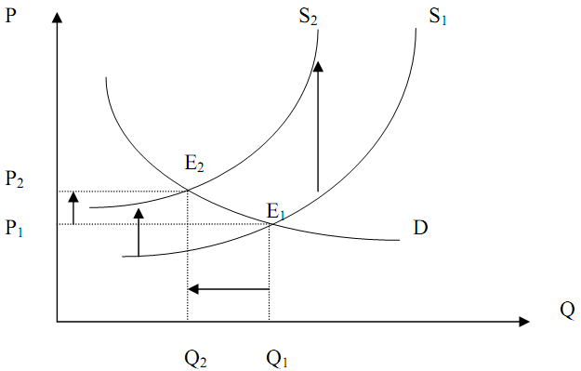
c) An insect pest attacks the coffee crop around the world. Assume that tea and coffee are substitutes. What happens to the demand and/or supply curves for tea? What happens to the equilibrium price and quantity of tea sold?
The supply of coffee is reduced, increasing the price of coffee. Therefore some coffee drinkers will find it too expensive to drink and will switch to its substitutes, one of which is tea. The demand for tea will increase (the demand curve for tea shifts to the right) and there is no change in the supply curve of tea. Both the equilibrium price of tea and the quantity of tea sold will increase.
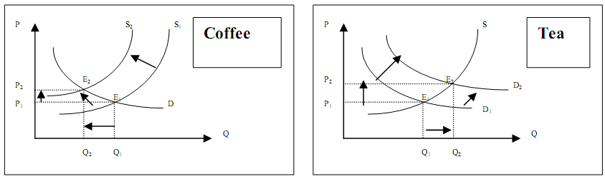

PART B: MULTIPLE CHOICE

- The Production Possibilities Frontier (PPF) depicts the fact that
- When a society combines its resources efficiently, it cannot produce more of one good without producing less of the other good.
- When a society combines its resources efficiently, it cannot produce more of one good without producing more of the other good.
- Some resources are always idle in a democratic society
- All points inside the curve are preferred to all points on the curve in terms of efficiency
- The demand for goods always exceeds the supply
- The opportunity cost of producing good A is defined as
- The money cost of the factors of production used in good A
- The retail price of good A
- The cheapest method of producing good A
- What must be the additional production cost get an additional unit of A
- The cost of having the best alternative in place of good A
- On the diagram of a PPF, the concept of scarcity is illustrated by
- the points on the curve
- the area within the curve
- the distance from origin to the curve
- the negative slope of the curve
- the unattainable points outside the curve
- Suppose that 1 unit of labor can produce either 5 units of wool or 2 pineapples. What is the opportunity cost of producing 1 pineapple?
- 5 units of wool
- 2 units of wool
- 2/5 units of wool
- 5/2 units of wool
- Zero

Refer to the graph below.
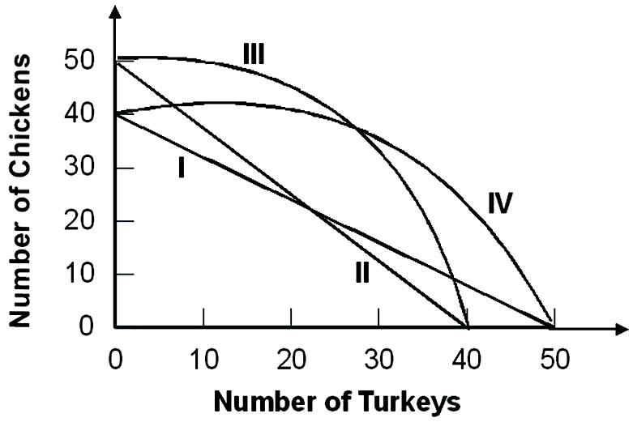
Suppose that the opportunity cost of producing 10 chickens is always 8 turkeys. Given this, the relevant production possibility curve must be:
  - I
  - II
  - III
  - IV
  - None of the above
- Refer to the graph below
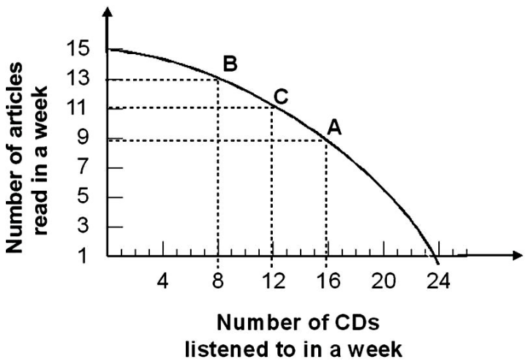

Given the production possibility curve, the opportunity cost of reading 2 more articles when you are already reading 11 articles is on average:
- ½ CD per article
- 2 CDs per article
- 2/3 CDs per article
- 3 CDs per article
- 3/2 CDs per article
- The principle of increasing opportunity costs states that the initial opportunity costs are:
- high but decrease the more you concentrate on the activity.
- low but increase the more you concentrate on the activity.
- high but increase the more you concentrate on the activity.
- low but decrease the more you concentrate on the activity.
- In a free market economy, the allocation of resources is decided by
- Central authorities only
- Central authorities and firms only
- Firms and households acting independently
- Political parties and firms only
- Individuals only
- In the economic theory, it is typically assumed that households and firms, respectively maximize
- Income and sales
- Savings and profits
- Wages and revenues
- Utility and profits
- Expenditures and profits
- Economic theory shows that in the private sector of a market economy, the price system allocates resources
- In goods market only
- In factor markets only
- In and equitable manner
- Better than they could be allocated by another allocation system
- In both goods and factor markets
- The circular flow of economic activity
- Illustrates the relationship between wants and resources
- Illustrates the relationship between financial system and government
- Shows why income flows do not balance the expenditure flows
- Illustrates the relationship between consumers and business
- Illustrates the relationship government, households and firms

- Markets coordinate economic activity through:
- the price mechanism.
- commanding individuals what to do.
- asking individuals what to do.
- the legal mechanism.
- The government intervention
- In the simple circular flow model, the government .
A) Has little influence over the markets
B) Influences both the input and output markets through taxes and regulations
C) Only siphons out income from the model through taxes
D) Increases the amount of income in the economy

- Which of the following is not an example of government's role as a referee?
- Equal opportunity and labor laws that restrict businesses' freedom to hire and fire whomever they want.
- Regulations governing safety in the workplace, wages, overtime, and hours of work
- Laws prohibiting businesses from meeting to fix prices
- Laws that require states and the federal government to balance their budgets

- The government serves as an actor in the economy when it
- alters anti-trust laws.
- increases defense spending
- reduces the minimum wage.
- improves health and safety standards for certain industries.
- Assume the demand for t-shirt decreases while the supply increases. Which of the following outcomes will occur unambiguously?
- The equilibrium quantity of t-shirt will fall.
- The equilibrium price of t-shirt will fall.
- The equilibrium quantity of t-shirt will rise.
- The equilibrium price of t-shirt will rise.

- A shift of a demand curve to the right or to the left is called
- a change in quantity demanded.
- a change in quantity supplied.
- a movement along a demand curve.
- a change in supply.
- a change in demand.

- Which of the following is NOT a characteristic of a market in equilibrium?
- Excess supply is zero.
- All consumers are able to purchase as much as they wish.
- Quantity demanded equals quantity supplied.
- The equilibrium price is stable, i.e., there is no pressure for it to change.
- Excess demand is zero.
- What might cause a demand function to shift to the right?
- An increase in the price of a substitute.
- An increase in the price of a complement.
- An increase in the product's own price.
- A decrease in the price of a substitute.

- A movement along a demand curve from one price-quantity combination to another is called
- a change in quantity demanded.
- a change in demand.
- a change in supply.
- a change in quantity supplied.
- a shift in the demand curve.

