METU
Department of Economics
Econ 101: Introduction to Economics I
Section 01-02
Fall 2024
PROBLEM SET 7 (Chapter 19)
- Briefly define the income and substitution effects. Give an example where the income effect surpasses the substitution affect.
The reduction in quantity demanded because the increase in price makes us poorer is called the income effect. (we’re poorer due to the rise in price). Second, the reduction in quantity demanded because relative price has risen is called a substitution effect. 2 For any other sort of good, as the price of the good rises, the substitution effect makes consumers purchase less of it, and more of substitute goods; for most goods, the income effect reinforces this decline in demand for the good. But the type of good, that is called Giffen Good, income elasticity is negative that this contrary income effect more than offsets the substitution effect, and the net effect of the good's price rise is to increase demand for it. Potatoes during a famine in Ireland in the 19th century were proposed as an example.
- A consumer has an income of 180 TL per month and he wishes to spend all of it on two goods A and B, whose prices are 3 and 5, respectively. (Put A in the vertical axis)

  - Draw the budget line

A
B
60
36

- Write the budget constraint equation.

P_{A}.A + P_{B}.B = Y, Y stands for income, 3A + 5B = 180

- How will budget lines be affected by following situations (assume each time you start from initial budget constraint).

i) Doubling of money income and doubling of all absolute prices.

Nothing changes. 6A + 10B = 360

ii) A doubling of money income and a doubling of price of B.

A
B
120
36
60

iii) Doubling of price of A, assuming all other things constant.
A
B
30
36
60

6A + 5B = 180

iv) An increase in income by 60.
A
B
80
48
36
60

3A + 5B = 240

- Consumer is currently maximizing his/her utility and consumes both A and B. Illustrate her initial equilibrium in an indifference curve/budget line diagram (put B on the horizontal axis.) Suppose that, the price of B decreases. Draw consumer’s new budget line. Using the concepts of the income and substitution effects, show consumer’s new utility maximizing consumption of A and B assuming that B is an inferior good for the consumer.

A
B
Z
Y
X
C₁
C₂
B₃
B₂
B₁

In the diagram above, consumer is initially consuming at point X on her original budget line. When the price of B decreases consumer’s budget line moves out along the horizontal axis and her consumption moves to point Z. We can break the move from X to Z down into two parts. If we let consumer see the new relative prices but keep her on her original indifference curve she will go to point Y (tangent point of original indifference curve and the new relative prices). We see that her consumption of B would increase from B₁ to B₂. This is the substitution effect. The only difference between her choice at point Y and at Z is her income (the budget lines have the same slope). As she moves from Y to Z her consumption of B decreases from B₂ to B₃. This is the income effect. Since her consumption of B fell (when income increased) B must be an inferior good for her.

- Deniz is trying to decide how much coffee, tea and biscuits to buy. A packet of coffee, tea and biscuits cost 5 TL, 4 TL and 2 TL respectively. Suppose she has an income of 43 TL.
 | Coffee |  |  | Tea |  |  | Biscuits
# of each | TU | MU | MU / P | TU | MU | MU / P | TU | MU | MU / P
0 | 0 |  |  | 0 |  |  | 0
1 | 75 | 75 | 15 | 100 | 100 | 25 | 60 | 60 | 30
2 | 130 | 55 | 11 | 180 | 80 | 20 | 110 | 50 | 25
3 | 170 | 40 | 8 | 240 | 60 | 15 | 140 | 30 | 15
4 | 200 | 30 | 6 | 292 | 52 | 13 | 156 | 16 | 8
5 | 220 | 20 | 4 | 324 | 32 | 8 | 170 | 14 | 7
6 | 225 | 5 | 1 | 340 | 16 | 4 | 178 | 8 | 4

- Fill in the empty cells of the table above.
- Does Deniz’s response to all goods obey the law of diminishing marginal utility?
As Deniz consumes more of coffee (or tea or biscuits), the utility derived from each additional unit of them is less than the utility derived from consumed before. As the number of all consumed goods increase, the marginal utility derived from additional unit decreases. Therefore the utility that Deniz derived from successive units of all goods diminishes as total consumption of the goods increase, so that Deniz’s response to all goods obey the law of diminishing marginal utility.

- How many units of each good should she purchase to maximize total satisfaction?
P_{Coffee} Q_{Coffee} + P_{Tea}Q_{Tea} + P_{Biscuits} Q_{Biscuits} = 43
5 * Q_{Coffee} + 4 * Q_{Tea} + 2 * Q_{Biscuits} = 43
To maximize the level of satisfaction; the following condition should be hold.
(MU_{Coffee} / P_{Coffee}) = (MU_{Tea} / P_{Tea}) = (MU_{Biscuits} / P_{Biscuits})
This holds for following pairs of coffee, tea and biscuits; (1,3,3), (3,5,4), (5,6,6). However, the consumption pair must also satisfy the budget constraint. Since the only (3,5,4) pair satisfy both of the constraints, Deniz should maximize his satisfaction by consuming 3 units of coffee, 5 units of tea and 4 units of biscuits.

- If her money income were cut to 23 TL, how many units of each should she purchase to maximize total satisfaction?

If income were cut to 23 TL, bundle of (1,3,3) satisfies both constraints.

- Suppose that Hakan allocates all his income on goods X and Y. The price of good X is 4 TL and the price of good Y is 6 TL per unit. Suppose that total utility function of Hakan is as follows:
TU = X² + Y²
Where X and Y represents the quantity of good X and Y consumed respectively.
- Obtain the marginal utility functions of good X and Y.

${MU}_{X}=\frac{∆TU}{∆X}=\frac{∂TU}{∂X}=2X$ ${MU}_{Y}=\frac{∆TU}{∆Y}=\frac{∂TU}{∂Y}=2Y$

- If Hakan’s income is 130 TL, by using the information you obtain above, find that how many units of each good should Hakan purchase to maximize his total satisfaction.
Utility maximization condition: $-\frac{{MU}_{X}}{{MU}_{Y}}=-\frac{P_{X}}{P_{Y}}$ or $\frac{{MU}_{X}}{P_{X}}=\frac{{MU}_{Y}}{P_{Y}}$
$\frac{2X}{2Y}=\frac{4}{6}$ $\frac{X}{Y}=\frac{2}{3}$
From budget constraint: 4X + 6Y = 130
If we solve these two equations simultaneously, X=10, Y=15; (X, Y) = (10, 15).
Note: there is a mathematical problem with the structure of the Utility function and we talked about it during the recitation. Please ignore that problem and just use MRS
- Suppose that Hakan consumes the bundle (X, Y) = (3, 18). Does this consumption bundle maximize the consumer’s utility? Why or why not? Explain by drawing a graph and making necessary calculations (Put Y on the vertical axis).
MU_{X}/P_{X} = MU_{Y}/P_{Y} , then -(MU_{X}/ MU_{Y}) = -(P_{X} /P_{Y})
At point A;
3/18 is not equal to 2/3.
At E, MRS equals to slope of the budget line.
All of the income is spent, consumer is at point like A= (3, 18).
However, at A, since MRS is not equal to slope of budget line, the equilibrium condition fails. Point A is not equilibrium, i.e. consumer’s utility is not maximized.
Y
30

X
20

E

A

- If the bundle in (c) does not maximize utility, what should this consumer do?

At A, consumer is using 3 X, and 18 Y. since MRS is not equal to slope of budget line, consumer should change his bundle to maximize utility. Then he should go to point E, given this budget constraint. So, in order to maximize the utility by spending all of income, consumer should consume less Y and more X as consumption of Y (X) decreases (increases), till point E. At point E, MRS is equal to the price ratio, utility maximization is satisfied.

- A consumer has a budget of $100 to spend on two goods: apples (Good X) and bananas (Good Y). The price of an apple is $2, and the price of a banana is $4. The consumer's utility function is given by U(X,Y)= X^{0.5}Y^{0.5}
- Write the equation for the consumer's budget line and graph it.

Equation for the budget line is : 2X+4Y=100
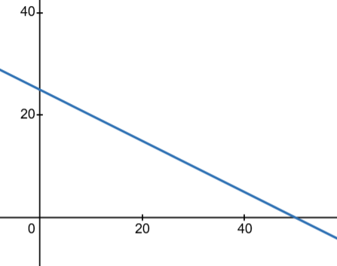

- Set up the utility maximization problem and solve for the optimal quantities of apples and bananas that the consumer should buy.

Utility maximization condition: $-\frac{{MU}_{X}}{{MU}_{Y}}=-\frac{P_{X}}{P_{Y}}$ or $\frac{{MU}_{X}}{P_{X}}=\frac{{MU}_{Y}}{P_{Y}}$
$${MU}_{x}=0.5X^{-0.5}Y^{0.5}$$

$${MU}_{Y}=0.5Y^{-0.5}X^{0.5}$$

$\frac{{MU}_{X}}{{MU}_{Y}}=\frac{Y}{X}=\frac{2}{4}$ which implies that X=2Y on the optimal bundle.
And the second constraint also be considered to find optimal bundle which is , 2X+4Y=100

When we solve this equation, we find that Y*=12.5 and X*=25

- Calculate the consumer's maximum utility at the optimal point."

The UMP Bundle gives the maximum utility that a consumer can get , which is

$TU={25}^{0.5}{12.5}^{0.5}$= $\sqrt{312.5}≈17.67$

- Suppose that Mrs. Aydın allocates all her income on food and shelter. The price of food is 10 TL and the price of shelter is 12 TL per unit.

- Suppose further that the following equations represent the marginal utilities of food and shelter, respectively.

MU_{F} = 40 – 5F; MU_{s} = 30 – 6S

where F and S represent the quantity of food and shelter consumed, respectively and and MU_{F} and MU_{s} are measured in million utils. If Mrs. Aydın’s income is 250 TL, how many units of each good should she purchase to maximize her total satisfaction?

$\frac{40-5F}{30-6S}$ = $\frac{10}{12}$

F-S = 3
From budget constraint: 10F + 12S = 250
When these two equations are solved simultaneously; F=13, S=10

- Suppose that Mrs. Aydın consumes the bundle (F, S) = (7,15). Does this consumption bundle maximize the consumer’s utility? Why or why not? Explain by drawing a graph and making necessary calculations (Put food on the vertical axis).

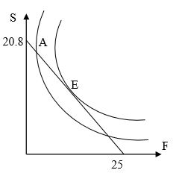
MRS = $\frac{40-5*7}{30-6*15}$ = $\frac{5}{-60}$
Slope of the Budget Line = - $\frac{50}{60}$
Since MRS is higher than the slope of the budget line and all of the income is spent, consumer is at point like A. Since the equilibrium condition fails, point A is
not equilibrium, i.e. consumer’s utility is not maximized.

- If the bundle in (b) does not maximize utility, what should this consumer do?

In order to maximize the utility by spending all of income, consumer should consume less shelter and more food. As consumption of shelter (food) decreases (increases), MRS declines and equilibrium is reached when it is equal to the price ratio, i.e. slope of the budget line.

- Suppose that there are two goods, clothes and foods, and their respective prices are Pc and Pf in a country.
(Put cloth to y axis and food to x axis).
- Draw initial equilibrium condition.
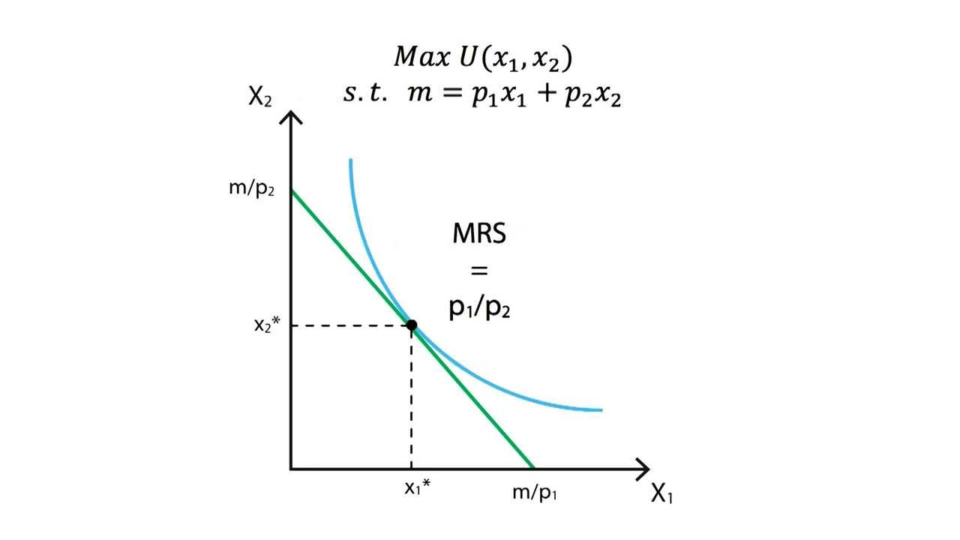
- Suppose that price of food, a normal good, decreases. Show income and substitution effects by drawing relevant graphs.
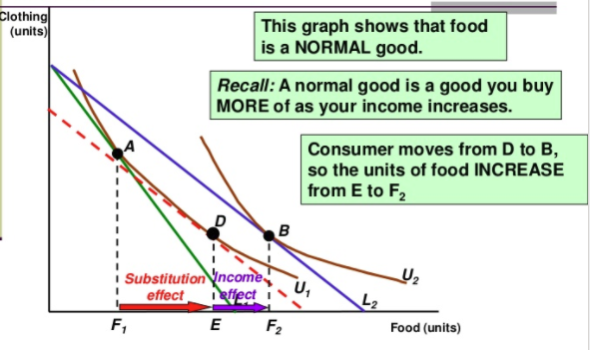
- How will your answer to part b change if food is an inferior good (not Giffen)? Draw the graphs.
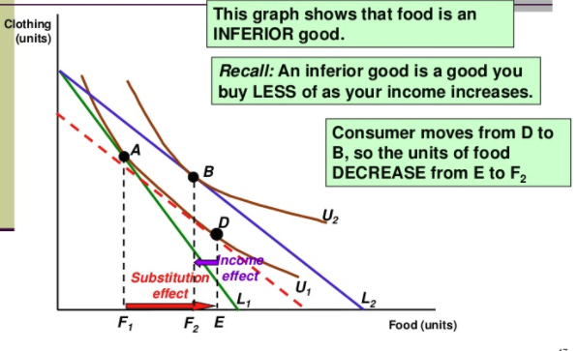
- How will your answer to part b change if food is a Giffen good? Draw the graphs.
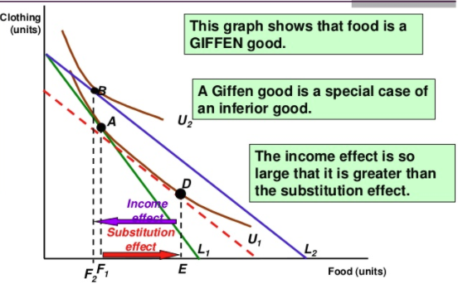

PART B- MULTIPLE CHOICES
- When money income increases while the prices of all goods remain unchanged
- the budget line shifts inward
- the slope of the budget line increases
- the slope of the budget line decreases
- the budget line shifts outward with the same slope
- If the price of a product X rises, then the resulting decline in the amount purchased will
- necessarily increase the consumer’s total utility from his aggregate purchases.
- increase the marginal utility of this good.
- increase the total utility from purchases of this good.
- reduce the marginal utility of this good.

- The hypothesis of diminishing marginal utility can be used to explain why total utility curves
- have positive slopes b) have negative slopes
c) become flatter as quantity increases d) become steeper as quantity increases

- As a consumer moves down on the indifference curve
- his level of satisfaction varies with the bundles of goods
- the combination of goods will remain constant although the level of satisfaction will vary
- the combination of goods will vary, but the level of satisfaction will remain constant
- both the combination of goods and the consumer’s income level will remain constant

- The substitution effect causes a consumer to buy less of a product when its price rises because
- consumer’s real income has decreased.
- consumer’s real income has increased.
- product is now less expensive in comparison to other products.
- product is now more expensive in comparison to other products.

- Which of the following statements concerning indifference curves is FALSE?
- An indifference curve shows all combinations of goods that give the same amount of satisfaction
- The indifference curve which is further away from the origin represents the greater amount of satisfaction
- Diminishing slope of indifference curve shows that consumer has greater amount of it and she is willing to exchange for another good
- An increase in real income will cause an indifference curve to shift outward

- All points on or below a budget constraint

are attainable with the given income. b) are equally desirable.

represent bundles that exactly exhaust the income available. d) are unattainable.
- Suppose that Ali allocates all her income on food and shelter. The price of food is 10 TL and the price of shelter is 5 TL per unit. Suppose further that the following equations represent the marginal utilities of food and shelter, respectively. (Red ones are the updated values .Original version does not have the exact quantities)
${MU}_{F}=30-4F$ ${MU}_{S}=30-5S$
where F and S represent the quantity of food and shelter consumed, respectively and and are measured in million utils. If Ali’s income is 105TL, how many units of each good should he purchase to maximize his total satisfaction?
- 9 units of F, 10 units of S b) 9 units of F, 9 units of S
c) 7.5 units of F, 6 units of S d) 8 units of F, 10 units of S
- The marginal utilities of consuming an additional unit of good A and good B are 10 and 4 respectively. What set of price for A and B respectively would be consistent with consumer equilibrium?
a) 4 TL and 4 TL b) 5 TL and 2 TL c) 2 TL and 5 TL d) 4 TL and 10 TL
- If the price of a normal good X rises;
- the income and substitution effects will both induce the consumer to buy less of X.
- the income and substitution effects will both induce the consumer to buy more of X.
- the income effect will induce the consumer to buy more of X and the substitution effect will induce him to buy less.
- the income effect will induce the consumer to buy less of X and the substitution effect will induce him to buy more.

- Suppose that $MU_{y}/P_{y}$ exceeds $MU_{x}/P_{x}$. To maximize the utility, consumer who is exhausting her money income should buy
- less of X only if its prices rise. b) more of Y only if its prices rise.
- more of Y and less of X. d) more of X and less of Y.

- Which of the following is FALSE?
- Points on a budget constraint represent bundles of the goods that exactly use up household’s income.
- Points below the budget constraint represent bundles of the goods that do not use up all the household’s income
- If bundles A and B lie on the budget constraint, we can deduce that the household is indifferent between the two bundles.
- If the price of one good decreases without any other changes, the budget constraint will swivel or rotate outward

A consumer’s demand curve for a product is downward sloping because
- total utility falls below marginal utility as more of a product is consumed.
- marginal utility diminishes as more of a product is consumed
- time becomes less valuable as more of a product is consumed.
- the income and the substitution effects precisely offset each other.

- In moving along a given budget line:
- The prices of both products and money income are assumed to be constant.
- Each point on the line will be equally satisfactory to consumers
- Money income varies, but the prices of the two goods are constant
- The prices of both products are assumed to vary, but money income is constant.

If food is on the vertical axis and shelter is on the horizontal axis, a set of indifference curves that are quite steep

reflect a preference pattern that generally values shelter high relative to food.

imply that food has a higher relative value than shelter for this consumer.

say nothing about how the consumer feels about the two goods until a budget line is introduced.

Mean that the two goods are perfect substitutes,
- The substitution effect refers to a change in quantity demanded that occurs due to a change in
- purchasing power b) income

c) marginal utility d) a good’s relative price

Answer the following five questions by using the information given below.
Hakan is choosing how to allocate her spending between CD’s and clothes. The figure below shows his budget line and an indifference curve.

CD
Clothes
e
f
d
b
a
c

- On which point Hakan maximizes his utility?
a) f b) c c) d d) e e) b
- On which point Hakan buys only CD’s and no cloths?
a) f b) c c) d d) e e) b

- Which point yields the same satisfaction as at point d but Hakan can not afford?
a) f b) c c) d d) e e) a

- Which point is the consumption bundle preferred to point d but Hakan can not afford?
a) f b) c c) d d) e e) a
21. At point d:
a) $MU_{x}=MU_{y}$ b) $MRS=P_{x}/P_{y}$ c) $MRS=P_{y}/P_{x}$ d) All of the above hold true
- Refer to the graph shown. Total utility is at its maximum at point:
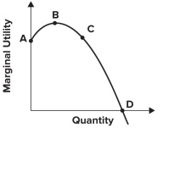
              - A.
              - B.
              - C.
              - D.

- Refer to the graph shown. Between points B and D, marginal utility is:
              - increasing, and so total utility is falling.
              - positive, and so total utility is increasing.
              - positive, and so total utility is falling.
              - increasing, and so total utility is at its maximum.

- Refer to the graph shown. Between points C and D, marginal utility is:
              - decreasing, and so total utility is falling.
              - positive, and so total utility is increasing.
              - positive, and so total utility is falling.
              - decreasing, and so total utility is at its maximum.

- Refer to the following graph.
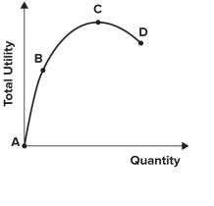
Marginal utility is:
              - negative between A and B.
              - negative between B and C.
              - negative between C and D.
              - not negative anywhere along the total utility curve.

- If the total utility curve is a straight line, the marginal utility curve would be:
              - a downward-sloping line.
              - a flat line with a slope of zero.
              - an upward-sloping line with a slope of 1.
              - a vertical line.
- Refer to the graphs shown, which show indifference curve analysis with the associated demand curves.
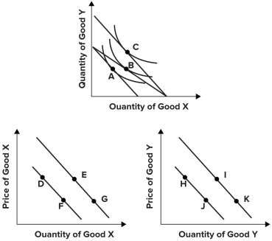
The best explanation for a movement from point D to point E is:
              - an outward rotation of the budget constraint along the x-axis, allowing the consumer to move from point A to point B.
              - a parallel shift of the budget constraint, allowing the consumer to move from point A to point C.
              - an inward rotation of the budget constraint along the x-axis, forcing the consumer to move from point B to point A.
              - an inward rotation of the budget constraint along the y-axis, forcing the consumer to move from point C to point B.
- Refer to the graph shown.
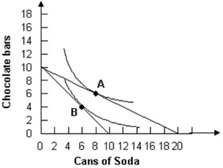
Assuming a consumer has $5 to spend, if a soda costs $0.25 and a chocolate bar costs $0.50, the consumer will optimally choose to consume:
              - at point A.
              - at point B.
              - 0 cans of soda and 10 chocolate bars.
              - 20 cans of soda and 0 chocolate bars.

- Refer to the graph shown.
Assuming a consumer has $5 to spend, if a soda costs $0.50 and a chocolate bar costs $0.50, the consumer will optimally choose to consume:
              - at point A.
              - at point B.
              - 10 cans of soda and 0 chocolate bars.
              - 0 cans of soda and 10 chocolate bars.

- Refer to the graph shown. A consumer would be expected to change consumption from point A to point B in response to a(n):
              - increase in the price of soda.
              - increase in the price of chocolate bars.
              - increase in income.
              - decrease in the price of soda.

