METU
Department of Economics
Econ 101: Introduction to Economics I
Section 01-02
Fall 2023
PROBLEM SET 1 (CH 1&2)
- Draw the graphs of following functions:

- y=8+3x
- y=8-3x
- y=3x+12

- Find the slopes and intercepts of the functions above and explain the relationship between dependent and independent variables.

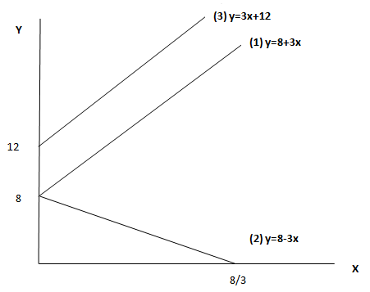
For (1), intercept = 8 (to find the intercept assign 0 value for the independent variable x.) & Slope = 3
There is a positive relationship between x and y.
For (2), Intercept = 8 & Slope = -3
There is a negative relationship between x and y.
For (2), intercept = 12 & Slope = 3
There is a positive relationship between x and y.
(In each case, consider the domain as consisting of nonnegative real numbers only.)

- Give economic examples of what the variables in equations may be.

(1) & (3) y= consumption expenditure, x= income, (consumption increases as increases increases) or y= price of a good, x= production cost of that good. If production cost of a good increases, the price of the good increases as well.
(2) z= demand for a good, x=price of the good, (demand for a good decreases as the price of the good increases)

- Write the equations of the linear functions whose graph
- has slope 2/3 and intercept (3, 0) y = 2/3x -2
- has slope 4 and intercept (4, 3) y =4x-13
- has slope 6 and passes through the point (5, 2) y =6x - 28
- has slope -1/4 and passes through the point (2, -3) y = -x/4 – 5/2
- passes through the points (2, 1) and (3, 5) y = 4x - 7

- From the graphs below, indicate which graph(s);
- are increasing for all x,
- are decreasing for all x,
- are increasing at a constant rate for all x ,
- are decreasing at a constant rate for all x,
- are increasing at an increasing rate for all x,
- are increasing at a decreasing rate for all x,
- are decreasing at an increasing rate for all x,
- are decreasing at a decreasing rate for all x,

(a) (b)

x x
y y

(c) (d)

x x

y y

x x
(e) (f)

x x

x x

y y
(g) (h)
        - a,b,c and d are increasing for all x.
        - e,g and h are decreasing for all x.
        - b is increasing at a constant rate for all x.
        - g is decreasing at a constant rate for all x.
        - a is increasing at an increasing rate for all x.
        - c is increasing at a decreasing rate for all x.
        - h is decreasing at an increasing rate for all x.
        - e is decreasing at a decreasing rate for all x.

- Suppose you won $15 on a lotto ticket and decided to spend all the winnings on candy bars and bags of peanuts. Candy bars cost $0.75 each while bags of peanuts cost $1.50 each.

- Construct a table showing the alternative combinations of the two products that are available.

Goods | A | B | C | D | E | F
Candy bars | 0 | 4 | 8 | 12 | 16 | 20
Bags of peanuts | 10 | 8 | 6 | 4 | 2 | 0
- Plot the data in your table as a budget line in a graph. What is the slope of the budget line? What is the opportunity cost of one candy bar? Of one bag of peanuts? Do these opportunity costs rise, fall, or remain constant as additional units are purchased?

The slope for the budget line above, with candy bars on the horizontal axis, is -0.5 (= -Pcb/Pbp). Note that the figure could also be drawn with bags of peanuts on the horizontal axis. The slope of that budget line would be -2.
The opportunity cost of one candy bar is ½ of a bag of peanuts. The opportunity cost of one bag of peanuts is 2 candy bars. These opportunity costs are constant. They can be found by comparing any two of the consumption alternatives for the two goods.

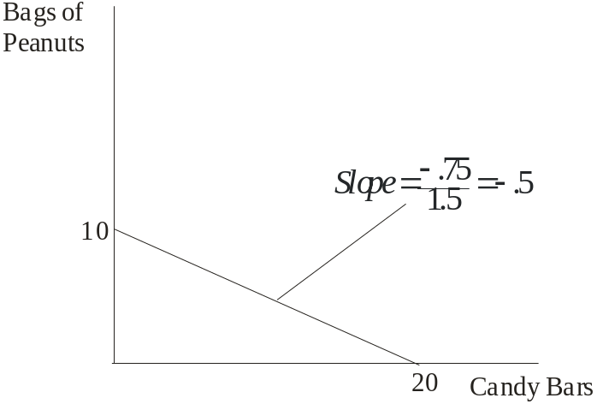
- Does the budget line tell you the optimal combination(s) of candy bars and bags of peanuts to buy?
No; it only tells you what is possible. The budget line does not tell you which of the available combinations of candy bars and bags of peanuts to buy. You will need to use your preference relationship for candy bars and bags of peanuts to determine which combination to buy. The budget line only tells you which combinations are feasible. In order to find the optimal bundle, we need to use the utility maximization problem, that we well cover later.
- Suppose that you had won $30 on your ticket, not $15. Show the $30 budget line in your diagram. Has the number of available combinations increased or decreased?
Increased.

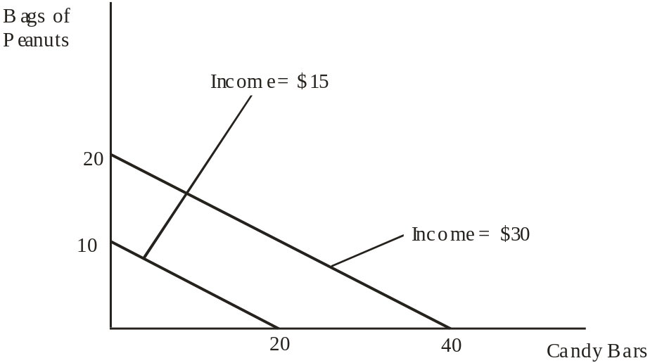

The budget line at $30 would be preferable because it would allow greater consumption of both goods.

- Below is a production possibilities table for consumer goods (automobiles) and capital goods (forklifts):

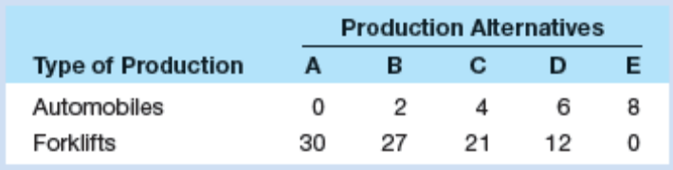

- Show these data graphically. Upon what specific assumptions is this production possibilities curve based?
The assumptions are full employment, fixed supplies of resources, fixed technology and two goods.
automobiles
forklifts
8
30
D (12,6)
C (21,4)
B (27,2)
- If the economy is at point C, what is the opportunity cost of one more automobile? Of one more forklift? Which characteristic of the production possibilities curve reflects the law of increasing opportunity costs: its shape or its length?

Assume the economy is producing at point C. Thus, the economy is producing 4 automobiles and 21 forklifts.
The cost of producing one more automobile can be found by moving to point D and calculating the number of forklifts given up for the 2 additional automobiles. At point D the economy is producing 12 forklifts, which is a loss of 9 forklifts (moving from C to D) for the 2 additional automobiles. Thus the cost of 1 more automobile equals 9 (forklifts) divided by 2 (automobiles), or (9/2) = 4.5 forklifts.
The cost of producing one more forklift can be found in a similar way. First, we will move to point B (from point C). Here we must give up 2 automobiles to get 6 forklifts. Thus, the cost of 1 more forklift equals 2 (automobiles) divided by 6 (forklifts), which is (2/6) = (1/3).
In review, take the cost (loss) and divide by the gain. If we were at point D, the cost of one more forklift equals 2 automobiles (loss) divided by 9 forklifts (gain). Thus, the cost of 1 more forklift at point B is (2/9) automobiles.
Increasing opportunity cost implies that we must give up more of a particular good to get an additional unit of a different good. This implies as we move along the production possibilities curve (from left to right) We must give up more automobiles to get an additional forklift. Thus, the SHAPE of the schedule captures the increasing opportunity cost concept. Hence, the production possibilities curve is bowed outward.
- If the economy characterized by this production possibilities table and curve were producing 3 automobiles and 20 fork lifts, what could you conclude about its use of its available resources?
Underutilizing. The economy is underutilizing resources (inside the PPC). There is either unemployment or inefficiency in utilization of resources

- Consider the following equations either increasing or decreasing in x . ( Suppose that x>0)

- y= 3x² + 4x+5
In order to understand if a function is increasing or decreasing, we need to look at first derivative.
$\frac{dy}{dx}=6x+4>0$ for all x>0, that is the function is increasing in x.
- y= ln3x+ 10

$\frac{dy}{dx}=\frac{3}{3x}>0$ for all x>0, that is the function is increasing in x.

- y= (1/3) x³ + 2.5 x² -14x+25

$\frac{dy}{dx}$ = x² + 5x-14. We cannot directly say that it is positive or negative, we need to look at the roots of the function.

x² + 5x-14 = (x-2) (x+7)

The roots of the function are x=2 and x=-7.

The function is increasing in (–∞, –7), decreasing in ( -7,+2), and increasing in (2, ∞). Since in the question, it is declared that x>0, we cannot use the first range. On the second range, the function is not increasing in x=1 and 2, but it is for x>2.

- The following table contains data on the relationship between saving and income. Rearrange these data into a meaningful order and graph them on the accompanying grid. What is the slope of the line? The vertical intercept? Interpret the meaning of both the slope and the intercept. Write the equation which represents this line. What would you predict saving to be at the $12,500 level of income?
Income  (per year)` | Saving  (per year)
$15,000  0  10,000  5,000  20,000 | $1,000  -500  500  0  1,500

Income column: $0; $5,000; $10,000, $15,000; $20,000. Corresponding Saving column: $-500; 0; $500; $1,000; $1,500. Slope = 0.1 (= $1,000 - $500)/($15,000 - $10,000). Vertical intercept = $-500. The slope shows the amount saving increase for every $1 increase in income; the intercept shows the amount of saving (dissaving) occurring when income is zero. Equation: S = $-500 + 0.1Y (where S is saving and Y is income). Saving will be $750 at the $12,500 income level.

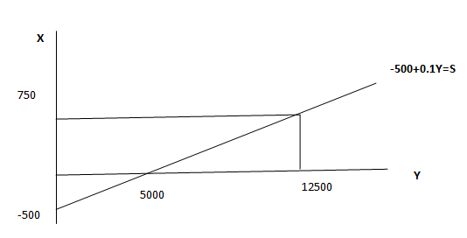

- Table below gives the values of Y in 2010 and 2011 in US dollars.

Year | Y
2010 | 731000$
2011 | 774860$

- Calculate the percentage change in Y from 2010 to 2011.

Formula for calculating percentage change is as follows:

$\frac{Y_{2011}-Y_{2010}}{Y_{2010}}*100$ =

More generally,
Percentage change = $\frac{Last year^{'}s value -first year^{'}s value}{first year^{'}s value}*100$

$$\frac{774860-731000}{731000}*100=6\%$$

- During 2012, Y grows 2 percent. Find the value of Y in 2012.

$\frac{Y_{2012}-Y_{2011}}{Y_{2011}}*100$=$\frac{Y_{2011}-774860}{774860}*100$ = 2

Y₂₀₁₂ = 790357.2

PART B: MULTIPLE CHOICE

- If the equation y = 3x + 9 was plotted:
                - the vertical intercept would be 9.
                - the slope would be 3.
                - it would look as an upward sloping line.
                - the horizantal intercept would be – 3.
                - all of the above would be true.

- Refer to the below figure the slope of the line between Points A and B is

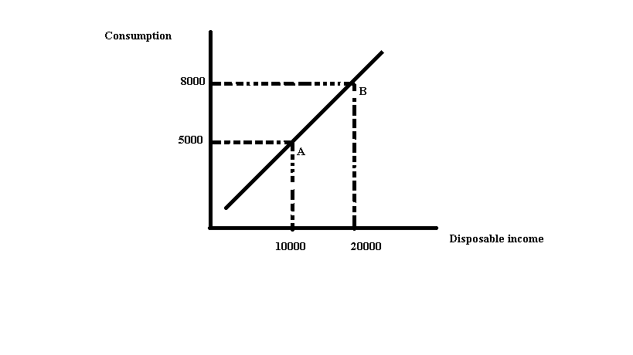
- 0.3
- 2.3
- 3.3
- Indeterminate from this information

- The slope of a vertical line is
- Zero
- Infinite
- Continually changing
- Negative
- The slope of a curve
- Is always positive
- Must first increase then decrease
- Is not constant
- Is constant

- The slope of a horizontal line is
- Negative
- Zero
- Continually changing
- Infinite
- Refer to the figure below. The expression of the slope of the line between points A and B equals:

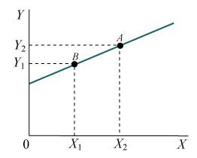
A)
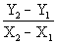

B) 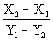

C) 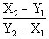

D) 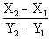

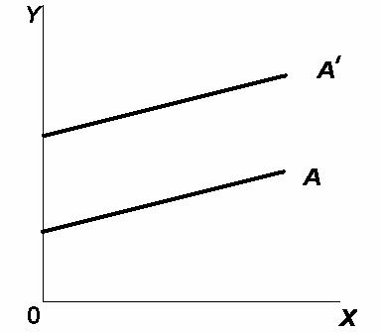

- In the figure above, the movement from line A to line A' (parallel lines) represents a change in:
- the slope only.
- the intercept only.

- both the slope and the intercept.
- neither the slope nor the intercept.

- Assume a household would consume $150 worth of goods and services per week if its weekly income were zero and would spend an additional $80 per week for each $100 additional income. Letting C represent consumption and Y represent income, the equation that summarizes this relationship is:
- C = 150 + 80Y
- C = 80 + 1.5Y
- C = 80 + 150Y
- C = 150 + 0.8Y
- C = 100 + 0.8Y

- Refer to the figure below. According to this graph, the relationship between hours of study time and points in the exam is as follows:

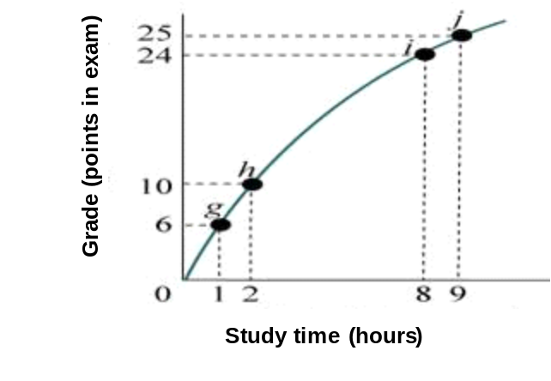

- Negative, because additional study time decreases points obtained in the exam.
- Positive but diminishing.
- The relationship between study time and points on the exam is first positive, and then it turns negative.
- Positive and increasing.
- Nonexistent. There appears to be no relationship between additional hours of study time and a better grade on the exam.

- Suppose you have a $20 iTunes gift card with which you can buy (download) songs or videos. Songs cost $1.00 each and videos cost $2.00 each. The opportunity cost of one video:
- increases as more videos are purchased
- is $1.00
- is constant and equal to ½ song
- is constant and equal to 2 songs

- The negative slope of the production possibilities curve illustrates that:
- some resources are always unemployed
- when resources are fully employed, an economy can produce more of one thing only by producing less of something else
- opportunity costs are constant
- businesses can sell more goods when their prices are low

- Refer to the following production possibilities diagram:

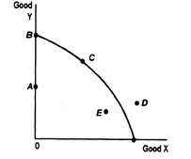

Production of which of the points in the diagram is currently unattainable given the economy's resources?
- Point A
- Point B
- Point C
- Point D

- Which one of the following represents the concept of ''opportunity costs”?
- a decision by your parents to put more of their savings to fund college expenses and less to life insurance.
- public policy in the state of Washington to reduce timber production so that more wildlife species will be preserved.
- a decision by a company to increase advertising expense for a new board game by decreasing its budget for telephone expenses.
- all of the above DO represent the concept of “opportunity costs''
- The concept of scarcity implies ________.
- unlimited human resources and limited producer wants
- unlimited human wants and limited resources
- limited human wants and unlimited resources
- that we can have everything we want

- If the Production Possibility Frontier (curve) is a downward sloping straight line, then ________.
- The opportunity cost is constant
- Production is efficient
- Technological changes have ceased
- Resources are highly specialized, making it difficult to use for alternative uses

- Which of the following will cause the production possibilities curve to shift outward?
- An inefficiency that has been corrected
- A decrease in the size of the capital stock
- An increase in the size of the labor force
- A decrease in the unemployment rate
- England has a relatively cool and cloudy climate that is ill suited for grape growing. It can produce 200 units of wine for every 400 units of cloth. Portugal, in contrast, has a relatively warm and sunny climate that is good for growing grapes. It can produce 200 units of wine for every 100 units of cloth. Which country has the higher opportunity cost of producing cloth?

- Portugal: 2 units of wine for every unit of cloth
- England: 2 units of wine for every unit of cloth.
- Portugal: ½ units of wine for every unit of cloth
- England: ½ unit of wine for every unit of cloth

