METU
Department of Economics
Econ 101: Introduction to Economics I
Section 01-02
Fall 2023
PROBLEM SET 1 (CH 2&3)
PART A: ESSAY QUESTIONS
- Draw the production possibility frontier and fill in the blanks according to the table.
(Put the amount of meat on the x-axis and the amount of fish on the y-axis)
Combination | A | B | C | D | E | F | G | H | K | L
Fish | 0 | 13 | 23 | 32 | 40 | 47 | 52 | 56 | 59 | 60
Meat | 108 | 102 | 95 | 87 | 78 | 67 | 53 | 36 | 19 | 0

- The production possibilities frontier for this isle will be shaped (convex/concave).
- The slope (in absolute value) along this production possibilities frontier (increases/decreases) at an (increasing/decreasing) rate as more meats (placed on the X-axis) are produced.
- The slope of this production possibilities frontier _______________.
- When the economy moves from point C to F, the opportunity cost of an additional fish, in terms of meat, is _ / _ meat(s).
- The opportunity cost of each additional fish in terms of meat ________.
- falls as more fish is produced
- increases as more fish is produced
- remains constant
- is meaningless because the cost of fish cannot be expressed in terms of meat(s).
- The opportunity cost of each additional meat in terms of fish ________.
- is meaningless because the cost of fish cannot be expressed in terms of meat(s)
- remains constant
- falls as more fish is produced
- increases as more meats is produced
g) When the economy moves from point K to D, the opportunity cost of a piece of additional meat, in terms of fish, is __ / __ fish.

- According to the information given below:
Combination | Meat (units) | Wheat (units)
A | 0 | 2000
B | 200 | 1800
C | 400 | 1500
D | 600 | 1100
E | 800 | 600
F | 1000 | 0

  - Draw the production possibility frontier (PPF) (put meat on the x-axis)
  - The production possibilities frontier is ________ to the origin. (concave /convex)
  - Can this economy produce 200 units of meat and 1500 units of wheat?
  - Can this economy produce 200 units of meat and 2200 units of wheat?
  - What is the opportunity cost of increasing meat production from 200 units to 400 units (i.e. if the economy moves from combination B to combination C) ?. What is the opportunity cost per unit of meat?
  - What is the opportunity cost of increasing meat production from 400 units to 600 units (i.e. if the economy moves from combination C to D)?. What is the opportunity cost per unit of meat?
  - Does the principle of “increasing opportunity cost” hold in this economy?
- How do the following events affect the production possibility frontier (PPF) of a country, which produces only two goods food (F) and smart devices (S) ? Show the shifts on the PPF graph. (Suppose that food is on the y axis and smart phones are on x axis.)
a) Rising sea levels causes floods damaging the buildings of some coastal cities.
b) Block chain design increases the productivity of the electronics industry.
c) Suppose that the government imposed a subsidy to farmers to support agriculture and livestock sectors.
- Define the following terms briefly and give an example for each.
    - Market failure:
    - Negative externalities:
    - Public good:
    - Demerit goods or activities:
    - Merit goods or activities:

- What are the specific roles for government in the economy?

- A market economy can be divided into three sectors: businesses, households and governments. Define the factor markets and goods markets and explain their relationship with these sectors using a diagram.
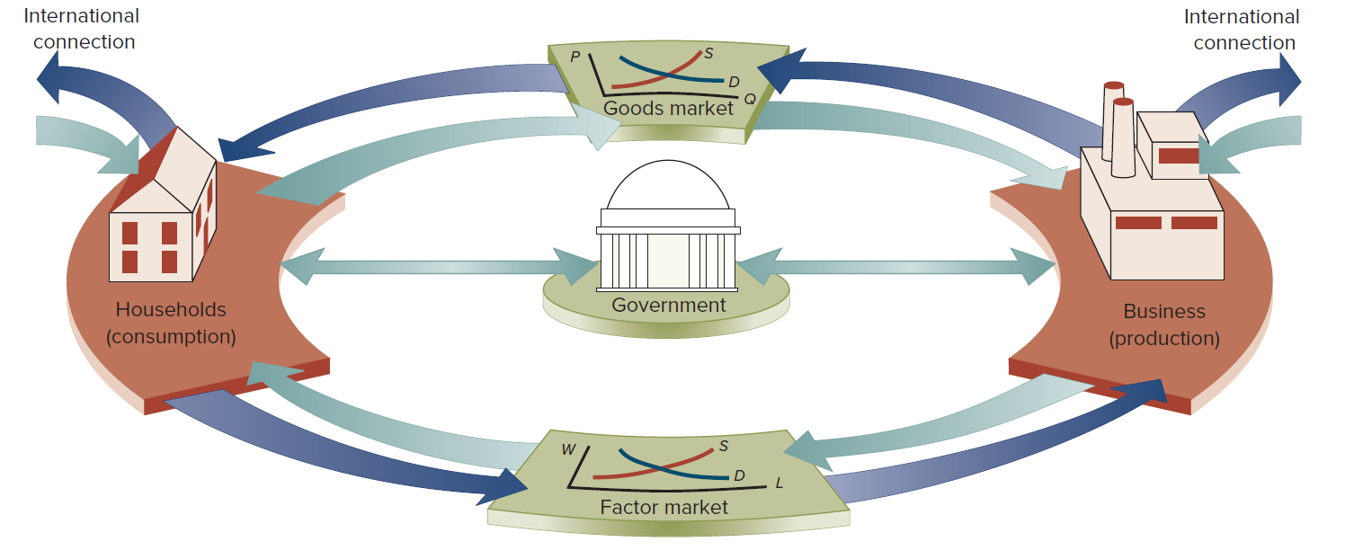
PART B: MULTIPLE CHOICE
- The Production Possibilities Frontier (PPF) depicts the fact that
- When a society combines its resources efficiently, it cannot produce more of one good without producing less of the other good.
- When a society combines its resources efficiently, it cannot produce more of one good without producing more of the other good.
- Some resources are always idle in a democratic society
- All points inside the curve are preferred to all points on the curve in terms of efficiency
- The demand for goods always exceeds the supply
- The opportunity cost of producing good A is defined as
- The money cost of the factors of production used in good A
- The retail price of good A
- The cheapest method of producing good A
- What must be the additional production cost get an additional unit of A
- The cost of having the best alternative in place of good A
- On the diagram of a PPF, the concept of scarcity is illustrated by
- the points on the curve
- the area within the curve
- the distance from origin to the curve
- the negative slope of the curve
- the unattainable points outside the curve
- Suppose that 1 unit of labor can produce either 5 units of wool or 2 pineapples. What is the opportunity cost of producing 1 pineapple?
- 5 units of wool
- 2 units of wool
- 2/5 units of wool
- 5/2 units of wool
- Zero

Refer to the graph below.
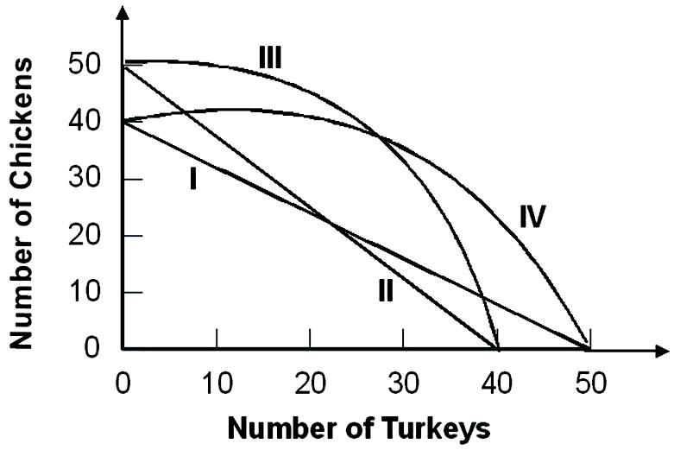
Suppose that the opportunity cost of producing 10 chickens is always 8 turkeys. Given this, the relevant production possibility curve must be:
  - I
  - II
  - III
  - IV
  - None of the above

- Refer to the graph below
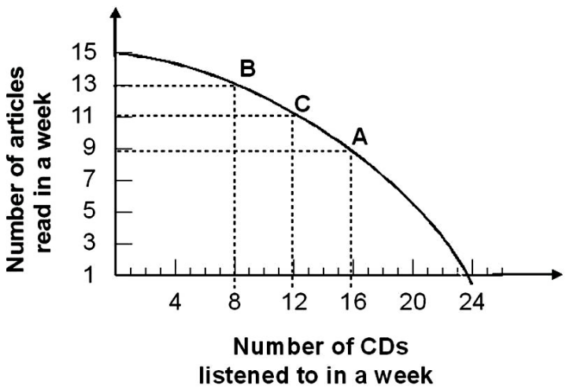

Given the production possibility curve, the opportunity cost of reading 2 more articles when you are already reading 11 articles is on average:
- ½ CD per article
- 2 CDs per article
- 2/3 CDs per article
- 3 CDs per article
- 3/2 CDs per article
- The principle of increasing opportunity costs states that the initial opportunity costs are:
- high but decrease the more you concentrate on the activity.
- low but increase the more you concentrate on the activity.
- high but increase the more you concentrate on the activity.
- low but decrease the more you concentrate on the activity.
- In a free market economy, the allocation of resources is decided by
- Central authorities only
- Central authorities and firms only
- Firms and households acting independently
- Political parties and firms only
- Individuals only
- In the economic theory, it is typically assumed that households and firms, respectively maximize
- Income and sales
- Savings and profits
- Wages and revenues
- Utility and profits
- Expenditures and profits
- Economic theory shows that in the private sector of a market economy, the price system allocates resources
- In goods market only
- In factor markets only
- In and equitable manner
- Better than they could be allocated by another allocation system
- In both goods and factor markets
- The circular flow of economic activity
- Illustrates the relationship between wants and resources
- Illustrates the relationship between financial system and government
- Shows why income flows do not balance the expenditure flows
- Illustrates the relationship between consumers and business
- Illustrates the relationship government, households and firms

- Markets coordinate economic activity through:
- the price mechanism.
- commanding individuals what to do.
- asking individuals what to do.
- the legal mechanism.
- The government intervention
- In the simple circular flow model, the government .
A) Has little influence over the markets
B) Influences both the input and output markets through taxes and regulations
C) Only siphons out income from the model through taxes
D) Increases the amount of income in the economy

- Which of the following is not an example of government's role as a referee?
- Equal opportunity and labor laws that restrict businesses' freedom to hire and fire whomever they want.
- Regulations governing safety in the workplace, wages, overtime, and hours of work
- Laws prohibiting businesses from meeting to fix prices
- Laws that require states and the federal government to balance their budgets

- The government serves as an actor in the economy when it
- alters anti-trust laws.
- increases defense spending
- reduces the minimum wage.
- improves health and safety standards for certain industries.

