METU Department of Economics
ECON102
Spring 2024
Sections 1&2
TA: Zeki Oğulcan Şengül

PROBLEM SET 4
- Explain why the AD curve is negatively sloped.

AD curve explains the relationship between the overall price level and the aggregate output (income). Aggregate demand falls when the price level increases because the interest rate effect, the international effect and the money wealth effect make the AD curve downward sloping.
The Interest Rate Effect → A decrease in the price level will increase the purchasing power of the money in people’s pocket and people will find they’re holding than they need. So, they deposit the extra money at banks in some form, giving banks more money to loan out. As banks make more loans, interest rates will fall, which, in turn, will increase investment expenditures. Since investment is one component of AD, the quantity of aggregate demand will increase when price level falls.
The International Effect → As price level in Turkey falls, the price domestic goods relative to foreign goods goes down and domestic goods become more competitive relative to foreign goods; thus, exports increase and imports decrease in Turkey. Since net export is a component of AD, the quantity of aggregate demand will increase when price level falls.
The Money Wealth Effect→ If the price level falls, the money in your pocket will but more than before because the purchasing power of your money rises. You are, in effect, richer and as you get richer, other things equal, you will buy goods and services. Since the consumption is a component of AD, the quantity of aggregate demand will increase when price level falls.

- Distinguish between the short run and the long run aggregate supply curves. In particular, explain the shape of each curve.

The SRAS curve is relatively flat (but positively sloping) at low Y’s and becomes steep at high Y’s. The idea is that at low Y’s if the AD were to shift outward, firms still have lost of excess capacity, so they will produce more while P will only increase a little. At high Y’s firms are operating close to full capacity, so if AD would shift outward, Y would only increase a little while P would increase a lot. The basic assumption behind the SRAS curve is that output prices increase before input price increase. In the long run however input prices will also increase, and therefore the output level of a profit maximizing firm will not change. Hence the LRAS curve should be vertical at Y₀. This Y₀ corresponds with the potential GDP of a country.

Y₀
P
SRAS
LRAS
Y

- Explain how each of the following would affect the aggregate demand curve:

- An increase in taxes
An increase in taxes decreases the disposable income and hence consumption expenditures. As consumption expenditures decrease, aggregate expenditure and output decreases. Given the price level, the fall in output is represented by a left shift of the aggregate demand curve. 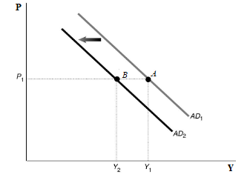
- An increase in the government expenditures
The increase in government expenditure leads to an increase in aggregate expenditure. The higher aggregate expenditure causes output to increase. This increase in output for a given price level is represented by a shift of the aggregate demand curve to the right.
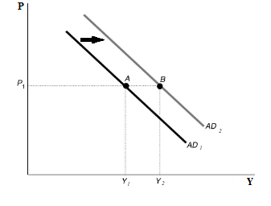
- An increase in the price level
An increase in price level decreases the quantity of aggregate demand in the economy. BE CAREFUL, there is no shift in the AD curve, we can just see a movement along the curve.
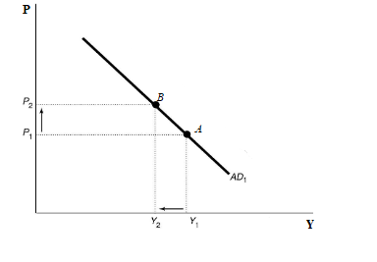
- An increase in the interest rate
The consumption link: $r↑ →C↓$
The investment link: $r↑ →I↓$
Both of them causes a decrease in the aggregate demand of output. AD curve shifts to the left.
- An increase in business confidence
If business confidence is high, then firms tend to spend more on investment, believing that the future payoff from that investment will be substantial. Increase in investment increases the aggregate expenditures and aggregate demand as well. It causes the rightward shift in the AD curve.
- Increase in global demand for Turkish products.

Increase in global demand for domestically produced goods increase the exports , that causes rise in aggregate expenditure and rightward shift of AD curve.
- Using an aggregate supply graph, illustrate the impact of the following changes in the AS curve.
- An enormous earthquake destroys most of the resources in the country.
When an enormous earthquake destroys most of the resources in the country, resource availability reduces increasing the price of remaining inputs. Thus, it decreases the aggregate supply; aggregate supply curve will shift to the left.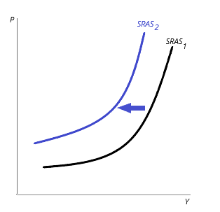
- A country witnesses a contagious disease.
Contagious disease causes a decrease in the workforce in the economy. Thus, aggregate supply curve will shift to the left.

- Technological improvement which lowers the cost of production.
A lower cost of production encourages firms to produce more. Therefore, aggregate supply curve will shift to the right.
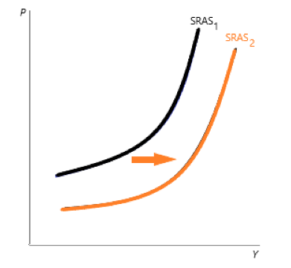
- Due to global crisis, the price of oil, which is an important intermedia good in production increases.

Increase in the price of oil leds firms to produce less since the production cost increases. Thus, aggregate supply curve shifts to the left.
- Which factors shift the long run aggregate supply curve (LAS)?
Because the position of the long run aggregate supply curve is determined by potential output, it shifts for the same reasons that potential output shifts: changes in
Capital (Increase in capital will increase the potential output, and it shifts the LAS curve to the right.)
Available Resources (Increase in available resources will increase the potential output, and it shifts the LAS curve to the right.)
Growth-compatible institutions (Increase in growth-compatible institutions increases the potential output, by reducing bureaucracy or by giving incentives etc.)
Technology (A development in technology shifts the LAS curve to the right.)
Entrepreneurship (An increase in entrepreneurship shifts the LAS curve to the right.)

6) Table below shows the initial aggregate demand, short-run, and long-run aggregate supply schedules for Econland:
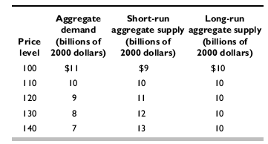
- Draw the AD, SAS, and LAS curves for Econland. Label the equilibrium point a. What is the equilibrium level of real GDP and price level?

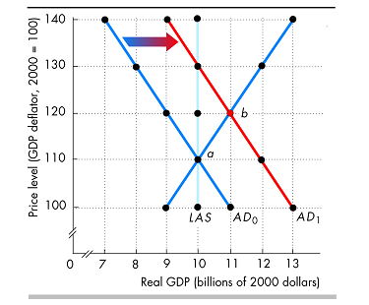
The figure shows the initial aggregate demand curve (AD₀) the initial short-run aggregate supply curve (SAS₀), and the long-run aggregate supply curve (LAS). The point a is the equilibrium point, where the aggregate demand curve crosses the short-run aggregate supply curve. This point also is a long-run equilibrium because it is on the LAS curve. The price level is 110 because this price level sets the aggregate quantity demanded equal to the aggregate quantity supplied. The level of real GDP is $10 billion.
- Suppose that government purchases increase so that aggregate demand increases by $2 billion at every price level. Draw the new aggregate demand curve. Label the new short run equilibrium point b. What is the equilibrium level of real GDP and price level in the short run?
As illustrated in the figure above, the increase in government purchases shifts the aggregate demand curve from AD0 to AD1. The new, short-run equilibrium point is labeled b. The price level rises to 120 and the level of real GDP in-creases to $11 billion.
- Why is the point b not a long-run equilibrium? In your answer, mention the level of potential real GDP, and describe whether the point b represents an above full-employment, a full-employment, or a below full-employment equilibrium. If either an inflationary or recessionary gap exists, calculate what it equals.
As illustrated in the figure above, the increase in government purchases shifts the aggregate demand curve from AD0 to AD1. The new, short-run equilibrium point is labeled b. The price level rises to 120 and the level of real GDP in-creases to $11 billion.
- As time passes, what moves the economy back to its long-run equilibrium? Illustrate this process in the figure by drawing additional curves you may need. Label the long-run equilibrium point as c. What is the equilibrium level of GDP and price level in the long run?
As illustrated in the figure above, the increase in government purchases shifts the aggregate demand curve from AD0 to AD1. The new, short-run equilibrium point is labeled b. The price level rises to 120 and the level of real GDP in-creases to $11 billion.
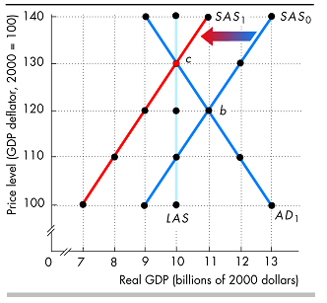
As money wages rise, the short-run aggregate supply curve shifts leftward. Figure illustrates this process, whereby the short-run aggregate supply curve has shifted from SAS₀ to SAS₁.When the short-run aggregate supply curve is SAS₁, the economy has reached its new long-run equilibrium at point c. At point c, the price level is 130 and the level of real GDP has returned to potential real GDP, $10 billion.

MULTIPLE CHOICE

- The basic aggregate demand and aggregate supply curve model helps explain
- short-term fluctuations in real GDP and the price level.
- long-term growth.
- price fluctuations in an individual market.
- output fluctuations in an individual market.
- Because of the slope of the aggregate demand curve, we can say that
- a decrease in the price level leads to a lower level of real GDP demanded.
- an increase in the price level leads to no change in the level of real GDP demanded.
- a decrease in the price level leads to a higher level of real GDP demanded.
- an increase in the price level leads to a higher level of real GDP demanded.
- Which of the following best describes the "wealth effect"?
- When the price level falls, the real value of household wealth falls.
- When the price level falls, the nominal value of household wealth falls.
- When the price level falls, the nominal value of household wealth rises.
- When the price level falls, the real value of household wealth rises.
- The "interest rate effect" can be described as an increase in the price level that raises the interest rate and chokes off
- government spending.
- government spending and unplanned investment.
- investment and consumption spending.
- net exports.
- How do lower taxes affect aggregate demand?
- They increase disposable income, consumption, and aggregate demand.
- They reduce disposable income, consumption, and aggregate demand.
- they increase corporate investment and aggregate demand.
- They increase aggregate supply and thus increase aggregate demand as well.
Please answer the next five questions referring to the figure below.
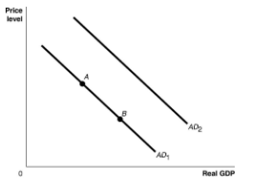
6) Ceteris paribus, an increase in the price level would be represented by a movement from
A) $AD_{1}$ to $AD_{2}.$
B) $AD_{2}$ to $AD_{1}$.
C) point $A$ to point $B$.
D) point $B$ to point $A.$
7) Ceteris paribus, an increase in interest rates would be represented by a movement from
A) $AD_{1}$ to $AD_{2}.$
B) $AD_{2}$ to $AD_{1}$.
C) point $A$ to point $B$.
D) point $B$ to point $A$.
8) Ceteris paribus, an increase in households' expectations of their future income would be represented by a movement from
A) $AD_{1}$ to $AD_{2}.$
B) $AD_{2}$ to $AD_{1}$.
C) point $A$ to point $B$.
D) point $B$ to point $A$.
9) Ceteris paribus, an increase in personal income taxes would be represented by a movement from
A) $AD_{1}$ to $AD_{2}.$
B) $AD_{2}$ to $AD_{1}$.
C) point $A$ to point $B$.
D) point $B$ to point $A$.
10) In the long-run aggregate supply curve,
A) a decrease in the price level decreases the level of potential GDP.
B) a decrease in the price level increases the aggregate quantity of GDP supplied.
C) a decrease in the price level decreases the aggregate quantity of GDP supplied.
D) a decrease in the price level has no effect on the aggregate quantity of GDP supplied.
11) If, due to a recession, foreign workers begin to leave Turkey to search for temporary work in their home countries until the recession has ended, this will
A) shift the short-run aggregate supply curve of the home country to the left.
B) shift the short-run aggregate supply curve of the home country to the right.
C) move the home country's economy up along a stationary short-run aggregate supply curve.
D) move the home country's economy down along a stationary short-run aggregate supply curve.
12) If full-employment GDP is equal to $4.2 trillion, what does the long-run aggregate supply curve look like?
A) It is a horizontal line at $4.2 trillion of GDP.
B) It is a vertical line at a level of GDP below $4.2 trillion.
C) It is a vertical line at $4.2 trillion of GDP.
D) It is a vertical line at a level of GDP above $4.2 trillion.

Please answer the next two questions referring to the figure below.

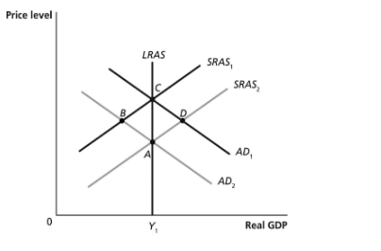
14) Which of the points in the above graph are possible long-run equilibria?
A) A and B
B) A and C
C) A and D
D) B and D
15) Which of the points in the above graph are possible short-run equilibria but not long-run equilibria? Assume that $Y_{1}$represents potential GDP.
A) A and B
B) A and C
C) C and D
D) B and D

16) A continual rightward shift in the LRAS would be caused by a recurring increase in
- entrepreneurship
- capital accumulation
- productivity
- all of them
- A technological improvement will shift;
- Both the SRAS and AD curves to the right.
- Both the SARS curve and LRAS curves to the right.
- The SRAS curve to the right but leave the LRAS curve unchanged.
- The LRAS to the right but leave the SRAS curve shifts to the left.
- An increase in oil prices, such as the oil shocks in the 70s, cause a ______(leftward / rightward) shift of _______ (SRAS / AD) curve, move the economy along_____ (SRAS / AD) curve causing a ______ (demand-pull / cost push) inflation.
- Leftward / AD / SRAS / cost-push
- Leftward / SRAS / AD / demand-pull
- Rightward / AD / SRAS / demand-pull
- Leftward / SRAS / AD /cost-push
- Suppose that there is a political crisis in Germany started in beginning of 2021. It is estimated that this crisis will affect the Turkish economy negatively and some economists believe that some factories might close by the mid-summer. As a Turkish economic advisor to the treasury, what would you suggest to the minister if you want to keep national income level stable?
A) Reduce government spending and increase taxes.
B) Increase government spending and decrease taxes.
C) Reduce government spending and lower taxes.
D) Increase government spending and increase taxes.
- Assume that aggregate demand in the economy is excessive, causing demand-pull inflation. Which of the following would be most in accord with appropriate government fiscal policy?
A) an increase in income tax rates
B) an increase in the size of income tax exemptions for each dependent
C) passage of legislation providing for the construction of 8,000 new school buildings
D) an increase in soil conservation subsidies to farmers
- An increase in the price level will:
- increase net exports
- reduce the value of household debt and increase investment
- increase production costs and reduce short-run aggregate supply
- reduce the purchasing power of household wealth and reduce consumption
- An increase in the incomes of Turkey’s trading partners would shift Turkey’s:
- aggregate demand curve to the right
- aggregate demand curve to the left
- aggregate supply curve to the right
- aggregate supply curve to the left
- Higher prices of imported resources will:
- move the economy downward and to the right along the aggregate demand curve
- make the aggregate demand curve steeper
- shift the aggregate supply curve to the left
- shift the aggregate demand curve to the left
- If major labor unions succeed in increasing wages, this will cause
- SRAS to shift upward (to the left) and then return immediately to its original position.
- Both the SRAS and AD curves to shift in opposite directions.
- The SRAS curve to shift upward (to the left) , increasing the price level.
- The SRAS curve to shift upward (to the left), reducing the price level.

- When a shift in AD occurs, the effect will be divided between a change in output and a change in price level. How the effect is divided depends on
- the position of the AE curve
- the slope of the SRAS curve
- the amount of inflation in the economy
- the size of the multiplier
- In the short-run, an increase in AD will increase ______ (price level / output / price level and output) and in the long run will increase ______ (price level / output / price level and output).
- price level and output; price level
- price level and output; output
- price level; price level
- output; price level and output

- Suppose that the economy is expanding, so actual output exceeds the potential output. Inflationary pressures are increasing. An appropriate fiscal policy would most likely result in;
- A reduction in government’s budget surplus.
- An increase in government’s budget deficit.
- An increase in the government’s budget surplus or at least a reduction in its deficit.
- Either an increase in the government’s budget deficit or a decrease in its surplus, depending on whether taxes increased or spending decreased.
- An increase in oil prices, such as the oil shocks in the 70s, cause a ______ shift of _______ curve, move the economy along _____ curve causing a ______ inflation.
- leftward / AD / SRAS / cost-push
- leftward / SRAS / AD / demand-pull
- rightward / AD / SRAS / demand-pull
- leftward / SRAS / AD /cost-push
- Suppose that the economy is shrinking, so actual output is less than the potential output. Inflationary pressures are increasing. An appropriate fiscal policy would most likely result in;
- A reduction in government’s budget surplus.
- An increase in government’s budget deficit.
- An increase in the government’s budget surplus or at least a reduction in its deficit.
- Either an increase in the government’s budget deficit or a decrease in its surplus, depending on whether taxes increased or spending decreased.
- An increase in the capital stock of the country improvement will shift;
- Both the SRAS and AD curves to the right.
- Both the SARS curve and LRAS curves to the right.
- The SRAS curve to the right but leave the LRAS curve unchanged.
- The LRAS to the right but leave the SRAS curve unchanged.

