METU
Department of Economics
Econ 101: Introduction to Economics I
Section 01-02
Fall 2023
PROBLEM SET 10
- The figure below depicts a monopolistically competitive barber shop. Use the diagram to answer the following questions.
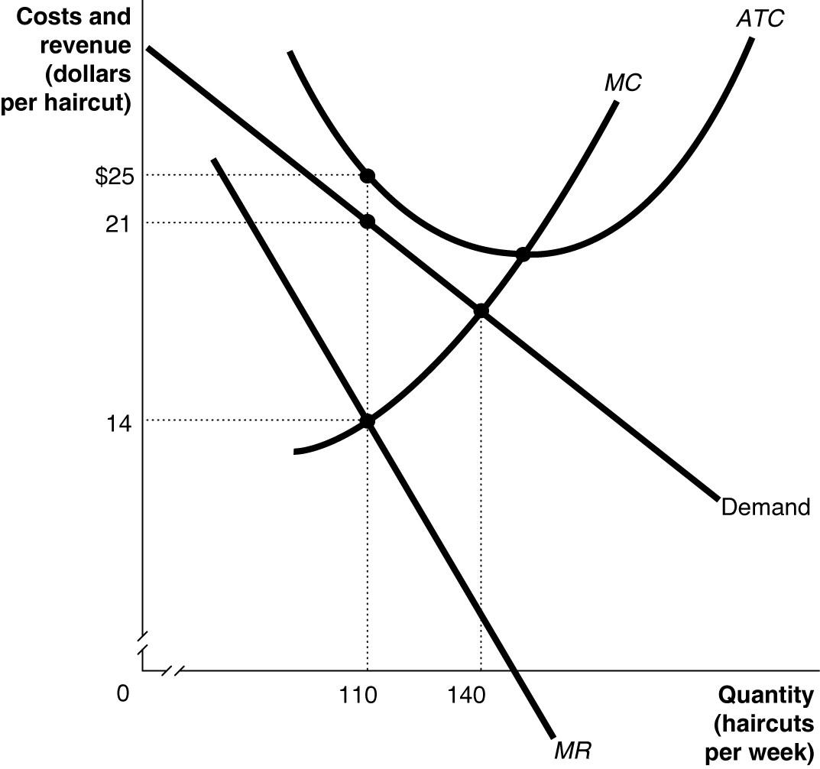
- Suppose the average variable cost of production is $15 when output equals 110 haircuts and $15.25 when output equals 140 haircuts. If the firm wants to maximize its profit or minimize its losses, how many haircuts will it produce and what price should it charge? Explain your answer.
Output = 110, Price = $21 whereby MR = MC. The barber shop will minimize its losses since P > AVC.
- Calculate the firm's profit or loss.
The economic loss = $440 (total revenue = $21 × 110 = $2,310; total cost = $25 × 110 = $2,750).
- What is likely to happen in this industry over time as it moves to its new long-run equilibrium?
Short-run losses will lead some firms to exit the market. As a result, the demand curve for a firm remaining in the market will shift to the right and become less elastic. Exit continues until economic losses are eliminated and each firm breaks even.
- Suppose the barber shop depicted in the diagram remains in the industry. Is this barber shop likely to produce this same quantity of haircuts as in part (a) in the long run?
No, its demand increases and becomes less elastic. It will produce a larger quantity.

- Assume firm A is in a perfectly competitive market and firm B has monopolistic (imperfect) competitors. Both firms are at the long-run equilibrium levels. Draw a diagram for firm A with MC, ATC, MR, AR, and Demand curves on it. Put the price on the vertical axis and the quantity on the horizontal axis. Draw firm B's diagram next to it for the same curves. Show the equilibrium price (P*) and quantities (Q*).
Which firm you would expect to make a higher profit? Show your answer using your graphs.
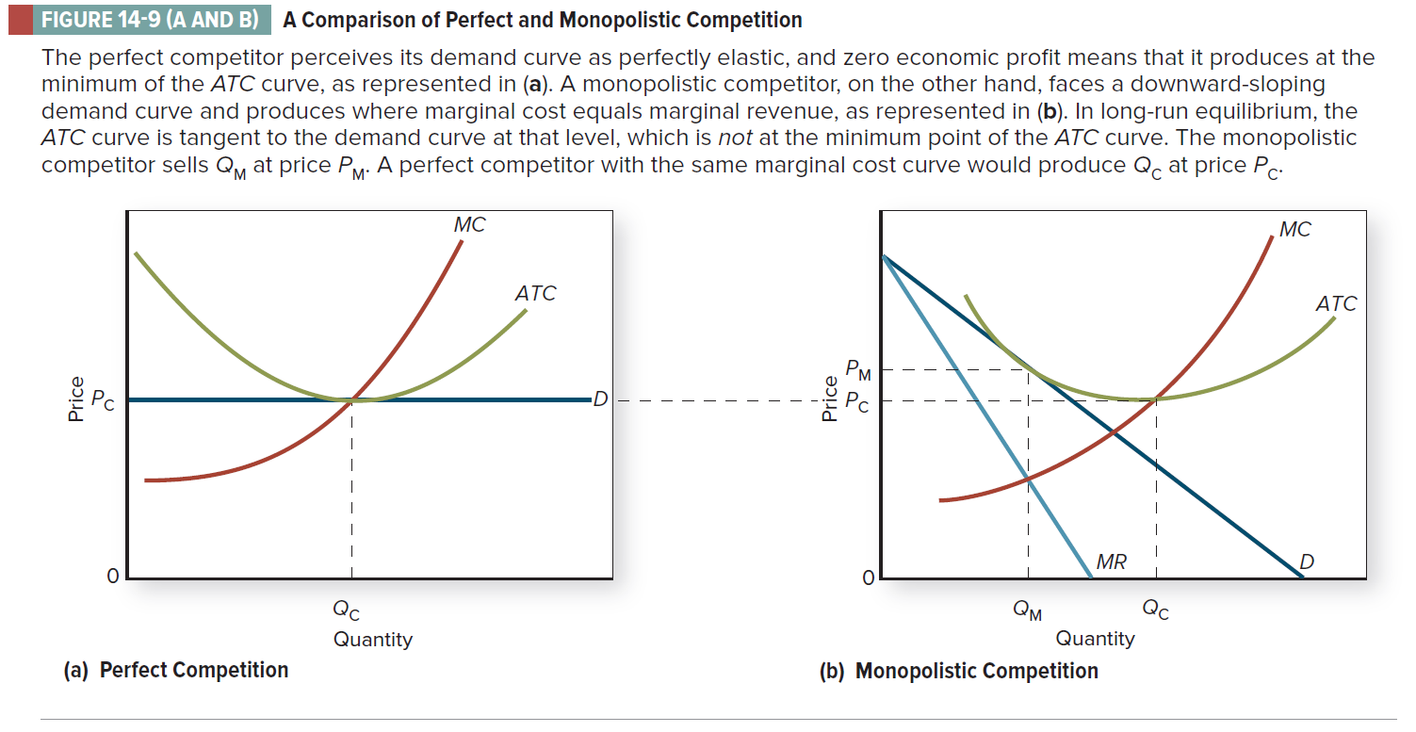

(Colander, D. (2020), “Microeconomics”, 11e, Page.312)

- If monopolistically competitive firms have some control over their prices, why don’t they set price above average total cost so they will realize an economic profit in the long run?

Entry is relatively easy in monopolistic competition. If a representative firm is earning economic profits in the short run, this condition will not persist as new firms enter the industry with the expectation of earning economic profits. As new firms enter, the demand curve faced by the typical firm will fall and become more elastic which tends to cause the disappearance of economic profits. Economic profits might persist in a few cases where product differentiation is very strong, or because some firm has some sort of permanent advantage such as location or especially effective advertising.

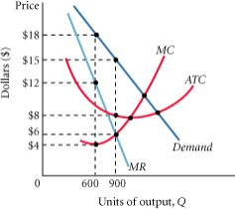
- The following diagram shows the structure of cost and demand facing a monopolistically competitive firm in the short run

- Identify the following on the graph and calculate each one. Profit- maximizing output level
Profit – maximizing price:
Total revenue:
Total cost:
Total profit:
- What is likely to happen in this industry in the long run?

i. Profit- maximizing output level: at 𝑀𝑅 = 𝑀𝐶 ⇒ 900
Profit – maximizing price: $15
Total revenue: 15 ∗ 900 = $13500
Total cost: 8 ∗ 900 = $7200
Total profit: 13500 − 7200 = $6300

ii.
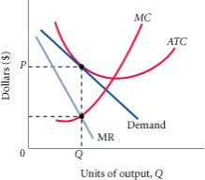
When monopolistically competitive firms make positive profits, new firms enter in search of profits, the demand curve for existing profit-making firms begin to shift to the left, pushing marginal revenue with them as consumers switch to the new close substitutes. This process continues until profits are eliminated, which occurs for a firm when its demand curve is just tangent to its average total cost curve.
- Graphically show the transition from short-run to long-run equilibrium for a monopolistic competitor. Begin by drawing a graph of short-run equilibrium. In the graph, have the firm make an economic profit at its profit-maximizing level of output. Identify its short-run profit, and then show and describe how profits will disappear in long-run equilibrium.

Answer:
In the graph shown below, the short-run equilibrium occurs where marginal revenue equals marginal cost, with price set on the demand curve at that level of output. Economic profits are made up of the difference between price and average total cost at that output level multiplied by output (the shaded area in the graph). Because economic profits will attract entry, which is easy in monopolistic competition, new competitors will begin to take away some of this firm's customers, and the demand curve will shift back to the left. The marginal revenue curve will shift along with it. Long-run equilibrium will be achieved when the demand curve is just tangent to the average total cost curve at the output level, at P₁ and Q₁.

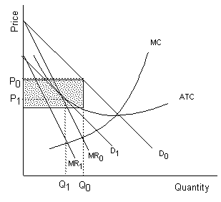

PART B: MULTIPLE CHOICE
1. In the long – run the firm in monopolistic competition will
a. Produce more than the quantity that minimizes ATC
b. Produces less than the quantity that minimizes ATC
c. Produce the quantity that minimizes ATC
d. Earn economic profits

2. Product differentiation may be present in:
a. Purely competitive markets
b. Monopolistically competitive markets
c. Oligopolistic markets
d. Both (b) and (c)

3. What are the characteristics of monopolistic competition?
a. Few firms, homogeneous product, and barriers to entry.
b. Few firms, differentiated product, and no barriers to entry.
c. Many firms, differentiated product, and no barriers to entry.
d. Many firms, homogeneous product, and barriers to entry.

4. Which of the following statements concerning a monopolistically competitive industry is correct?
a. If there are short-run losses, firms will leave the industry and the demand curves of the remaining firms will shift to the right.
b. If there are short-run economic profits, firms will enter the industry and the demand curves of the existing firms will shift to the right
c. If there are short-run losses, firms will leave the industry and the demand curves of the remaining firms will shift to the left.
d. If there are short-run economic profits, firms will leave the industry and the demand curves of the existing firms will shift to the right
5. Which of the following is true for perfect competition, monopolistic competition and single-price monopoly?
a. Homogenous product
b. Zero long-run economic profits
c. Short-run profit maximizing quantity where MC=MR
d. None of the above
6. In the short run, a monopolistically competitive firm chooses
a. its quantity but not its price.
b. neither its price nor its quantity.
c. its price but not its quantity.
d. both its price and its quantity.

7. One difference between perfect competition and monopolistic competition is that
a. a perfectly competitive industry has fewer firms.
b. monopolistic competition has barriers to entry.
c. firms in monopolistic competition face a downward-sloping demand curve.
d. in perfect competition, firms produce slightly differentiated products.

Refer to the following figure for questions 8-9:

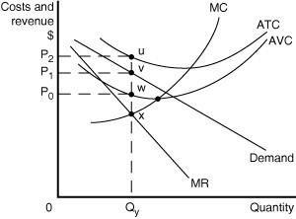
8. Which of the following statements describes the best course of action for the firm depicted in the diagram?

a. The firm should exit the industry because its price is less than its average total cost.
b. The firm should minimize its losses by producing Qy units and charging a price of P₀.
c. The firm should minimize its losses by producing Qy units and charging a price of P₂.
d. The firm should minimize its losses by producing Qy units and charging a price of P₁.

9. Which of the following is the area that represents the profit or loss experienced by the firm?

a. a loss represented by the rectangle P₂uvP₁
b. a loss represented by the rectangle P₂uwP₀
c. a loss represented by the rectangle P₁vwP₀
d. an accounting profit equal to P₁vwP₀

10. Suppose a monopolistically competitive firm's output where marginal revenue equals marginal cost is 66 units and the price corresponding to this quantity is $18. If the average total cost at this output is $16.55, then its total profit is
a. | $1,188.
b. | $1,092.30.
c. | $95.70.
d. | $1.45.
11. Monopolistic competition resembles pure competition because:
- both industries emphasize non-price competition.
- in both instances firms will operate at the minimum point on their long-run average cost curves.
- both industries entail the production of differentiated products.
- barriers to entry are either weak or nonexistent.

12. A conclusion that monopolistic competition will be characterized by excess capacity
- means that the firm produces less than the profit-maximizing level of output
- means that the firm produces more than the profit-maximizing level of output
- means that the firm does not operate its plant at the minimum point of the long-run average cost curve
- means that there are too many firms in the industry

13. Monopolistic competition results in
- Allocative efficiency
- Production efficiency
- Some production inefficiency
- Marginal cost pricing

14. A difference between monopoly and monopolistic competition is
- In monopolistic competition firms have brand loyalty but must still compete with firms that sell close substitutes; a monopoly has the market to itself
- A monopoly faces a downward – sloping demand curve, but a monopolistically competitive firm does not
- A monopoly has some control over price, and a monopolistically competitive firm does not
- All of the answers are correct.

15. A monopolistically competitive firm in long – run equilibrium

- Charges a price equal to the minimum average total cost
- Produces an output level at which price equals marginal cost
- Charges a price equal to average total cost
- Charges a price above average total cost

