METU
Department of Economics
Econ 101: Introduction to Economics I
Section 01-02
Fall 2024
PROBLEM SET 6 (CH 8)
PART A: ESSAY QUESTIONS
- Define the following terms:
Externality: A benefit or cost that affects someone who is not directly involved in the production or consumption of a good or service.
Private cost: The cost borne by the producer of a good or service.
Social Cost: The total cost of producing a good or service, including both the private cost and any external cost.
Private benefit: The benefit received by the consumer of a good or service.
Social Benefit: The total benefit from consuming a good or service, including both the private benefit and any external benefit.
Market Failure: A situation in which the market fails to produce the efficient level of output.
Property Rights: The rights individuals or businesses have to the exclusive use of their property, including the right to buy or sell it.
Rivalry: The situation that occurs when one person’s consumption of a unit of a good means no one else can consume it.
Excludability: The situation in which anyone who does not pay for a good cannot consume it.

- Give the definition of “externality” and indicate why externalities can result in a failure to achieve equality between social marginal cost and social marginal benefit. Demonstrate your answer graphically with a negative externality.

Answer:
Externalities are the effects (costs or benefits) of decisions not taken into account by the decision makers when the decision was made. For example, when a supplier chooses to supply electricity to a consumer who chooses to purchase it, neither party may consider the costs of pollution from electricity production that falls on third parties. In this example, the externality is an external cost. Where external costs are present, marginal social cost is greater than marginal private cost (the private cost of producing electricity, the cost of the necessary capital and labor, does not include the pollution cost). This is illustrated in the diagram below. So Q₁ electricity is sold at a price, P₁, which is less than its marginal social cost, P₃, and still returns a profit to the producer (who only has to cover private costs). This case is shown in the diagram below. Too much electricity is produced at too low a cost to equate marginal social costs and marginal social benefits.
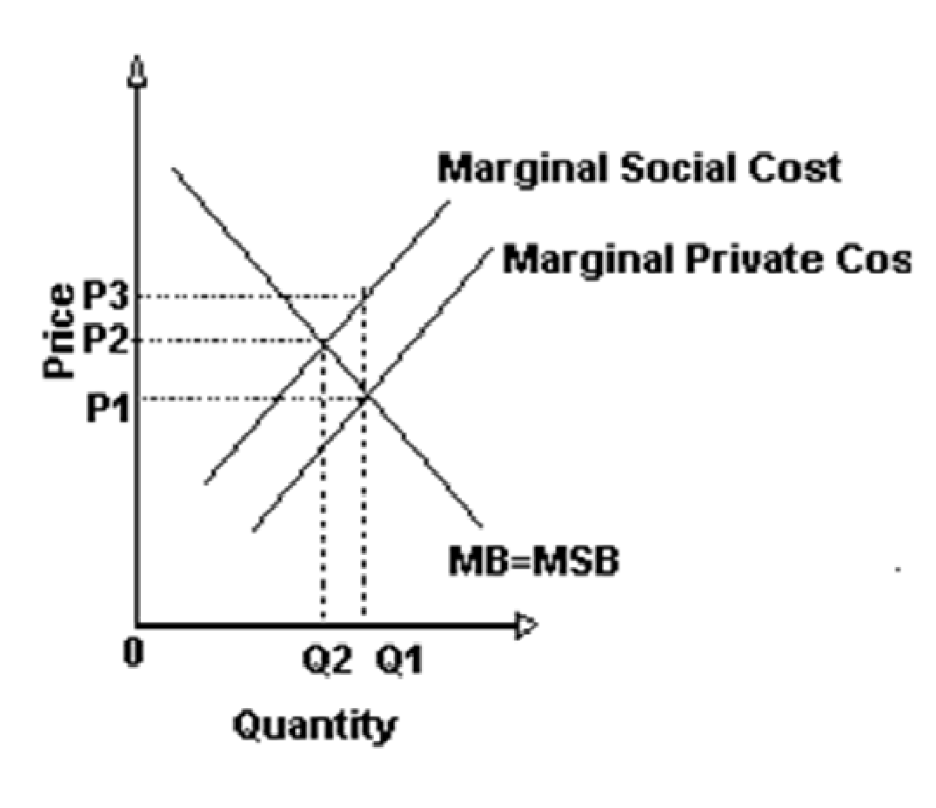

- Explain the following questions shortly.
- What are the arguments for and against government intervention to deal with externalities?

Answer:
Government intervention can respond to a negative externality by making the firm internalize the external costs so that the marginal social costs equal the marginal social benefits. The argument against intervention in the case of externality is again a practical one—intervention may make matters worse. Government agencies are not well suited to the weighing and balancing of social and private costs. But they are suited to pressure group infighting and special deals for special interests.

- Demonstrate graphically and explain verbally the impact of a negative externality on a supply and demand market outcome.

Answer:
The presence of a negative externality results in too much of a good being provided at too low a price—when viewed from society's point of view. The reason for this is that the supply curve that represents the marginal private cost of the good is not the true (complete) marginal social cost (which includes the costs imposed by the negative externality). In the diagram this is shown by S₁ (marginal social cost) above S (private social cost). The market outcome occurs where demand (marginal social benefit) intersects S, giving us quantity Q₀ and price P₀. The socially preferred outcome occurs where demand intersects S₁, giving us quantity Q₁ and price P₁. In comparing the socially desirable outcome to the market outcome we see that output is too high (Q₀ > Q₁) and price is too low (P₀ < P₁).
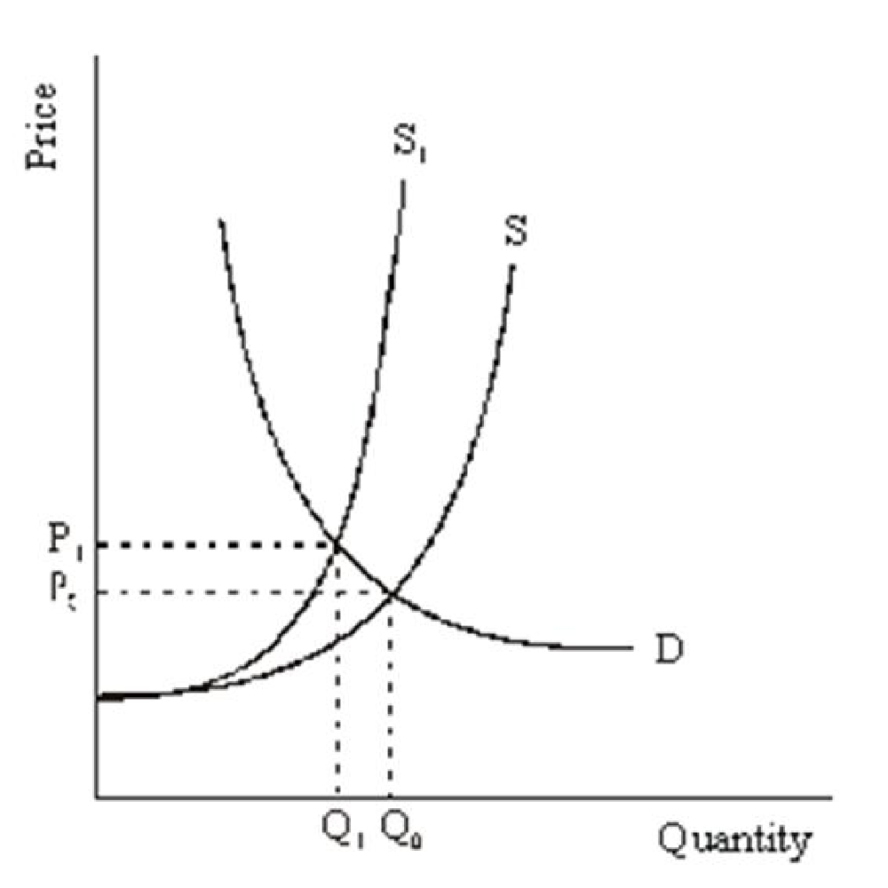
- Suppose that there is a small town in Colorado called Nepsa, and at one end of town there is a great ski mountain called Ajax Mountain. The market for skiing this large mountain is perfectly competitive- that is, there are lots of firms all over the mountain that each sells tickets to their own lift. The demand for lift tickets in this market is given by Qd = 320 – 4P. The market supply curve is given by Q = 6P. Also suppose the only way for skiers to get to the mountain is to drive through the town. Assume that each skier drives his or her own car. This flow of skiers through the town increases traffic and therefore the damage done to the roads, costing the town money in additional road repair. This marginal external cost of the skiers to the town is (1/12)Q.

  - Graph the demand and supply curve in this market for lift tickets.
- Find the equilibrium price and quantity for lift tickets, and also label these values on your graph.
- Is this equilibrium efficient? Why or Why not?
- Find the equation for the Marginal Social Cost (MSC) of skiers and graph this on your diagram. What is the MSC of the quantity of lift tickets that are sold in equilibrium?
- Find the socially efficient quantity of lift tickets sold, and also label this point on your graph.
- What is one way that the town of Nepsa could achieve this Q?

a.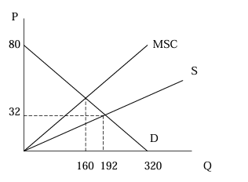

b. In equilibrium, the quantity demanded of lift tickets, Qd, equal to its quantity supplied, Qs. Setting Qd = Qs gives 320 – 4P = 6P. Solving for P yields P = 32. Plug this back to get Q = 192.

c. No, the flow of skiers through Nepsa increases traffic and this damages the roads, costing the town money in extra road renovation. Firms supply lift tickets according to their private cost, without regard to the road damages caused to the town. Since this external effect or external cost is ignored, firms tend to undercharge and overproduce, and this leads to allocative inefficiency.
d. Note that the supply curve can be considered as the marginal private cost curve, after some algebraic manipulation:

Qs = 6*P = 6*marginal private cost, so marginal private cost = (1/6)Q.

We are given that marginal external cost = (1/12)Q.
The marginal social cost of skiers (MSC) is equal to the sum of both the marginal private cost and marginal external cost:
MSC = marginal private cost + marginal external cost = (1/6)Q + (1/12)Q = (1/4)Q.

Currently, 192 lift tickets are being sold. (This is the equilibrium quantity) Substitute this

number to the marginal social cost function,
MSC = (1/4)*192 = 48.

e. Note that the inverse demand schedule can be considered as the marginal social benefit (MSB) curve. By algebraic manipulation:

Qd = 320 – 4P = 320 – 4*marginal social benefit, so MSB = 80 – (1/4)Q. The socially efficient quantity of lift tickets can be found by setting MSB = MSC: 80 – (1/4)Q = (1/4)Q. Solving this yields Q = 160.

f. The socially efficient quantity can be attained by taxing each firm an amount equal to (1/12)*160 = $40/3 per lift ticket so that firms will now consider the external effect when determining their output level.

PART B: MULTIPLE CHOICE

- What do economists mean when they say there is "market failure"?
              - Business has introduced a product that consumers do not want.
              - Free markets have led to excessive profits.
              - Markets have surpluses or shortages so that government rationing is necessary.
              - Free markets yield results that economists do not consider socially optimal.

- Some economists believe that the market will not solve all problems. They are referring to:
              - market failure.
              - market incentive plans.
              - optional policy.
              - the need to balance the good of the individual with the good of society as a whole.

- All of the following are considered sources of market failure except:
              - public goods.
              - imperfect information.
              - profit-maximizing behavior.
              - externalities.

- If a market has no externalities, marginal private costs:
              - exceed marginal social costs.
              - equal marginal social costs.
              - are below marginal social costs.
              - intersect marginal social costs.

- If a market has only positive externalities, marginal private costs:
              - always equal marginal private benefits.
              - include social costs.
              - do not equal marginal social costs.
              - equal marginal social costs.

- Economists generally call the effect of an agreement on others that is not taken into account by the parties making the agreement:
              - excess burden.
              - welfare loss.
              - Pareto optimality.
              - an externality.

- The best example of a positive externality is:
              - roller coaster rides.
              - pollution.
              - alcoholic beverages.
              - education.
- The best example of a negative externality is:
              - a tornado siren.
              - sugary processed foods.
              - flu shots.
              - a scientific discovery.
- The free rider problem:
              - can never prevent pure public goods from being supplied.
              - results because people act unselfishly.
              - results because people behave irrationally.
              - prevents voluntary cost sharing from achieving the efficient output of a public good.

- The best example of a public good is:
              - competition.
              - government-subsidized lunches.
              - pollution.
              - national defense.

- Refer to the graph shown. The amount of a tax sufficient to reduce quantity supplied to the level that individuals would have supplied had they included the cost in their decision on third parties is:
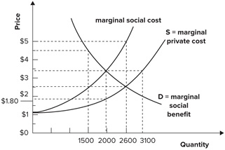
              - $2.50.
              - $1.70.
              - $1.00.
              - $0.80.

- Refer to the graph shown. The free market equilibrium in the graph is at a price and quantity of:
              - $5.00 and 2,600 units.
              - $3.50 and 2,000 units.
              - $2.50 and 2,600 units.
              - $3.50 and 3,100 units.

- If a positive externality exists in the provision of education when education is provided in a perfectly competitive market without government intervention, at the market equilibrium level of education:
              - additional net gains to society are possible by reducing the level of education.
              - additional net gains to society are possible by raising the level of education.
              - the marginal social benefit of education equals the marginal social cost.
              - additional net gains to society are not possible by either increasing or decreasing the level of education.
- If a negative externality is associated with burning firewood:
              - the marginal social cost of burning firewood falls short of its price.
              - the marginal social cost of burning firewood is exactly equal to its price.
              - less than the efficient amount of firewood for burning will be used each year.
              - the marginal social cost of burning firewood exceeds the price of burning firewood.

- When negative externalities exist in the production of a good, the marginal social cost of producing the good:
              - is equal to the marginal benefit received by consumers if competitive markets exist and there is no government intervention.
              - equals the marginal cost borne by the firm minus marginal cost borne by a third party that results from the production and consumption of the good.
              - is less than the marginal cost borne by the firm.
              - equals the marginal cost borne by the firm plus the marginal cost borne by third parties from the production and consumption of the good.
- Adverse selection is most likely to be a problem when:
              - one side of the market, either buyer or seller, has better information than the other side.
              - there are public goods involved.
              - the good being exchanged has negative externalities.
              - the good being exchanged has free rider problems.

- If medical insurers could use information contained in DNA to predict the likelihood of major medical illnesses, the most likely outcome is that:
              - there would be an adverse selection problem and average insurance rates would rise.
              - there would be an adverse selection problem and average insurance rates would fall.
              - the adverse selection problem would be decreased and average insurance rates would rise.
              - the adverse selection problem would be decreased and average insurance rates would fall.
- The problem that arises when people don't have to bear the negative consequence of their actions is known as:
              - adverse selection.
              - externality.
              - moral hazard.
              - signaling.

- A person who has auto insurance is likely to drive a little less safely and to take less care in parking their car in a safe place off the street. This is an example of a problem called:
              - signaling.
              - moral hazard.
              - externality.
              - adverse selection.
- If employers were made responsible for injuries suffered by employees while working at home:
              - there might be an adverse selection problem since employees have better information about the safety conditions of their own homes than employers do.
              - employers would never permit employees to work at home.
              - more employees would be able to work safely at home.
              - there might be an adverse selection problem since employers have better information about the safety conditions of their employees than the employees have themselves.

