METU
Department of Economics
Econ 101: Introduction to Economics I
Section 01-02
Fall 2024
PROBLEM SET 2 (CH 2&3)
PART A: ESSAY QUESTIONS
- The table below is a production possibility table for the fictional country of Myopia. Use it to construct the corresponding production possibility curve in the quadrant below. (Label the axes.)

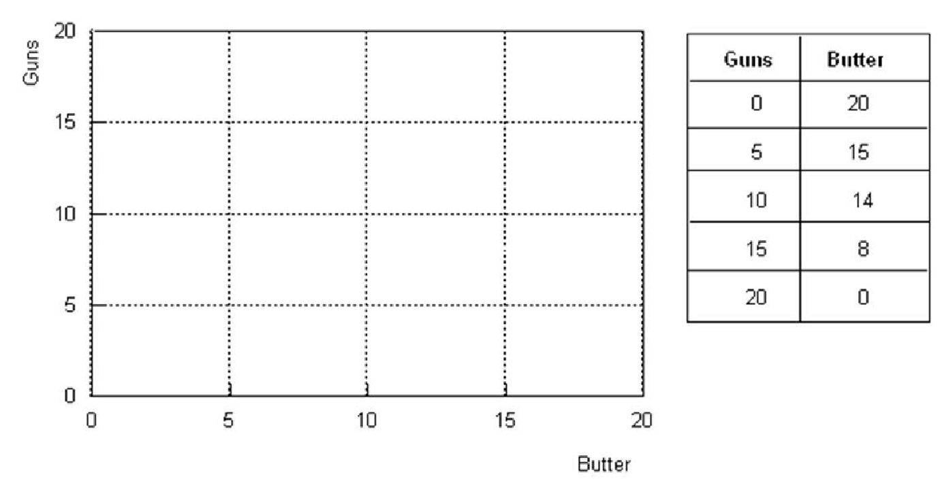
- Explain the meaning of a production possibilities curve.

- What is assumed to be constant when we draw that curve?

- How is a point on the curve different from (1) a point inside the curve or (2) a point outside the curve?

- How does this curve illustrate the concept of opportunity cost?

- How does it illustrate the principle of increasing marginal opportunity cost?

- Draw the production possibility frontier and fill in the blanks according to the table.
(Put the amount of meat on the x-axis and the amount of fish on the y-axis)

Combination | A | B | C | D | E | F | G | H | K | L
Fish | 0 | 13 | 23 | 32 | 40 | 47 | 52 | 56 | 59 | 60
Meat | 108 | 102 | 95 | 87 | 78 | 67 | 53 | 36 | 19 | 0

- The production possibilities frontier for this isle will be shaped ___________
- The slope (in absolute value) along this production possibilities frontier _________________ as more meats (placed on the X-axis) are produced.
- The slope of this production possibilities frontier _____________
- When the economy moves from point C to F, the opportunity cost of an additional fish, in terms of meat, is __________ meat(s).
- The opportunity cost of each additional fish in terms of meat ________.
- falls as more fish is produced.
- increases as more fish is produced
- remains constant
- is meaningless because the cost of fish cannot be expressed in terms of meat(s).
- The opportunity cost of each additional meat in terms of fish ________.
- is meaningless because the cost of fish cannot be expressed in terms of meat(s)
- remains constant
- falls as more fish is produced.
- increases as more meat is produced
- When the economy moves from point K to D, the opportunity cost of a piece of additional meat, in terms of fish, is ________ fish.

- According to the information given below:
Combination | Meat (units) | Wheat (units)
A | 0 | 2000
B | 200 | 1800
C | 400 | 1500
D | 600 | 1100
E | 800 | 600
F | 1000 | 0

  - Draw the production possibility frontier (PPF) (put meat on the x-axis)
  - The production possibilities frontier is _______ to the origin. (concave /convex)
  - Can this economy produce 200 units of meat and 1500 units of wheat? ____________
  - Can this economy produce 200 units of meat and 2200 units of wheat? ______________
  - What is the opportunity cost of increasing meat production from 200 units to 400 units (i.e. if the economy moves from combination B to combination C)? __________. What is the opportunity cost per unit of meat? _______________
  - What is the opportunity cost of increasing meat production from 400 units to 600 units (i.e. if the economy moves from combination C to D)? ______________. What is the opportunity cost per unit of meat? ______________
  - Does the principle of “increasing opportunity cost” hold in this economy?
- How do the following events affect the production possibility frontier (PPF) of a country, which produces only two goods food (F) and smart devices (S)? Show the shifts on the PPF graph. (Suppose that food is on the y axis and smart phones are on x axis.)
a) Rising sea levels causes floods damaging the buildings of some coastal cities.

b) Block chain design increases the productivity of the electronics industry.
c) Suppose that the government imposed a subsidy to farmers to support agriculture and livestock sectors.
- Define the following terms briefly and give an example for each.
- Market failure:
- Positive externalities:
- Negative externalities
- Public good:
- Demerit goods or activities:
- Merit goods or activities:

- What are the specific roles for government in the economy?

- Draw a production possibilities curve that indicates how you might divide up 10 hours of study time between your economics and accounting midterm exams. Put expected grade in economics on the horizontal axis and expected grade in accounting on the vertical axis. If you don't study at all, you expect to make a 70 on both exams. For every one additional hour of studying economics, your exam grade rises by 3 points. The same is true for accounting.
- What is the opportunity cost of studying one extra hour for your economics exam?
- What is the opportunity cost of studying one extra hour for your accounting exam?
- Can the production possibility curve shift? Explain.

- For each of the following events, show the shift in the demand curve and/or supply curve that results from the event, and the change in equilibrium price and quantity.
- Medical reports show that apples do not reduce cholesterol, contrary to earlier beliefs. What happens to the demand and/or supply curves for apples? What happens to the equilibrium price and quantity of apples sold?

b) The price of water sold to agricultural producers is raised. What happens to the demand and/or supply curves for vegetables? What happens to the equilibrium price and quantity of vegetables sold?
c) An insect pest attacks the coffee crop around the world. Assume that tea and coffee are substitutes. What happens to the demand and/or supply curves for tea? What happens to the equilibrium price and quantity of tea sold?

PART B: MULTIPLE CHOICE

- The Production Possibilities Frontier (PPF) depicts the fact that
- When a society combines its resources efficiently, it cannot produce more of one good without producing less of the other good.
- When a society combines its resources efficiently, it cannot produce more of one good without producing more of the other good.
- Some resources are always idle in a democratic society
- All points inside the curve are preferred to all points on the curve in terms of efficiency
- The demand for goods always exceeds the supply

- The opportunity cost of producing good A is defined as
- The money cost of the factors of production used in good A
- The retail price of good A
- The cheapest method of producing good A
- What must be the additional production cost get an additional unit of A
- The cost of having the best alternative in place of good A
- On the diagram of a PPF, the concept of scarcity is illustrated by
- the points on the curve
- the area within the curve
- the distance from origin to the curve
- the negative slope of the curve
- the unattainable points outside the curve
- Suppose that 1 unit of labor can produce either 5 units of wool or 2 pineapples. What is the opportunity cost of producing 1 pineapple?
- 5 units of wool
- 2 units of wool
- 2/5 units of wool
- 5/2 units of wool
- Zero

Refer to the graph below.
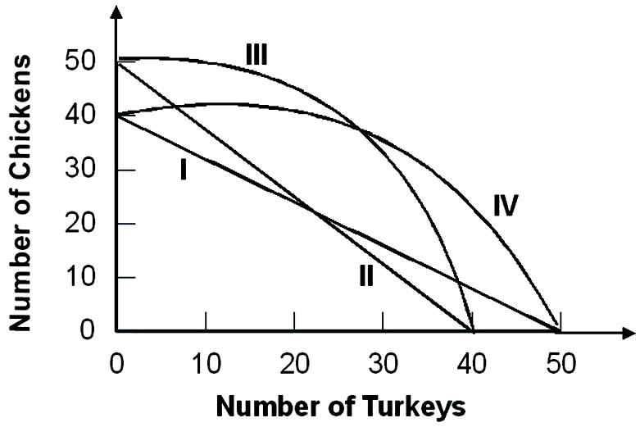
Suppose that the opportunity cost of producing 10 chickens is always 8 turkeys. Given this, the relevant production possibility curve must be:
  - I
  - II
  - III
  - IV
  - None of the above
- Refer to the graph below
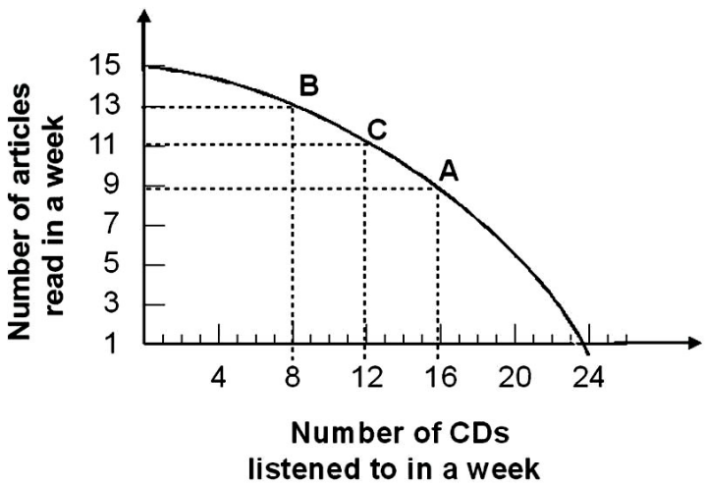

Given the production possibility curve, the opportunity cost of reading 2 more articles when you are already reading 11 articles is on average:
- ½ CD per article
- 2 CDs per article
- 2/3 CDs per article
- 3 CDs per article
- 3/2 CDs per article
- The principle of increasing opportunity costs states that the initial opportunity costs are:
- high but decrease the more you concentrate on the activity.
- low but increase the more you concentrate on the activity.
- high but increase the more you concentrate on the activity.
- low but decrease the more you concentrate on the activity.
- In a free market economy, the allocation of resources is decided by
- Central authorities only
- Central authorities and firms only
- Firms and households acting independently
- Political parties and firms only
- Individuals only
- In the economic theory, it is typically assumed that households and firms, respectively maximize
- Income and sales
- Savings and profits
- Wages and revenues
- Utility and profits
- Expenditures and profits
- Economic theory shows that in the private sector of a market economy, the price system allocates resources
- In goods market only
- In factor markets only
- In and equitable manner
- Better than they could be allocated by another allocation system
- In both goods and factor markets
- The circular flow of economic activity
- Illustrates the relationship between wants and resources
- Illustrates the relationship between financial system and government
- Shows why income flows do not balance the expenditure flows
- Illustrates the relationship between consumers and business
- Illustrates the relationship government, households and firms

- Markets coordinate economic activity through:
- the price mechanism.
- commanding individuals what to do.
- asking individuals what to do.
- the legal mechanism.
- The government intervention
- In the simple circular flow model, the government .
A) Has little influence over the markets
B) Influences both the input and output markets through taxes and regulations
C) Only siphons out income from the model through taxes
D) Increases the amount of income in the economy

- Which of the following is not an example of government's role as a referee?
- Equal opportunity and labor laws that restrict businesses' freedom to hire and fire whomever they want.
- Regulations governing safety in the workplace, wages, overtime, and hours of work
- Laws prohibiting businesses from meeting to fix prices
- Laws that require states and the federal government to balance their budgets

- The government serves as an actor in the economy when it
- alters anti-trust laws.
- increases defense spending
- reduces the minimum wage.
- improves health and safety standards for certain industries.
- Assume the demand for t-shirt decreases while the supply increases. Which of the following outcomes will occur unambiguously?
- The equilibrium quantity of t-shirt will fall.
- The equilibrium price of t-shirt will fall.
- The equilibrium quantity of t-shirt will rise.
- The equilibrium price of t-shirt will rise.

- A shift of a demand curve to the right or to the left is called
- a change in quantity demanded.
- a change in quantity supplied.
- a movement along a demand curve.
- a change in supply.
- a change in demand.

- Which of the following is NOT a characteristic of a market in equilibrium?
- Excess supply is zero.
- All consumers are able to purchase as much as they wish.
- Quantity demanded equals quantity supplied.
- The equilibrium price is stable, i.e., there is no pressure for it to change.
- Excess demand is zero.
- What might cause a demand function to shift to the right?
- An increase in the price of a substitute.
- An increase in the price of a complement.
- An increase in the product's own price.
- A decrease in the price of a substitute.

- A movement along a demand curve from one price-quantity combination to another is called
- a change in quantity demanded.
- a change in demand.
- a change in supply.
- a change in quantity supplied.
- a shift in the demand curve.

