CHAPTER 12: PRODUCTION AND COST ANALYSIS II

Questions and Exercises
- Technical efficiency in production means that as few inputs as possible are used to produce a given output. Economic efficiency means using the method that produces a given level of output at the lowest possible cost.
- a. Because the second farmer can produce the same amount of corn with fewer hours of labor and less seed, both methods cannot be technically efficient. Only the second farmer is technically efficient.
- All economically efficient methods are also technically efficient. However, the first method is not technically efficient. So, it is not possible for both methods to be economically efficient.
- a. It is possible that both methods are technically efficient because neither dressmaker is using more of both inputs to produce the same number of garments.
- The economically efficient method is the least-cost method. The cost of 800 garments for the first dressmaker is . The cost of the same number of garments for the second dressmaker is $36,000 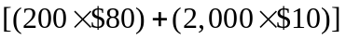. Therefore, the second method is the economically efficient method.
- It is incorrect because in the long run, there would be no fixed cost—all costs would be variable. The shape of the long-run average total cost curve is determined by economies of scale.
- If production relationships were only technical relationships, diseconomies of scale would never occur because the same technical process could be used over and over again at the same cost. In reality, however, the social dimensions of production relationships among workers introduce the potential for diseconomies of scale because, as the firm size increases, monitoring costs increase, and team spirit or morale generally decreases.
- a. Carmakers were taking advantage of both economies of scope (combining production of different models to lower the cost of production for both) and economies of scale (increasing production of cars on one assembly line to lower average cost per unit).
- The plan shifted the average total cost curve down.
- a. The long-run cost curve is shown in the accompanying graph. Initially it will fall because of economies of scale.
- It will later rise due to diseconomies of scale.
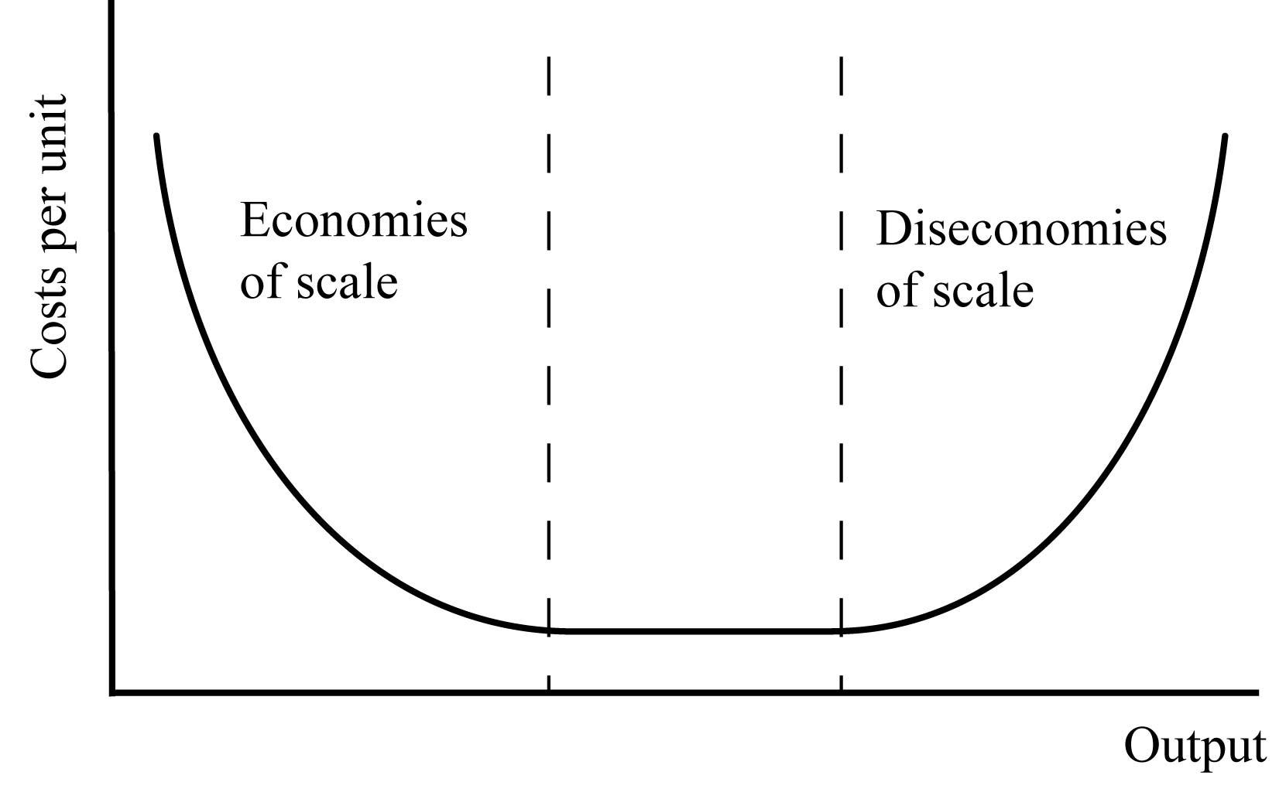
- The average cost curves in the short run are also U-shaped. Their shape is due initially to increasing marginal productivity and eventually to decreasing marginal productivity.
- There is no fixed component since there are no fixed costs in the long run.
- The long-run cost curve would be a horizontal line equivalent to the constant costs.
- a.
Units | Total Cost | Average Total Cost
1 | $16,000 | $16,000
2 | $21,000 | $10,500
3 | $26,000 | $8,667
4 | $31,000 | $7,750
5 | $36,000 | $7,200
6 | $41,000 | $6,833
7 | $46,000 | $6,571
8 | $51,000 | $6,375
9 | $56,000 | $6,222
10 | $61,000 | $6,100
- It exhibits economies of scale because average total costs are declining.
- The fixed cost of producing whales is the cost of the mold, or $11,000.
- The variable cost of producing whales is the materials used to make a new whale, or $5,000 per whale.
- Long-run costs are always lower than or equal to short run costs because in the long run all factors of production are variable. A firm can lower costs in the long run by adjusting what are fixed costs in the short run. Constraints to production always raise production costs.
- The long-run average total cost (L R A T C) curve is an envelope of the short run average total cost (S R A T C) curves. The short run marginal costs (SRMC) curve cuts the S R A T C at its lowest point.
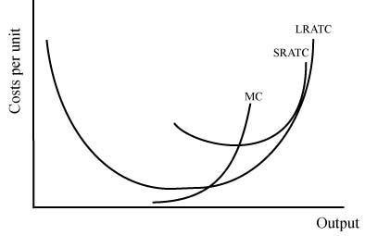
- A firm will produce along the segment where there are constant returns to scale. A firm producing where there are increasing returns to scale has an incentive to increase production to lower costs. A firm producing where there are decreasing returns to scale has an incentive to decrease production to lower costs.
- An entrepreneur is an individual who sees an opportunity to sell an item at a price higher than the average total cost of producing it. He or she creates supply by organizing production as efficiently as possible and fully taking advantage of any potential economies of scale or economies of scope.
- No, not in the long run. In the long run, you should not continue to produce at a loss, and because all inputs are variable, you can go out of business. In the short run, the decision whether or not to produce depends on what portion of your costs are fixed.
- False. Financial reward plays a role in entrepreneurial effort, but it is not the only role. Entrepreneurs can also be motivated by providing social goods such as clean air. Recently a new type of firm has emerged called a for-benefit firm that includes both profit and social good in its charter.
- Cost curves are defined within a period of time. In the short run, technology is assumed constant. In the long run, technological change shifts the cost curves down. It does not explain the downward-sloping portion of cost curves.
- Learning by doing lowers average total costs (shifts the curve down) because workers become better at their jobs—producing more in the same time period or producing the same with fewer inputs to production.
- The long-run average total cost curve is shifting down. Learning by doing means that workers can produce more with fewer inputs, shifting the short-run average total cost curve down. If the short-run average total cost curve shifts down so will the long-run average total cost curve

Questions from Alternative Perspectives
- Austrian
- True costs are revealed through the workings of the market process. Without the market, one has little sense of the true costs.
- There is probably no one optimal method of finding costs, but experience in an actual competitive marketplace is probably the best that firms can do.
- Feminist
- To the extent that women provide less detail about their jobs in surveys and applications, they lead employers to believe that they know less than men and therefore have less experience.
- Women who have completed their formal education may have periodically withdrawn from the labor force. Working without pay in volunteer work for non-profits as well as years of experience as a household executive provide women with the experience of multitasking, delegating, managing schedules, and carrying out complicated tasks required on PTAs and other volunteer positions.
- Religious
It suggests that differences in productivity are not inherent but are matters of luck and circumstance such as having fewer opportunities to learn, and it thereby undermines some aspects of the moral arguments for paying more productive people more. A possible policy implication is to provide opportunities for increasing productivity to those who have fewer opportunities.
- Institutionalist
- An example is large-scale hog farming. The environmental consequences of large-scale hog farming are enormous: two are contamination of groundwater and destruction of freshwater lakes, streams and rivers (deadly algae blooms in tidal ecosystems). There are also problems with airborne pollutants, not the least of which is ammonia. The presence of a large-scale hog farm will reduce property values in the associated area.
- The implication for policy is that a system should be set up that requires firms to internalize all of their costs. One way to do this is to tax producers based on the costs that they externalize. Another option is to regulate the production process to reduce or eliminate the environmental consequences.
- Radical
If the empirical work that shop floor participation improves productivity is true, one would expect that firms that adopt it would out-compete firms that do not. One reason why firms may not adopt floor shop participation is that giving workers a larger voice in the work process might undermine employers’ control of the production process and reduce some of the prerogatives of bosses, which the firm may find ideologically unacceptable.

Issues to Ponder
- a. Variable costs would likely include manufacturing labor, materials, and possibly sales costs (to the extent that they are for the sale of additional production). Certain other costs have a variable component to them, but they will unlikely vary directly with production.
- Fixed costs would likely include factory overhead, operating expenses and profit, research and development, interest, and, to some extent, advertising. In the real world, the division between fixed and variable costs is not as clear-cut as it is in the textbooks.
- If output were to rise, average total cost would likely fall because fixed costs are spread over a higher level of production. This is the case for many real-world firms.
- The inputs used in studying would certainly be labor, probably energy (i.e., lighting and temperature control), and a place (desk, bed, etc.), which would represent the "plant." Pens or pencils and paper to take notes and a highlighter to mark the text are also likely inputs to be mentioned, as well as study snacks (food for thought?). The shapes of the long-run average total cost curve and the marginal cost curve will depend on whether or not there are economies or diseconomies of scale in studying, and that will be determined by the relationship between how resources are used and the study time.
- The marginal costs of an additional car driving on a road would be the added costs of the road's usage. This includes the added wear and tear to the road surface, which is minimal for every car. There could also be a congestion cost, which at certain times can be substantial. Most likely the marginal cost curve would be a straight line at close to zero with a quickly rising slope as the highway becomes congested. Because of congestion, marginal costs increase as more and more cars use the road.
- a. In the short run, the college is probably right. However, it depends on how short the short run is. To the extent that fewer laborers could be hired to prepare less food and to the extent that the empty dining halls could be used for other purposes, these are variable costs and could be rebated as saved variable costs. In reality, labor contracts are somewhat fixed, and the opportunity cost of college dining halls (or the additional seats available) is minimal. One less meal does not allow fewer laborers or alternative uses of the space because they are indivisible costs.
- At the planning stage, the argument can be made that they are all variable costs, and that the college could plan for a percentage of off-board students and consequently build fewer dining halls and hire fewer laborers. In fact, some dining halls allow a set number of off-board students and do not charge board. However, colleges must accommodate visitors and all students who would like board and must build a too-large hall. Thus, the variability of demand also plays a role. However, the longer the time period, the higher the relevant marginal cost.
- Administration at these schools would probably argue that the $6.00 cost is justified because it is the expectation of occasional guests that led to the building of larger dining halls. Therefore, some of the cost of building the space should be assigned to them. However, if that is correct, it is difficult to see why that higher marginal cost should not be used for determining rebates. Furthermore, it could be argued that too low a price would lead to too many “guests,” which the dining halls cannot accommodate.
- The draftsman was right because marginal cost curves pass through the minimum points of their short-run average cost curves, and short-run average cost curves are not all tangent to the long-run average total cost curve at these minimum points (except at that output where short-run average total cost curve is at the minimum of the long-run average cost curve). Thus, that Viner really wanted many of the marginal cost curves to pass through two different points on a single short-run average cost curve is not possible.
- Producing steel in this fashion involves an enormous fixed cost. These fixed costs must be spread out over sufficient production to lower average total costs and make the average total production costs (which includes fixed costs) less than the price.

APPENDIX: ISOCOST/ISOQUANT ANALYSIS
- Due to diminishing marginal productivity, the marginal rate of substitution falls as the firm adds more of the variable input.

- See the accompanying graph. The dotted line is the original isocost curve. Each of the following is shown with respect to the dotted line.
- This is line A in the graph.
- The isocost curve rotates in along the machinery axis as shown in the graph to line B.
- The isocost curve shifts in along both axes as shown to line C.
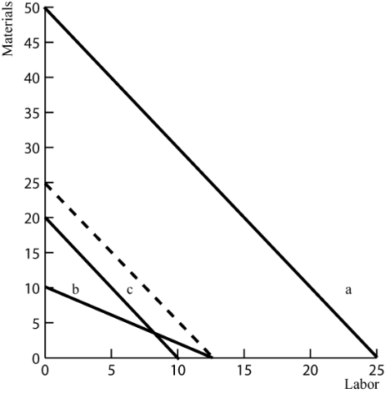
- As shown in the accompanying graph, land is cheaper in the United States than in Japan and labor is cheaper in Japan than in the United States. This accounts for the differing isocost lines. For each country to produce efficiently, it must equate the marginal rate of substitution to the relative costs of inputs. Then, they will choose different combinations of labor and land. Japan will choose more labor and less land as shown by point A. The U.S. will choose more land and less labor as shown by point B.
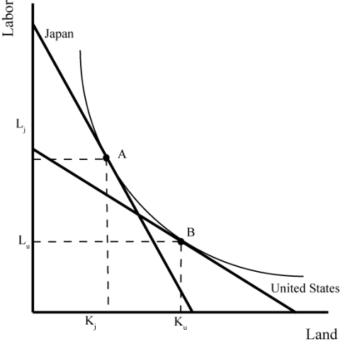
- Technical efficiency in production means that as few inputs as possible are used to produce a given output. On the accompanying graph, this would be anywhere on the isoquant curve, including points A and B. Economic efficiency means using that method that produces a given level of output at the lowest possible cost. Given the cost of inputs, the efficient point to produce that level of output corresponding to the isoquant curve is point B, where the isocost curve lies tangent to the isoquant curve.
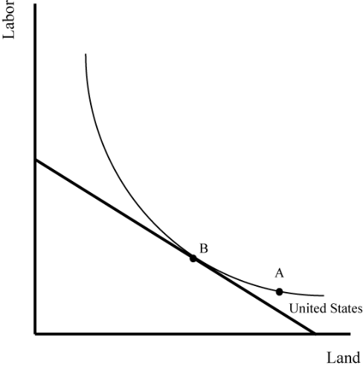
- See the accompanying graph. The efficient combination of inputs for isocost line A is point A.
- Technological innovation that makes land and labor equally more productive will increase the output that corresponds to Isoquant A.
- The isocost curve rotates in along the x-axis to Isocost B. The firm cannot produce as much as before. The efficient combination of inputs is now point B on a lower isoquant curve.
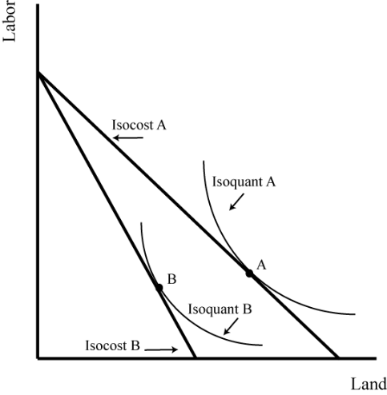
- If the price of labor falls to $3, the isocost curve shifts out along the labor axis, intersecting at 20 units of labor. Producing 60 earrings with the new labor costs is now inefficient. The firm can now produce more than 60 earrings, shown by point D, which is on a new isoquant curve to the right of the isoquant curve that corresponds to 60 earrings.
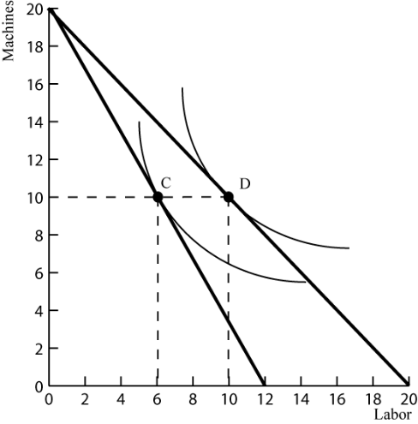
- A rise in the cost of machines shifts the isocost curve in along the machine axis to intersect at 12 machines. The firm can no longer produce 60 earrings. It must produce fewer at a point such as E.
