METU Department of Economics
ECON102
Spring 2024
Section: 1&2
TA: Zeki Oğulcan Şengül
PROBLEM SET 7
- Explain how automatic stabilizers work, both on the taxation side and on the spending side, first in a situation where the economy is producing less than potential GDP and then in a situation where the economy is producing more than potential GDP.

In a recession, because of the decline in economic output, less income is earned, and so less in taxes is automatically collected. Many welfare and unemployment programs are designed so that those who fall into certain categories, like “unemployed” or “low income,” are eligible for benefits. During a recession, more people fall into these categories and become eligible for benefits automatically. The combination of reduced taxes and higher spending is just what is needed for an economy in recession producing below potential GDP. With an economic boom, average income levels rise in the economy, so more in taxes is automatically collected. Fewer people meet the criteria for receiving government assistance to the unemployed or the needy, so government spending on unemployment assistance and welfare falls automatically. This combination of higher taxes and lower spending is just what is needed if an economy is producing above its potential GDP

- What causes the crowding out effect?

There are several possible sources of crowding out. First, higher government spending may be financed by higher taxes which reduce private consumption spending. Second, higher government spending may be financed by borrowing (issuing government bonds) which reduces spending on private bonds, therefore decreasing private investment spending. Third, if government borrowing to finance increases in government spending reaches high enough levels, the issue of additional bonds may depress bond prices and raise 3 interest rates. Higher interest rates make consumer and business spending more expensive, thus further decreasing private consumption and investment

- Assume a simple closed economy, with an mpc equal to 0.75. Assume that marginal tax rate is equal to zero. In other words, the tax function only consists of autonomous taxes. The government has passed a balanced budget amendment. The economy goes into a recession, so the government increases government spending by 40 million to try to expand the economy.

- Calculate the change in output (ΔY) from the increase in government spending (ΔG).

The spending multiplier = 1/(1-0.75) = 4 ΔY = multiplier*ΔG ΔY=4*40 =160 million

- The balanced budget amendment requires the government to also raise taxes by 40 million. Calculate the change in output (ΔY) from the tax hike.
The tax multiplier = $\frac{-c1}{1-c1}$

= $\frac{-0.75}{1-0.75}=-3$

$$∆Y=Tax multiplier*∆T$$

$$∆Y=-3*40$$

$$∆Y-120$$
- What is the net effect on output from these two policies? Was there any expansionary effect?

The net effect of the two policies is: ΔY(a+b)=160 million – 120 million=40 million. Yes, it expanded output by 40 million.

- Why is a balanced budget amendment problematic or undesirable?

A balanced budget rule means that one can’t respond to severe emergencies, such as a natural disaster, war, or deal with a severe recession. Because the multiplier is only equal to one, it provides a fairly weak stimulus

- What role has globalization played in increasing the target unemployment rate? What other factors have affected the target rate?

Globalization requires structural change and that structural change affects the target unemployment rate. For developed countries, such as the U.S., globalization is characterized by large trade deficits and large capital account inflows. These tend to increase the target unemployment rate since they involve moving production abroad, and a lowering of the wage that firms will pay developed country’s workers, creating, or widening, people’s reservation wage above what firms are willing to pay. Other factors that affect the target rate of unemployment include demographics, the economy’s changing social and institutional structure, technological change, and the change of government institutions.
- Explain the types of unemployment.

Frictional Unemployment: The short-run unemployment caused by normal workings of the economy is called frictional unemployment. Such unemployment occurs as people are fired from jobs or as people quit their jobs to move to a new career or location or as a result of first time entrants to the labor market such as new graduates. The number of unemployed people is equal to the number of vacant jobs; however the unemployed and the vacant jobs need to be matched. The best way to lower this kind of unemployment is to provide more and better information to job-seekers on available jobs and employers on unemployed people.
Structural Unemployment: The unemployment caused by structural changes in an economy is called structural unemployment. Consider an economy that produces agricultural products. Assume that this economy suddenly experiences a major structural change and starts to produce high-technology products, like computers. In this case, the workers in the labor force of this economy need to be retrained. The reason is that the workers simply do not have the knowledge and abilities to produce computers. Note here that in the case of structural unemployment, number of unemployed and the number of vacant jobs are equal. However, the workers and the jobs cannot be matched due to misaligned job requirements and labor qualifications. Unlike frictional employment, structural employment lasts longer and creates significant losses in jobs.
Cyclical Unemployment: Cyclical unemployment is the increase in unemployment observed during recessions and depressions of an economy. As it is created by business cycles, this unemployment receives the name “cyclical”. The number of available jobs decreases during a recession. Therefore the number of jobs is less than the number of unemployed in the case of cyclical unemployment.

- The following data from 2018 for tiny island nation of Carousel: $money supply = 600 million$; $price level=2.5$; $velocity of money=4$. Use the quantity theory of money to answer the following questions
- What is the value of real output (income) in 2018?
The quantity theory of money says that:
$$MV=PY$$
$$M:money supply$$
$$V:Velocity of money$$
$$P:Price level$$
$$Y:Real output \left( income\right)$$
According to the information above we have:
$$600*4=2.5(Y)$$
$$Y=960$$
- What is the value of nominal output (income) in 2018?
$$Nominal output=P*Y$$
$$Nominal output=2.5*960=2400$$
- If real output doubled, by how much would the money supply need to change?

If real output doubles, we have this equation,
$$M*4=2.5*(2*960)$$
$$M^{'}=1200$$
It should be doubled.
- What happens if the money supply increases more rapidly than real output?
If the money supply increases faster than real output increases, the result is inflation.

- If the annual GDP (nominal) growth rate is 8 percent in Carousel, by how much will the money supply need to change in 2019?
If the annual GDP growth rate is 8 percent in Carousel, the nominal GDP will be:
$$NGDP_{2019}=2400+2400\left(0.08\right)=2592$$
$$M*4=2592$$
$$M_{2019}=648$$
Money supply should change by 8 percent.
OR
There is a different version of the quantity theory of money.
$$\% Δ M + \% Δ v = \% Δ P + \% Δ Y$$
In this example,
$$\% Δ M + \% Δ v =\%8$$
Since velocity is constant;
$$\% Δ M =\%8$$
- Define the short run and long run Phillips Curves and use the following information to draw a graph showing the short run and long run Phillips curves:
Natural rate of unemployment=5%
Current rate of unemployment=4%
Expected inflation rate=4%
Current inflation rate=6%

The short- run Phillips curve is the relationship between the inflation rate and the
unemployment rate when the natural unemployment rate and the expected inflation rate
remain constant.
The long - run Phillips curve is the relationship between the inflation rate
and the unemployment rate when the economy is at full employment. The short- run
Phillips curve is downward sloping, indicating that if the expected inflation rate and
natural unemployment rate do not change, a higher inflation rate decreases the
unemployment rate.
The long - run Phillips curve is a vertical line illustrating that in the
long run, the economy at full employment can have any inflation rate. The short - run
Phillips curve intersects the long - run Phillips curve at the expected inflation rate. A
change in the expected inflation rate shifts the short- run Phillips curve but has no effect
on the long- run Phillips curve. An increase in the natural unemployment rate shifts both
the short- run and the long - run Phillips curve.

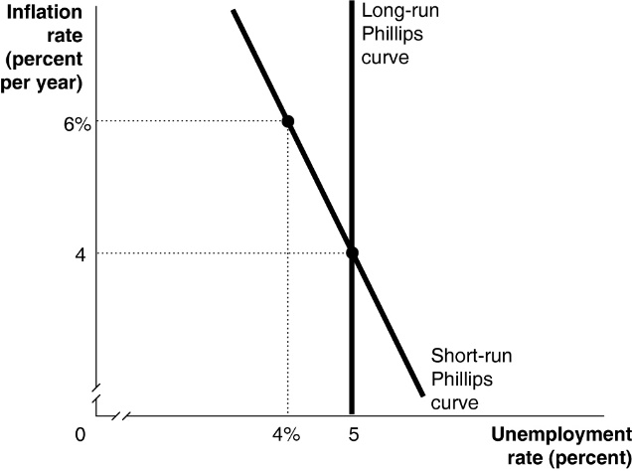

- Assume that expectations are adaptive. How will the economy adjust to a new long-run equilibrium in response to the following policies? Support your answer with a graph of the Phillips Curve.

- Expansionary monetary policy

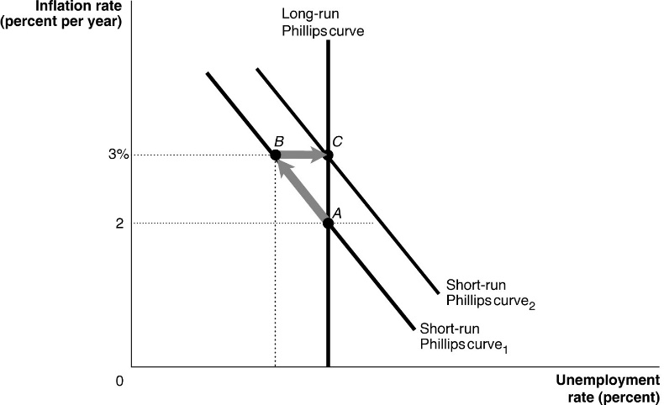
Expansionary monetary policy increases the inflation rate. With adaptive expectations, workers and firms will underestimate inflation, resulting in a decrease in the real wage and a decrease in the unemployment rate (move from A to B on the short-run Phillips curve above). Eventually, workers and firms will adjust to the fact that inflation is higher, shifting the short-run Phillips curve up and increasing the unemployment rate to its natural rate (move from B to C in the graph above).

- Contractionary monetary policy

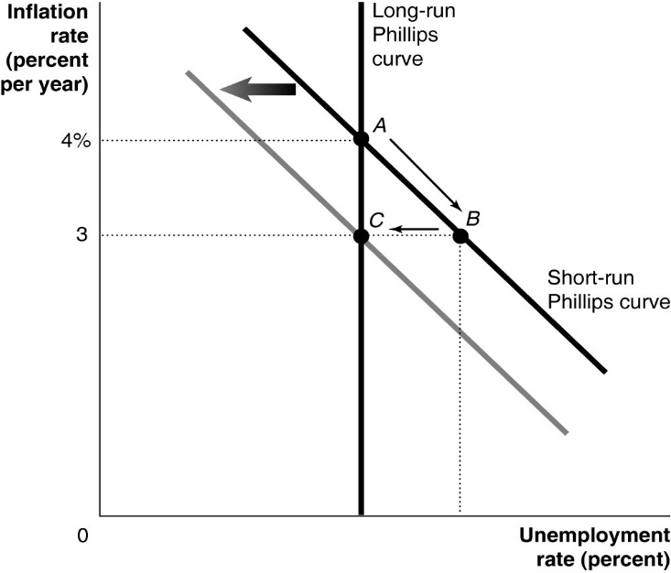
Contractionary monetary policy reduces the inflation rate. With adaptive expectations, workers and firms will overestimate inflation, resulting in an increase in the real wage and an increase in the unemployment rate (move from A to B on the short-run Phillips curve above). Eventually, workers and firms will adjust to the fact that inflation is lower, shifting the short-run Phillips curve down and reducing the unemployment rate to its natural rate (move from B to C in the graph above).

- If firms and workers have adaptive expectations, what impact will expansionary monetary policy have on inflation, unemployment, and the Phillips curve?
Adaptive expectations exist when firms and workers expect inflation in the current time period to be the same as inflation in the previous time period. If the Central Bank follows an expansionary monetary policy, inflation will rise. If expectations about inflation are adaptive, the expansionary monetary policy will increase actual inflation above expected inflation. With no adjustment in nominal wages, the real wage will fall, and the unemployment rate will be pushed below its natural rate. In other words, the inflation rate and the unemployment rate will be negatively related, as indicated by a short-run Phillips curve.
- Explain why expansionary monetary policy would not result in reduced unemployment rates if workers and firms have rational expectations.
If workers and firms have rational expectations, they anticipate that expansionary monetary policy will increase inflation. The increase in inflation expectations will be incorporated into wage contracts, resulting in no change in the real wage. If there is no change in the real wage, then there will be no change in unemployment and no change in real GDP. As a result, there will be no trade-off between unemployment and inflation. Inflation will rise, but the unemployment rate will not be affected

PART B: MULTIPLE CHOICE
- What action could The Central Bank (CB) take to reduce the crowding – out effect of an expansionary fiscal policy?
- The CB could increase the money supply at the same time the government increases its spending
- No action choice of The CB can reduce crowding – out effect
- The Central Bank should increase the required reserve ratio
- The CB should sale securities.
- Fiscal policy involves changes in…
- Real interest rates and taxation
- Government spending and the value of TL.
- Government spending and taxation.
- None of the above
- Which of the following fiscal policies would help restore the Turkish economy to full employment if it were in a recessionary gap?
  - A tax cut, since it would shift AD rightward by increasing C and I
- A tax increase, since it would shift AD leftward by decreasing C and I
- A decrease in government spending, since it would shift AD rightward by increasing G
- An increase in taxes and a decrease in government spending used at the same time
- When would a contractionary fiscal policy help restore full employment?
A) When the economy is at potential GDP
B) When the economy is in an inflationary gap
C) When the economy is in a recessionary gap
D) When the economy's unemployment rate is higher than the natural rate of unemployment
- The crowding-out effect occurs when...
A) The government reduces its spending, thus decreasing the demand for money, and the interest rate
B) Consumption spending increases, which raises the demand for money, and interest rates. This reduces the level of business investment spending
C) Business investment increases as a result of lower interest rates
D) The government finances increases in spending with money borrowed from the money market. This increases the demand for money, which increases the interest rate, and reduces business investment.

- Fiscal policy would be more effective if:
A) potential income was unknown.
B) the government could change taxes and expenditures rapidly.
C) the size of the government debt didn't matter.
D) crowding out occurred more often.
- Refer to the graph shown. Expansionary fiscal policy is most likely to shift the aggregate demand curve from:
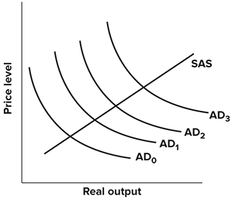
A) AD ₀ to AD ₂ if crowding out does not occur and from AD ₀ to AD ₁ if crowding out does occur.
B) AD ₀ to AD ₂ if crowding out does not occur and from AD ₀ to AD ₃ if crowding out does occur.
C) AD ₂ to AD ₀ if crowding out does not occur and from AD ₁ to AD ₂ if crowding out does occur.
D) AD ₂ to AD ₀ if crowding out does not occur and from AD ₁ to AD ₃ if crowding out does occur.
- When the government runs a deficit, the interest rate tends to:
A) rise.
B) fall.
C) remain unchanged.
D) rise or fall, depending on how the deficit is financed.

- Refer to the graph shown. Assume the economy is in short-run equilibrium at point A below potential output. The government opts for an expansionary fiscal policy in an attempt to pull the economy out of the recession. An economist with a Classical view holding the Ricardian equivalence theorem to be practically true would conclude that the economy will most likely end up at point:
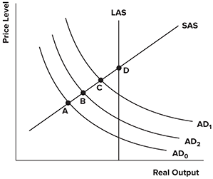

A) A.
B) B.
C) C.
D) D.

- According to the Ricardian equivalence theorem, government deficits do not affect output because people:
A) save more when government deficits decrease.
B) save more when government deficits increase.
C) consume more when government deficits increase.
D) do not change consumption nor savings.

- Okun's rule of thumb states that a:
A) 2 percentage point rise in the unemployment rate will tend to be associated with a 1 percent fall in output from its trend and vice versa.
B) 2 percentage point rise in the unemployment rate will tend to be associated with a 1 percent rise in output from its trend and vice versa.
C) 1 percentage point rise in the unemployment rate will tend to be associated with a 2 percent fall in output from its trend and vice versa.
D) 1 percentage point rise in the unemployment rate will tend to be associated with a 2 percent rise in output from its trend and vice versa.
- Unemployment caused by a recession is called:
A) frictional unemployment.
B) cyclical unemployment.
C) natural unemployment.
D) structural unemployment.
- Which of the following types of unemployment is considered to be the most controllable through demand-side macroeconomic policy?
A) Frictional unemployment
B) Natural unemployment
C) Cyclical unemployment
D) Structural unemployment
- News Story: Workers at a car-manufacturing plant in Flint, Michigan, are laid off because the car technology has been changed and new cars will be electric cars which the old workers are not capable of to produce them since they have old fashioned skills. What type of unemployment describes the workers' situation?
A) Cyclical unemployment
B) Full unemployment
C) Structural unemployment
D) Frictional unemployment
- What will likely lower structural unemployment?
A) People lower their reservation wages.
B) The labor force participation rate rises.
C) The Fed sells bonds.
D) The economy expands.
- Globalization, accompanied by large trade deficits, most likely raises:
A) utilized unemployment.
B) cyclical unemployment.
C) the target rate of unemployment.
D) frictional unemployment.
- Over the past several years, the target rate of unemployment has risen. Which of the following would not be used to explain this?
A) Congress passed a bill that requires the target rate to rise along with rising government deficits.
B) The workforce is getting younger.
C) More women have entered the workforce.
D) Government has expanded income support programs
- The wage a person requires before accepting a job is referred to as the _____ wage:
A) compensating
B) minimum
C) reservation
D) psychological
- When workers and employers correctly anticipate an increase in inflation caused by an increase in aggregate demand,
A) there will be no unemployment.
B) workers will overestimate the real wage rate.
C) unemployment will be at the natural rate.
D) workers will underestimate the real wage rate.
- If the economy is initially at potential GDP and people correctly anticipate an increase in inflation so that their money wage rate adjusts immediately, then
A) only real GDP increases with no change in the price level.
B) only the price level rises with no change in real GDP.
C)both the price level and real GDP increase.
D) neither the price level nor real GDP increase.
- Moving along a short- run Phillips curve,
A) the price level is constant.
B) unemployment is constant.
C) the expected inflation rate is constant.
D) the inflation rate is constant.
- In the short run, an unexpected increase in the inflation rate leads to
A) a higher unemployment rate.
B) a decrease in aggregate demand.
C) a lower unemployment rate.
D) workers thinking the money wage rate has fallen.
- Along a shortrun Phillips curve, suppose the expected inflation rate is 6 percent. If the inflation rate turns out to be 8 percent instead,
A) there is a movement upward along the short- run Phillips curve.
B) there is a movement downward along the short- run Phillips curve.
C) there is a downward shift of the short- run Phillips curve.
D) None of the above answers are correct.
- Which of the following leads to a downward shift in the short- run Phillips curve?
A)People expected inflation to be 5 percent last year and now expect inflation to be 3 percent this year.
B) People expect the unemployment rate to increase.
C) The long - run Phillips curve shifts rightward.
D) Unexpected inflation increases.
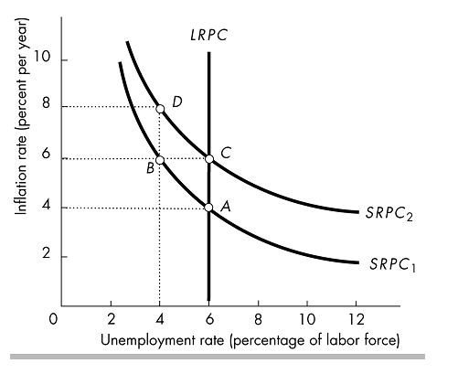

- In the above figure, suppose the economy is at point A. An unexpected increase in the inflation rate to 6 percent will result in a movement to point
A) A, that is, there is no movement.
B) B .
C) C .
D) D.
- In the above figure, suppose the economy is at point A. An expected increase in the inflation rate to 6 percent will result in a movement to point
A) A, that is, there is no movement.
B) B .
C) C .
D) D.
- The long - run Phillips curve is
A) vertical at potential GDP.
B) the horizontal sum of the short- run Phillips curves.
C) vertical at the natural unemployment rate.
D) the vertical sum of the short- run Phillips curves.

- Along the long - run Phillips curve,
A) actual inflation is greater than expected inflation.
B) actual inflation is equal to expected inflation.
C) actual inflation is less than expected inflation.
D) None of the above answers is correct.

