METU Department of Economics
ECON102
Spring 2024
Section 1&2
TA: Zeki Oğulcan Şengül
PROBLEM SET 2

- The graph below shows a Lorenz curve for income distribution in the country of Fairland.
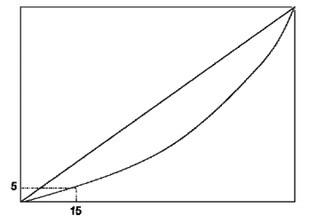
- Label the horizontal and vertical axes on this graph.
The horizontal axis should be labeled as “(Cumulative) Percent of Households,” and the vertical axis should be labeled as “(Cumulative) Percent of Income.”

- In words, explain what information is communicated by the numbers shown in this graph.
Based on this graph, we can see that the poorest 15% of households in Fairland receive 5% of total household income.

- Suppose that the pattern of employment and wages in Fairland changes, so that now the distribution of income is less unequal ( more equal). On the graph, draw an example of a Lorenz curve that could illustrate this result.
The curve will shift upward, toward the diagonal:
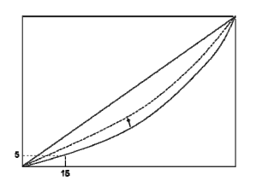

- Suppose that the per capita GDP (i.e. mean income per person) in country A is 50% higher than it is in country B. Will this necessarily imply that a randomly chosen individual in country A will generally have higher income than a randomly chosen individual in country B? Discuss why or why not. No, not necessarily.
We can give a counterexample for this statement. Suppose each country has 3 people. In country A, two people have incomes of $5000 and the third has an income of $200,000. That means mean income in country A is $70,000. Alternatively, in country B suppose each person has an income of $30,000, meaning mean income is also $30,000. Hence, country A has over twice the mean income of country B. However, if we randomly choose a person from each country, two out of every three times the person drawn from B will have a higher income than the person drawn from A. Let us examine this question by using real data. In the figure below, you can see the Gini indexes of Finland and US from 2003 to 2018.

According to figure, Gini index of Finland has been lower than the US in the given period, which means that the income distribution in Finland is more equal than the US. (Note that as Gini coefficient closes to 0, the income distribution becomes more equal. The extreme cases, Gini =0 means that everybody gets the same income, and 1 means, one person gives all). However, that does not mean that a randomly chosen Finnish people is richer than its American counterpart. Although, Gini gives an information about income distribution, it does not completely explain the wealth of the society.

- The following table provides information about the family income distribution both in Country A and Country B.

Family Income Rank | Share of Aggregate Income (%)
Family Income Rank | Country A | Country B
Lowest fifth | 10 | 2
Second fifth | 15 | 4
Middle fifth | 20 | 6
Fourth fifth | 25 | 18
Highest fifth | 30 | 70

- Draw the Lorenz curves for family income for both countries on the same diagram

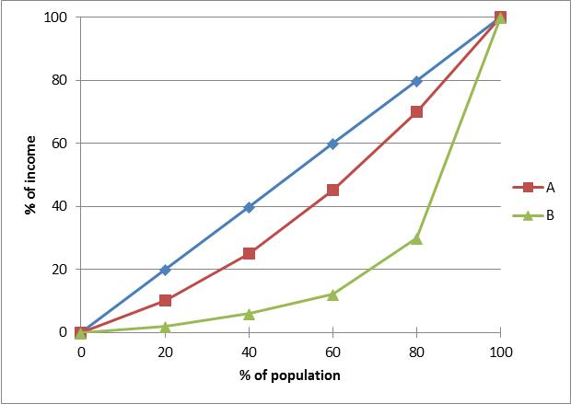

- Which of the two countries has more equal family income distribution? Why?
Country A has a more equal income distribution. This is because Country A’s Lorenz curve is closer to the 45-degree line.

- Assume that you are just employed as the economist for the OECD. Beside the above figures you are given that Gini coefficient for country A = 0.50 while Gini coefficient for Country B = 0.45. What can you say about the situation?
Gini coefficient is equal to the area that difference between Lorenz curve and 45-degree line divided by the triangular area under 45-degree line. Information given are wrong since country A should have a lower Gini coefficient and B should have a higher Gini coefficient according to the diagram.

Aggregate Output (Income) | Aggregate Consumption | Planned Investment | Planned Aggregate Expenditure | Unplanned Inventory Changes | Savings | Marginal Propensity to Consume | Induced Consumption Expenditure | Autonomous Consumption Expenditure
2000 | 2100 | 300
2500 | 2500 | 300
3000 | 2900 | 300
3500 | 3300 | 300
4000 | 3700 | 300
4500 | 4100 | 300
5000 | 4500 | 300
5500 | 4900 | 300

a) Using the provided data, fill “Marginal Propensity to Consume”, “Induced Consumption Expenditure” and “Autonomous Consumption Expenditure” columns.
Then obtain the algebraic expression for the consumption function.

Marginal propensity to consume (MPC) is calculated as the change in consumption caused by a change in income. It is also the slope of the consumption function. Algebraically, MPC = ∆C/∆Y. For example, as income increases from 2000 to 2500, aggregate consumption increases from 2100 to 2500. MPC is calculated as
MPC = ∆C/∆Y = (2500-2100)/(2500-2000) = 400/500 = 0.8
Similarly, as income increases from 2500 to 3000, aggregate consumption increases from 2500 to 2900. MPC in this case is calculated as
MPC = ∆C/∆Y = (2900-2500)/(3000-2500) = 400/500 = 0.8
The rest of the column is filled in a similar fashion.

Induced consumption expenditure is the part of consumption that depends on the state of the economy as represented by income. To clarify, consider the consumption function as C = C₀ + MPC*Y, where C is aggregate consumption, MPC is marginal propensity to consume and Y is income. C₀ is the autonomous part of aggregate consumption. Note that the part MPC*Y is a share of income and is therefore dependent on income. This part of the aggregate consumption expenditure is induced consumption expenditure. The other part, C₀, is exogenously given and is not dependent on the state of the economy as represented by income. Therefore C₀ is autonomous consumption.

It should be noted that since consumption function is assumed to be linear, it has a constant slope and thus constant MPC. Even though MPC can not be calculated for the first row, we know that it is 0.8. Since induced expenditure is MPC*Y, it is calculated for the firs row that MPC*Y = 0.8*2000 = 1600. Also for the second row, induced consumption is MPC*Y = 0.8*2500 = 2000. The rest of the column is filled similarly.

As for the autonomous consumption, C₀ = C – MPC*Y. Therefore, for the first row, C₀ = 2100 – 1600 = 500. For the second row, C₀ = 2500 – 2000 = 500. The rest of the column is filled similarly. Note that since C₀ is autonomous, it has the same value for all levels of income.

The consumption function is C = C₀ + MPC*Y. Given that MPC = 0.8 and C₀ = 500, the function is C = 500 + 0.8Y.

b) Fill the other blank columns in the table.
Aggregate Output (Income) | Aggregate Consumption | Planned Investment | Planned Aggregate Expenditure | Unplanned Inventory Changes | Savings | Marginal Propensity to Consume | Induced Consumption Expenditure | Autonomous Consumption Expenditure
2000 | 2100 | 300 | 2400 | -400 | -100 | - | 1600 | 500
2500 | 2500 | 300 | 2800 | -300 | 0 | 0.8 | 2000 | 500
3000 | 2900 | 300 | 3200 | -200 | 100 | 0.8 | 2400 | 500
3500 | 3300 | 300 | 3600 | -100 | 200 | 0.8 | 2800 | 500
4000 | 3700 | 300 | 4000 | 0 | 300 | 0.8 | 3200 | 500
4500 | 4100 | 300 | 4400 | 100 | 400 | 0.8 | 3600 | 500
5000 | 4500 | 300 | 4800 | 200 | 500 | 0.8 | 4000 | 500
5500 | 4900 | 300 | 5200 | 300 | 600 | 0.8 | 4400 | 500

For planned aggregate expenditure,
Planned Aggregate Expenditure = Planned Aggregate Consumption + Planned Investment
Therefore, for the first row,
Planned Aggregate Expenditure = 2100 + 300 = 2400
For the second row:
Planned Aggregate Expenditure = 2500 + 300 = 2800
The rest of the column is filled similarly.

Unplanned inventory change is the difference between aggregate output and planned aggregate expenditures;
Unplanned Inventory Changes = Aggregate Output – Planned Aggregate Expenditures
For the first row,
Unplanned Inventory Changes = 2000 – 2400 = - 400
For the second row,
Unplanned Inventory Changes = 2500 – 2800 = - 300
The rest of the column is filled similarly.

An individual can do two things with income: consume it or save it. Then, what is not consumed is saved;
Savings = Income – Aggregate Consumption
For the first row,
Savings = 2000 – 2100 = - 100
For the second row,
Savings = 2500 – 2500 = 0
The rest is filled in a similar fashion.

c) What is the equilibrium level of output for the data presented in the table?
At the equilibrium level of output, aggregate output (generally denoted by Y) is equal to planned aggregate expenditure (generally denoted by AE). The equilibrium occurs when Y = AE. This occurs at the fifth row, where AE = 4000 and Y = 4000. Note for this row that i) unplanned inventory changes are 0, and ii) savings (300) are equal to investment (300).

- Use the following information to fill in the blanks in the table. The economy is a closed economy without a government. Planned investment spending is determined autonomously. (All figures are in billions of TL).
Real GDP | Consumption | Planned Investment | Aggregate Planned Expenditures
0 |  | 400
1000 | 2000 | 400
2000 | 2800
3000
4000 | 4400
5000 | 5200
6000
7000
8000
9000

Real GDP | Consumption | Planned Investment | Aggregate Planned Expenditures
0 | 1200 | 400 | 1600
1000 | 2000 | 400 | 2400
2000 | 2800 | 400 | 3200
3000 | 3600 | 400 | 4000
4000 | 4400 | 400 | 4800
5000 | 5200 | 400 | 5600
6000 | 6000 | 400 | 6400
7000 | 6800 | 400 | 7200
8000 | 7600 | 400 | 8000
9000 | 8400 | 400 | 8800

- Calculate the MPC and MPS.
$$MPC=\frac{ΔC}{ΔY}=\frac{2000-1200}{1000-0}=0.8$$
$$MPS=1-MPC=0.2$$
- Determine the equilibrium level of income for this economy.
$$In equilibrium, Y=AE (8000=8000)$$
$$AE=C+I= 7600+400=8000$$
- If real GDP is 5000, is unplanned inventory investment positive or negative? How producers will respond?
$$Unplanned Investment = Y-AE = 5000 – 5600 = -600$$
Since producers have unplanned decrease in their inventories, they will produce more. Thus, we expect an increase in the level of output.
- If real GDP is 9000, is unplanned inventory investment positive or negative? How producers will respond?
$$Unplanned Investment = Y-AE = 9000 – 8800 = 200$$
Since producers have unplanned increase in their inventories, they will produce less. Thus, we expect an decrease in the level of output.

PART B: MULTIPLE CHOICE
- A value of 1 in Gini index represents
A) low inequality.
B) maximum inequality.
C) 0,1% inequality.
D) 1% inequality.

    - If the marginal propensity to save is 0.25, then a $10,000 decrease in disposable income will
A) increase consumption by $7,500.
B) increase consumption by $2,500.
C) decrease consumption by $7,500.
D) decrease consumption by $2,500.
    - If firms are more optimistic that future profits will rise and remain strong for the next few years, then
A) investment spending will fall.
B) investment spending will rise.
C) investment spending will remain unaffected.
D) investment spending will rise and then fall.
Answer the following questions according to the curve below
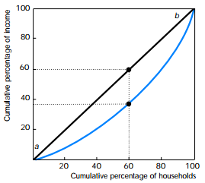

    - The straight line labeled ab is the
A) Lorenz curve.
B) line of equality.
C) line of poverty.
D) line of distribution
- The poorest 60 percent of households have what percent of the nation’s total income.
A)About 37 percent
B)About 60 percent
C)About 63 percent
D)Precisely 100 percent

- The Lorenz curve is a representation of
A) a perfectly equal distribution of income
B) a perfectly equal distribution of wealth
- the percentage of total income earned by each quintile of the population
D) the percentage of poor people in a country
- The farther away a Lorenz curve for income is from the line of equality, the
A)more equally wealth is distributed.
B)more equally income is distributed.
C)less equally income is distributed.
D)None of the above.

- If all households in a nation receive the same income, the nation’s Lorenz curve would
- be horizontal.
- be vertical.
- be a 45º line.
- run along the horizontal axis until it reached 50 percent of households, and then run vertically up to 100 percent of income.
- World Bank data show that in 1995, the poorest 20% of households accounted for 7.5% of household income in Niger, the next 20% of households accounted for 11.8% of income, the middle 20% accounted for 15.5% of income, the second richest 20% accounted for 21.1% of income, and the top 20% accounted for 44.1% of income. What was the cumulative income share of the bottom 60% of households in Niger?
- 15.5%
- 34.8%
- 48.1%
- 65.2%

- In country A the first three groups each have 10% of the national income, and the fourth group has the rest of it. In country B the groups have 15%, 20%, 30% and 35% of the national income respectively. Which society has a higher Gini coefficient?
- Society A.
- Society B.
- They are equally unequal.
- There is not enough information to decide.
- You would have to draw the Lorenz Curve to answer this question.

- The proportion of total income received by a particular group is called the group's:
- Market share.
- Income share.
- Gini coefficient.
- Functional distribution of income.

- Private Consumption function will certainly shift up if
- wealth decreases
- interest rates decrease
- interest rates increase and household wealth increases
- interest rates increase and consumer confidence about future strengthens

13) Suppose that the change in consumption is 40 TL and the change in disposable income is 50 TL. The slope of the consumption function would be _____ and marginal propensity to save would be _____, respectively.
- 0.7; 0.3
- 0.8; 0.8
- 0.8; 0.2
- 0.2; 0.8

14) Consumption function is C = 200 + 0.8*Y_{d}. The saving function is:
- S = 200 – 0.2*Y_{d}; where 200 is autonomous saving and -0.2 is MPS.
- S = – 200 – 0.2*Y_{d}; where – 200 is MPS and – 0.2 is autonomous saving.
- S = – 200 + 0.2*Y_{d}; where – 200 is dissaving and 0.2 is (1 – MPS).
- S = – 200 + 0.2*Y_{d}; where – 200 is dissaving and 0.2 is (1 – MPC).

15) If the slope of AE function became steeper, MP to Spend would become ____ and the multiplier would become_____.
- larger; smaller
- smaller; larger
- larger; larger
- smaller; smaller

