METU Department of Economics Fall 2024-2025
ECON 202

Instructor: Pınar Derin Güre
T.A: Pınar Özpala

Discussion Session 6 (Chapter 1-5)

PART A: LONG QUESTIONS

ESSAY QUESTIONS

- Consider a bond that promises to pay $100 in one year.
  - What is the interest rate on the bond if its price today is $75? $85? $95?
  - What is the relation between the price of the bond and the interest rate?
  - If the interest rate is 8%, what is the price of the bond today?

Solution:
        - i = 100/PB –1;
i = 33%; 18%; 5% when PB =$75; $85; $95.
        - When the bond price rises, the interest rate falls.
        - PB =100/(1.08) ≈ $93

- (All units are trillions of US$)

Money Demand: MD = $Y (0.2 – i)
Nominal Income: $Y = 2000
Money Supply: MS = 300
- Find MD for i= 10% and i=5%.
- What is the relationship between i and M^{D}.
- Graph M^{S} and M^{D} and calculate the equilibrium i.
- Alan Greenspan decreases M^{S} by 50. What happens to money market equilibrium? (Solve and graph.)
- Describe how the Fed changes I in the US.

Solution:

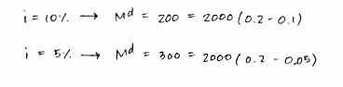
- Find MD for i= 10% and i=5%.

- What is the relationship between i and M^{D}.
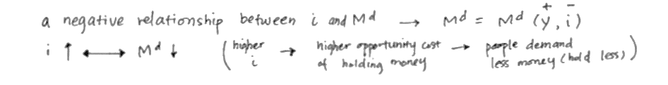
- Graph M^{S} and M^{D} and calculate the equilibrium i.
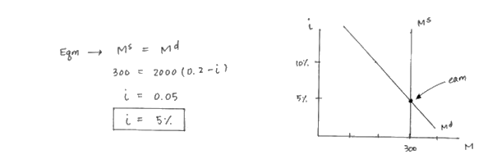
- Alan Greenspan decreases M^{S} by 50. What happens to money market equilibrium? (Solve and graph.)
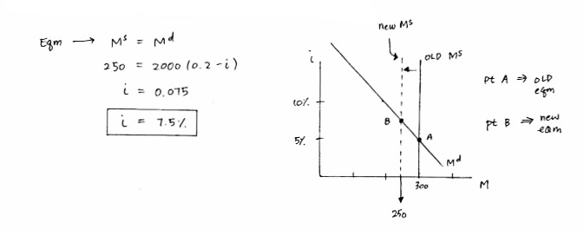
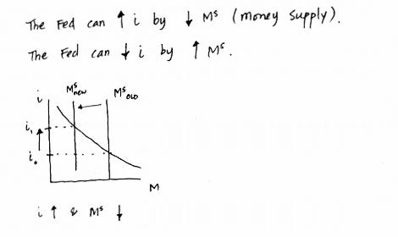
- Describe how the Fed changes I in the US.

- Use the IS-LM model to answer this question. Suppose there is a simultaneous increase in government spending and reduction in the money supply. Explain what effect this particular policy mix will have on output and the interest rate. Based on your analysis, do we know with certainty what effect this policy mix will have on investment? Explain.

In this case, the LM curve shifts up and the IS curve shifts to the right. The interest rate will clearly be higher. The effects on output depend on the relative magnitude of the two policies. The effects on I are also ambiguous. If output falls, I will be lower. However, it is possible that output will rise here which creates the ambiguity

- When the central bank pursues contractionary monetary policy, we that this policy will result in an increase in the interest rate, a reduction in investment, a reduction in demand, and a lower level of equilibrium output. Explain what happens to the position of the IS curve as the central bank pursues contractionary monetary policy.

Changes in the interest rate do cause changes in investment, demand, and output. However, they do not cause shifts of the IS curve. Changes in the interest rate cause movements along the IS curve.

- Suppose

$$C=1000+0.75Y_{d}$$
$$I =850$$
$$G=2500$$
$$T=1000$$

- Given the above variables, calculate the equilibrium output in the goods market. Secondly, illustrate the equilibrium output in a graph.
- Now assume that consumer confidence increases, resulting in an increase in autonomous consumption by 100 (c0 increases from 1000 to 1100). I) Find the new equilibrium output level using the concept of the multiplier. II) Explain why the change in output is larger than 100 (why is the multiplier larger than one intuitively?). III) Show the changes in an appropriate graph.
- What is the savings function? Explain the function intuitively by showing the marginal propensity to save and autonomous savings and mentioning what they mean.

Solution:

- Given the above variables, calculate the equilibrium output in the goods market. Secondly, illustrate the equilibrium output in a graph.

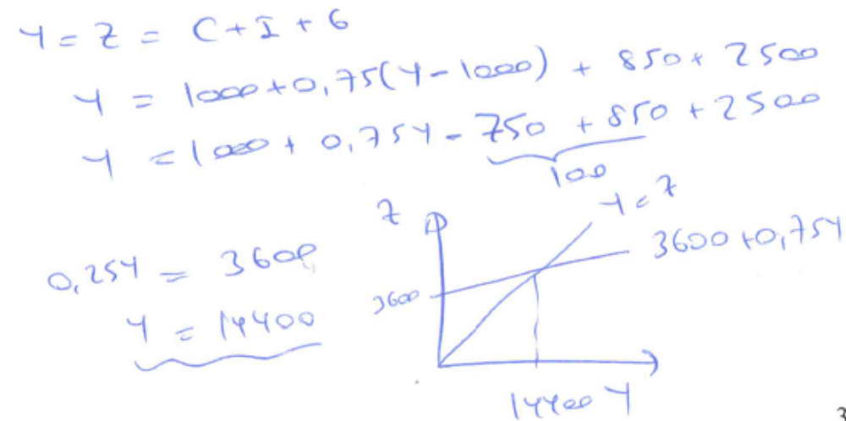

- Now assume that consumer confidence increases, resulting in an increase in autonomous consumption by 100 (c0 increases from 1000 to 1100). I) Find the new equilibrium output level using the concept of the multiplier. II) Explain why the change in output is larger than 100 (why is the multiplier larger than one intuitively?). III) Show the changes in an appropriate graph.

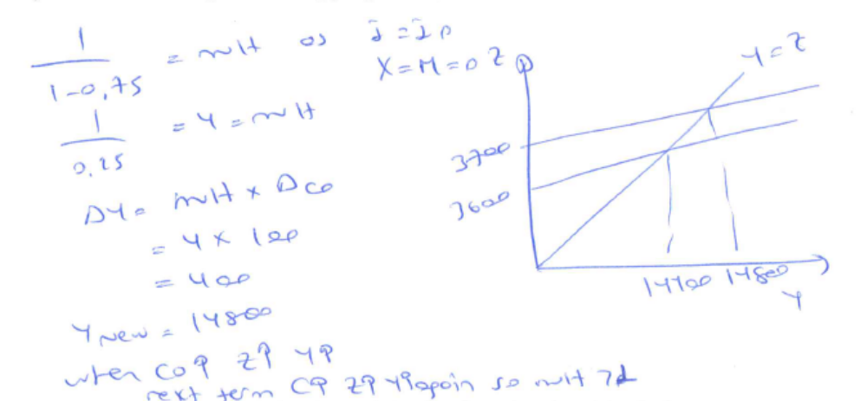

- What is the savings function? Explain the function intuitively by showing the marginal propensity to save and autonomous savings and mentioning what they mean.

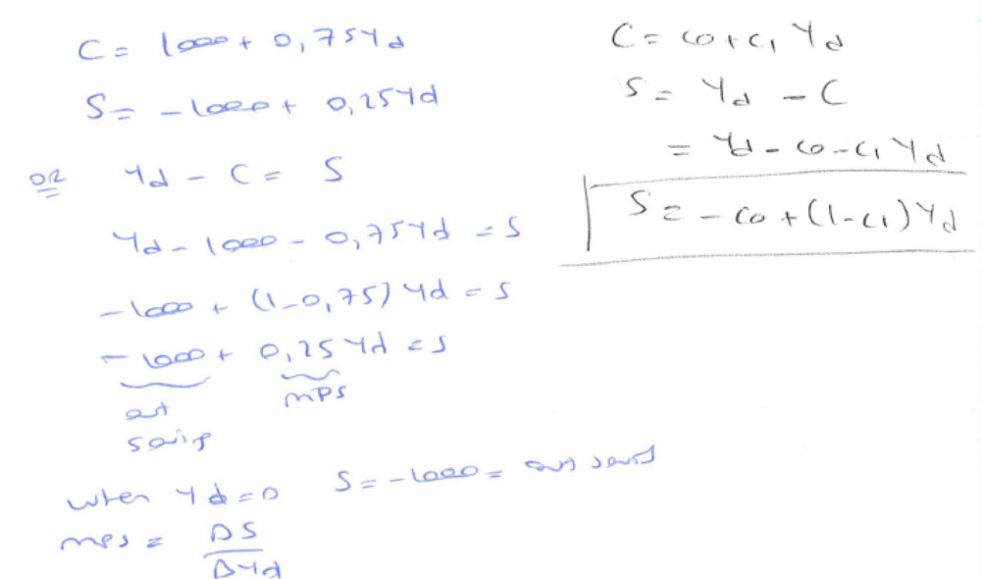

- After the global financial crises many economies would like to get rid of the negative impacts of the crises on output.

  - Explain which policy mix had been used after the crises.

  - Using the IS-LM graph show the impacts of these policies on output and interest rates, consumption and investment at the equilibrium.

  - Assume a country where the responsiveness of investments to interest rate changes is 0. (Investment doesn’t depend on the interest rate but only on output). Show on the graph and explain intuitively that the monetary policy implemented by the Central Bank would be ineffective (in terms of output) but fiscal policy would be totally effective (in terms of output).

Solution:

- Explain which policy mix had been used after the crises.

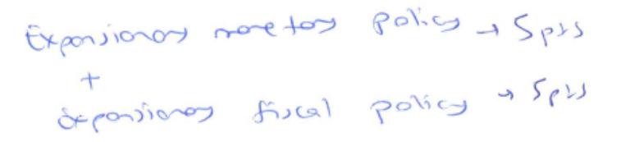

- Using the IS-LM graph show the impacts of these policies on output and interest rates, consumption and investment at the equilibrium.

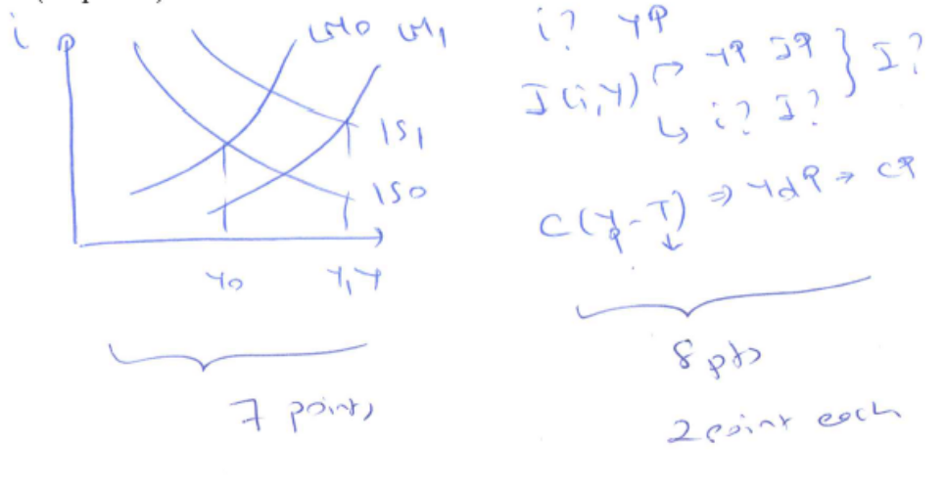
- Assume a country where the responsiveness of investments to interest rate changes is 0. (Investment doesn’t depend on the interest rate but only on output). Show on the graph and explain intuitively that the monetary policy implemented by the Central Bank would be ineffective (in terms of output) but fiscal policy would be totally effective (in terms of output).

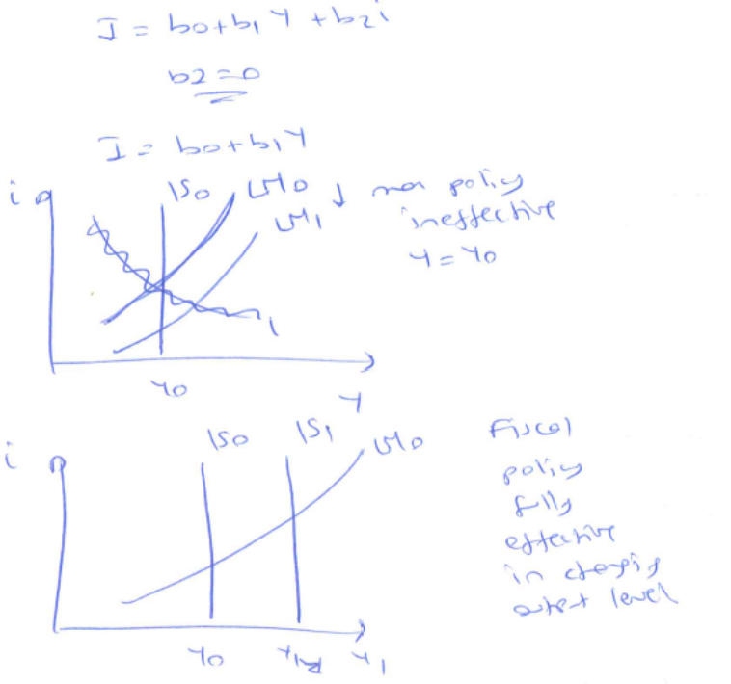

PART B: SHORT QUESTIONS
TRUE/FALSE/UNCERTAIN (Explain it.)

- Assume we have a fixed basket of 6 apples and 10 oranges. Base year = 1990. CPI in 2011 is 2, which means it is twice as expensive to buy the same bundle in 2011 compared to 1990.

TRUE
- Suppose that in an economy, imports, consumption, and investments depend positively on output. If that is the case, the tax multiplier will rise when the marginal propensity to import rises and when responsiveness of investment to output rises.

TRUE

- If inflation calculated by the Producer Price Index is much higher than the inflation calculated by the Consumer Price Index, we can forecast that inflation will fall in the future.

FALSE

PART B: MULTIPLE CHOICE
Choose the one alternative that best completes the statement or answers the question.

- Fiat money
- has no or very little value except as money.
- is rarely used in modern economies.
- functions well only if can be redeemed for gold or other precious metals.
- serves well as a medium of exchange, but not as a store of value.
- All of the above

- What is the yield to maturity on a $1,000 face value discount bond maturing in 1 year and selling for a price of $800?
- 0.2
- 0.25
- -0.2
- 0.4
- 0.5

- The Federal Reserve Bank is the U.S. central bank:
A) whose liabilities serve as cash in the United States.
B) whose assets serve as cash in the United States.
C) who holds, in reserve, all financial assets of banks.
D) who holds, in reserve, all financial liabilities of banks.

- Which of the following will cause a shift of the IS curve?
A) an increase in taxes
B) an increase in consumer confidence
C) an increase in government spending
D) all of the above
E) none of the above

- Which of the following is true for a given point on the LM curve?
A) No inventory investment equals zero.
B) The goods market is in equilibrium.
C) Production is equal to demand.
D) all of the above
E) none of the above

- Which of the following will cause a shift in the LM curve?
A) an open market purchase of bonds
B) an increase in output
C) a reduction in taxes
D) an increase in consumer confidence
E) all of the above

- Suppose the central bank decides to conduct an open market purchase of bonds. Which of the following will occur as a result of this monetary policy action?

A) The LM curve shifts down.
B) The LM curve shifts up.
C) The IS curve shifts leftward as the interest rate increases.
D) The IS curve shifts rightward as the interest rate falls.
E) none of the above

- Which of the following is the definition for the real supply of money?
A) the stock of money measured in terms of goods, not dollars
B) the ratio of the real GDP to the nominal money supply
C) the actual quantity of money, rather than the officially reported quantity
D) the stock of high powered money only
E) the real value of currency in circulation only

- A reduction in the money supply will cause a reduction in which of the following variables?
A) investment
B) output
C) consumption
D) all of the above
E) none of the above

- Suppose there is a fiscal contraction. Which of the following is a complete list of the variables that must decrease?
A) consumption, output and the interest rate
B) consumption
C) consumption, output and investment
D) consumption and investment

- For this question, assume that investment spending depends only on output and no longer depends on the interest rate. Given this information, an increase in government spending:
A) will have no effect on output.
B) will cause investment to decrease.
C) will cause an increase in output and have no effect on the interest rate.
D) will cause investment to increase.
E) may cause investment to increase or to decrease.

- We know with certainty that a tax increase must cause which of the following?
A) an increase in the interest rate and an ambiguous effect on investment
B) an increase in the interest rate and an upward shift in the LM curve
C) no change in output if the Fed simultaneously pursues expansionary monetary policy
D) an increase in the interest rate and a reduction in investment

- Assume that investment does NOT depend on the interest rate. A reduction in the money supply will cause which of the following for this economy?
A) no change in the interest rate
B) a reduction in investment
C) no change in output
D) an increase in investment

- An increase in the aggregate price level, P, will most likely have which of the following effects?
A) a rightward shift in the IS curve
B) a leftward shift in the IS curve
C) an upward shift in the LM curve
D) a downward shift in the LM curve

- The IS curve will NOT shift when which of the following occurs?
A) a reduction in the interest rate
B) a reduction in government spending
C) a reduction in consumer confidence
D) all of the above
E) none of the above

