METU Department of Economics
ECON102
Spring 2024
Sections 1&2
TA: Zeki Oğulcan Şengül
PROBLEM SET 5
- The money demand curve is given by M^{d} = 100-500i; where M^{d} is money demand and i is the interest rate. The money supply is at 60 TL. (TL is domestic currency)
- Calculate the equilibrium interest rate.
Ms = Md ; 60 = 100 – 500i => i* = 0.08 , equilibrium interest rate is 8 %
- At an interest rate of 10 %, calculate the level of money demand. Is there excess demand or excess supply of money?
If the interest rate is 10%; Md= 100-(500 × 0.1)= 50. Since money supply is 60 > 50; there is excess supply of money.
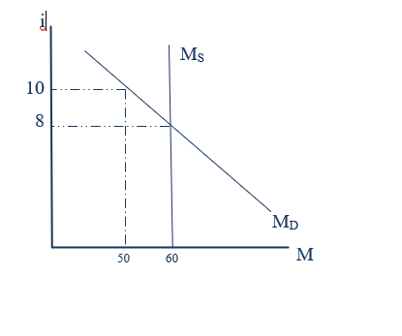
- If Central Bank increases money supply to 80 TL, what will be the new equilibrium interest rate? Explain adjustment and graphically demonstrate the effect on the equilibrium interest rate of an increase in the money supply by the CB.

Ms = Md ; 80 = 100 – 500i => i* = 0.04 , the new interest rate will be 4 %. When the Central Bank increases money supply to 80 TL, households and firms have more money than they want to hold at an interest rate of 8 percent. They are most likely to use the money to buy short-terms financial assets, such as Treasury bills, or to deposit the money in interest-paying bank accounts. This increase in demand for interest-paying bank accounts allows banks to offer lower interest rates on certificates of deposit, and it allows sellers of Treasury bills and similar assets to also offer lower interest rate. As interest rate falls, so does the opportunity cost of holding money, which increases the demand for money (more specifically there is a downward movement along the money demand curve). Interest rate keeps falling until money demand equals money supply and the new equilibrium is reached. In this case this happens when interest rate equals 4 %.

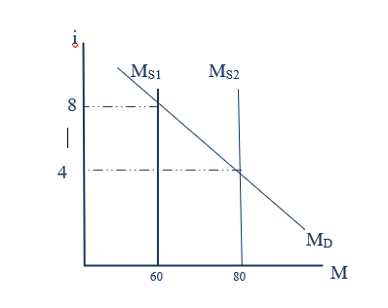
- Label each of the following events as either leading to an increase or a decrease in the equilibrium interest rate (i)? Explain why in each case.
- Decrease in the price level
Since it causes a decrease in the demand for money, i decreases.
- Increase in the discount rate
Since cost of borrowing of commercial banks increases, loans decrease and Ms decreases, i increases.
- Decrease in aggregate output
Since it causes a decrease in the demand for money, i decreases.
- Sale of government securities by the Central Bank
Since it reduces the supply of money, i increases.
- Illustrate the following situations using supply and demand curves for money.(Hint: Remember that the M_{d} curve is affected during a period of high inflation and recession)

- During a recession, the CB buys bonds in the open market.
MD curve shifts left due to the recession. MS curve shifts to the right due to CB’s buying bonds.
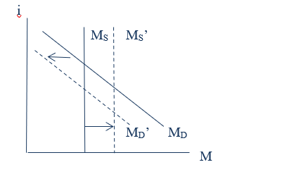
- During a period of rapid inflation, the CB increases the reserve requirement ratio.

M_{D} curve shifts right due to the rapid inflation. M_{S} curve shifts to the left due to the increase in reserve requirement ratio.
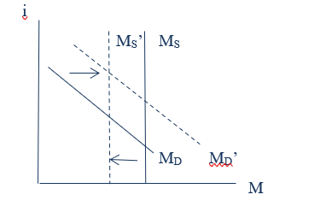
- During a period of high inflation, the CB acts to hold interest rates constant.

M_{D} curve shifts right due to the high period of inflation. M_{S} curve shifts right due to the CB’s policy.
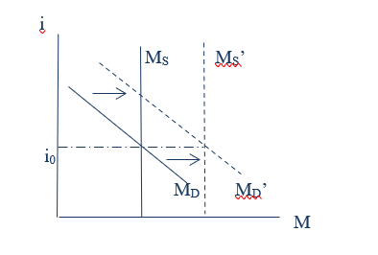
- During a period of no growth of GDP and zero inflation, the CB lowers the discount rate.
MS curve shifts right due to the CB’s policy.

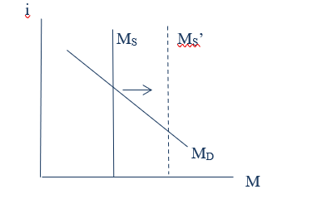
- During a period of rapid growth of real GDP, the CB acts to increase the reserve requirement.

MD curve shifts right due to the rapid growth of GDP. MS curve shifts to the left due to the increase in reserve requirement ratio.

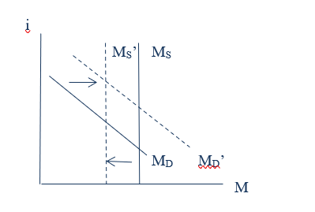

- Fill in the following table by indicating whether the proposed Central Bank action will increase or decrease the money supply. If it cannot be a Central Bank action, then write not applicable.
Action | Effect on money supply
A decrease in government spending | not applicable
A decrease in the required reserve ratio | Increases
A sale of government securities | Decreases
A lowering of the discount rate | Increases
Buying government securities | Increases
A decrease in taxes | not applicable

- Suppose that a commercial bank, Best Bank NA, has the following balance sheet:

Assets Liabilities
Reserves $1000 Checkable Deposits $10000
Loans $9000
Total Assets $10000 Total Liabilities $10000
Assume that the legal reserve requirement ratio is 10%; therefore, the bank does comply with the requirement. Now suppose that there is extra $1000 deposited to the bank.

- Describe a couple of stages of the money creation process. (Assume that Best Bank NA is the only bank that’s participating in the process.) Use balance sheets.
Initilally, the extra money that deposited to the bank is taken place on reserves and deposits.

Assets Liabilities
Reserves $2000 Checkable Deposits $11000
Loans $9000
Total Assets $11000 Total Liabilities $11000
The main reason is that, since the bank cannot give money as a loan simultaneously, it will store all of the amount on the reserves. In this stage, it is seen that there is excess reserve and bank does not want to hold excess reserve. Then, final situation will be like that,

Assets Liabilities
Reserves $2000 Checkable Deposits $20000
Loans $18000
Total Assets $20000 Total Liabilities $20000

- What is the value of the money multiplier?

$$k_{m}=\frac{1}{r}=\frac{1}{0.1}=10$$
- Now suppose that instead of depositing new money, one of the customers withdrawn $500 of her money from the bank. Conduct the same process

Initially

Assets Liabilities
Reserves $500 Checkable Deposits $9500
Loans $9000
Total Assets $9500 Total Liabilities $9500

Final:
Assets Liabilities
Reserves $500 Checkable Deposits $5000
Loans $4500
Total Assets $5000 Total Liabilities $5000

- Suppose that, we have such information in the money market

Checkable Deposits: D^{d} = $900 Billion
Total Money Supply : M^{s}= $1800 Billion
Reserve Requirement Ratio : r= 0.2

- Find C^{d} and Rd and monetary base H^{d} in the equilibrium

In the equilibrium, money supply equals to money demand,
M^{s}= C^{d} + D^{d}

1800= C^{d} + 900

C^{d} = 900

R^{d}= r* D^{d} = 0.2*900=180 Billion

H^{d}= C^{d}+ R^{d}= 900+180 =1080 Billion

- What is money multiplier? How do we calculate it?

$$Money Multiplier=\frac{Change in Total Money Supply }{Change in Monetary Base}$$

$$=\frac{1800}{1080}=1.67$$
- Describe the ways that Fed can increase money supply

It can either
Decrease policy rate
Decrease reserve requirement ratio
Conduct open market purchase

- If Fed wants money supply to decrease by 500 million , how would the monetary base change?

As is seen from the second part, the money multiplier is 1.67
$$1.67=\frac{500}{x}$$
then the x = 500/1.67 = 299.4 (300 approximately)

The monetary base should decrease by 300. That is, central bank sells 300 million worth of bonds to the public and take currency instead of it.

- Suppose a commercial bank has the following assets and liabilities:

Loans | $50000
Property | $300000
Reserves | $20000
Securities | $30000
Stock Share | $320000
- Construct the balance sheet of the bank and find the checkable deposits of the bank.

Commercial Bank (initial situation)
Assets |  | Liabilities
Reserves | 20.000 | Deposits | 80.000
Loans  Property  Securities | 50.000  300.000  30.000 | Stock Share | 320.000

Total Assets: 400.000
According to the general logic of the balance sheet, sum of the assets and liabilities should be equal. Thus, Deposits are 400.000-320.000 =80.000

- If the bank does not hold excess reserves, what is the required reserve ratio ?

$$r= \frac{R}{D}= \frac{20.000}{80.000}=0.25$$

- Suppose a person who was keeping $2000 of his banknotes at home deposits, decides to keep them at the commercial bank. Calculate the amount of new money created, change in deposits, change in currency in circulation, and change in the money supply as a consequence of this new deposit of $2000.

2000 ∗ 0. 25 = 500 − Required Reserves
2000 − 500 = 1500 − Excess Reserves

New Money (deposit) Creation = (1/r) x Excess Reserves = 4 ∗ 1500 = 6000
Change in Deposits = Initial increase in Deposits + Created Deposits
= 2000 + 6000 = 8000

Δ in currency in circulation = − 2000
Δ in money supply = Δ in deposits (new deposit) +
Δ in currency in circulation = 8000 – 2000 = 6000

- Return to the information at the beginning of the question and the
balance sheet of the bank in part (i). If required reserve ratio is 20%, calculate the amount of excess reserves and excess reserve ratio of the bank.

80000x20% = 16000

20000 − 16000 = 4000 Excess Reserves

4000/80000 = 5%

- (PAST EXAM QUESTION) You are given the following information about a hypothetical economy.
The money demand function is
M_{d} = 10.000 – 10.000 i + P.Y where Md is money demand, i is the interest rate, P is the price level and Y is national income. The current price level is 1 and national income is 5000. The Central Bank set the money supply at 12 500.

a. (2) The equilibrium interest rate, i is ___0.25___.

The equilibrium interest rate is the situation where money demand equals to money supply, that is 10.000 – 10.000 i + 1*5000= 12500 and i= 0.25

b. (2) Roughly draw the money market for this economy to show the equilibrium values you found in (a). Do not forget to label the axes.

0.025

Assume in this economy there is only one monopoly bank, HÜPBANK. The bank holds no excess reserves and there is no cash drain from the system. The bank’s only liabilities are
10 000 TL. Demand Deposits. The bank currently meets its reserve requirements where reserve requirement ratio is 20 percent. Assuming that its only assets are reserves and loans,
c. (2) Draw the bank’s balance sheet.
HÜPBANK
A L
Reserves:2000 Deposits: 10.000
Loans: 8000

d. (4) Assume there is an open market sale of 1000 TL. to Mr. X who pays from his deposit account at HÜPBANK. Show the initial and final balance sheets of HÜPBANK.

Initial: Final:

A L A L
Reserves 1000 Deposits 9000 Reserves 1000 Deposits 5000
Loans 8000 Loans 4000

e. (4) As a result of the open market sale, the new level of money stock is __7500___ and the equilibrium interest rate, i is: ___0.75______ .

7500= 1500-1000i
i = 0.75

f.(4) Open market sale is an example of contractionary(expansionary/ contractionary) monetary_(fiscal / monetary) policy. Name and indicate direction of other tools of this policy to have the same effect.

PART B: MULTIPLE CHOICE
- Which of the following cannot be one of the monetary goals of the Central Bank?
- High Employment
- Price Stability
- Maintaining balanced budget
- Stability of financial markets
- The demand for money curve is downward sloping; because,
- it is more attractive to hold money at high interest rates than at low interest rates.
- the opportunity cost of holding money declines as the interest rate rises.
- the opportunity cost of holding money rises as the interest rate rises.
- bond prices rise as interest rate rise.

- The demand for money depends on all of the following except;
- inflation such that a rise in the price level, causes the demand for money to increase.
- income such that an increase in Y causes the demand for money to increase.
- money supply such that an increase in money supply causes the demand for money to increase
- interest rate such that the higher the interest rate the less money people will want to hold.
- All of the following are means of contractionary monetary policy except;
- raising the reserve requirement
- raising the discount rate
- open market sales by the Central Bank
- purchase of securities by the Central Bank
- If money supply exceeds the quantity of money demanded, the interest rate will:
- fall, leading the people to hold less money.
- rise, leading the people to hold less money.
- rise, leading the people to hold more money.
- fall, leading the people to hold more money.
- Suppose the money market is in equilibrium and the Central Bank buys securities. There will be excess _________ money. This will cause the interest rate to _________.
  - demand for; fall
- supply of ; rise
- demand for ; rise
- supply of; fall
- If the combination of shifts in demand for and supply of money leads to a reduction in the interest rate, we conclude that,
- money supply fell by less than money demand
- money supply fell by more than money demand
- money supply fell by the same proportion as money demand
- none of the above

Answer the following three questions according to the graph given below:
100
200
300
M^{d}
M^{s}₀
M^{s}₁
4
5
6

- If equilibrium interest rate is 5%, there is
- a $100 billion excess demand for money if money supply is represented by M^{s}₀
- a $100 billion surplus if money supply is represented by M^{s}₁
- a $100 billion excess demand for money if money supply is represented by M^{s}₁
- a $100 billion surplus if money supply is represented by M^{s}₀

- Which of the following is true?
  - At 5% interest rate, a $100 billion increase in money supply lowers interest rate by 1 point
  - At 6% interest rate, there is a shortage of money
  - At 5% interest rate, there is a shortage of money if money supply is represented by M^{s}₀
  - At 4% interest rate, there is a surplus of money if money supply is represented by M^{s}₁
- Suppose that equilibrium interest rate is 5%. Which would make it rise to 6%?
- The Central Bank sells government securities
- An increase in the GDP
- An increase in the discount rate
- All of them
- If the Fed believes the economy is about to fall into recession, what action could it conduct?
- Decrease Money Supply
- Contractionary monetary policy
- Expansionary monetary policy
- Increase the interest rate
- Which of the following sequence of events follows an expansionary monetary policy?
- r ↑→I↓ →AE↓→ Y↓
- r ↑→I↑ →AE↓→ Y↑
- r ↓→I↑ →AE↑→ Y↑
- r ↓→I↓ →AE↓→ Y↓
- Which of the following can be an aim of contractionary monetary policy?
- Increasing the real GDP that is below the potential GDP
- Reducing the government expenditures.
- Maintaining price stability
- Decreasing the interest rate.
- Which of the following sequence of events by central bank follows an contractionary monetary policy ?
- Selling government bonds to the market
- Decrease in reserve requirement ratio
- Decreasing the policy rate
- Buying treasury from the public

- Increased investment spending in the economy would be a possible result of:
  - an increase in interest rates
  - an open market purchase of bonds by the Central Bank
  - an open market sale of bonds by the Central Bank
- a decrease in the money supply.

- If CB prints money there will be a(an) ________in the money supply and a(an) _______in the liquidity preference, leading to a(an) _______ in interest rates and a(an) _______ in investment that leads to a(an) _____ shift in AE. This whole mechanism is called as the ____________.
  - decrease / no change / increase / increase / upward / transmission mechanism.
  - increase / increase / increase / decrease /downward / adjustment mechanism.
  - decrease / decrease / increase / increase /upward / adjustment mechanism.
  - increase / no change / fall / increase / upward / transmission mechanism
- If the combination of shifts in demand for and supply of money leads to a increase in the interest rate, we conclude that, (typo in questions file)
  - money supply fell by less than money demand
  - money supply fell by more than money demand
  - money supply fell by the same proportion as money demand
  - none of the above
- As the price level increases, the quantity of money demanded
- increases and thus quantity of aggregate demanded goods and services increases.
- increases and thus quantity of aggregate demanded goods and services decreases.
- decreases and thus quantity of aggregate demanded goods and services decreases.
- decreases and thus quantity of aggregate demanded goods and services increases.
- When economists say that money serves as a medium of exchange, they mean that it is:
- a way to keep wealth in a readily spendable form for future use.
- a means of payment.
- a monetary unit for measuring and comparing the relative values of goods.
- declared as legal tender by the government.

- In defining money as M1, economists exclude time deposits because:
- the intrinsic value of time deposits is nil.
- the purchasing power of time deposits is much less stable than that of checkable deposits and currency.
- they are not directly or immediately a medium of exchange.
- they are not recognized by the federal government as legal tender.

- Which of the following is not part of the M2 money supply?
- Money market mutual fund balances.
- Money market deposit accounts.
- Currency.
- Large-denominated time deposits.

- The largest component of the money supply (M1) is:
- currency in bank vaults.
- currency in circulation.
- checkable deposits.
- stock certificates.

- Assume there is no leakage from the banking system and that all commercial banks are loaned up. The required reserve ratio is 20%. If the Central Bank sells $10 million worth of government securities to the public, the change in the money supply will be
- -$50 million.
- -$20 million.
- $20 million.
- $50 million.

- Open market operations change:
- The money multiplier, but do not affect commercial bank reserves.
- Neither the money multiplier nor the commercial bank reserves.
- Both the money multiplier and the commercial bank reserves.
- The commercial bank reserves, but do not affect the money multiplier

- When Mexico experiences a period of high inflation and Mexicans lose confidence in their peso as a store of value, which of the following would be most likely to occur?
- The demand for pesos would increases.
- The buying power of the peso would increase
- The value of foreign currencies would depreciate relative to peso.
- Mexicans would use a different currency as a medium of exchange.

- The main advantage of using M2 instead of M1 as the measure for money is that
- M2 can be measured more accurately
- M2 includes only readily spendable assets
- M2 is sometimes more stable
- M2 varies at the interest rate varies.

- The Bank of Texas has $1 million in deposits and $200,000 in reserves. If excess reserves are equal to $150,000, the required reserve ratio is:
a. 15% b. 10% c. 8% d. 5%
Refer to the information provided in Scenerio 1 below to answer the questions that follow:
Scenario 1: The following table shows the changes in deposits, reserves, and loans of 4 banks as a result of a $100,000 initial deposit in Bank No.1. Assume all banks are loaned up.

 | New Deposit | Required Reserve | Loans
Bank No.1 | $100,000 | $5,000 | $95,000
Bank No.2 | $95,000 | $4,750 | $90,250
Bank No.3 | $90,250 | $4,512.5 | $85,737
Bank No.4 | $85,737.5 | $4,286.9 | $81,450.63

- Refer to Scenario 1. What is the required reserve ratio?
  - 4%
  - 5%
  - 8%
  - 10%

- Refer to Scenario 1. What is the money multiplier in this economy.
  - 20
  - 10
  - 50
  - 16.67

- Refer to Scenario 1. How much money will be created out of the initial $100,000 deposit?
  - $1 million
  - $ 2 million
  - $50 million
  - $16.67 million

- Refer to Scenario 1. If the required reserve ratio were changed to 12%, total loans of Bank No. 2 will change to
  - 87,550
  - 65,500
  - 75, 490
  - 77, 440

- If a person withdraws $500 from his/her savings account and puts it in his/her
checking account, then M1 will ________ and M2 will ________.
- increase; decrease
- increase; not change
- not change; increase
- not change; decrease

- Banks can make additional loans when required reserves are
- greater than total reserves.
- less than total reserves.
- less than total deposits.
- less than total loans.

Please answer the next four questions referring to the scenario below.

Imagine that Carmen deposits $10,000 of currency into her checking account deposit at
Bank A and that the required reserve ratio is 20%.

- As a result of Carmen’s deposit, Bank A's reserves immediately increase by
- $2,000.
- $8,000.
- $10,000.
- $50,000.
- As a result of Carmen's deposit, at the end , Bank A's reserves increase by
- $2,000.
- $8,000.
- $10,000.
- $50,000.
- As a result of Carmen's deposit, at the end, Bank A's deposits increase by
- $2,000.
- $8,000.
- $10,000.
- $50,000.
- As a result of Carmen's deposit, at the end, Bank A can make a maximum loan of
- $2,000.
- $8,000.
- $40,000.
- $50,000.
- As a result of Carmen’s deposit, Bank A's excess reserves immediately increase by
- $2,000.
- $8,000.
- $10,000.
- $50,000

