METU Department of Economics Fall 2024-2025
ECON 202

Instructor: Pınar Derin Güre
T.A: Pınar Özpala

Discussion Session 6 (Chapter 1-5)
PART A: LONG QUESTIONS

- Suppose that a person’s wealth is $50,000 and that her yearly income is $60,000. Also suppose that her money demand function is given by
M^{d} = Y(0.35 – i)

  - Derive the demand for bonds. Suppose the interest rate increases by 10 percentage points. What is the effect on her demand for bonds?
  - What are the effects of an increase in wealth on her demand for money and her demand for bonds? Explain in words.
  - What are the effects of an increase in income on her demand for money and her demand for bonds? Explain in words.
  - Consider the statement “When people earn more money, they obviously will hold more bonds.” What is wrong with this statement?

Solution:
- BD = 50,000 – 60,000 (.35 – i)
If the interest rate increases by 10 percentage points, bond demand increases by $6,000.
- An increase in wealth increases bond demand, but has no effect on money demand, which depends on income (a proxy for transactions demand).
- An increase in income increases money demand, but decreases bond demand, since we implicitly hold wealth constant.
- First of all, the use of “money” in this statement is colloquial. “Income” should be substituted for “money.” Second, when people earn more income, their wealth does not change right away. Thus, they increase their demand for money and decrease their demand for bonds.

- After the Global Economic Crises in 2008-2009 most of the world economies pursued an expansionary fiscal policy (governments decreased the tax rates and increased the government expenditures) and the Central banks used expansionary monetary policies (they cut the interest rates). Using the IS-LM model talk about the effect of this policy mix on the equilibrium output level and the interest rates. Do these policies make sense considering the recessions of the world economies?

After the Global Economic Crisis in 2008-2009, most of the world economies pursued expansionary monetary policy and expansionary fiscal policy to steer out of the recession. Expansionary monetary policy shifts the LM curve to the right, represented as the LM2 curve on the graph. Expansionary fiscal policy shifts the IS curve to the right, represented as the IS2 curve. When both policies are applied, output increases from Y1 to Y2. However, the effect of these policies on the interest rate is ambiguous. If the shift in IS is stronger than the shift in LM, the equilibrium interest rate will increase, and vice versa. It may even remain unchanged if both shifts are equal. These policies make sense because output certainly increases, and when they work together, they eliminate the risk of crowding out caused by expansionary fiscal policy and the risk of a liquidity trap caused by expansionary monetary policy.
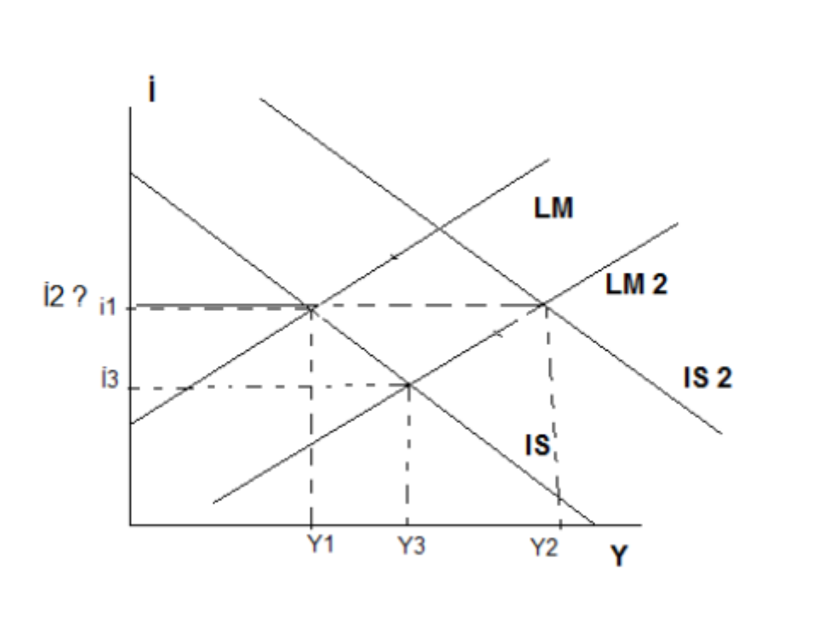
- Suppose the Turkish economy is represented by the following equations:
$$Z=400-10i+Y$$
$$M^{d}=400-\left(\frac{1}{4}\right)Y-15i$$
$$M^{s}=1200$$
$$P=2$$
Where:
- $Z$ is demand for domestic goods,
- $M^{d}$is real money demand,
- $M^{s}$is nominal money supply,
- $P$ is the general price level.

- Derive the IS equation and explain what it means intuitively.

- Calculate the output level that makes the goods market at equilibrium when $i=10\%$ (take $i$ as 10 in your calculations, not 0.1) and show it on a graph.

- When $i=10$ (take $i$ as 10 in your calculations, not 0.1) and $Y=1240$, what kind of disequilibrium do we find in the goods market?

- Calculate the LM equation.

- Calculate the equilibrium output and the interest rate.

- What would be the impact of a monetary expansion on output and interest rates when the investment is totally unresponsive to changes in the interest rates? Show your answer on a graph.
Solution:
- Derive the IS equation and explain what it means intuitively.

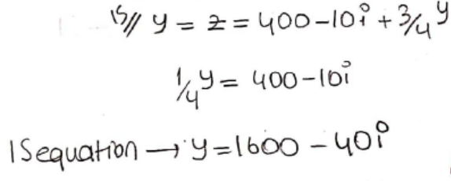

- Calculate the output level that makes the goods market at equilibrium when $i=10\%$ (take $i$ as 10 in your calculations, not 0.1) and show it on a graph.

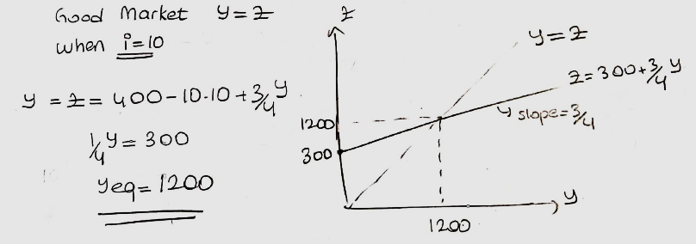

- When $i=10$ (take $i$ as 10 in your calculations, not 0.1) and $Y=1240$, what kind of disequilibrium do we find in the goods market?

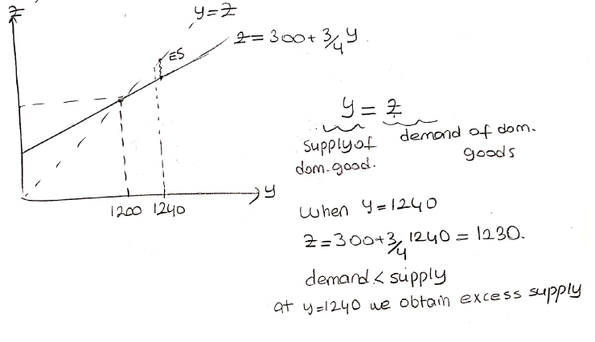

- Calculate the LM equation.

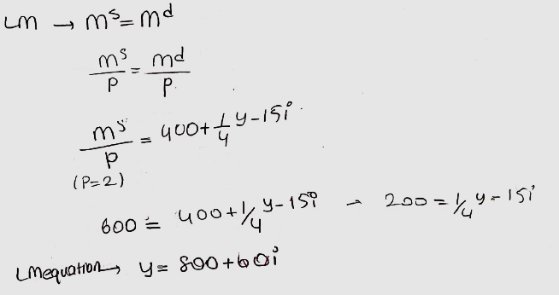

- Calculate the equilibrium output and the interest rate.

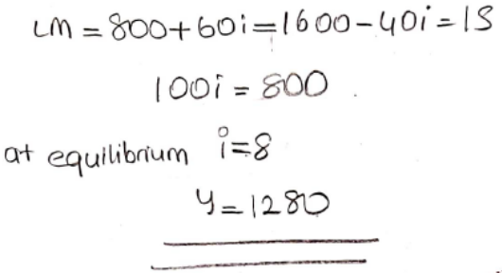
- What would be the impact of a monetary expansion on output and interest rates when the investment is totally unresponsive to changes in the interest rates? Show your answer on a graph.

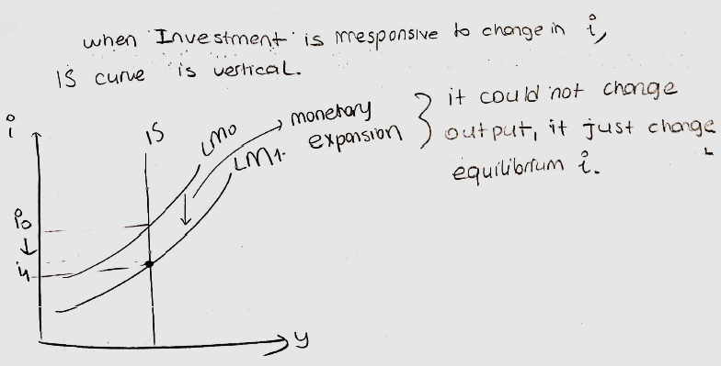

- Consider an economy with no government, imports, or exports, and with fixed prices and interest rates. Let C = 150 + 0.60Y and I = 50.
  - What is the equilibrium output?
  - What is the value of the marginal propensity to consume?
  - What is the value of the multiplier?
  - Suppose planned investment rises by 10 to I = 60. Calculate the new equilibrium output in two ways. First, calculate the new equilibrium output using the multiplier from (c). Second, calculate the new equilibrium output using the same procedure as you did for (a), but with I = 60 instead of I = 50. Your answer should be the same under both methods.
i. Using the multiplier, we simply multiply the increase in investment by the value of the multiplier to find the increase in output:
ii. By the procedure from (a) we have:

Solutions:
  - What is the equilibrium output?

Equilibrium output occurs where aggregate expenditure (C + I) equals aggregate output (Y).
That is, C + I = Y
=> (150 + 0.6Y) + 50 = Y
=> 200 + 0.6Y = Y
=> 200 = 0.4Y
=> 500 = Y
Therefore, equilibrium output equals 500.

  - What is the value of the marginal propensity to consume?

The marginal propensity to consume (MPC) is the fraction of an increase in income that is consumed. In this economy, the MPC is 0.6.

  - What is the value of the multiplier?

The multiplier is the factor by which equilibrium output changes in response to a change in an autonomous variable (such as investment). It is calculated as follows:
Multiplier = 1 / (1 - MPC) = 1 / (1 - 0.6) = 2.5

  - Suppose planned investment rises by 10 to I = 60. Calculate the new equilibrium output in two ways. First, calculate the new equilibrium output using the multiplier from (c). Second, calculate the new equilibrium output using the same procedure as you did for (a), but with I = 60 instead of I = 50. Your answer should be the same under both methods.

i. Using the multiplier, we simply multiply the increase in investment by the value of the multiplier to find the increase in output:
(change in investment) x (multiplier) = change in output
=> 10 x 2.5 = 25
Therefore, equilibrium output is now 525.

ii. By the procedure from (a) we have:

C + I = Y
=> (150 + 0.6Y) + 60 = Y
(Notice that I is now 60, not 50.)
=> 210 + 0.6Y = Y
=> 210 = 0.4Y
=> 525 = Y
Therefore, equilibrium output now equals 525.

PART B: SHORT QUESTIONS
TRUE/FALSE/UNCERTAIN (Explain it.)

- Assume we have a fixed basket of 6 apples and 10 oranges. Base year = 1990. CPI in 2011 is 2, which means it is twice as expensive to buy the same bundle in 2011 compared to 1990.

TRUE

- Suppose that in an economy, imports, consumption, and investments depend positively on output. If that is the case, the tax multiplier will rise when the marginal propensity to import rises and when responsiveness of investment to output rises.

TRUE

- If inflation calculated by the Producer Price Index is much higher than the inflation calculated by the Consumer Price Index, we can forecast that inflation will fall in the future.

FALSE

PART B: MULTIPLE CHOICE
Choose the one alternative that best completes the statement or answers the question.

- Fiat money
- has no or very little value except as money.
- is rarely used in modern economies.
- functions well only if can be redeemed for gold or other precious metals.
- serves well as a medium of exchange, but not as a store of value.
- All of the above

- What is the yield to maturity on a $1,000 face value discount bond maturing in 1 year and selling for a price of $800?
- 0.2
- 0.25
- -0.2
- 0.4
- 0.5

- The Federal Reserve Bank is the U.S. central bank:
A) whose liabilities serve as cash in the United States.
B) whose assets serve as cash in the United States.
C) who holds, in reserve, all financial assets of banks.
D) who holds, in reserve, all financial liabilities of banks.

- Which of the following will cause a shift of the IS curve?
A) an increase in taxes
B) an increase in consumer confidence
C) an increase in government spending
D) all of the above
E) none of the above

- Which of the following is true for a given point on the LM curve?
A) No inventory investment equals zero.
B) The goods market is in equilibrium.
C) Production is equal to demand.
D) all of the above
E) none of the above

- Which of the following will cause a shift in the LM curve?
A) an open market purchase of bonds
B) an increase in output
C) a reduction in taxes
D) an increase in consumer confidence
E) all of the above

- Suppose the central bank decides to conduct an open market purchase of bonds. Which of the following will occur as a result of this monetary policy action?

A) The LM curve shifts down.
B) The LM curve shifts up.
C) The IS curve shifts leftward as the interest rate increases.
D) The IS curve shifts rightward as the interest rate falls.
E) none of the above

- Which of the following is the definition for the real supply of money?
A) the stock of money measured in terms of goods, not dollars
B) the ratio of the real GDP to the nominal money supply
C) the actual quantity of money, rather than the officially reported quantity
D) the stock of high powered money only
E) the real value of currency in circulation only

- A reduction in the money supply will cause a reduction in which of the following variables?
A) investment
B) output
C) consumption
D) all of the above
E) none of the above

- Suppose there is a fiscal contraction. Which of the following is a complete list of the variables that must decrease?
A) consumption, output and the interest rate
B) consumption
C) consumption, output and investment
D) consumption and investment

- For this question, assume that investment spending depends only on output and no longer depends on the interest rate. Given this information, an increase in government spending:
A) will have no effect on output.
B) will cause investment to decrease.
C) will cause an increase in output and have no effect on the interest rate.
D) will cause investment to increase.
E) may cause investment to increase or to decrease.

- We know with certainty that a tax increase must cause which of the following?
A) an increase in the interest rate and an ambiguous effect on investment
B) an increase in the interest rate and an upward shift in the LM curve
C) no change in output if the Fed simultaneously pursues expansionary monetary policy
D) an increase in the interest rate and a reduction in investment

- Assume that investment does NOT depend on the interest rate. A reduction in the money supply will cause which of the following for this economy?
A) no change in the interest rate
B) a reduction in investment
C) no change in output
D) an increase in investment

- An increase in the aggregate price level, P, will most likely have which of the following effects?
A) a rightward shift in the IS curve
B) a leftward shift in the IS curve
C) an upward shift in the LM curve
D) a downward shift in the LM curve

- The IS curve will NOT shift when which of the following occurs?
A) a reduction in the interest rate
B) a reduction in government spending
C) a reduction in consumer confidence
D) all of the above
E) none of the above

