- Two cards from an ordinary deck of 52 cards are missing. What is the probability that a random card drawn from this deck is a spade?

Let E be the event that the randomly drawn card is a spade. Let F_{i} be the event that i spades are missing from the 50-card (defective) deck, for i = 0,1,2
We want P(E), which we compute by conditioning on how many spades are missing from the original (good) deck:

$$P\left(E\right)=P\left(E | F_{0}\right)P\left(F_{0}\right)+P\left(E | F_{1}\right)P\left(F_{1}\right)+P\left(E | F_{2}\right)P\left(F_{2}\right)$$

$$=\frac{13}{50}×\frac{\left(\begin{matrix}13 \\ 0\end{matrix}\right)\left(\begin{matrix}39 \\ 2\end{matrix}\right)}{\left(\begin{matrix}52 \\ 2\end{matrix}\right)}+\frac{12}{50}\frac{\left(\begin{matrix}13 \\ 1\end{matrix}\right)\left(\begin{matrix}39 \\ 1\end{matrix}\right)}{\left(\begin{matrix}52 \\ 2\end{matrix}\right)}+\frac{11}{50}\frac{\left(\begin{matrix}13 \\ 2\end{matrix}\right)\left(\begin{matrix}39 \\ 0\end{matrix}\right)}{\left(\begin{matrix}52 \\ 2\end{matrix}\right)}=\frac{1}{4}$$

- Suppose that Bob can decide to go to work by one of three modes of transportation, car, bus, or commuter train. Because of high traffic, if he decides to go by car, there is a 50% chance he will be late. If he goes by bus, which has special reserved lanes but is sometimes overcrowded, the probability of being late is only 20%. The commuter train is almost never late, with a probability of only 1%, but is more expensive than the bus.

- Suppose that Bob is late one day, and his boss wishes to estimate the probability that he drove to work that day by car. Since he does not know which mode of transportation Bob usually uses, he gives a prior probability of $1/3$to each of the three possibilities. What is the boss’ estimate of the probability that Bob drove to work?

- Suppose that a coworker of Bob’s knows that he almost always takes the commuter train to work, never takes the bus, but sometimes, 10% of the time takes the car. What is the coworker’s probability that Bob drove to work that day, given that he was late?

- BAYES’ THM

We have the following information given in the problem:
P r{ bus } = P r{ car } = P r{ train } = 1/3
P r{ late | car } = 0.5
P r{ late | train } = 0.01
P r{ late | bus } = 0.2

We want to calculate P r{ car | late }.
By Bayes Theorem, this is
$$\operatorname{Pr}\left\{car\right|late\} =\frac{P r\{ late | car \}P r\{ car \}}{P r\{ late | car \}P r\{ car \} + P r\{ late | bus \}P r\{ bus \} + P r\{ late | train \}P r\{ train \}}=\frac{0.5 × 1/3}{0.5 × 1/3 + 0.2 × 1/3 + 0.01 × 1/3}=0.7042$$

- Repeat the identical calculations as the above, but instead of the prior probabilities being 1/3, we use P r{ bus} = 0, P r{car} = 0.1, and P r{ train } =0.9. Plugging in to the same equation with these three changes, we get P r{ car | late } = 0.8475

- The telephone lines serving an airline reservation office are all busy about 60% of the time.
- If you are calling this office, what is the probability that you will complete your call on the first try? The second try? The third try?
- If you and a friend must both complete calls to this office, what is the probability that a total of four tries will be necessary for both of you to get through, assuming call attempts are independent?

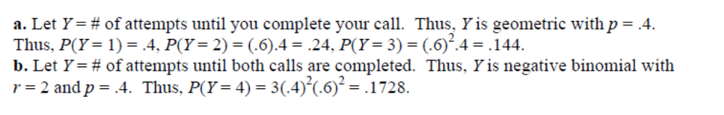
- Suppose that Y is a random variable with moment-generating function m(t).
- What is m(0)?
- If W = 3Y, show that the moment-generating function of W is m(3t).
- If X = Y − 2, show that the moment-generating function of X is e^{−2t}m(t).

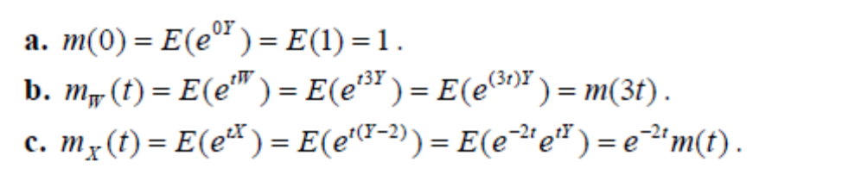
5) Would you rather take a multiple-choice test or a full-recall test? If you have absolutely no knowledge of the test material, you will score zero on a full-recall test. However, if you are given 5 choices for each multiple-choice question, you have at least one chance in five of guessing each correct answer! Suppose that a multiple-choice exam contains 100 questions, each with 5 possible answers, and guess the answer to each of the questions.
- What is the expected value of the number Y of questions that will be correctly answered?
- Find the standard deviation of Y.
- Calculate the intervals μ± 2σ and μ± 3σ.
- If the results of the exam are curved so that 50 correct answers is a passing score, are you likely to receive a passing score? Explain.

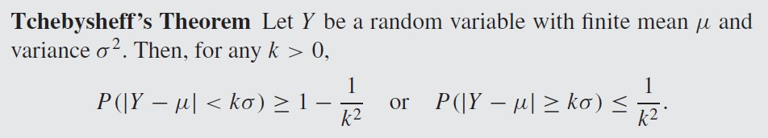

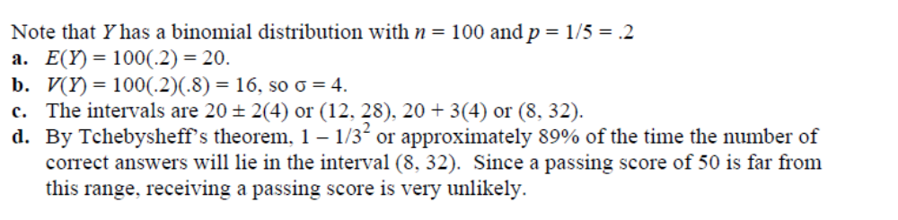

- A random variable Y has the following cumulative distribution function:
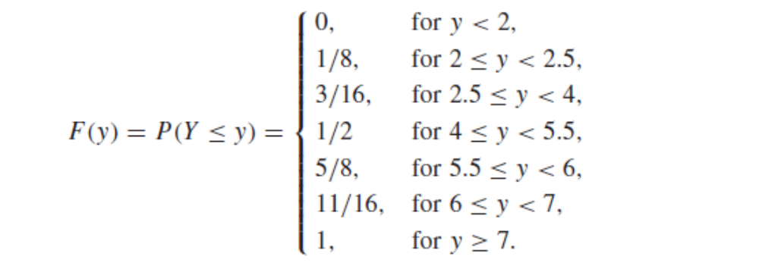
- Is Y a continuous or discrete random variable? Why?
- What values of Y are assigned positive probabilities?
- Find the probability function for Y.
- What is the median, φ_{.5}, of Y?

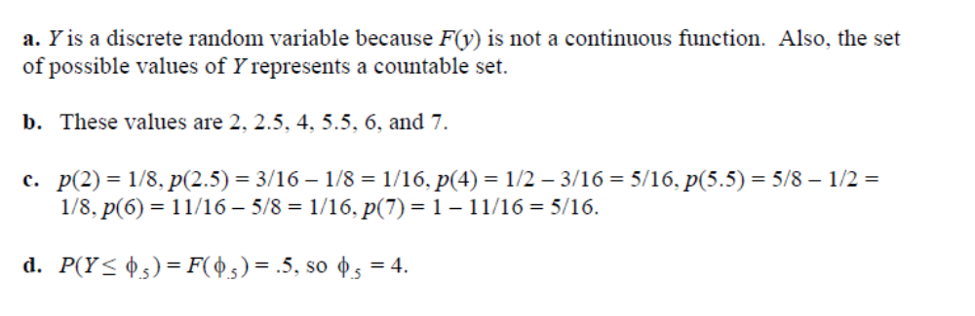
(For a discrete random variable, we can define the median $ϕ_{0.5}$ can be defined as the smallest value such that F${(ϕ}_{0.5}) ≥0.5$ .)

- The length of time to failure (in hundreds of hours) for a transistor is a random variable Y with cumulative distribution function given by
F(y) = 0, if y < 0, and F(y) = 1 – exp(−y²), if y ≥ 0.

- Show that F(y) has the properties of a cumulative distribution function.
- Find the .30-quantile (which is the 30th percentile), φ_{.30}, of Y.
- Find f(y).
- Find the probability that the transistor operates for at least 200 hours.
- Find P(Y > 1|Y ≤ 2).

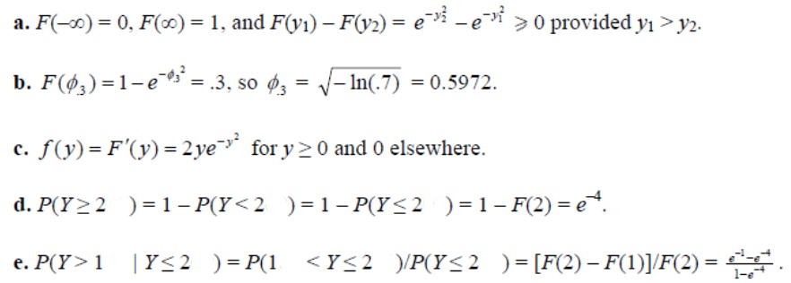
Remark: The notation F(-∞) and F(∞) were shorthand notations introduced in another textbook for $\lim_{x→-∞}F\left(x\right)$ and $\lim_{x→∞}F\left(x\right)$, respectively.

REMARK: Solutions for the following three examples (titled Examples 4,5 and 7) are on https://www.math24.net/probability-density-function/

There are typos in the solution of Example 5 in this website, so an edited version of the solution is posted below under 9) Example 5.
- Example 4.
Assume that the waiting time for your next email is described by the exponential density function with rate λ=3 (emails per hour), that is f(t)= 3 exp(-3t) for t ≥0 and f(t)=0 otherwise where t is measured in hours. Determine the probability that you receive no email during the next hour.

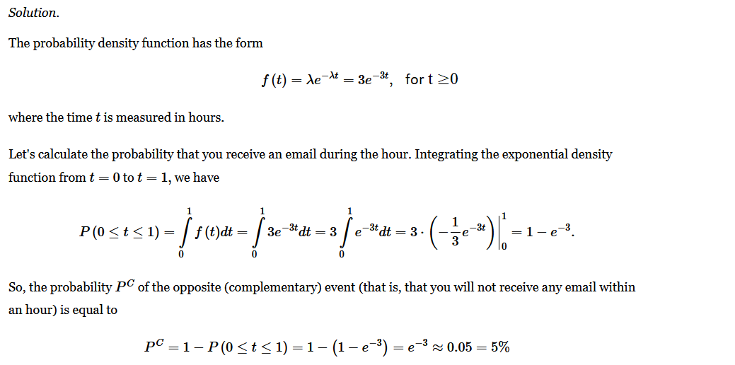

- Example 5.
Let X be a normal random variable with the mean μ=20 and the variance σ²=25. Find the probability that the random variable X falls in the range [15,30].
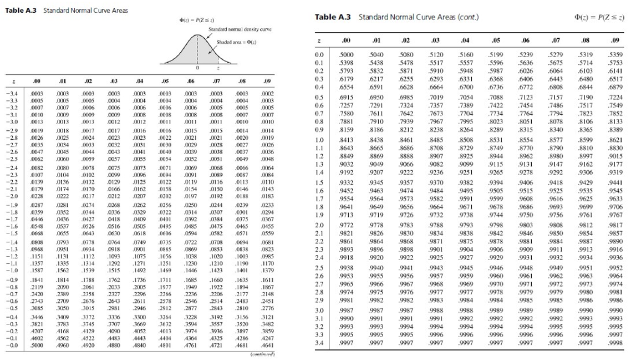

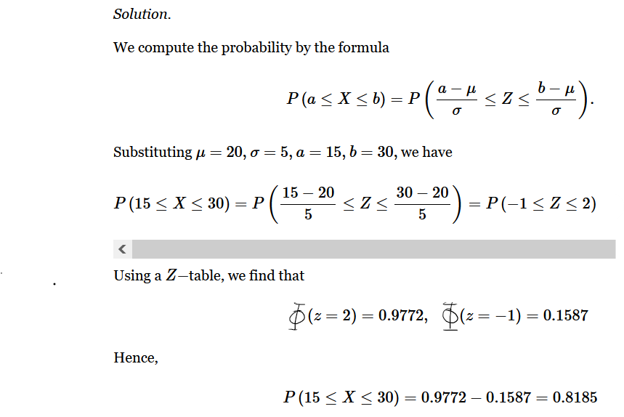
- Example 7.
A random variable X is defined by the PDF in the form f(x)=kx on the interval [0,10] and f(x)= 0 otherwise.
- Find the value of k;
- Determine the mean value μ of X;
- Calculate the probability P(2≤X≤5);

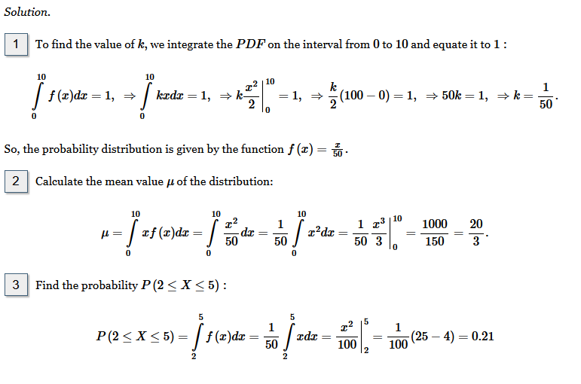

- Suppose that the reaction time in seconds of a person can be modelled by a lognormal distribution with parameter values, $μ=-0.35$ and $σ=0.2.$
- Find the probability that the reaction time is less than 0.6 seconds.
- Find the reaction time that is exceeded by $95\%$ of the population.

Let $X$be the reaction time in seconds of a person, and $lnX$is the log version of $X$.
$$lnX \sim N\left(-0.35, {\left(0.2\right)}^{2}\right)$$
- Find the probability that the reaction time is less than 0.6 seconds.
We are trying to find $P\left(X<0.6\right)$
$$P\left(X<0.6\right)=P(lnX<ln\left(0.6\right))$$ | (1)
$$P\left(X<0.6\right)=P\left(Z<\frac{ln\left(0.6\right)-\left(-0.35\right)}{0.2}\right)$$ | (2)
$$P\left(X<0.6\right)=P\left(Z<-0.80\right)=0.2119$$ | (3)

- Find the reaction time that is exceeded by $95\%$ of the population.
We are trying to find $c,$
$$P\left(X<c\right)=0.05→P\left(ln(X)<ln(c)\right)=0.05$$ | (5)
$$P\left(Z<\frac{ln\left(c\right)-\left(-0.35\right)}{0.2}\right)=0.05$$ | (6)
$$\frac{ln\left(c\right)-\left(-0.35\right)}{0.2}=-Z_{0.05}$$ | (7)
$$ln\left(c\right)=-1.645*0.2-0.35→c=0.679 seconds$$ | (8)
12) Recall: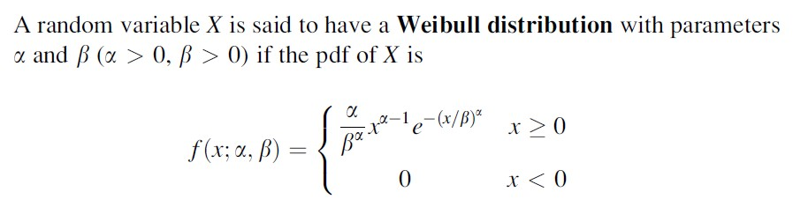
Assume that a random variable X has Weibull distribution with parameters α=2 and β=1. What is P(2 ≤ X ≤ 5)?

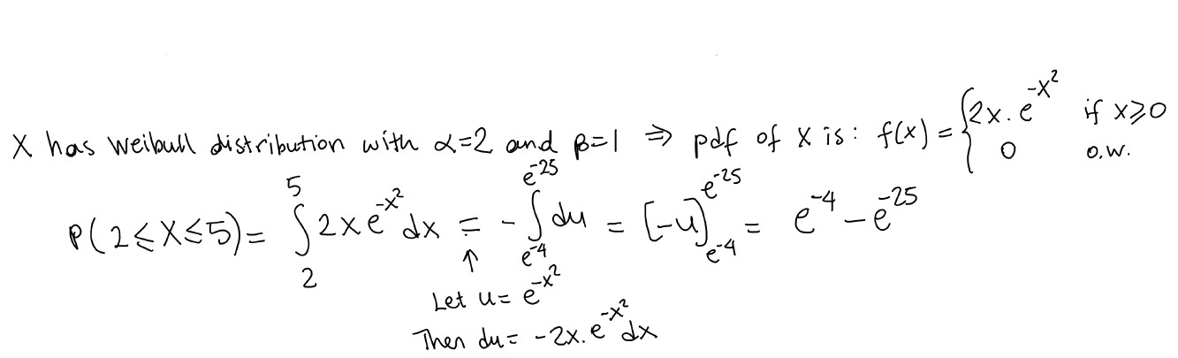

13) Paşabahçe began placing 1 of 10 cute animal miniatures in its 100-bag tea sets.
a) On average, how many boxes of tea sets must be purchased by a customer to obtain a complete set of 10 different animals?
b) If the customer uses one tea bag per day, how long can a customer, on average, expect to obtain a complete collection?

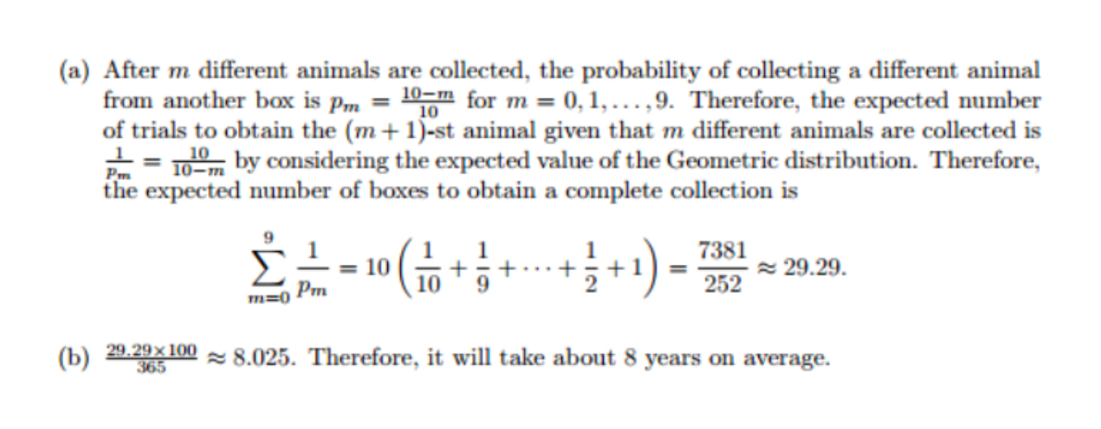
14) 