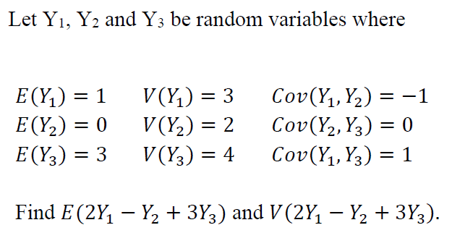
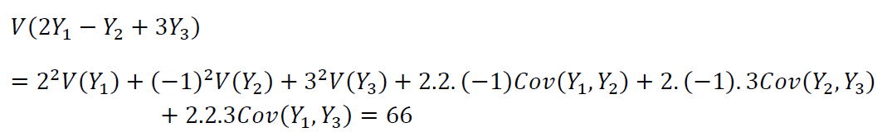
1)

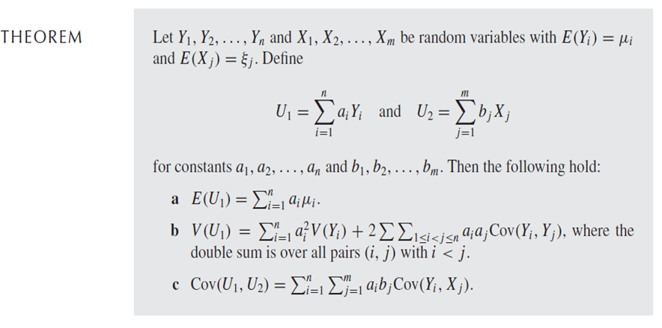

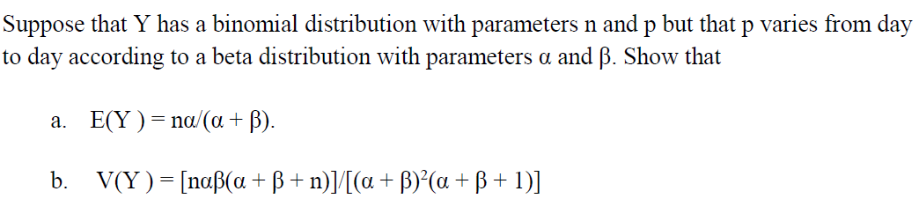
2) (The sentence below should be: “…. according to a standard beta distribution….”)
Recall : The mean and the variance of the beta distribution (Standard beta distribution is when A=0 and B=1):
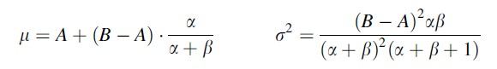

Solution:
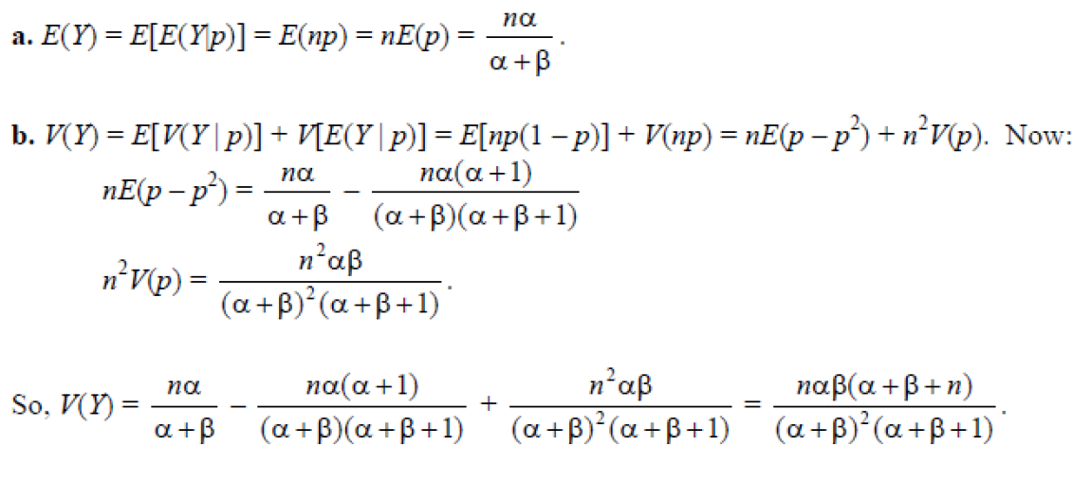

3) Suppose that a radioactive particle is randomly located in a square with sides of unit length. A reasonable model for the joint density function for Y₁ and Y₂ is

f ($y_{1}$, $y_{2}$) =$\left\{\begin{aligned} 1 0 ≤ y_{1} ≤ 1, 0 ≤ y_{2} ≤ 1 \\ 0 elsewhere\end{aligned}\right.$

a) What is E(Y₁ − Y₂)?
b What is E(Y₁ Y₂)?
c) What is E($Y_{1}^{2}$ + $Y_{2}^{2}$)

a) $E(Y_{1}-Y_{2})$=$\int_{0}^{1}{\int_{0}^{1}{(y_{1}-y_{2})dy_{1}}}dy_{2}$=$\int_{0}^{1}{(\frac{1}{2}-y_{2})dy_{2}}$=1/2-1/2=0
b) $E(Y_{1}Y_{2})$=$\int_{0}^{1}{\int_{0}^{1}{(y_{1}y_{2})dy_{1}}}dy_{2}$= $\frac{1}{2}\int_{0}^{1}{y_{2}dy_{2}}$=$\frac{1}{2}\frac{1}{2}$=$\frac{1}{4}$
c) E($Y_{1}^{2}$ + $Y_{2}^{2}$)=$\int_{0}^{1}{\int_{0}^{1}{(y_{1}^{2}+y_{2}^{2})dy_{1}}}dy_{2}$=$\int_{0}^{1}{(\frac{1}{3}}+y_{2}^{2}$)$dy_{2}=\frac{1}{3}+\frac{1}{3}-0=\frac{2}{3}$

4) For the joint pdf $f_{X,Y}\left(x,y\right)=x+y , 0≤x≤1 , 0≤y≤1$, find the variance of X+Y.

Since they are not assumed to be independent,
$$Var\left(X+Y\right)=Var\left(X\right)+Var\left(Y\right)+2Cov\left(X,Y\right)$$
Since the given pdf is symmetric, we can conclude that $Var\left(X\right)=Var\left(Y\right)$
Thus, $Var\left(X+Y\right)=2\left[Var\left(X\right)+Cov\left(X,Y\right)\right]$
$f_{x}\left(x\right)=\int_{0}^{1}{\left(x+y\right)dy=x+\frac{1}{2}}$ $for 0≤x≤1$
$$E\left(X\right)=\int_{0}^{1}{x\left(x+\frac{1}{2}\right)dx=\frac{7}{12}}$$
$$E\left(X^{2}\right)=\int_{0}^{1}{x^{2}\left(x+\frac{1}{2}\right)dx=\frac{5}{12}}$$
$$Var\left(X\right)=E\left(X^{2}\right)-{\left[E\left(X\right)\right]}^{2}=\frac{5}{12}-{\left(\frac{7}{12}\right)}^{2}=\frac{11}{144}$$
$$E\left(XY\right)=\int_{0}^{1}{\int_{0}^{1}{xy\left(x+y\right)dydx=\int_{0}^{1}{\left(\frac{x^{2}}{2}+\frac{x}{3}\right)dx=}\left(\frac{x^{3}}{6}+\frac{x^{2}}{6}\right)|_{0}^{1}=\frac{1}{3}}}$$
$$Cov\left(X,Y\right)=\frac{1}{3}-\left(\frac{7}{12}\right)×\left(\frac{7}{12}\right)=-\frac{1}{144}$$
$$Var\left(X+Y\right)=2\left[\frac{11}{144}+\left(-\frac{1}{144}\right)\right]=\frac{5}{36}$$

5) Remark: We rather denote the function f(x,y) given below as p(x,y) since it is a pmf. 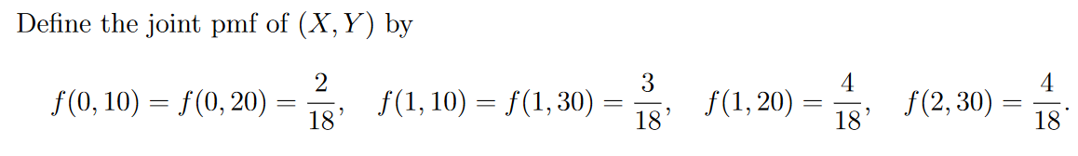
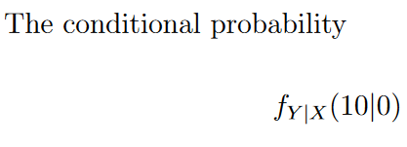
Find:

Solution:

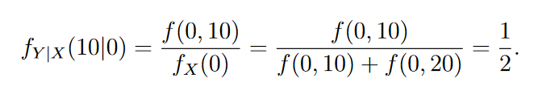

6)
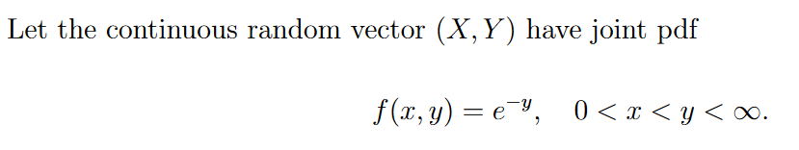
- Find the marginal probability density function of X.
- Find the conditional probability density function of Y given X=x.
- Find the conditional mean of Y given X=x.
- Find the conditional variance of Y given X=x.
- Calculate $P\left(Y>4 | X=5\right).$

Solution:
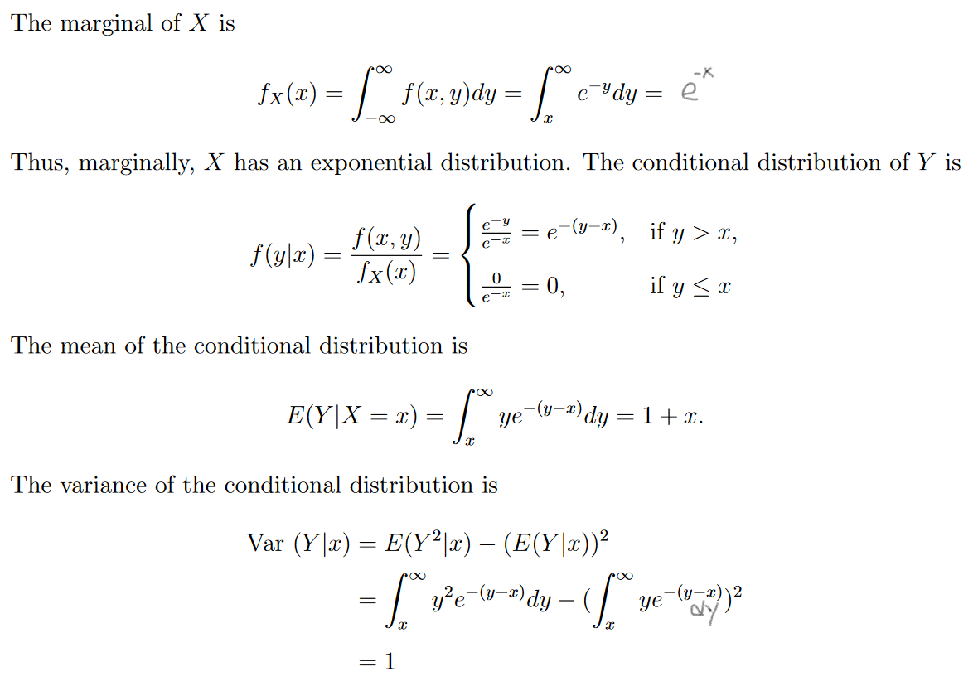

For x>0:

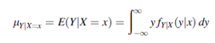
For x>0:

For x>0:

For x>0:

v)
For $x>0:$
$$f_{Y|X}\left(y|x\right)=\frac{f\left(x,y\right)}{f_{X}\left(x\right)}=\left\{\begin{aligned}e^{-y+x} , &if x<y \\ 0, &otherwise\end{aligned}\right.$$ | (3)
$$P\left(Y>4 | X=5\right)=\int_{5}^{∞}{f(y|x=5)dy}=\int_{5}^{∞}{e^{-y+5}dy}$$ | (4)
$$P\left(Y>4 | X=5\right)={\left[-e^{-y+5}\right]}_{5}^{∞}=e^{0}=1$$ | (5)

7) Prove the following theorem:
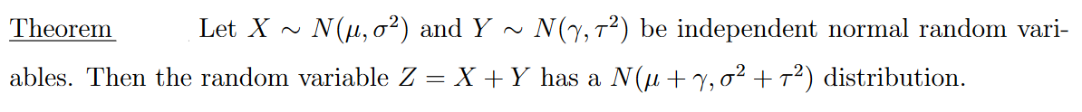
Recall:
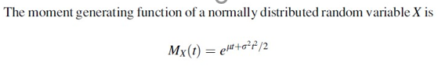

Proof: We have the following theorem:
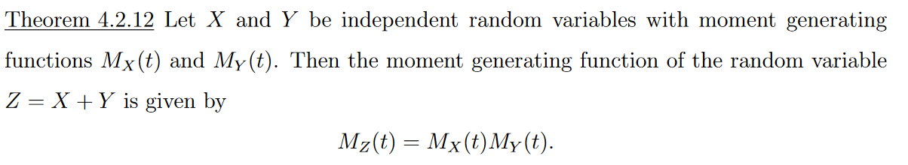

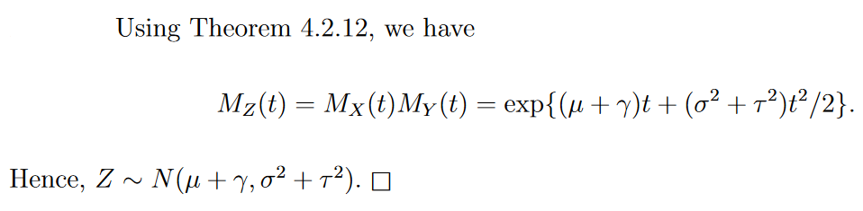

8)
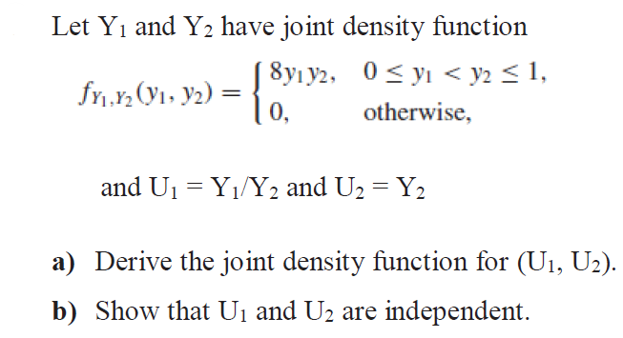

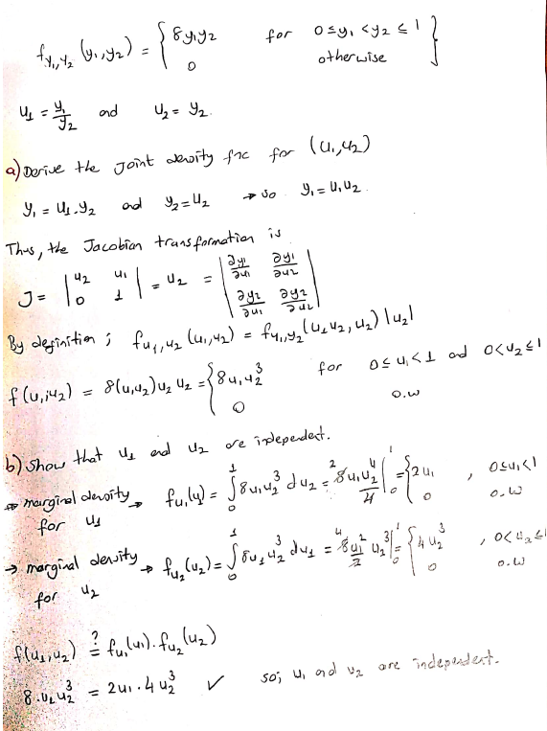

9) Show that $E\left[V\left(Y_{1} | Y_{2}\right)\right]≤V(Y_{1})$.

Note that
$$V\left(Y_{1}\right)=E\left[V\left(Y_{1} | Y_{2} \right)\right]+V\left[E\left(Y_{1} | Y_{2}\right)\right]$$ | (1)

So,
$$E\left[V\left(Y_{1} | Y_{2} \right)\right]=V\left(Y_{1}\right)-V\left[E\left(Y_{1} | Y_{2}\right)\right]$$ | (2)
Thus,
$$E\left[V\left(Y_{1} | Y_{2}\right)\right]≤V(Y_{1})$$
10) Let $X$ and $Y$ be jointly continuous random variables with joint pdf
$$f\left(x,y\right)=\left\{\begin{aligned}cx+1, &x,y≥0, x+y≤1 \\ 0, &otherwise\end{aligned}\right.$$
- Find the constant $c$.
- Find the marginal pdf’s $f_{X}\left(x\right)$ and $f_{Y}(y)$.
- Find $P(Y<2X^{2})$.

- Find the constant $c$.
To find the constant $c$, we write
$$\int_{-∞}^{∞}{\int_{-∞}^{∞}{f\left(x,y\right)dxdy}}=1$$ | (1)
$$\int_{0}^{1}{\int_{0}^{1-x}{(cx+1)dydx}=1}$$ | (2)
$$\int_{0}^{1}{(cx+1)(1-x)dx=1}$$ | (3)
$$\int_{0}^{1}{(-cx^{2}+\left(c-1\right)x+1)dx=1}$$ | (4)
$$\frac{1}{2}+\frac{1}{6}c=1→c=3$$ | (5)
- Find the marginal pdf’s $f_{X}\left(x\right)$ and $f_{Y}(y)$.

$$f_{X}(x)=\int_{-∞}^{∞}{f\left(x,y\right)dy}$$ | (6)
For$0≤x≤1,$ $f_{X}(x)=\int_{0}^{1-x}{\left(3x+1\right)dy}$ | (7)
$$f_{X}\left(x\right)=\left(3x+1\right)\left(1-x\right), for x∈[0,1]$$ | (8)
Thus, we have
$$f_{X}\left(x\right)=\left\{\begin{aligned}(3x+1)(1-x), &0≤x≤1 \\ 0, &otherwise\end{aligned}\right.$$ | (9)
Similarly, we obtain
$$f_{Y}(y)=\int_{-∞}^{∞}{f\left(x,y\right)dx}$$ | (10)
For$0≤y≤1, f_{Y}(y)=\int_{0}^{1-y}{\left(3x+1\right)dx}$ | (11)
$$f_{Y}\left(y\right)=\frac{1}{2}(1-y)(5-3y), for y∈[0,1]$$ | (12)

Thus, we have
$$f_{Y}\left(y\right)=\left\{\begin{aligned}\frac{1}{2}(1-y)(5-3y), &0≤y≤1 \\ 0, &otherwise\end{aligned}\right.$$ | (12)
- Find $P(Y<2X^{2})$.
To find $P(Y<2X^{2})$, we need to integrate $f(x,y)$ over the region A in figure below.
y
1
$$y=2x^{2}$$

A
1
x
We have
$$P(Y<{2X}^{2})=\int_{-∞}^{∞}{\int_{-∞}^{2x^{2}}{f\left(x,y\right)dydx}}$$ | (13)
$$P(Y<{2X}^{2})=\int_{0}^{1}{\int_{0}^{min(2x^{2},1-x)}{(3x+1)dydx}}$$ | (14)
$$P(Y<{2X}^{2})=\int_{0}^{1}{(3x+1)min(2x^{2},1-x)}dx$$ | (15)
$$P\left(Y<{2X}^{2}\right)=\int_{0}^{\frac{1}{2}}{2x^{2}\left(3x+1\right)}dx+\int_{\frac{1}{2}}^{1}{\left(3x+1\right)(1-x)}dx$$ | (16)
$$P\left(Y<{2X}^{2}\right)= {\left.\left(\frac{3x^{4}}{2}+\frac{2x^{3}}{3}\right)\right|}_{x=0}^{x=1/2}+{\left.\left(-x^{3}+x^{2}+x\right)\right|}_{x=1/2}^{x=1}$$ | (17)
$$P\left(Y<{2X}^{2}\right)=\frac{53}{96}$$ | (18)
11) $X$is a continuous variable with the following probability density function:
$$f_{X}\left(x\right)=\frac{3}{8}x^{2}, for 0<x<2$$
Find the probability density of $Y=X^{3}$

Since Y= X³ is a (strictly) monotonic function of X for all x such that f_{x}(x)>0, the transformation method can be used.

Note that the function:
$$Y=X^{3}$$
defined over the interval $0<x<1$ is an invertible function. The inverse function is:
$$x=v\left(y\right)=\sqrt[3]{y}=y^{1/3} for 0<y<8$$ | (1)
Now, taking derivative of $v\left(y\right)$, we get:
$$v^{'}\left(y\right)=\frac{1}{3}y^{-2/3}$$ | (2)
Using the transformation method
$$f_{Y}\left(y\right)=f_{X}\left(v\left(y\right)\right)*\left|v^{'}\left(y\right)\right|$$ | (3)
the probability function of $Y$ is:
${For 0<y<8 , f}_{Y}\left(y\right)=\frac{3}{8}{\left[y^{1/3}\right]}^{2}*\frac{1}{3}y^{-2/3}$ | (3)
And, simplifying we get that the probability density function of $Y$ is:
$$f_{Y}\left(y\right)=\left\{\begin{aligned}\frac{1}{8} , &0<y<8 \\ 0, &otherwise\end{aligned}\right.$$ | (3)

Alternatively, the method of distribution function can be used:
The distribution function of X is:
$F_{X}$(x)$=\left\{\begin{aligned}0 for x≤0 \\ \int_{0}^{x}{\frac{3}{8}t^{2} dt=\frac{1}{8}x^{3} for 0<x<2} \\ 1 for x≥2\end{aligned}\right.$

$$F_{Y}(y)=P\left(Y≤y\right)=P\left(X^{3}≤y\right)=P\left(X≤y^{1/3}\right)=F_{X}\left(y^{1/3}\right)$$

For $y^{1/3}≤0$ , $that is for y≤0$, ${ F}_{X}\left(y^{1/3}\right)=0$

For $0< y^{1/3}<2, { that is for 0<y<8, F}_{X}\left(y^{1/3}\right)=\frac{1}{8}y$

For $y^{1/3}≥2$ , $that is for y≥8$, $F_{X}\left(y^{1/3}\right)=1$

$$f_{Y}\left(y\right)=F_{Y}^{'}\left(y\right)=\frac{1}{8},0<y<8$$
$$f_{Y}\left(y\right)=\left\{\begin{aligned}\frac{1}{8} , 0<y<8 \\ 0, otherwise\end{aligned}\right.$$

